A retrospective analysis of historical data from multi-environment trial evaluation for dry bean (*Phaseolus vulgaris*) in Michigan

Leonardo Volpato, Francisco E. Gomez, Evan Wright, and Scott Bales

Last compiled on 28 March, 2023

Table of Contents

This is the supplemental material for the manuscript **A retrospective analysis of historical data from multi-environment trial evaluation for dry bean** *(Phaseolus vulgaris)* **in Michigan.**

It has six main sections: The first contains the Supplemental Tables; the second contains the Supplemental Figures; the third section contains the R code to reproduce the descriptive analysis and methods of this manuscript; section fourth contains the R code for reproducing the MET analysis (Multi Environmental Trials); section fifth contains the R code for reproducing the Multi-Trait Multi-Environmental analysis, while section sixth contains the references and literature cited in this manuscript.

introduce the metan (multienvironment trials analysis) R package reproducing the examples shown in the manuscript using the oat dataset.

# 1 Appendix A - Supplementary Tables

Supplementary Table S3: Estimated variance components and genetic parameters for grain yield (GY), days to maturity (DM), plant height (PH) and lodging (LD) for 37 Black, 37 Navy and 14 Red Small beans genotypes evaluated in BA, SA, and TU environments during 2021 growing season only.

**Black Beans**

| REML | GY2 | DM | PH | LD |
| --- | --- | --- | --- | --- |
| ${}_{g}^{2}$ | 68572 (32%)‡ | 2.86 (39.5%) | 0.63 (10.5%) | 0.063 (17.6%) |
| ${}_{ge}^{2}$ | 17115 (8%) | 0.8 (11%) | 0.18 (3.0%) | 0.02 (5.32%) |
| ${}_{ε}^{2}$ | 128582 (60%) | 3.58 (49.5%) | 5.17 (86.4%) | 0.27 (77.1%) |
| ${}_{p}^{2}$ | 214269 | 7.24 | 5.98 | 0.356 |
| $h_{g}^{2}$ | 0.32 | 0.395 | 0.105 | 0.176 |
| $R_{gei}^{2}$ | 0.08 | 0.11 | 0.0305 | 0.0532 |
| $h_{gm}^{2}$ | 0.81 | 0.835 | 0.561 | 0.682 |
| $Acc$ | 0.90 | 0.914 | 0.749 | 0.826 |
| $r_{ge}$ | 0.12 | 0.182 | 0.0341 | 0.0645 |
| $CVg$ | 8.19 | 1.84 | 4.37 | 14.5 |
| $CVr$ | 11.21 | 2.06 | 12.5 | 30.3 |
| $CVg/CVr$ | 0.73 | 0.894 | 0.349 | 0.478 |

**Navy Beans**

| REML | GY2 | DM | PH | LD |
| --- | --- | --- | --- | --- |
| ${}_{g}^{2}$ | 50195 (25.72%)‡ | 1.97 (32%) | 1.36 (19.1%) | 0.195 (39.3%) |
| ${}_{ge}^{2}$ | 22779 (11.67%) | 0.63 (10.2%) | 0.81 (11.4%) | 0.04 (7.19%) |
| ${}_{ε}^{2}$ | 122206 (62.61%) | 3.56 (57.8%) | 4.95 (69.5%) | 0.27 (53.5%) |
| ${}_{p}^{2}$ | 195181 | 6.17 | 7.12 | 0.496 |
| $h_{g}^{2}$ | 0.26 | 0.32 | 0.191 | 0.393 |
| $R_{gei}^{2}$ | 0.12 | 0.102 | 0.114 | 0.0719 |
| $h_{gm}^{2}$ | 0.74 | 0.796 | 0.666 | 0.851 |
| $Acc$ | 0.86 | 0.892 | 0.816 | 0.923 |
| $r_{ge}$ | 0.16 | 0.15 | 0.141 | 0.118 |
| $CVg$ | 7.45 | 1.54 | 6.35 | 23.6 |
| $CVr$ | 11.62 | 2.07 | 12.1 | 27.6 |
| $CVg/CVr$ | 0.64 | 0.744 | 0.524 | 0.856 |

**Red Beans**

| REML§ | GY2 | DM | PH | LD |
| --- | --- | --- | --- | --- |
| ${}_{g}^{2}$ | 0.1 (0.01%)‡ | 0.61 (12.2%) | 1.81 (25.3%) | 0.18 (34.6%) |
| ${}_{ge}^{2}$ | 75950 (31.4%) | 0.66 (13.2%) | 0.35 (4.9%) | 0.03 (5.0%) |
| ${}_{ε}^{2}$ | 165822 (68.59%) | 3.72 (74.6%) | 4.99 (69.8%) | 0.32 (60.4%) |
| ${}_{p}^{2}$ | 241772 | 4.98 | 7.142 | 0.53 |
| $h_{G}^{2}$ | 0.00 | 0.12 | 0.2531 | 0.35 |
| $R_{gei}^{2}$ | 0.31 | 0.13 | 0.04876 | 0.05 |
| $h_{gm}^{2}$ | 0.00 | 0.54 | 0.7728 | 0.84 |
| $Acc$ | 0.00 | 0.73 | 0.8791 | 0.91 |
| $r_{ge}$ | 0.31 | 0.15 | 0.06528 | 0.07 |
| $CVg$ | 0.00 | 0.86 | 7.307 | 22.9 |
| $CVr$ | 12.90 | 2.12 | 12.13 | 30.2 |
| $CVg/CVr$ | 0.00 | 0.4 | 0.6022 | 0.76 |

${}_{G}^{2}$, genotypic variance; ${}_{GE}^{2}$, variance of G × E interaction; ${}_{ε}^{2}$ residual variance; ${}_{P}^{2}$ phenotypic variance; $h_{G}^{2}$ broad-sense heritability; $r_{gei}^{2}$ coefficient of determination for the genotype-vs-environment interaction effects; $h_{gm}^{2}$ heritability of the genotypic mean; $Acc$ accuracy of genotype selection; $r_{GE}$ correlation between genotypic values across environments; $CVg$ genotypic coefficient of variation; $CVr$ residual coefficient of variation; $CVg/CVr$ and is the ratio between genotypic and residual coefficient of variation.‡ Parenthetical values indicate the percentage of the observed phenotypic variance ${}_{P}^{2}$. The genetic parameters were estimated by $h_{G}^{2}=\frac{{}_{G}^{2}}{{}_{G}^{2}+{}_{GE}^{2}+{}_{e}^{2}}$; where ${}_{G}^{2}$ is the genotypic variance; ${}_{GE}^{2}$ is the genotype-by-environment interaction variance; and ${}_{ε}^{2}$ is the residual variance. Coefficient of determination of the interaction effects: $R_{gei}^{2}= \frac{{\hat{σ}}_{GE}^{2}}{{\hat{σ}}_{G}^{2} + {\hat{σ}}_{GE}^{2} +{\hat{σ}}_{ε}^{2}}$; heribability on the mean basis: $h_{gm}^{2}=\frac{{}_{G}^{2}}{\left[{}_{G}^{2}+{}_{GE}^{2}/e+{}_{e}^{2}/\left(eb\right)\right]}$ where *e* and *b* are the number of environments and blocks, respectively; The accuracy of selection: $Acc=\sqrt{h_{GM}^{2}}$; genotype-environment correlation $r_{GE}= \frac{{\hat{σ}}_{g}^{2}}{{\hat{σ}}_{G}^{2} + {\hat{σ}}_{GE}^{2}}$; genotypic coefficient of variation $CVg=\left(\sqrt{{}_{g}^{2}}/μ\right)×100$ residual coefficient of variation estimated: $CVr=\left(\sqrt{{}_{e}^{2}}/μ\right)×100$ where $μ$ is the grand mean; ratio between genotypic and residual coefficient of variation: ${CV}_{g}/{CV}_{r}$.

Supplementary Table S10: Selection differential of the WAASBY index for 27 Black, 29 Nayv and 12 Red beans.

**Black Beans**

| Factor | Trait | Xo‡ | Xs§ | SD (%)¶ | Sense |
| --- | --- | --- | --- | --- | --- |
| FA 1 | GY | 3,201 | 3,258 | 57.92 (1.81) | Increase |
| FA 1 | LD | 1.73 | 1.63 | -0.1 (-5.556) | Decrease |
| FA 2 | DM | 91.78 | 91.90 | 0.12 (0.1324) | Decrease |
| FA 2 | PH | 18.15 | 18.34 | 0.19 (1.063) | Increase |

**Navy Beans**

| Factor | Trait | Xo‡ | Xs§ | SD (%)¶ | Sense |
| --- | --- | --- | --- | --- | --- |
| FA 1 | GY | 3,006 | 3,145 | 138.90 (4.619) | Increase |
| FA 1 | DM | 91.25 | 91.54 | 0.29 (0.3184) | Decrease |
| FA 1 | PH | 18.34 | 19.69 | 1.35 (7.371) | Increase |
| FA 1 | LD | 1.88 | 1.65 | -0.22 (-11.85) | Decrease |

**Red Beans**

| Factor | Trait | Xo‡ | Xs§ | SD (%)¶ | Sense |
| --- | --- | --- | --- | --- | --- |
| FA 1 | PH | 18.25 | 20.07 | 1.82 (9.966) | Increase |
| FA 1 | LD | 1.87 | 1.91 | 0.04 (2.104) | Decrease |
| FA 2 | GY | 3,156 | 3,162 | 5.92 (0.1875) | Increase |
| FA 2 | DM | 90.85 | 90.88 | 0.03 (0.02776) | Decrease |

GY, grain yield; PH, plant height; DM, days to maturity; LD, lodging;‡ Xo, mean for WAASBY index of the original population; § Xs, mean for WAASBY index of the selected genotypes (BB: B55, B1, B29, B20, B28; NB: N38, N6, N61, N35, N52, N22; SR: R2, R13); SD, Selection differential; ¶% of SD in parenthesis.

# 2 Appendix B - Supplementary Figures

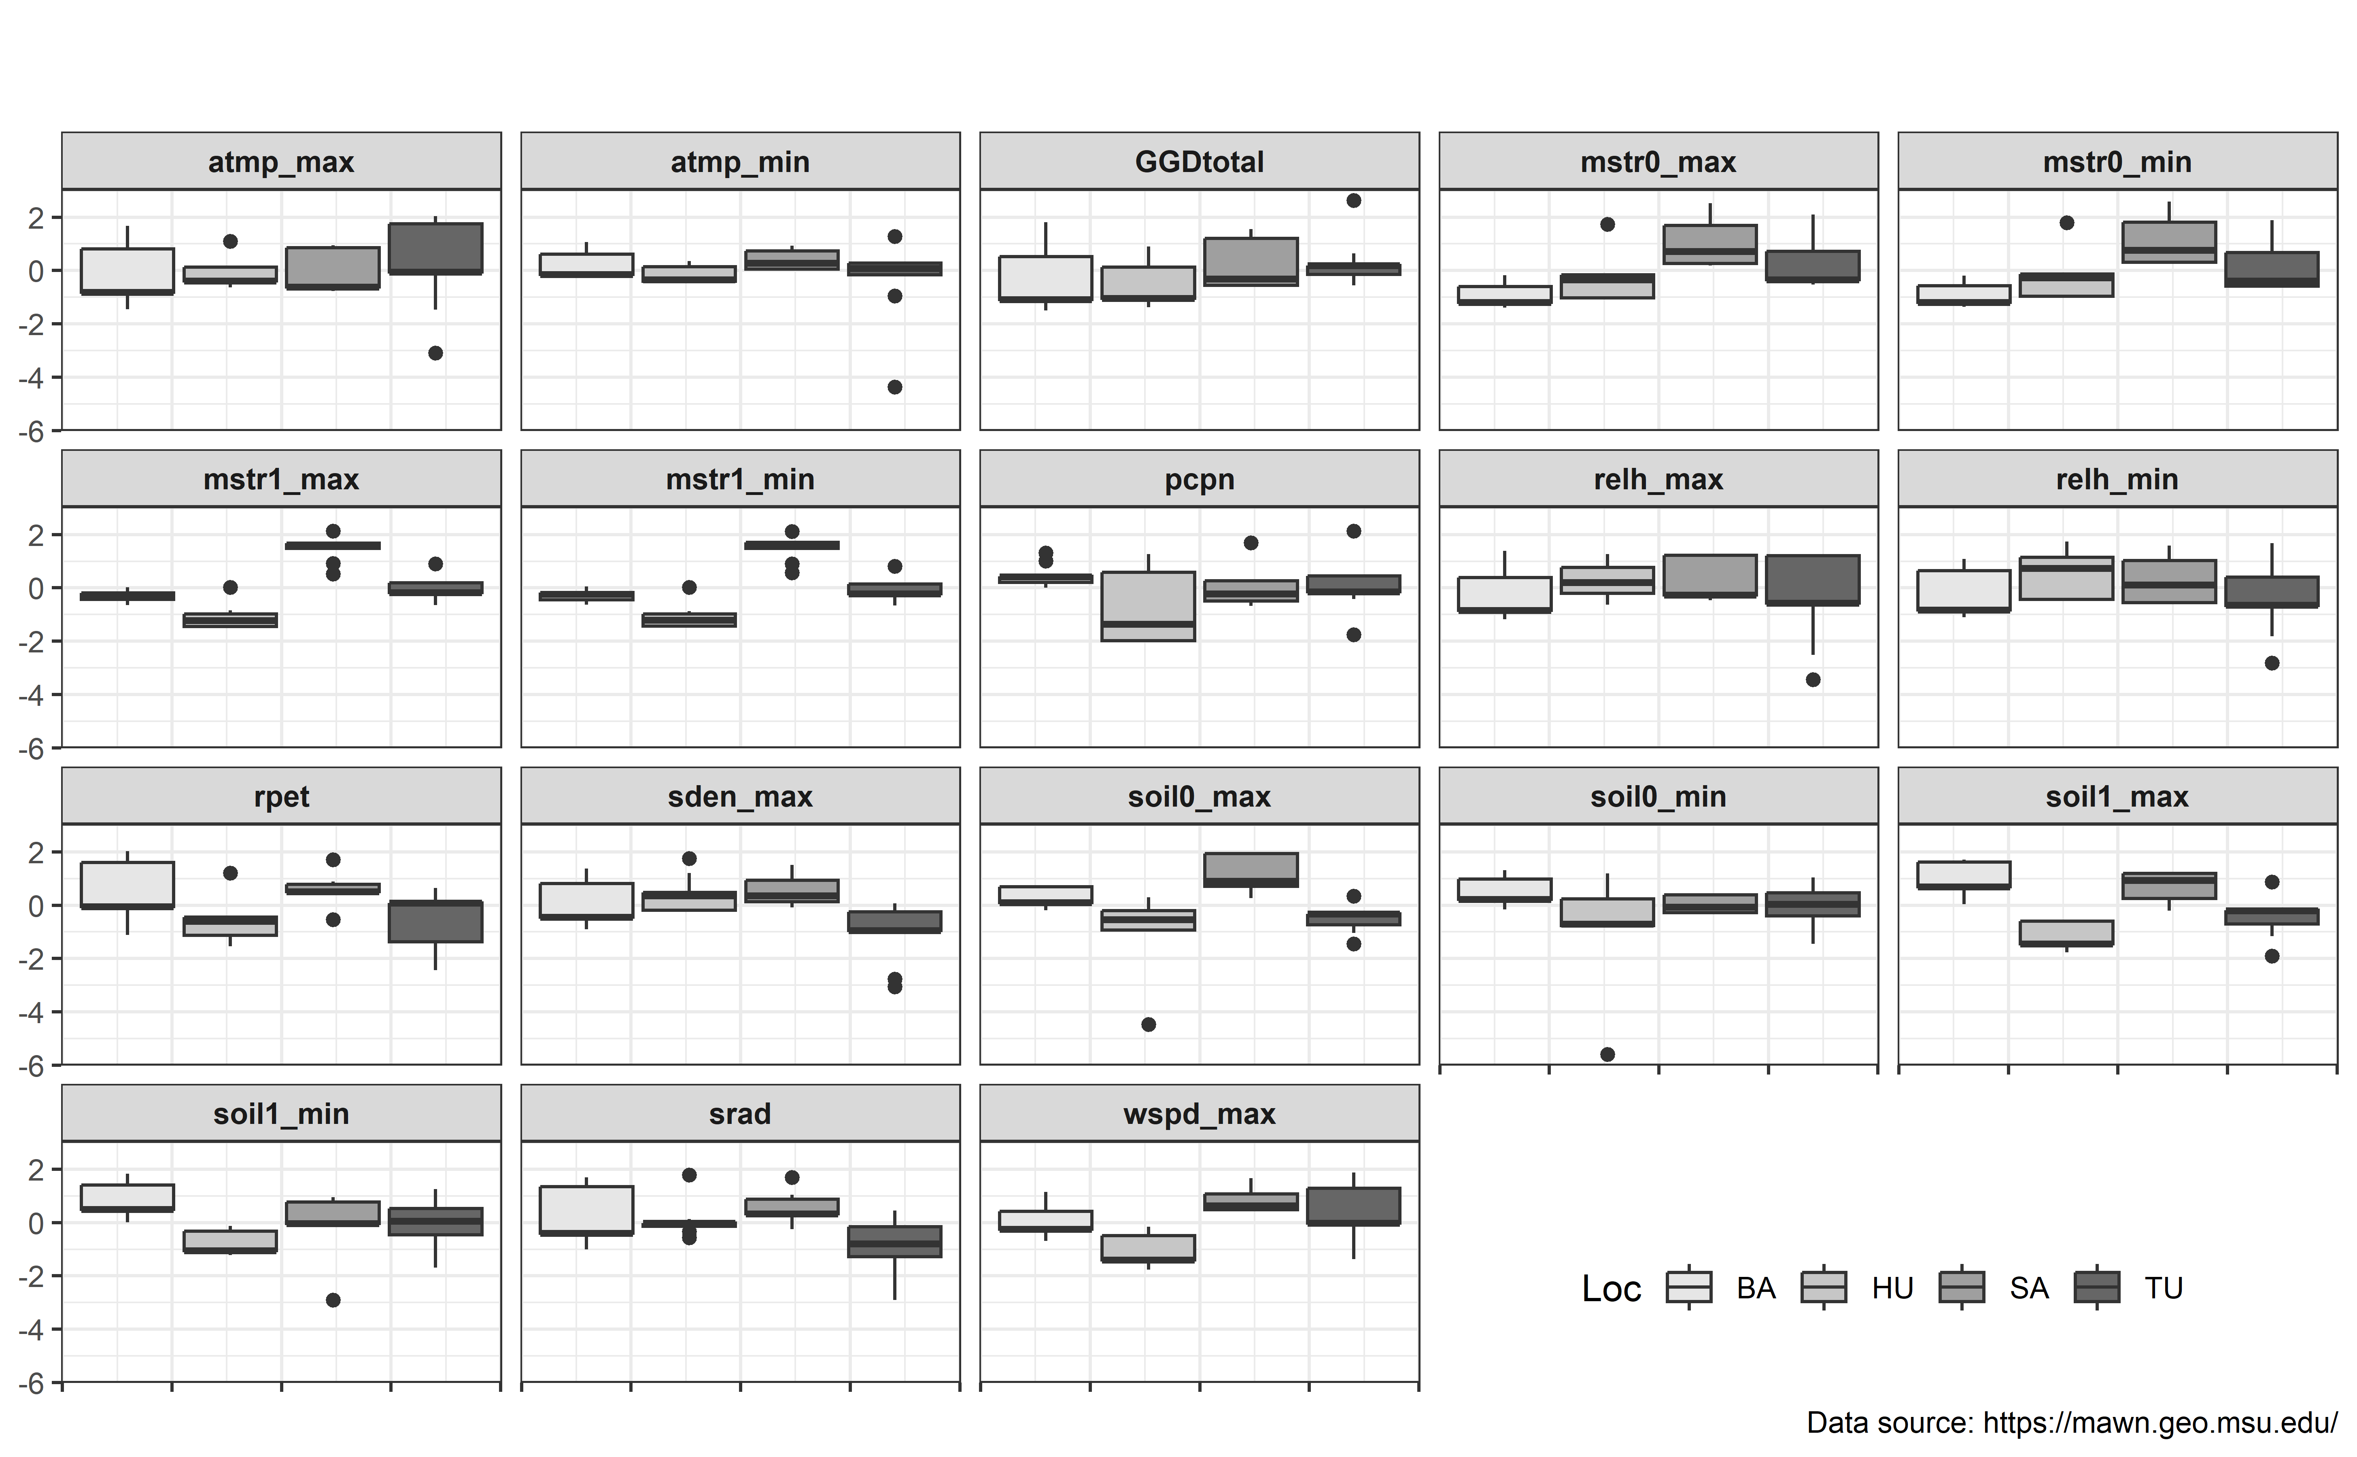 atmp_max: Max Air Temperature (1.5m), atmp_min: Min Air Temperature (1.5m), mstr0_max: Max Soil Moisture (0-30cm), mstr0_min: Min Soil Moisture (0-30cm), mstr1_max: Max Soil Moisture (30-60cm), mstr1_min: Min Soil Moisture (30-60cm), pcpn: Precipitation, relh_max: Max Relative Humidity (1.5m), relh_min: Min Relative Humidity (1.5m), rpet: Reference Potential Evapotranspiration, sden_max: Max Solar Flux, soil0_max: Max Soil Temperature (5cm), soil0_min: Min Soil Temperature (5cm), soil1_max: Max Soil Temperature (10cm), soil1_min: Min Soil Temperature (10cm), srad: Total Solar Flux, wspd_max: Max Wind Speed (3m). GGDtotal: Growing Degree-Day Calculations in Celsius (C) given by: $\left(max−min\right)/2−10$

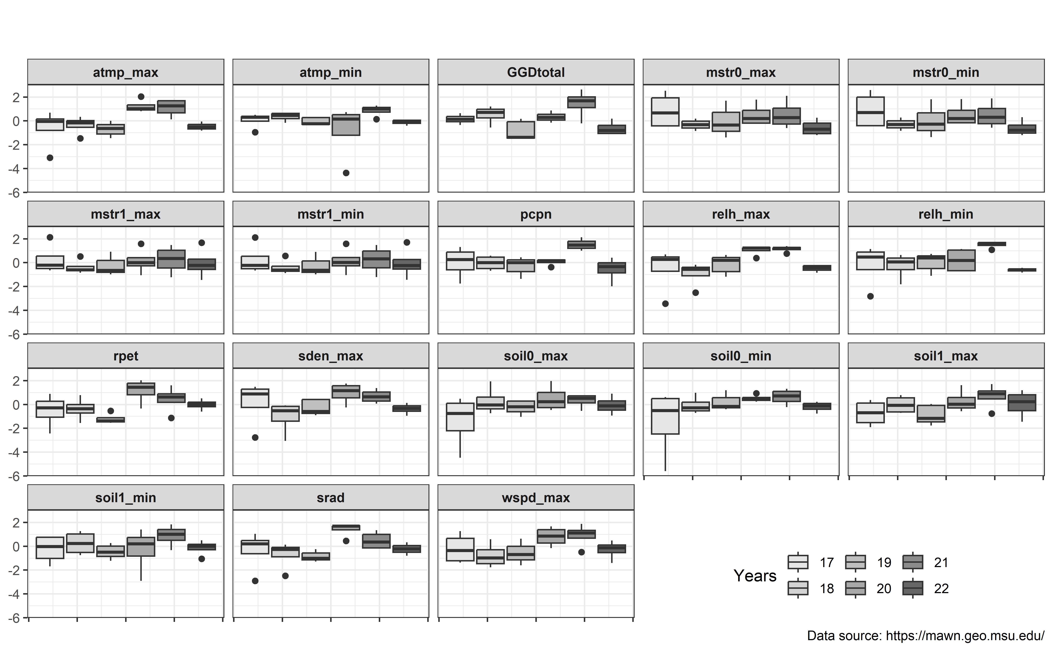 atmp_max: Max Air Temperature (1.5m), atmp_min: Min Air Temperature (1.5m), mstr0_max: Max Soil Moisture (0-30cm), mstr0_min: Min Soil Moisture (0-30cm), mstr1_max: Max Soil Moisture (30-60cm), mstr1_min: Min Soil Moisture (30-60cm), pcpn: Precipitation, relh_max: Max Relative Humidity (1.5m), relh_min: Min Relative Humidity (1.5m), rpet: Reference Potential Evapotranspiration, sden_max: Max Solar Flux, soil0_max: Max Soil Temperature (5cm), soil0_min: Min Soil Temperature (5cm), soil1_max: Max Soil Temperature (10cm), soil1_min: Min Soil Temperature (10cm), srad: Total Solar Flux, wspd_max: Max Wind Speed (3m). GGDtotal: Growing Degree-Day Calculations in Celsius (C) given by: $\left(max−min\right)/2−10$

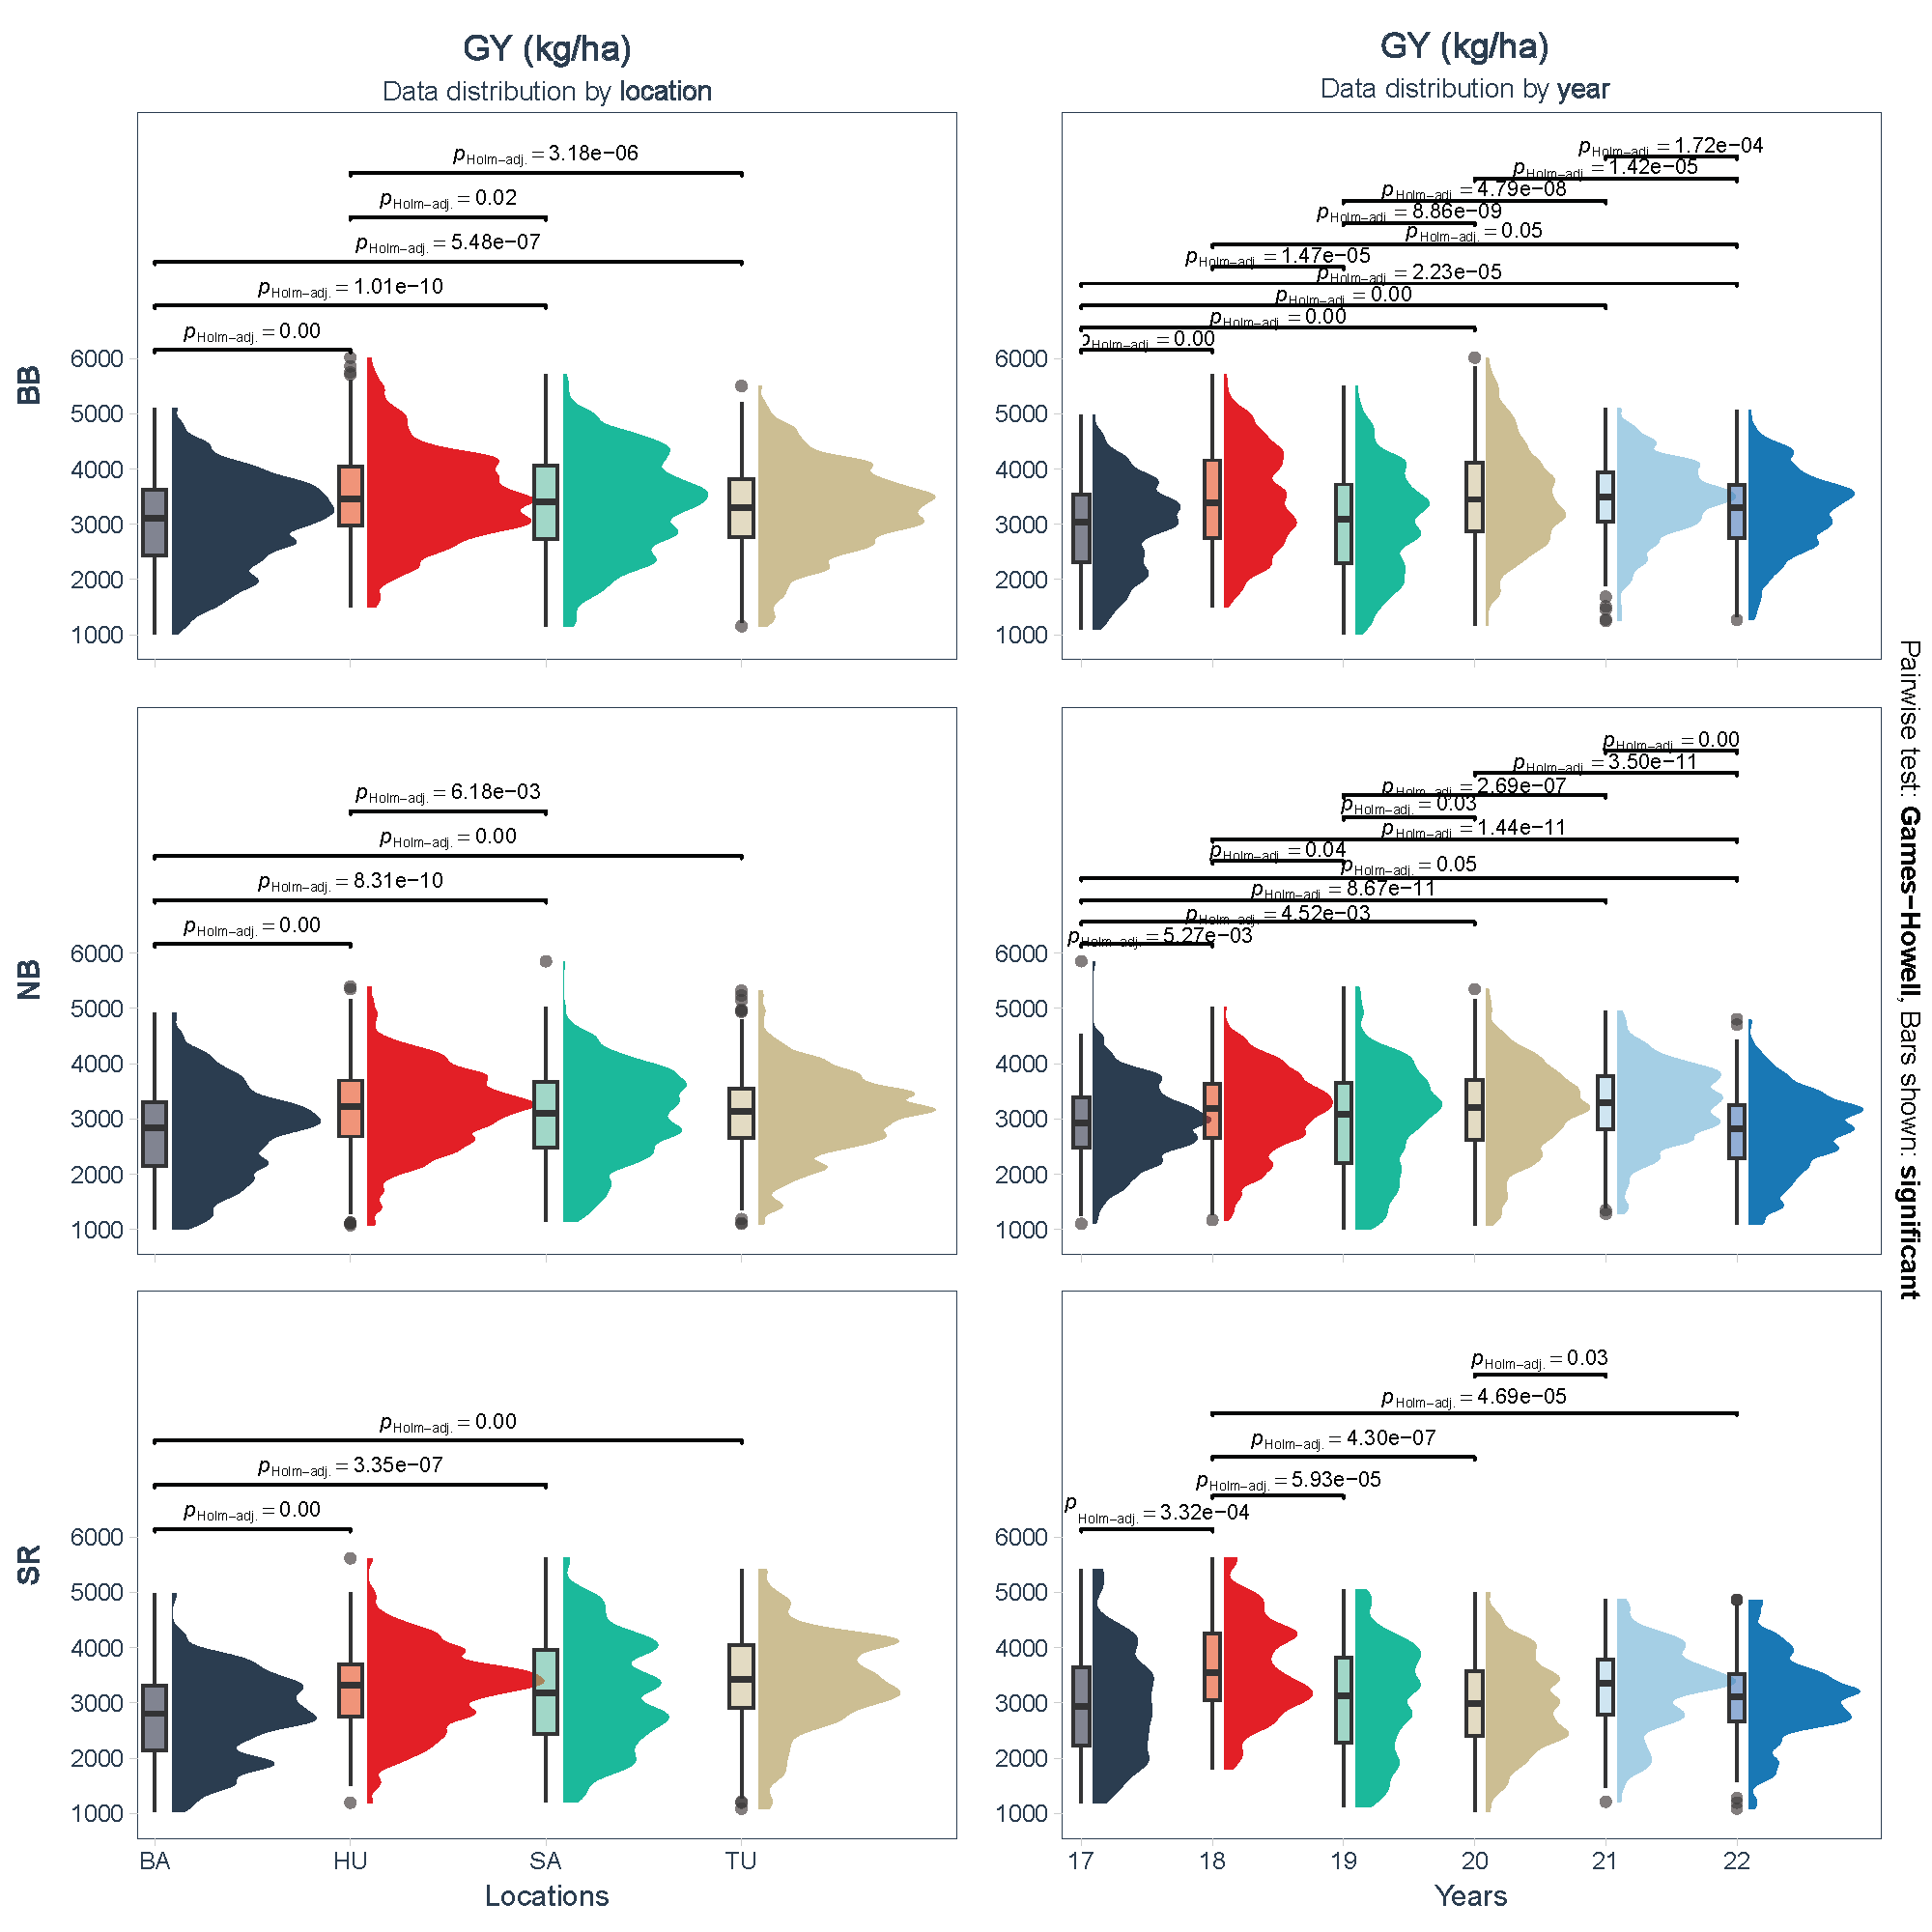

Supplementary Figure S3: Combination of box and density plots for between subjects comparisons by locations (left) and year (right) of grain yield (GY in Kg/ha) for black (BB), Navy (NB) and Red (SR) beans. BA: Bay, HU: Huron, SA:Sanilac, TU: Tuscola locations.

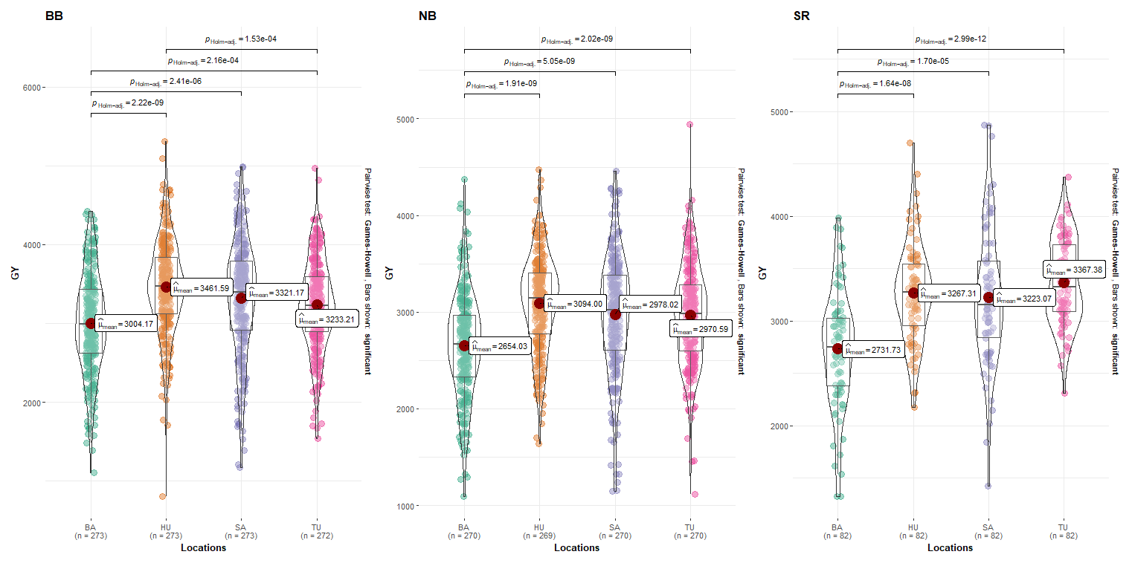

Supplementary Figure S4: Combination of box and violin plots along with jittered data points and grand mean values for between subjects comparisons by locations of grain yield (GY) for black (BB), Navy (NB) and Small Red (SR) beans. Pairwise Games-Howell test used. Comparisons showing only significant values. BA: Bay, HU: Huron, SA:Sanilac, TU: Tuscola. Pairwise Games-Howell test used. Comparisons showing only significant between the pairs of environments

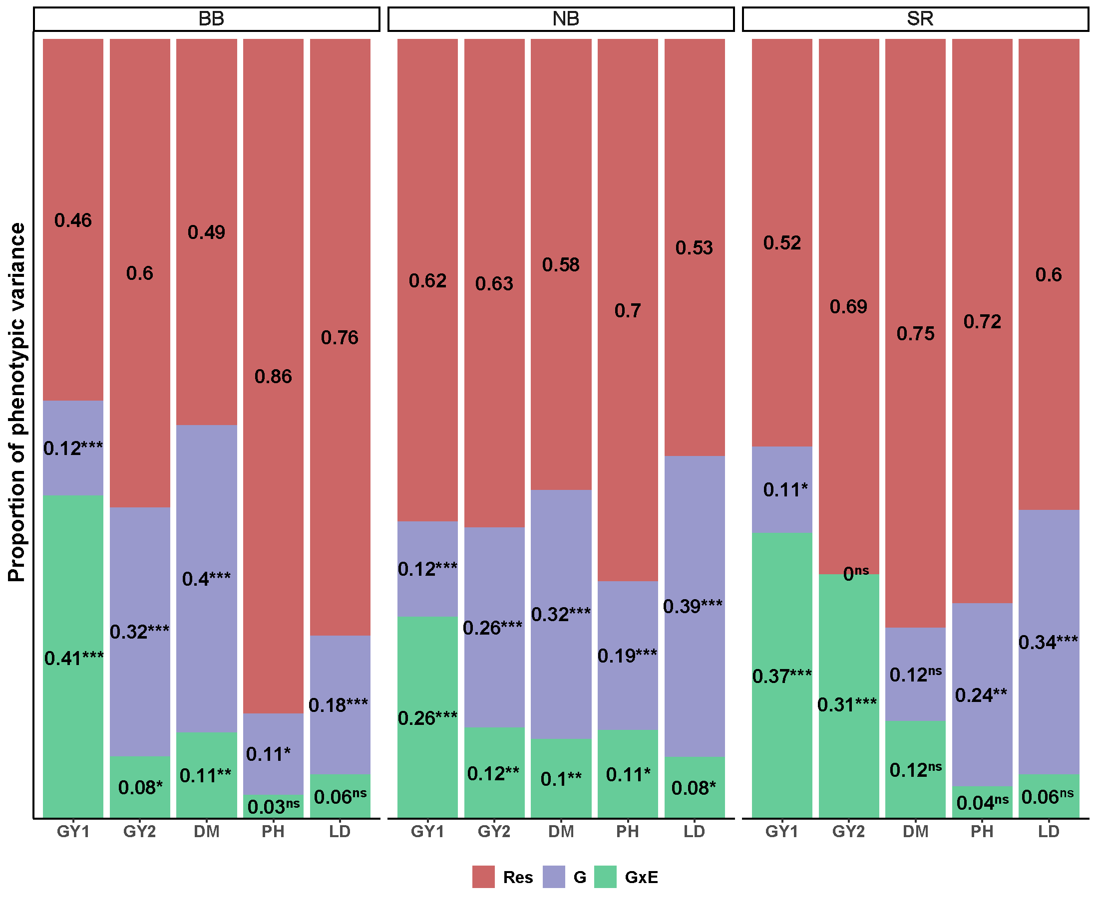

Supplementary Figure S5:Proportion of the phenotypic variance for 71 Black (BB), 72 Navy (NB), and 21 Red (SR) beans for grain yield in Kg/ha (GY: 2017 - 2022; GY2: only 2021) days to maturity (DM, days), plant height (PH, cm) and lodging (LD,scale) traits evaluated in the study. * Significant at P < 0.05. ** Significant at P < 0.01. *** Significant at P < 0.001. ns, nonsignificant.

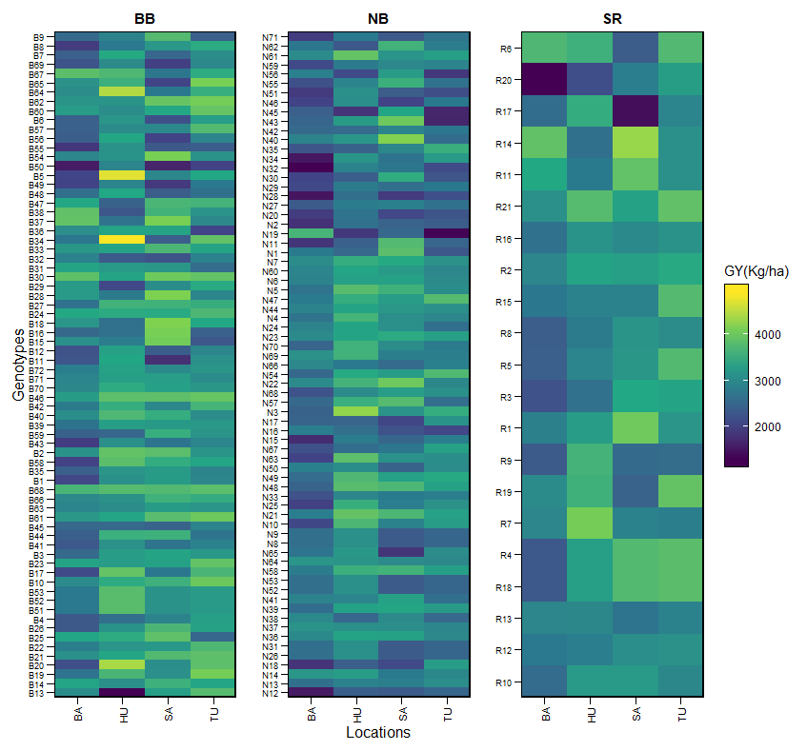

Supplementary Figure S6: Genotype’s performance across the environments for Black (BB), Navy (NB), and Small Red (SR) beans using the estimated means (BLUEs) values. BA: Bay, HU: Huron, SA:Sanilac, TU: Tuscola locations

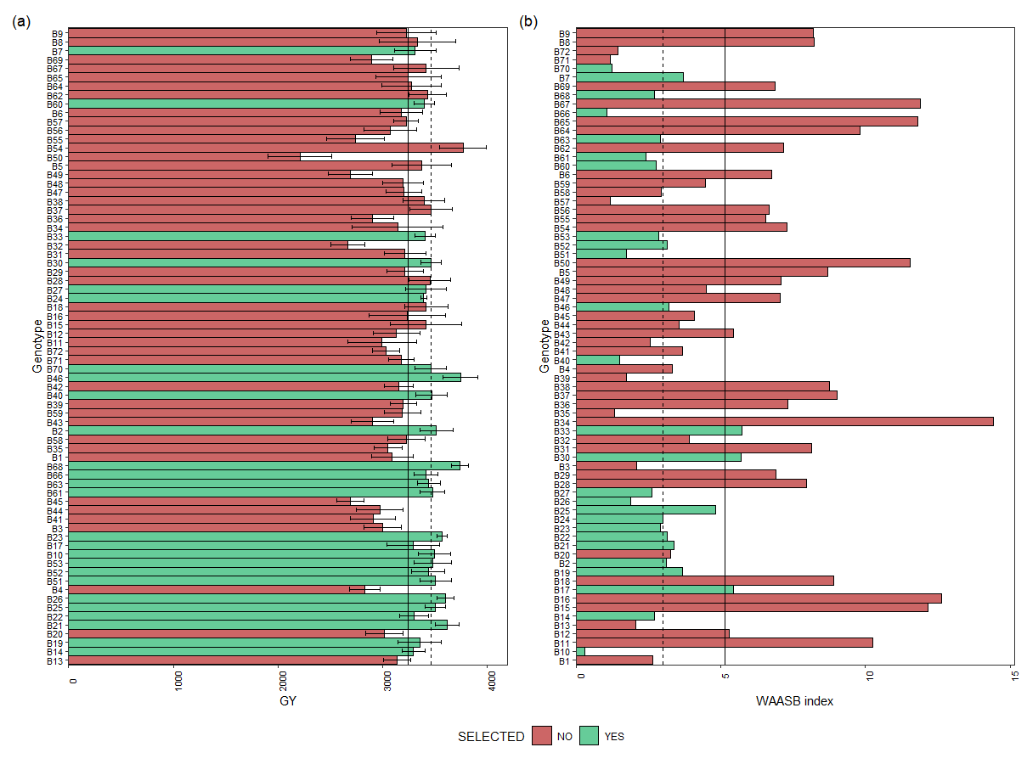

Supplementary Figure S7:Mean performance (a) and stability (b) for grain yield (GY) of 72 black beans genotypes. The vertical dashed and solid lines shows, respectivelly, the mean of the selected genotype and the overall mean for both mean performance and WAASB index.

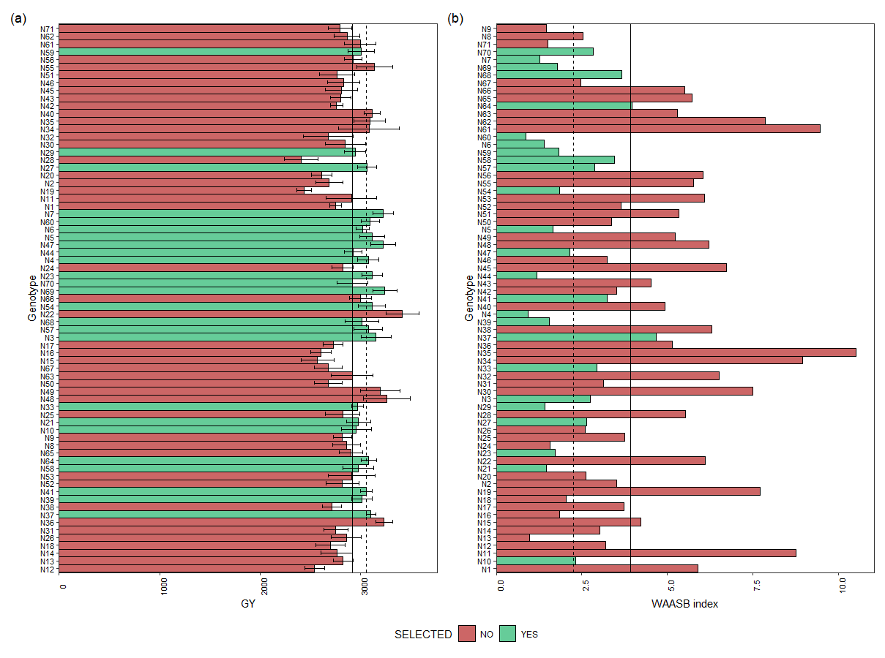

Supplementary Figure S8: Mean performance (a) and stability (b) for grain yield (GY) of 71 navy beans genotypes. The vertical dashed and solid lines shows, respectivelly, the mean of the selected genotype and the overall mean for both mean performance and WAASB index.

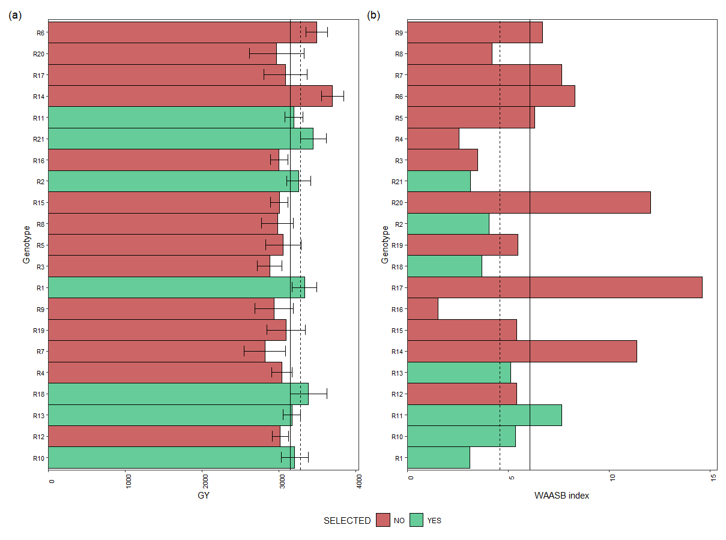

Supplementary Figure S9: Mean performance (a) and stability (b) for grain yield (GY) of 21 red beans genotypes. The vertical dashed and solid lines shows, respectivelly, the mean of the selected genotype and the overall mean for both mean performance and WAASB index.

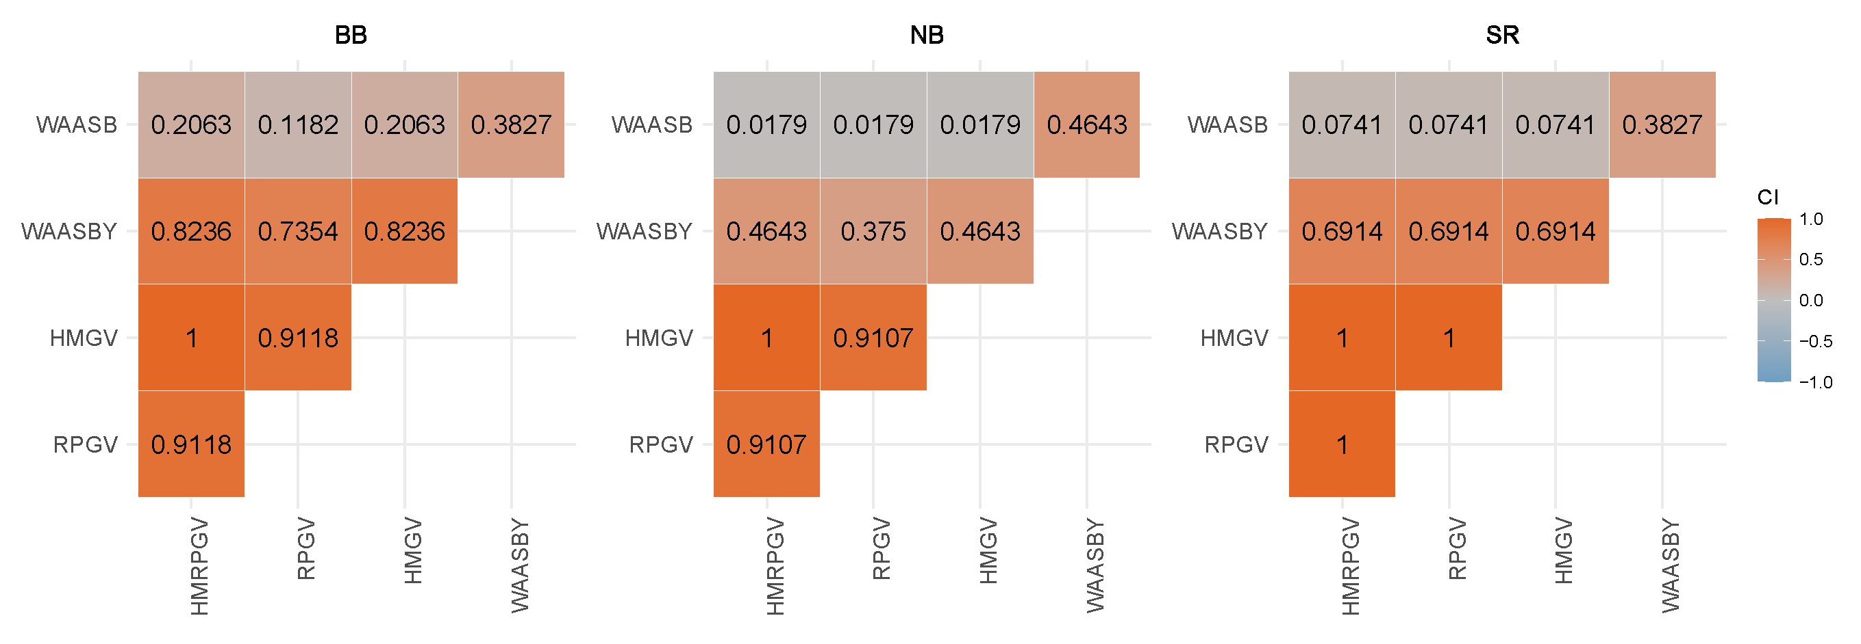

Supplementary Figure S11: BLUP-based stability indexes coincidence index (CI) using selection intensity of 20 top genotypes. BB, black; NB, navy; SR, red beans.

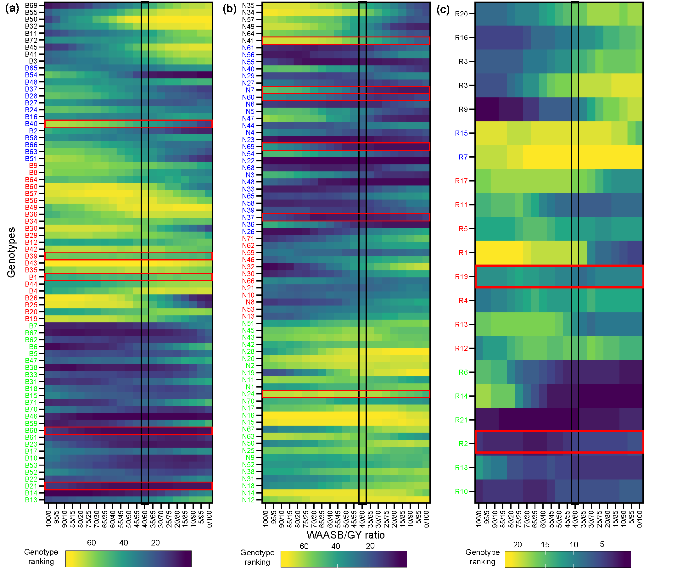

Supplementary Figure S10: Ranks of dry beans genotypes (a: 72 black, b:71 navys and c: 21 small red/pink) considering different weights for stability and yielding. The most-left ranks were obtained considering the stability only. The most right-ranks were obtained considering the grain yield only. Between the extremes, the ranks were obtained different weights for stability and yielding. The four clusters represent four classes of genotypes: (1) Poorly productive and unstable genotypes; (2) productive but unstable genotypes; (3) stable but poorly productive genotypes; and (4), highly productive and stable genotypes. The ranks highlighted by a black rectangle are the same from those BLUPs predicted to WAASBY index and the red rectangle box are the selected genotypes by the Multi-Trait Stability Index (MTSI).

# 3 Appendix C - R codes

# Getting started

The present analysis aims to dissect the genotype by environment interaction study (aka GEI) using a data set from the Dry Beans breeding program at Michigan State University - MSU.

The trait in study is the grain yield (GY) per plot (lb/plot) adjusted to the international measurements (Kg/ha). A previous data analysis (not shown here) was done to perform the historical data mining and adjust of raw data. Besides the GY, plant height (PH), date of maturity (DM) and lodging (LD) were investigate using a subset from 2021, which contains the all the data available.

The main focus of this manuscript, as describe in the [published paper](link%20here), is to investigate the varieties performance of GY across four locations at different Michigan counties. However, the MTME (three locations and 4 traits) also was studied in this manuscript when available (only in 2021 in Bay, Tuscola and Sanilac sites). Thus, different types of analysis will be performed in order to study the GEI in the Multi-Environment-Trials (MET) data to provide better varieties recommendations to the Dry Beans breeding program, which:

* ☒ Multi-Environment Trials – Genotype x Environment Interaction to grain yield (GY)
* ☒ Mean performance and stability of multiple traits

## 3.1 Packages

This document was prepared on 2023-03-28.

The analysis was done using the R Statistical language (v4.2.2; R Core Team, 2022) on Windows 10 x64, using the packages rmarkdown (v2.19), ggpmisc (v0.5.1), ggpp (v0.5.0), gridExtra (v2.3), magrittr (v2.0.3), Matrix (v1.5.1), mapdata (v2.3.1), maps (v3.4.1), spData (v2.2.1), asremlPlus (v4.3.40), asreml (v4.1.0.160), tidyquant (v1.0.6), data.table (v1.14.4), flextable (v0.8.3), lubridate (v1.9.0), purrr (v0.3.5), raster (v3.6.3), ggcorrplot (v0.1.4), ggdist (v3.2.1), tibble (v3.1.8), rcartocolor (v2.0.0), metan (v1.17.0), ggstatsplot (v0.10.0), sf (v1.0.9), sp (v1.5.1), ggforce (v0.4.1), PerformanceAnalytics (v2.0.4), broom (v1.0.2), quantmod (v0.4.20), xts (v0.12.2), openxlsx (v4.2.5.1), timechange (v0.1.1), naniar (v0.6.1), TTR (v0.24.3), statgenGxE (v1.0.5), tigris (v2.0), plyr (v1.8.8), ggplot2 (v3.4.0), forcats (v0.5.2), stringr (v1.5.0), tidyverse (v1.3.2), dplyr (v1.0.10), tidyr (v1.2.1), readr (v2.1.3), cowplot (v1.1.1), nadiv (v2.17.2), DT (v0.26), zoo (v1.8.11) and kableExtra (v1.3.4).

## 3.2 Data preparation

data_beans = read.csv("data/DataBean_MET_GYv2.csv",h=T, stringsAsFactors = T)  
  
if (knitr::is_html_output()) {  
  
 print_table(data_beans)  
   
}else{  
   
 flextable(head(data_beans)) %>%  
 add_footer_lines(  
 c("Varieties Dry Beans data set from 2017 to 2022",  
 "Header data set showing the 6 first entry")) %>%  
 autofit() %>%  
 add_header_lines("Dry Beans varieties trial") %>%  
 theme_design2()  
}

| **Dry Beans varieties trial** | | | | | | | |
| --- | --- | --- | --- | --- | --- | --- | --- |
| **codename** | **name** | **rep** | **mkt** | **year_loc** | **loc** | **year** | **gy_kg_ha** |
| 213SP | N1 | 1 | NB | 17_BA | BA | 17 |  |
| 213SP | N1 | 1 | NB | 17_HU | HU | 17 |  |
| 213SP | N1 | 1 | NB | 17_SA | SA | 17 |  |
| 213SP | N1 | 1 | NB | 17_TU | TU | 17 |  |
| 213SP | N1 | 1 | NB | 18_BA | BA | 18 |  |
| 213SP | N1 | 1 | NB | 18_HU | HU | 18 |  |
| Varieties Dry Beans data set from 2017 to 2022 | | | | | | | |
| Header data set showing the 6 first entry | | | | | | | |

# Data adjustment  
# All the effect columns must be as a factor to run in ASReml-r.  
cols <- c("rep", "name", "loc","year", "mkt", "year_loc")  
data_beans[cols] <- lapply(data_beans[cols], factor)  
data_beans <- data.table(data_beans)

## 3.3 Descriptive Stats - Raw data

Data set distribution, checking data and locations of study.

data_beans = read.csv("data/DataBean_MET_GYv2.csv",h=T, stringsAsFactors = T)  
  
# Data adjustment  
# All the effect columns must be as a factor to run in ASReml-r.  
cols <- c("rep", "name", "loc","year", "mkt", "year_loc")  
data_beans[cols] <- lapply(data_beans[cols], factor)  
data_beans <- data.table(data_beans)

### 3.3.1 Box plot dist.

plotDM_stats_mkt_loc<- grouped_ggbetweenstats(data=data_beans, x= loc, y=gy_kg_ha, type = "parametric", bf.message = F, results.subtitle = F,   
 ylab= "GY", xlab = "Locations",  
 plot.type = "boxviolin", grouping.var = mkt )   
#print(plotDM_stats_mkt_loc)  
  
plotDM_stats_mkt_year<- grouped_ggbetweenstats(data=data_beans, x= year, y=gy_kg_ha, type = "parametric", bf.message = F, results.subtitle = F,   
 ylab= "GY", xlab = "Years",  
 plot.type = "boxviolin", grouping.var = mkt )   
#print(plotDM_stats_mkt_year)  
  
print(arrange_ggplot(plotDM_stats_mkt_loc,plotDM_stats_mkt_year))

a<- ggplot(data=data_beans, aes(x=reorder(loc, -gy_kg_ha), y=gy_kg_ha, fill=loc)) +  
 ggdist::stat_halfeye(  
 adjust = 0.5,  
 justification = -0.1,  
 .width = 0,  
 point_colour = NA  
 ) +  
   
 geom_boxplot(   
 width = .12,  
 # outlier.color = NA,  
 alpha = 0.5)+  
 tidyquant::theme_tq()+  
 facet_wrap("year")+  
 facet_grid("mkt") +  
 tidyquant::scale_fill_tq() +  
 scale_x_discrete(expand = c(0.03,0)) +  
 scale_y_continuous(limits = c(1000,6000), breaks = seq(1000, 6000, by = 1000)) +  
 theme(axis.text.x=element_text(angle = 90),  
 strip.text=element_blank(),  
 legend.position = "none",  
 panel.grid = element_blank())+  
 labs(title="GY (kg/ha)",   
 subtitle="Data distribution by location",   
 caption=NULL, x=NULL, y=NULL)  
  
b<- ggplot(data=data_beans, aes(x=reorder(year, -gy_kg_ha), y=gy_kg_ha, fill=year)) +  
 ggdist::stat_halfeye(  
 adjust = 0.5,  
 justification = -0.1,  
 .width = 0,  
 point_colour = NA  
 ) +  
   
 geom_boxplot(   
 width = .12,  
 #outlier.color = NA,  
 alpha = 0.5)+  
 tidyquant::theme_tq()+  
 facet_wrap("loc")+  
 facet_grid("mkt") +  
 tidyquant::scale_fill_tq() +  
 scale_x_discrete(expand = c(0.03,0)) +  
 scale_y_continuous(limits = c(1000,6000), breaks = seq(1000, 6000, by = 1000)) +  
 theme(axis.text.x=element_text(angle = 90),  
 strip.text=element_text(face="bold"),  
 legend.position = "none",  
 axis.text.y = element_blank(),  
 panel.grid = element_blank())+  
 labs(title="GY (kg/ha)",   
 subtitle="Data distribution by year",   
 caption=NULL, x=NULL, y=NULL)  
  
print(arrange_ggplot(a,b))

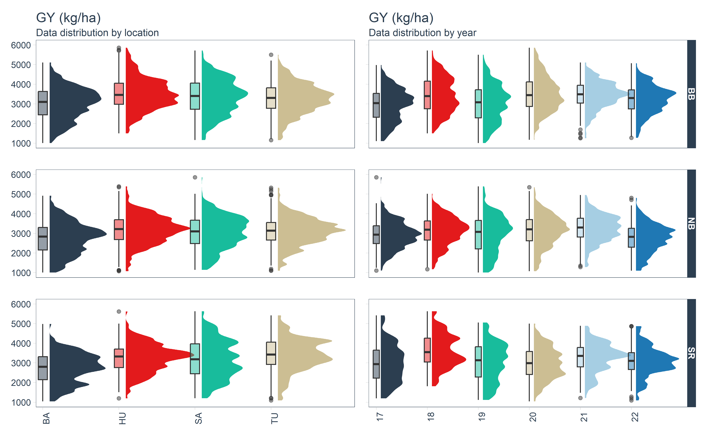

#### 3.3.1.1 BB

data_beans_plotBB<- droplevels(subset(data_beans, mkt=="BB"))  
  
stats_results_BB<- ggbetweenstats(data=data_beans_plotBB, x= loc, y=gy_kg_ha) %>% extract_stats()   
#print(stats_results_BB$pairwise_comparisons_data$p.value)  
  
stats_results_BB2<- stats_results_BB$pairwise_comparisons_data %>%   
dplyr::mutate(groups = purrr::pmap(.l = list(group1, group2), .f = c)) %>%  
 dplyr::arrange(group1)%>%   
 filter(p.value <= 0.05)  
  
bb1<- ggplot(data=data_beans_plotBB, aes(x=reorder(loc, -gy_kg_ha), y=gy_kg_ha, fill=loc)) +  
 ggdist::stat_halfeye(  
 adjust = 0.5,  
 justification = -0.1,  
 .width = 0,  
 point_colour = NA  
 ) +  
   
 geom_boxplot(   
 width = .12,  
 # outlier.color = NA,  
 alpha = 0.5)+  
 tidyquant::theme_tq()+  
 #facet_grid("loc")+  
 tidyquant::scale_fill_tq() +  
 scale_x_discrete(expand = c(0.03,0)) +  
 scale_y_continuous(limits = c(1000,10000), breaks = seq(1000, 10000, by = 1000)) +  
 theme(axis.text.x=element_blank(),  
 strip.text=element_blank(),  
 legend.position = "none",  
 panel.grid = element_blank())+  
 labs(title="GY (kg/ha)",   
 subtitle="Data distribution by location",   
 caption=NULL, x=NULL, y="BB")  
  
bb1<-bb1 +  
 ggsignif::geom_signif(  
 comparisons = stats_results_BB2$groups,  
 map_signif_level = TRUE,  
 tip_length = 0.01,  
 textsize = 2.7,  
 y_position = c(5900, 6700, 7500,8300, 9100),  
 annotations = as.character(stats_results_BB2$expression),  
 test = NULL,  
 na.rm = TRUE,  
 parse = TRUE  
 )

data_beans_plotBB<- droplevels(subset(data_beans, mkt=="BB"))  
  
stats_results_BB<- ggbetweenstats(data=data_beans_plotBB, x= year, y=gy_kg_ha) %>% extract_stats()   
#print(stats_results_BB$pairwise_comparisons_data$p.value)  
  
stats_results_BB3<- stats_results_BB$pairwise_comparisons_data %>%   
dplyr::mutate(groups = purrr::pmap(.l = list(group1, group2), .f = c)) %>%  
 dplyr::arrange(group1) %>%   
 filter(p.value <= 0.05)  
  
bb2<- ggplot(data=data_beans_plotBB, aes(x=reorder(year, -gy_kg_ha), y=gy_kg_ha, fill=year)) +  
 ggdist::stat_halfeye(  
 adjust = 0.5,  
 justification = -0.1,  
 .width = 0,  
 point_colour = NA  
 ) +  
   
 geom_boxplot(   
 width = .12,  
 # outlier.color = NA,  
 alpha = 0.5)+  
 tidyquant::theme_tq()+  
 #facet_grid("loc")+  
 tidyquant::scale_fill_tq() +  
 scale_x_discrete(expand = c(0.03,0)) +  
 scale_y_continuous(limits = c(1000,10000), breaks = seq(1000, 10000, by = 1000)) +  
 theme(axis.text.x=element_blank(),  
 strip.text=element_blank(),  
 legend.position = "none",  
 panel.grid = element_blank())+  
 labs(title="GY (kg/ha)",   
 subtitle="Data distribution by year",   
 caption=NULL, x=NULL, y=NULL)  
  
  
bb2<-bb2 +  
 ggsignif::geom_signif(  
 comparisons = stats_results_BB3$groups,  
 map_signif_level = TRUE,  
 tip_length = 0.01,  
 textsize = 2.7,  
 y_position = c(5900, 6300, 6700,7100, 7400, 7800,8200, 8600, 9000, 9400),  
 annotations = as.character(stats_results_BB3$expression),  
 test = NULL,  
 na.rm = TRUE,  
 parse = TRUE  
 )

#### 3.3.1.2 NB

data_beans_plotBB<- droplevels(subset(data_beans, mkt=="NB"))  
  
stats_results_BB<- ggbetweenstats(data=data_beans_plotBB, x= loc, y=gy_kg_ha) %>% extract_stats()   
#print(stats_results_BB$pairwise_comparisons_data$p.value)  
  
stats_results_BB2<- stats_results_BB$pairwise_comparisons_data %>%   
dplyr::mutate(groups = purrr::pmap(.l = list(group1, group2), .f = c)) %>%  
 dplyr::arrange(group1)%>%   
 filter(p.value <= 0.05)  
  
nb1<- ggplot(data=data_beans_plotBB, aes(x=reorder(loc, -gy_kg_ha), y=gy_kg_ha, fill=loc)) +  
 ggdist::stat_halfeye(  
 adjust = 0.5,  
 justification = -0.1,  
 .width = 0,  
 point_colour = NA  
 ) +  
   
 geom_boxplot(   
 width = .12,  
 # outlier.color = NA,  
 alpha = 0.5)+  
 tidyquant::theme_tq()+  
 #facet_grid("loc")+  
 tidyquant::scale_fill_tq() +  
 scale_x_discrete(expand = c(0.03,0)) +  
 scale_y_continuous(limits = c(1000,10000), breaks = seq(1000, 10000, by = 1000)) +  
 theme(axis.text.x=element_blank(),  
 strip.text=element_blank(),  
 legend.position = "none",  
 panel.grid = element_blank())+  
 labs(   
 caption=NULL, x=NULL, y="NB")  
  
nb1<-nb1 +  
 ggsignif::geom_signif(  
 comparisons = stats_results_BB2$groups,  
 map_signif_level = TRUE,  
 tip_length = 0.01,  
 textsize = 2.7,  
 y_position = c(5900, 6700, 7500,8300, 9100),  
 annotations = as.character(stats_results_BB2$expression),  
 test = NULL,  
 na.rm = TRUE,  
 parse = TRUE  
 )

data_beans_plotBB<- droplevels(subset(data_beans, mkt=="NB"))  
  
stats_results_BB<- ggbetweenstats(data=data_beans_plotBB, x= year, y=gy_kg_ha) %>% extract_stats()   
#print(stats_results_BB$pairwise_comparisons_data$p.value)  
  
stats_results_BB3<- stats_results_BB$pairwise_comparisons_data %>%   
dplyr::mutate(groups = purrr::pmap(.l = list(group1, group2), .f = c)) %>%  
 dplyr::arrange(group1) %>%   
 filter(p.value <= 0.05)  
  
nb2<- ggplot(data=data_beans_plotBB, aes(x=reorder(year, -gy_kg_ha), y=gy_kg_ha, fill=year)) +  
 ggdist::stat_halfeye(  
 adjust = 0.5,  
 justification = -0.1,  
 .width = 0,  
 point_colour = NA  
 ) +  
   
 geom_boxplot(   
 width = .12,  
 # outlier.color = NA,  
 alpha = 0.5)+  
 tidyquant::theme_tq()+  
 #facet_grid("loc")+  
 tidyquant::scale_fill_tq() +  
 scale_x_discrete(expand = c(0.03,0)) +  
 scale_y_continuous(limits = c(1000,10000), breaks = seq(1000, 10000, by = 1000)) +  
 theme(axis.text.x=element_blank(),  
 strip.text=element_blank(),  
 legend.position = "none",  
 panel.grid = element_blank())+  
 labs(   
 caption=NULL, x=NULL, y=NULL)  
  
  
nb2<-nb2 +  
 ggsignif::geom_signif(  
 comparisons = stats_results_BB3$groups,  
 map_signif_level = TRUE,  
 tip_length = 0.01,  
 textsize = 2.7,  
 y_position = c(5900, 6300, 6700,7100, 7400, 7800,8200, 8600, 9000, 9400),  
 annotations = as.character(stats_results_BB3$expression),  
 test = NULL,  
 na.rm = TRUE,  
 parse = TRUE  
 )

#### 3.3.1.3 SR

data_beans_plotBB<- droplevels(subset(data_beans, mkt=="SR"))  
  
stats_results_BB<- ggbetweenstats(data=data_beans_plotBB, x= loc, y=gy_kg_ha) %>% extract_stats()   
#print(stats_results_BB$pairwise_comparisons_data$p.value)  
  
stats_results_BB2<- stats_results_BB$pairwise_comparisons_data %>%   
dplyr::mutate(groups = purrr::pmap(.l = list(group1, group2), .f = c)) %>%  
 dplyr::arrange(group1)%>%   
 filter(p.value <= 0.05)  
  
sr1<- ggplot(data=data_beans_plotBB, aes(x=reorder(loc, -gy_kg_ha), y=gy_kg_ha, fill=loc)) +  
 ggdist::stat_halfeye(  
 adjust = 0.5,  
 justification = -0.1,  
 .width = 0,  
 point_colour = NA  
 ) +  
   
 geom_boxplot(   
 width = .12,  
 # outlier.color = NA,  
 alpha = 0.5)+  
 tidyquant::theme_tq()+  
 #facet_grid("loc")+  
 tidyquant::scale_fill_tq() +  
 scale_x_discrete(expand = c(0.03,0)) +  
 scale_y_continuous(limits = c(1000,10000), breaks = seq(1000, 10000, by = 1000)) +  
 theme(  
 strip.text=element_blank(),  
 legend.position = "none",  
 panel.grid = element_blank())+  
 labs(  
 caption=NULL, x="Locations", y="SR")  
  
sr1<-sr1 +  
 ggsignif::geom_signif(  
 comparisons = stats_results_BB2$groups,  
 map_signif_level = TRUE,  
 tip_length = 0.01,  
 textsize = 2.7,  
 y_position = c(5900, 6700, 7500,8300, 9100),  
 annotations = as.character(stats_results_BB2$expression),  
 test = NULL,  
 na.rm = TRUE,  
 parse = TRUE  
 )

data_beans_plotBB<- droplevels(subset(data_beans, mkt=="SR"))  
  
stats_results_BB<- ggbetweenstats(data=data_beans_plotBB, x= year, y=gy_kg_ha) %>% extract_stats()   
#print(stats_results_BB$pairwise_comparisons_data$p.value)  
  
stats_results_BB3<- stats_results_BB$pairwise_comparisons_data %>%   
dplyr::mutate(groups = purrr::pmap(.l = list(group1, group2), .f = c)) %>%  
 dplyr::arrange(group1) %>%   
 filter(p.value <= 0.05)  
  
sr2<- ggplot(data=data_beans_plotBB, aes(x=reorder(year, -gy_kg_ha), y=gy_kg_ha, fill=year)) +  
 ggdist::stat_halfeye(  
 adjust = 0.5,  
 justification = -0.1,  
 .width = 0,  
 point_colour = NA  
 ) +  
   
 geom_boxplot(   
 width = .12,  
 # outlier.color = NA,  
 alpha = 0.5)+  
 tidyquant::theme_tq()+  
 #facet_grid("loc")+  
 tidyquant::scale_fill_tq() +  
 scale_x_discrete(expand = c(0.03,0)) +  
 scale_y_continuous(limits = c(1000,10000), breaks = seq(1000, 10000, by = 1000)) +  
 theme(  
 strip.text=element_blank(),  
 legend.position = "none",  
 panel.grid = element_blank())+  
 labs(  
 caption=NULL, y=NULL, x="Years")  
  
  
sr2<- sr2 +  
 ggsignif::geom_signif(  
 comparisons = stats_results_BB3$groups,  
 map_signif_level = TRUE,  
 tip_length = 0.01,  
 textsize = 2.7,  
 y_position = c(5900, 6500, 7200,8000, 8700, 9500),  
 annotations = as.character(stats_results_BB3$expression),  
 test = NULL,  
 na.rm = TRUE,  
 parse = TRUE  
 )

Box plot distribution for each market class in this study across years and locations.

print(arrange_ggplot(bb1,bb2,  
 nb1,nb2,  
 sr1,sr2,  
 nrow = 3,  
 ncol = 2))

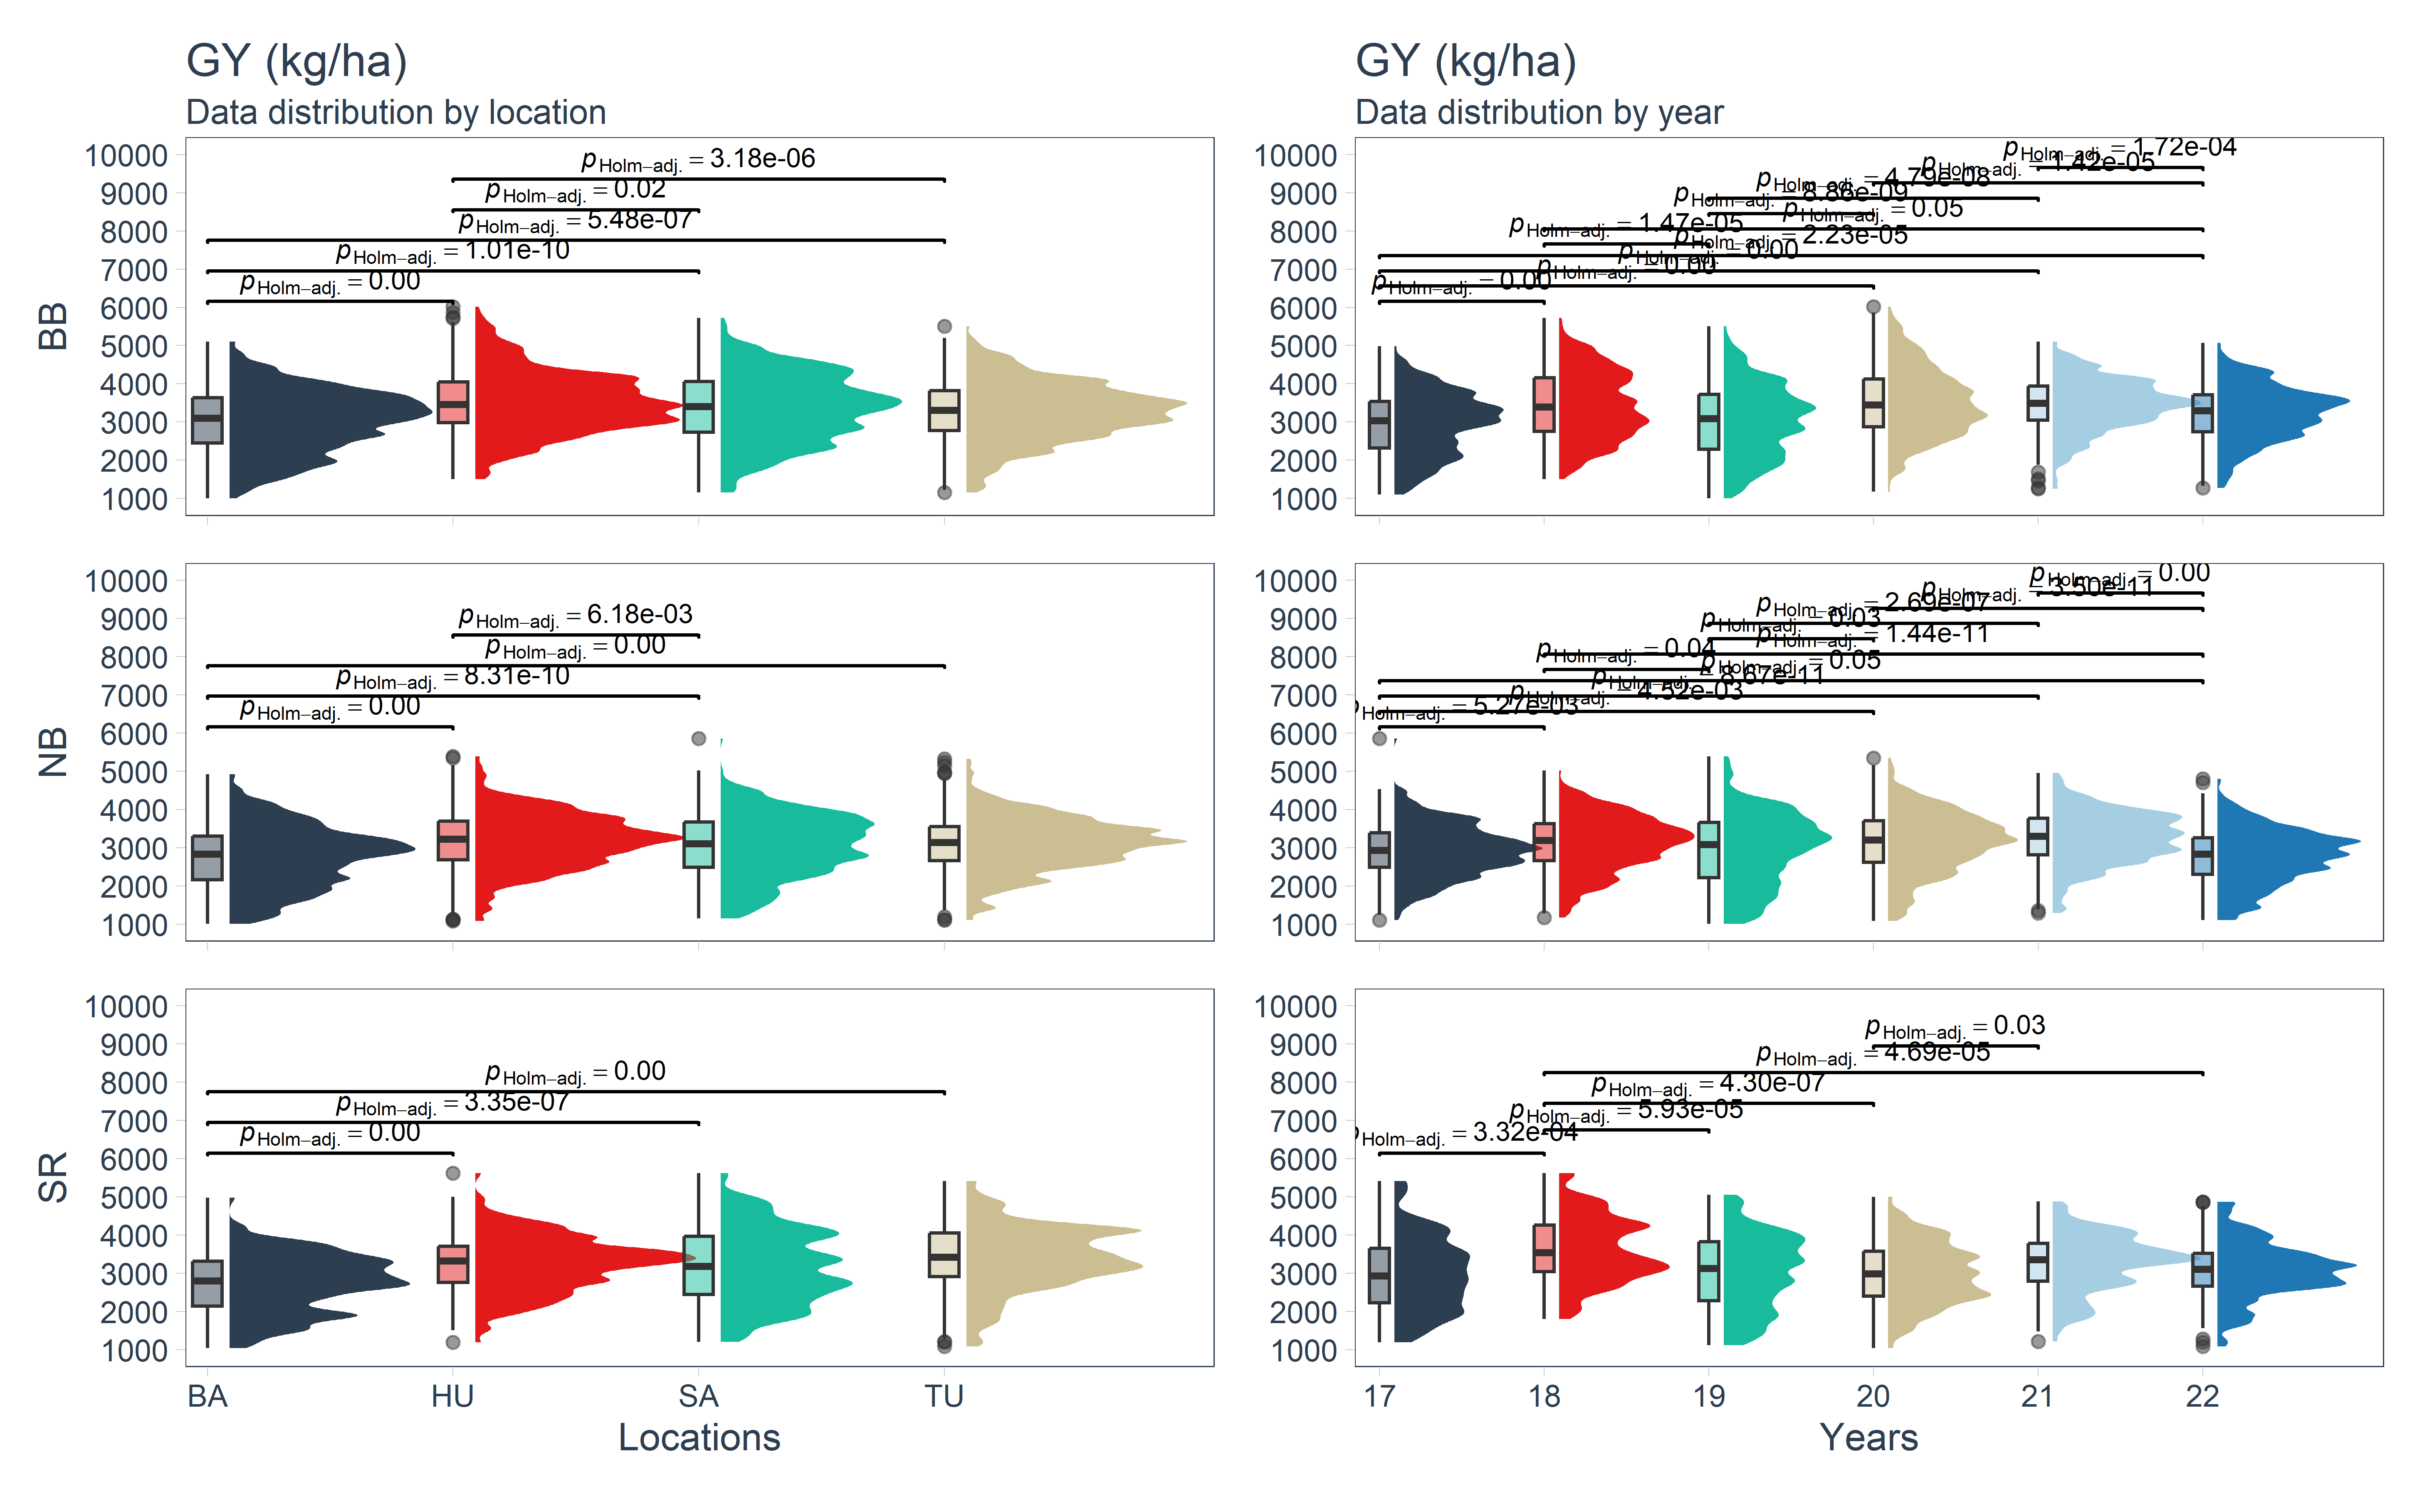

### 3.3.2 GEI Comparisons (loc:year) - BB

Box plots for between-subjects comparisons by locations using the R package ggstatsplot.

* Black beans (BB) **Pairwise Games-Howell test used. Comparisons showing only significant**

data_beans_plotBB<- droplevels(subset(data_beans, mkt=="BB"))  
  
plotDM_stats_mkt_loc_BB<- grouped_ggbetweenstats(data=data_beans_plotBB, x= loc, y=gy_kg_ha, type = "parametric", bf.message = F, results.subtitle = F,   
 ylab= "GY", xlab = "Locations",  
 plot.type = "boxviolin", grouping.var = year )   
print(plotDM_stats_mkt_loc_BB)

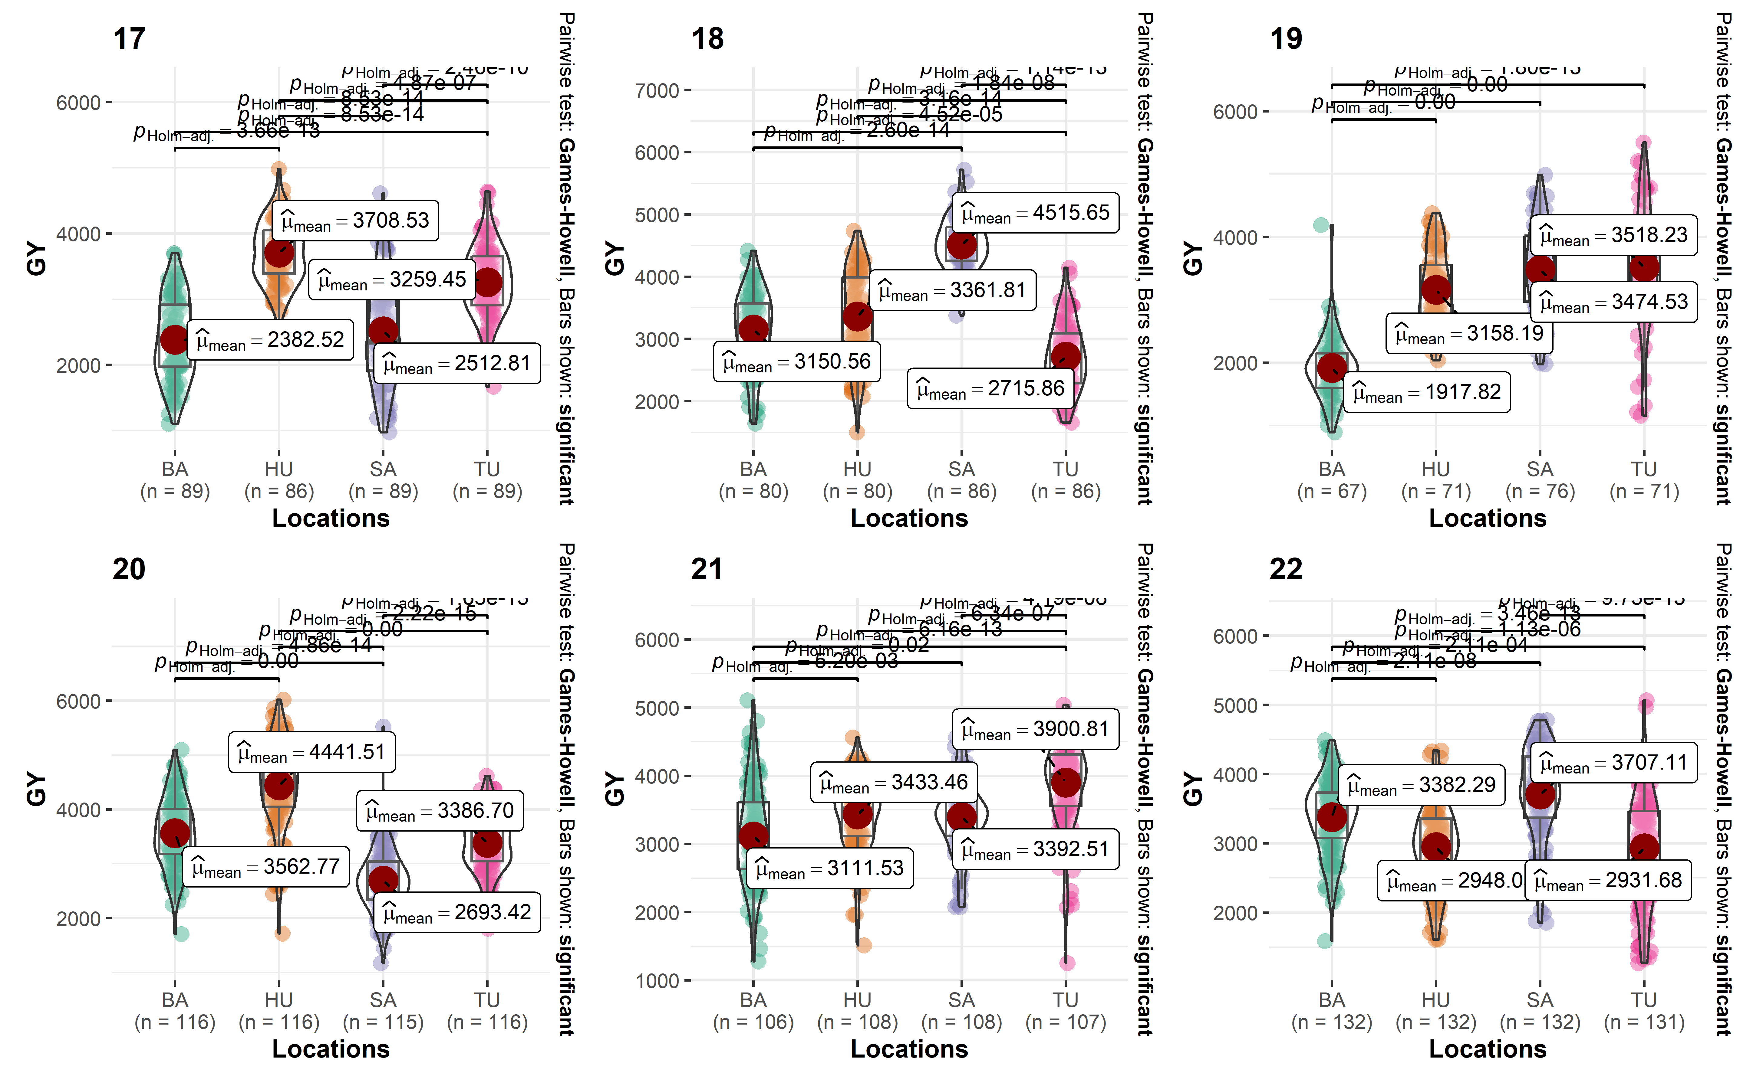

### 3.3.3 GEI Comparisons (loc:year) - NB

Box plots for between-subjects comparisons by locations using the R package ggstatsplot. - Navy beans (NB) **Pairwise Games-Howell test used. Comparisons showing only significant**

data_beans_plotNB<- droplevels(subset(data_beans, mkt=="NB"))  
  
plotDM_stats_mkt_loc_NB<- grouped_ggbetweenstats(data=data_beans_plotNB, x= loc, y=gy_kg_ha, type = "parametric", bf.message = F, results.subtitle = F,   
 ylab= "GY", xlab = "Locations",  
 plot.type = "boxviolin", grouping.var = year )   
print(plotDM_stats_mkt_loc_NB)

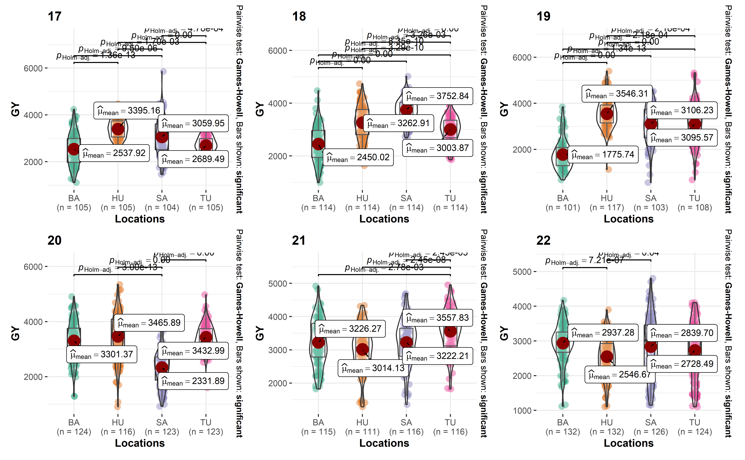

### 3.3.4 GEI Comparisons (loc:year) - SR

Box plots for between-subjects comparisons by locations using the R package ggstatsplot. - Black beans (SR) **Pairwise Games-Howell test used. Comparisons showing only significant**

data_beans_plotSR<- droplevels(subset(data_beans, mkt=="SR"))  
  
plotDM_stats_mkt_loc_SR<- grouped_ggbetweenstats(data=data_beans_plotSR, x= loc, y=gy_kg_ha, type = "parametric", bf.message = F, results.subtitle = F,   
 ylab= "GY", xlab = "Locations",  
 plot.type = "boxviolin", grouping.var = year )   
print(plotDM_stats_mkt_loc_SR)

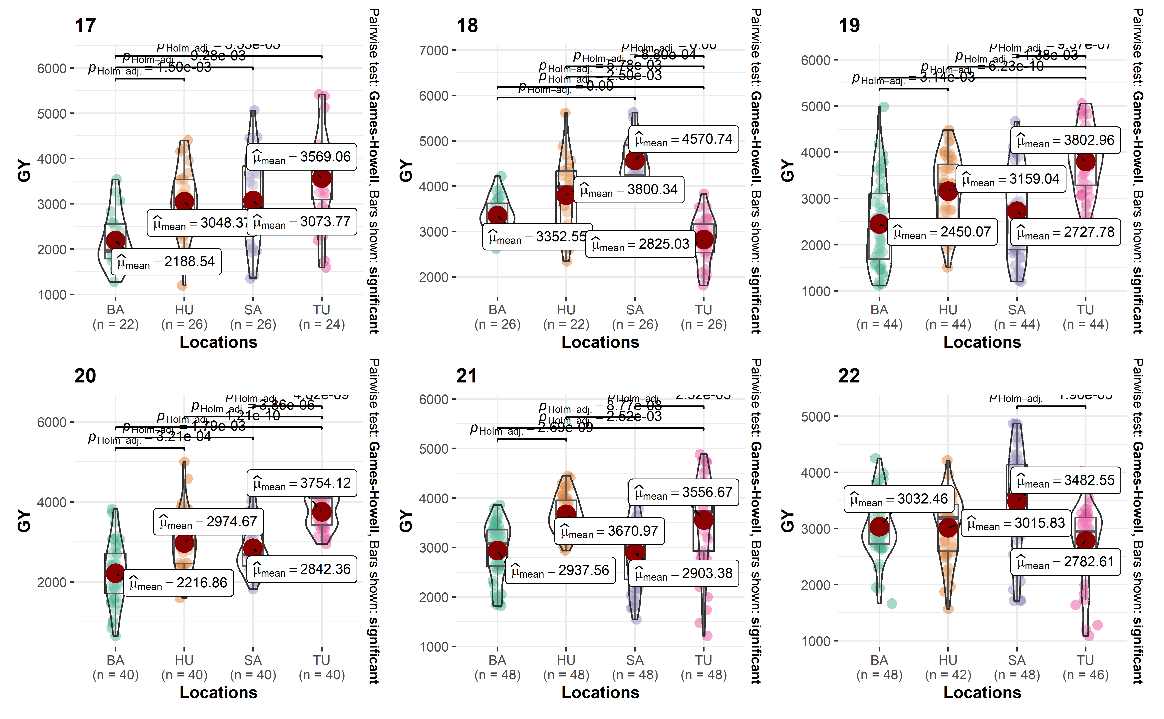

### 3.3.5 Scatter plot

For further insight into the correlation structure between trials a scatter plot matrix can be made using the package statgenGxE

dropsTD <- statgenSTA::createTD(data = data_beans, genotype = "name", trial = "loc")  
options("statgen.genoColors" = c("black", "blue", "red"))  
plot(dropsTD, plotType = "scatter", traits = "gy_kg_ha", colorGenoBy = "mkt",   
 colorTrialBy = "trial", title = "Scatterplots of trials for grain yield (Kg/ha)" )

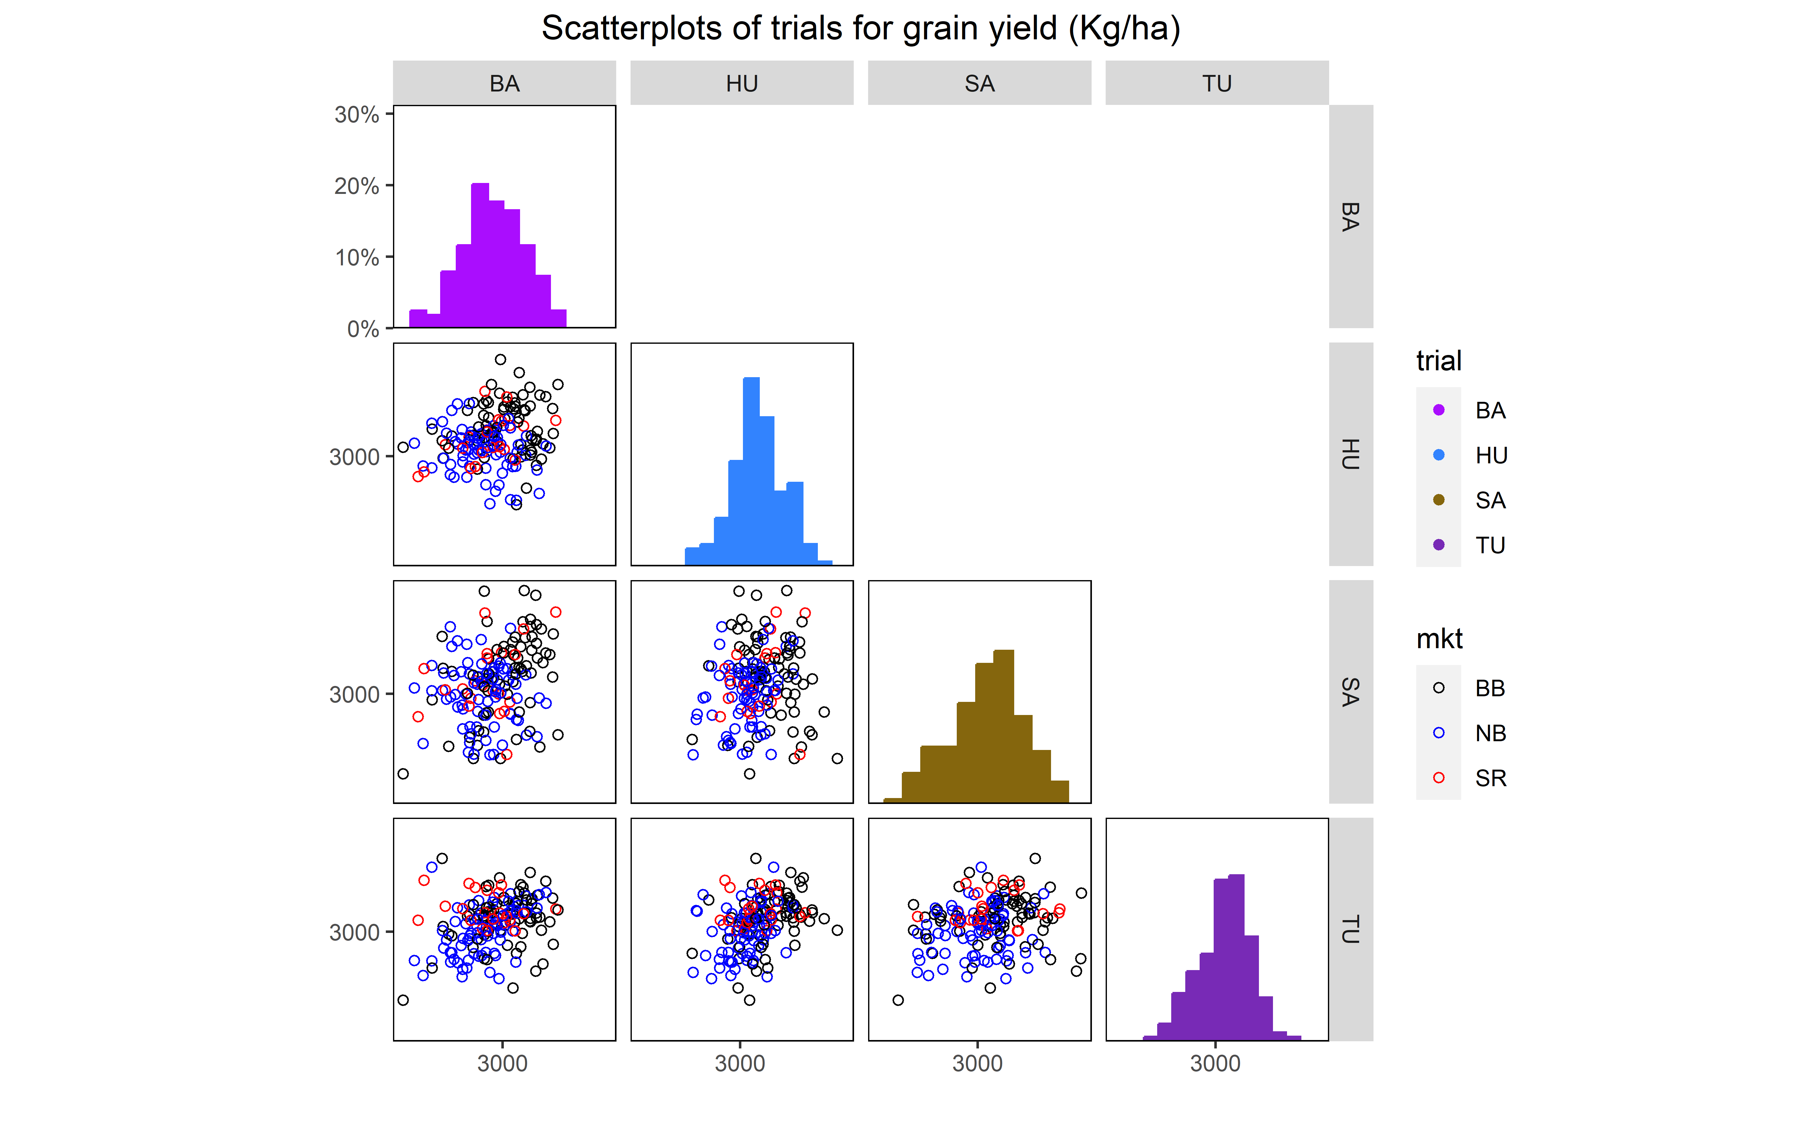

### 3.3.6 Outliers

Check for common errors in multi-environment trial by market class data using the R package metan However, the data set was cleaned before at a previous analysis not shown in this vignette using the criteria for GY:

* yield <= 0.5 | yield >= 7.5 (considering yield as Lb per plot)
* moisture >= 30 | moisture <= 5 (considering moisture in %)

At this point yield data will not be removed anymore, but we can check it out for further investigation, if it was needed.

out_beans<- find_outliers(data_beans, by=mkt, var = gy_kg_ha, plots = F)

Trait: gy_kg_ha Number of possible outliers: 9 Line(s): 1113 2052 4478 4522 4539 4620 4739 4740 4761 Proportion: 0.3% Mean of the outliers: 3320 Maximum of the outliers: 5854 | Line 4539 Minimum of the outliers: 554.8 | Line 4739 With outliers: mean = 3015 | CV = 26.27% Without outliers: mean = 3014 | CV = 25.93%

Trait: gy_kg_ha Number of possible outliers: 10 Line(s): 127 1910 3723 3993 4161 4358 5630 6302 6638 6710 Proportion: 0.4% Mean of the outliers: 4313 Maximum of the outliers: 6014 | Line 6302 Minimum of the outliers: 889.9 | Line 3993 With outliers: mean = 3298 | CV = 25.57% Without outliers: mean = 3294 | CV = 25.21%

Trait: gy_kg_ha Number of possible outliers: 4 Line(s): 533 1422 1951 1975 Proportion: 0.4% Mean of the outliers: 4355 Maximum of the outliers: 5625 | Line 1951 Minimum of the outliers: 654.1 | Line 533 With outliers: mean = 3139 | CV = 27.68% Without outliers: mean = 3134 | CV = 27.29%

#out_beans

* No outliers removed after the data inspection based on the Breeder expertise.

### 3.3.7 Map of locations

This figure represent all counties locations evaluated in this study at Michigan, midwest in the USA.

source("utils/map.R")  
  
print(MI_trials_beans_map)

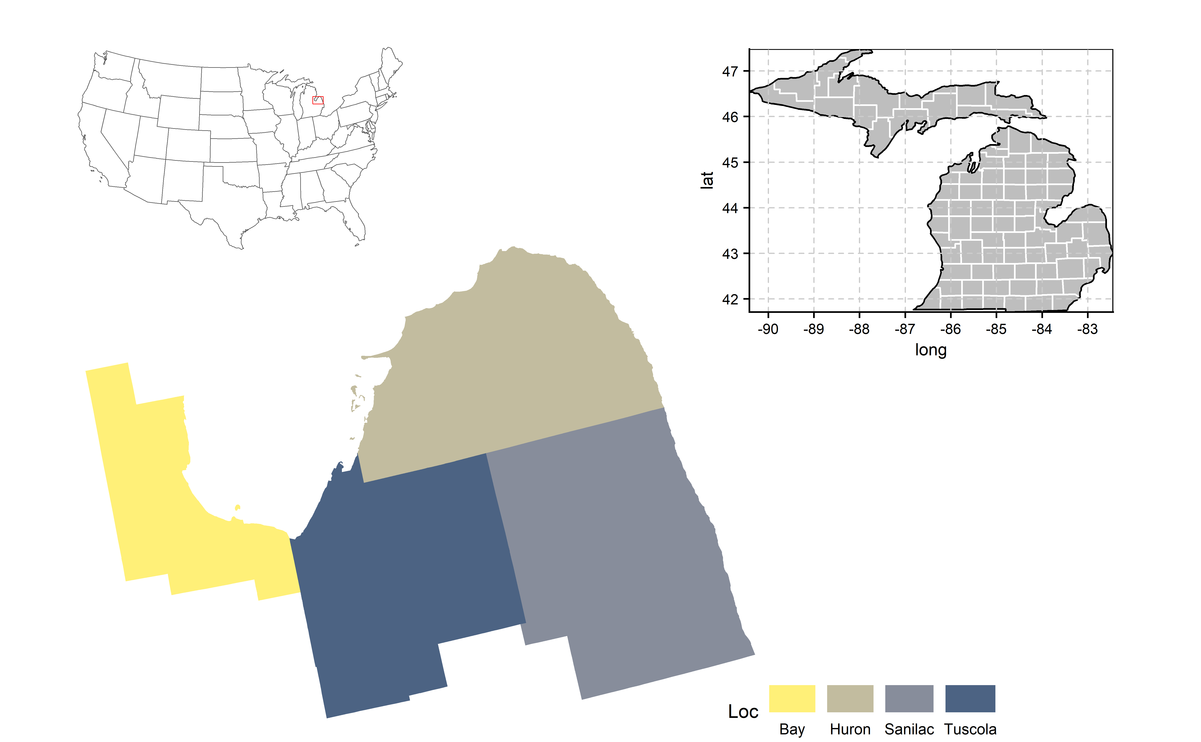

### 3.3.8 Missing values

data_beans.miss.f<- data_beans %>%   
 unite(name_year_loc, c(name, year_loc), remove = F) %>%   
 group_by(name_year_loc) %>%   
 dplyr::summarise(Mean = mean(gy_kg_ha, na.rm = TRUE)) %>%   
 filter(!is.na(Mean))   
  
data_beans.miss<- data_beans %>%   
 unite(name_year_loc, c(name, year_loc), remove = F)  
  
data_beans.miss<- data_beans.miss%>%   
 filter((name_year_loc %in% data_beans.miss.f$name_year_loc))   
  
gg_miss_fct(data_beans.miss,fct = mkt)+ggtitle("Missing values (NA)") +   
 theme(axis.text.x=element_text(face="bold", size = 12),   
 axis.text.y = element_text(face = "bold",size = 12) ,  
 title = element_text(face = "bold",size = 14))

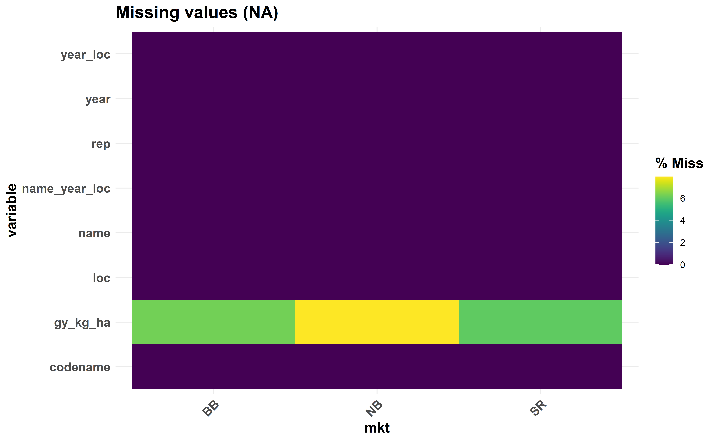

Missing genotypes by market classes

### 3.3.9 Coincidence Genotypes

Genotypes coincidentes across years combinations

source("utils/Coinc.R")

#> [1] "The coincidence file is present"

arrange_ggplot(plotB, plotN, plotSR,ncol = 1)

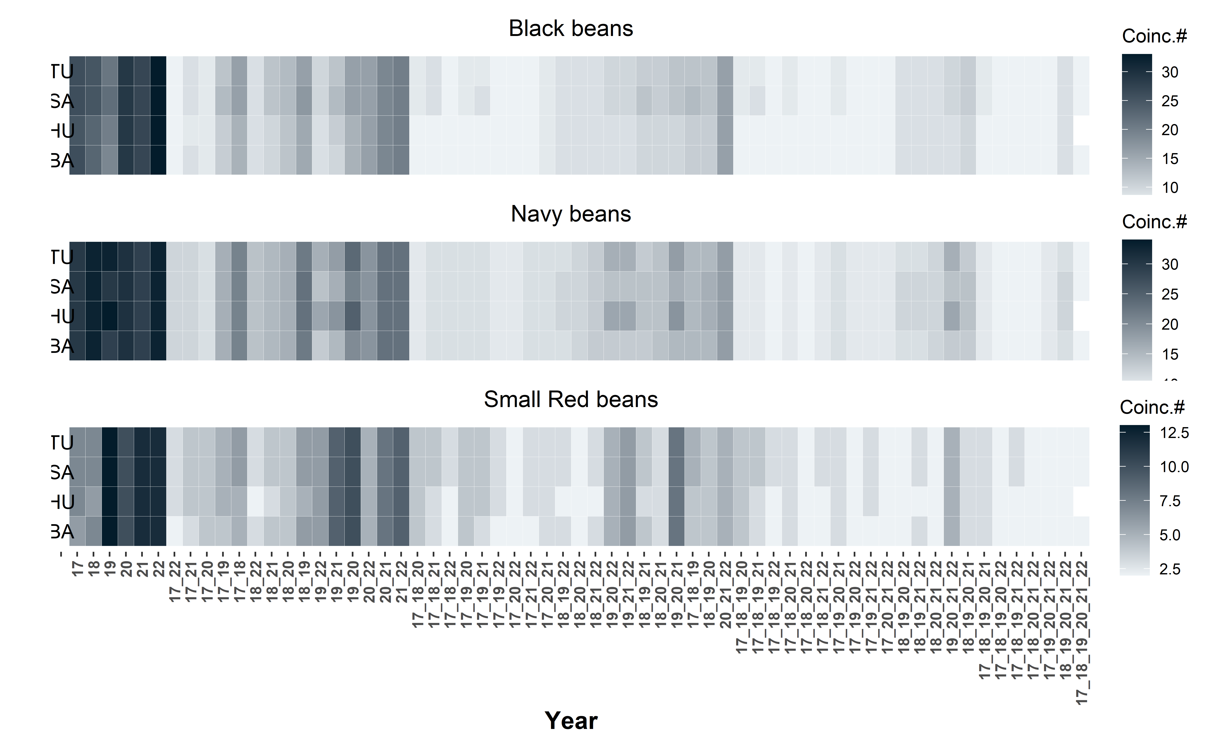

Coincidence genotypes per year and combinations of years across locations for each market class.

## 3.4 Predicted by year mixed model analysis

To predict the BLUPs per year and plot it versus year: BLUPs prediction for the vector of the variable GY in the ith genotype, and jth loc within year.

## 3.5 Data preparation

#setwd("G:/Shared drives/Bean_Lab/Volpato/GxE_Variety_trials_Scott/Manuscript/Suppl_mat/TemplateResults-main")  
data_beans = read.csv("data/DataBean_MET_GYv2.csv",h=T, stringsAsFactors = T)  
  
# Data adjustment  
# All the effect columns must be as a factor to run in ASReml-r.  
cols <- c("rep", "name", "loc","year", "mkt", "year_loc")  
data_beans[cols] <- lapply(data_beans[cols], factor)  
data_beans <- data.table(data_beans)

### 3.5.1 By year mixed model analysis

The BLUPS will be estimated using a mixed-effect model and these values obtained by year using a loop with ASReml and storage into the list.

The following mixed model was used to estimate the BLUPs of each genotype within year with one value per genotype per year (random effects are underlined in all equations):

$$\underset{_}{Y_{ijl}}=μ+\underset{_}{G_{i}}+E_{l}+β_{jl}+\underset{_}{GE_{il}}+\underset{_}{ε_{ijl}}$$

where $Y_{ijl}$ is the response variable (e.g., grain yield) observed in the *j*th repetion of the *i*th genotype in the *l*th location (*i* = 1, 2, …, *g*; *j* = 1, 2, …, *b*; *l* = 1, 2, …, *e*); is the grand mean; is the effect of the *i*th genotype; is the effect of the *l*th location (env); is the effect of the *j*th rep with the *l*th location; is the interaction effect of the *i*th genotype nested within the *l*th location; and is the random error, in witch with ~N(0,), ~N(0,), and ~N(0,), all independent, where is the genotype (name) variance, $GS_{GE}^{2}$ is the interaction genotype x environment variance, and $σ_{ε}^{2}$ is the mean error variance across experiments.

## Analysis per site and mkt class  
mkt_n <- levels(data_beans$mkt)  
  
Envs <- levels(data_beans$year)  
  
stgI_list <- matrix(data=list(), nrow=length(Envs), ncol=1,  
 dimnames=list(Envs, c("BLUPS")))  
  
mkt <- nlevels(data_beans$mkt)  
  
for(k in 1:mkt){  
  
 bk <- levels(data_beans$mkt)  
 cj <- bk[k]  
 #print(cj)  
   
 data_beans_temp <- droplevels(subset(data_beans, mkt==cj))  
  
 for (i in Envs){  
 #i=Envs[1]  
 Edat <- droplevels(subset(data_beans_temp, year==i))  
   
 #print(i)  
   
mod.1 <- asreml(fixed = gy_kg_ha ~ loc + loc:rep,  
 random = ~ name + name:loc,  
 data = Edat,  
 predict = predict.asreml(classify = "name"),  
 trace = F,  
 maxit = 500)  
   
 # print(summary.asreml(mod.1)$varcomp)  
 # wald(mod.1)  
  
 blup.1<- data.table((mod.1$predictions$pvals[1:3]))   
 names(blup.1) <- c("name", "yield", "se")  
 blup.1$mkt<- cj  
   
 stgI_list[[i, "BLUPS"]] <- blup.1 # put all the results of Stage 1 in the list  
   
 # rm(Edat,mod.1, blue, blup.1)  
   
 }  
 if(k==1){stgI_list.1<-stgI_list}else{stgI_list.1<-rbind(stgI_list.1, stgI_list)}  
   
}

#### 3.5.1.1 Preparing dataset

Merging the original data to have all the factors in the final table with: name, year, and mkt

##### Unlist the results of Stage I and format as data.table #####  
blups_stageI <- data.table(ldply(stgI_list.1[, "BLUPS"], data.frame, .id="year"))  
  
blues_stage.I <- blups_stageI[order(blups_stageI$year,blups_stageI$mkt),]  
  
# Change the order of columns  
blues_stage.I <- blues_stage.I %>%   
 dplyr::select(year, name, mkt, se, yield)  
  
str(blues_stage.I)

Classes ‘data.table’ and ‘data.frame’: 984 obs. of 5 variables: $ year : Factor w/ 6 levels “17”,“18”,“19”,..: 1 1 1 1 1 1 1 1 1 1 … $ name : Factor w/ 164 levels “B1”,“B10”,“B11”,..: 1 2 3 4 5 6 7 8 9 10 … $ mkt : chr “BB” “BB” “BB” “BB” … $ se : num 141.3 98.7 113.8 113.8 355.7 … $ yield: num 2727 3579 2947 3092 2959 … - attr(*, “.internal.selfref”)=

### 3.5.2 Descriptive variance

#### 3.5.2.1 Beans data set by year

if (knitr::is_html_output()) {  
  
 print_table(blues_stage.I)  
   
}else{  
   
flextable(head(blues_stage.I)) %>%   
 add_footer_lines(  
 c("Beans data set by year",   
 "Header data set showing the 6 first entry")) %>%   
 autofit() %>%   
 add_header_lines("Dry Beans varieties trial") %>%   
 theme_design2()  
   
}

| **Dry Beans varieties trial** | | | | |
| --- | --- | --- | --- | --- |
| **year** | **name** | **mkt** | **se** | **yield** |
| 17 | B1 | BB | 141.29 | 2,727 |
| 17 | B10 | BB | 98.73 | 3,579 |
| 17 | B11 | BB | 113.83 | 2,947 |
| 17 | B12 | BB | 113.83 | 3,092 |
| 17 | B13 | BB | 355.72 | 2,959 |
| 17 | B14 | BB | 355.72 | 2,959 |
| Beans data set by year | | | | |
| Header data set showing the 6 first entry | | | | |

#### 3.5.2.2 Box plot distribution

**Pairwise Games-Howell test used. Comparisons showing only significant** 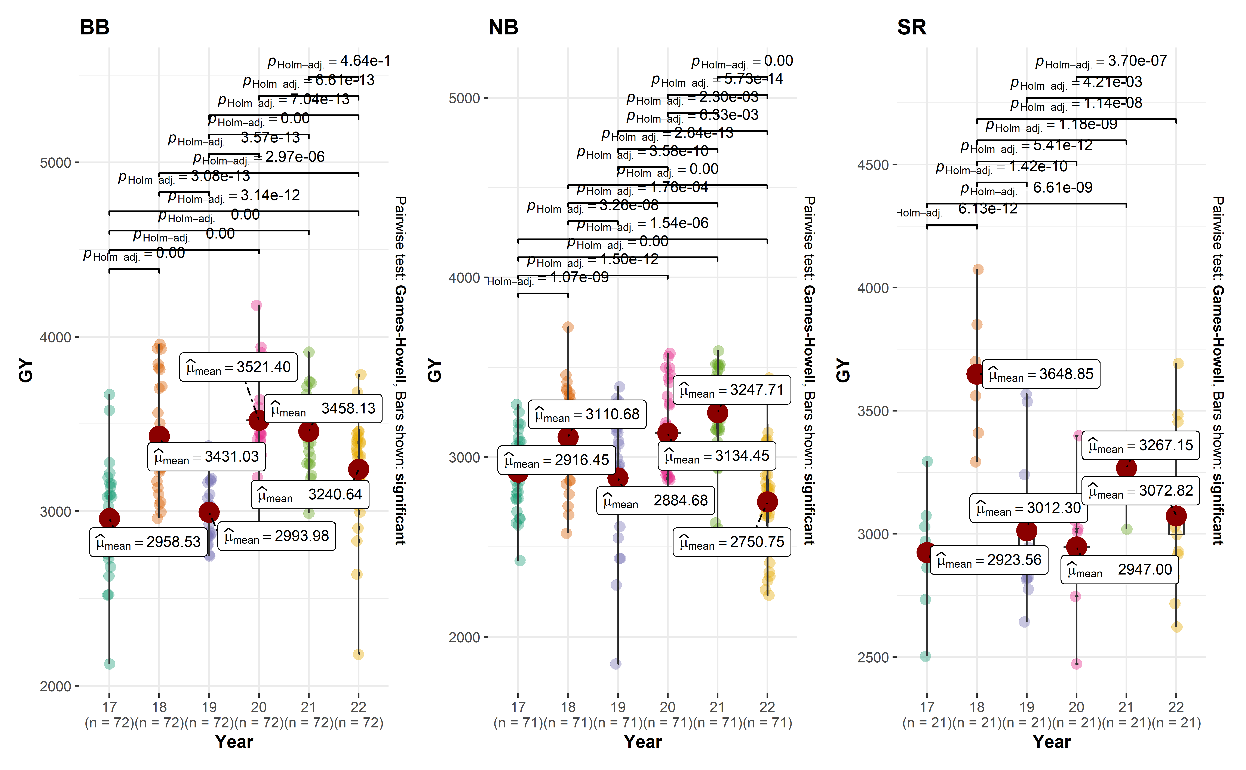

str(blues_stage.I)

Classes ‘data.table’ and ‘data.frame’: 984 obs. of 5 variables: $ year : Factor w/ 6 levels “17”,“18”,“19”,..: 1 1 1 1 1 1 1 1 1 1 … $ name : Factor w/ 164 levels “B1”,“B10”,“B11”,..: 1 2 3 4 5 6 7 8 9 10 … $ mkt : chr “BB” “BB” “BB” “BB” … $ se : num 141.3 98.7 113.8 113.8 355.7 … $ yield: num 2727 3579 2947 3092 2959 … - attr(*, “.internal.selfref”)=

blues_stage.I$year <- as.numeric(blues_stage.I$year)  
  
blues_stage.I$year[blues_stage.I$year == 1]<- 17  
blues_stage.I$year[blues_stage.I$year == 2]<- 18  
blues_stage.I$year[blues_stage.I$year == 3]<- 19  
blues_stage.I$year[blues_stage.I$year == 4]<- 20  
blues_stage.I$year[blues_stage.I$year == 5]<- 21  
blues_stage.I$year[blues_stage.I$year == 6]<- 22

beans_desc <- desc_stat(blues_stage.I, yield, stats = ("ci.t, hmean, n, se"), by = mkt)  
#print(beans_desc)  
  
beans_desc<-beans_desc[-c(2)]  
  
colnames(beans_desc)<- c("MKT","CI", "Mean", "N", "SE")  
  
beans_desc<-data.frame(beans_desc, row.names =T)  
  
#rownames(beans_desc) <- NULL

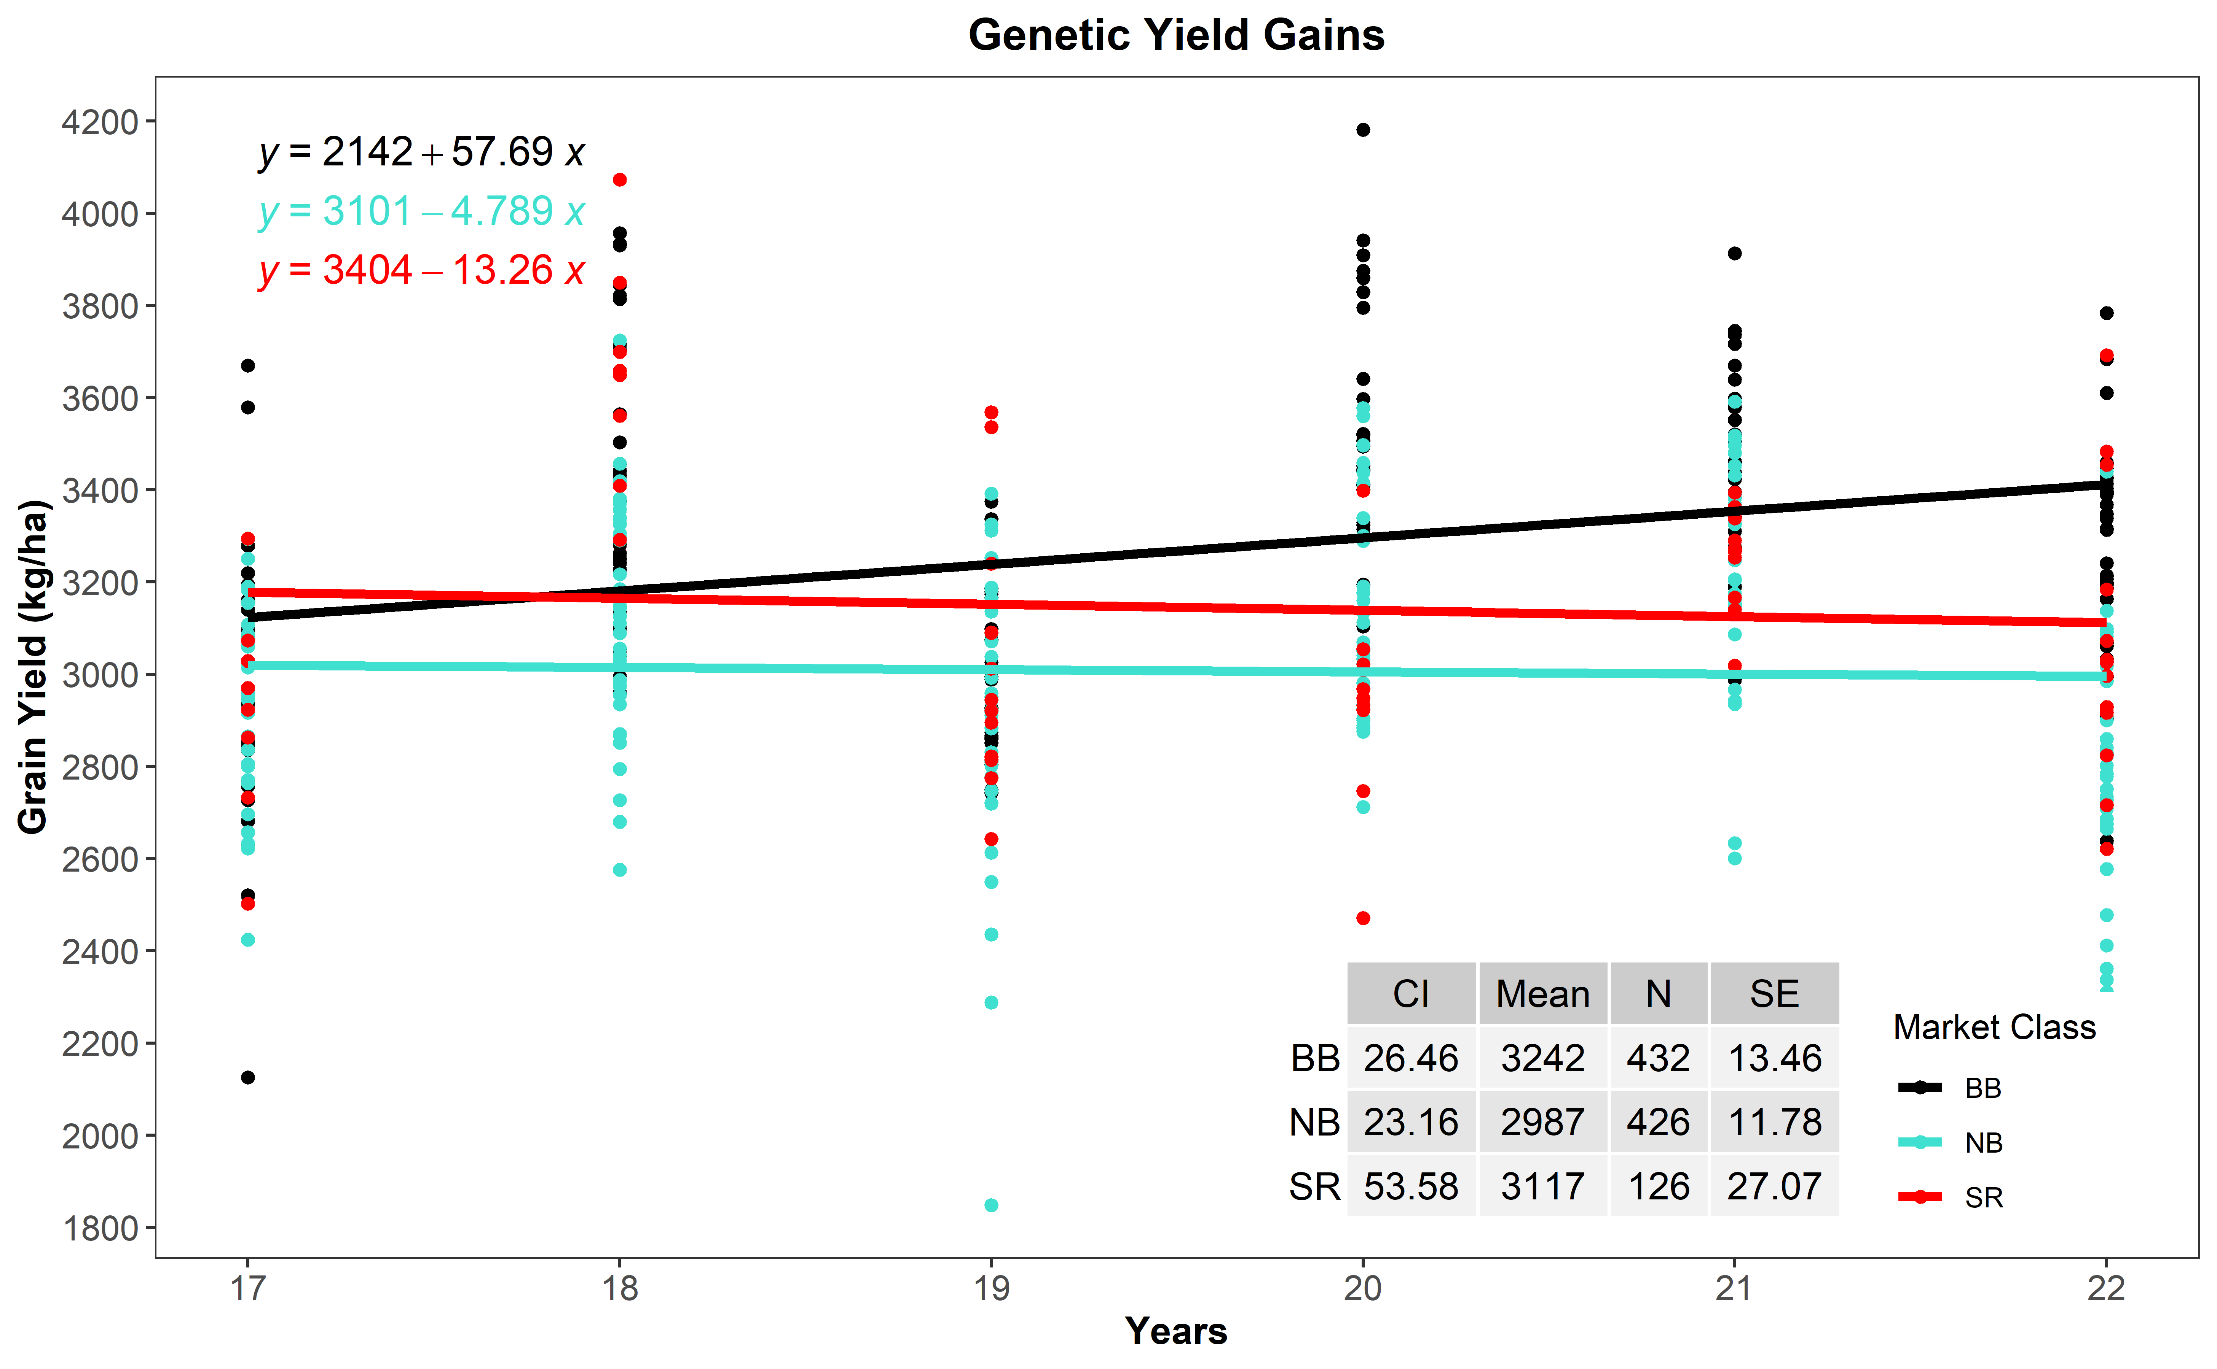

Combination of box and violin plots along with jittered data points for between subjects comparisons by years of grain yield (GY) for black (BB), Navy (NB) and Red (SR) beans. Pairwise Games-Howell test used. Comparisons showing only significant values.

## 3.6 Two Stage mixed model analysis

The following pipeline will be used: 1-Stage = BLUEs estimation for the vector of the variable GY in the ith genotype, and jth year within loc. Then the BLUEs from the 1-Stage (Yik) will be used to predict the BLUPs (Yijl) of the ith genotype in the lth location and jth rep in the 2-Stage in which this second model have name and loc effects as random.

### 3.6.1 1st Stage mixed model analysis

#rm(list=ls())  
data_beans = read.csv("data/DataBean_MET_GYv2.csv",h=T, stringsAsFactors = T)  
#str(data_beans)  
# Data adjustment  
# All the effect columns must be as a factor to run in ASReml-r.  
cols <- c("rep", "name", "loc","year", "mkt", "year_loc")  
data_beans[cols] <- lapply(data_beans[cols], factor)  
data_beans <- data.table(data_beans)

The BLUES will be estimated using a mixed-effect model. The BLUEs will be obtained by location using a loop with ASReml and storage into the list.

The following mixed model was used to estimate the BLUEs of each genotype within location with one value per genotype per experiment and rep, for the first step (random effects are underlined in all equations):

$$\underset{_}{Y_{ik}}=μ+G_{i}+\underset{_}{S_{k}}+\underset{_}{GS_{ik}}+\underset{_}{ε_{ik}}$$

where $Y_{ik}$ is the observed yield in the *i*th genotype and *k*th year, $μ$ is the overall mean, $G_{i}$ is the effect of the *i*th genotype, $S_{k}$ is the effect of the *k*th year, $GS_{ik}$ is the effect of the interaction between the ith genotype and the kth year, and $ε_{ik}$ are the residual, with $S_{k}$ ~N(0, $σ_{Y}^{2}$), $GS_{ik}$ ~N(0, $σ_{Y}^{2}$), and $ε_{ik}$ ~N(0, $σ_{ε}^{2}$), all independent, where $σ_{Y}^{2}$ is the year variance, and $σ_{ε}^{2}$ is the mean error variance across experiments.

#> `summarise()` has grouped output by 'name'. You can override using the `.groups` argument.  
#> `summarise()` has grouped output by 'name'. You can override using the `.groups` argument.  
#> `summarise()` has grouped output by 'name'. You can override using the `.groups` argument.  
#> `summarise()` has grouped output by 'name'. You can override using the `.groups` argument.  
#> `summarise()` has grouped output by 'name'. You can override using the `.groups` argument.  
#> `summarise()` has grouped output by 'name'. You can override using the `.groups` argument.  
#> `summarise()` has grouped output by 'name'. You can override using the `.groups` argument.  
#> `summarise()` has grouped output by 'name'. You can override using the `.groups` argument.  
#> `summarise()` has grouped output by 'name'. You can override using the `.groups` argument.  
#> `summarise()` has grouped output by 'name'. You can override using the `.groups` argument.  
#> `summarise()` has grouped output by 'name'. You can override using the `.groups` argument.  
#> `summarise()` has grouped output by 'name'. You can override using the `.groups` argument.

## Loop to get the year effect corrected by year  
## Only genotypes present in years  
  
#str(data_beans)  
data_beans$var_years <- as.factor(data_beans$var_years)  
year <- nlevels(data_beans$var_years)  
## Analysis per site and mkt class  
#mkt_n <- levels(data_beans$mkt)  
  
Envs <- levels(data_beans$loc)  
  
stgI_list <- matrix(data=list(), nrow=length(Envs), ncol=1,  
 dimnames=list(Envs, c("BLUES")))  
  
mkt <- nlevels(data_beans$mkt)  
  
for (y in 1:year) {  
  
 by <- levels(data_beans$var_years)  
 cy <- by[y]  
   
 data_beans_temp1 <- droplevels(subset(data_beans, var_years==cy))  
   
if(y == 1) {next  
  
}else {   
   
 for(k in 1:mkt){  
  
 bk <- levels(data_beans_temp1$mkt)  
 cj <- bk[k]  
 #print(cj)  
   
 data_beans_temp2 <- droplevels(subset(data_beans_temp1, mkt==cj))  
  
 for (i in Envs){  
 #i=Envs[1]  
 Edat <- droplevels(subset(data_beans_temp2, loc==i))  
   
 #print(i)  
   
 mod.1 <- asreml(fixed = gy_kg_ha ~ name:rep,  
 random = ~ year + name:year ,  
 data = Edat,  
 predict = predict.asreml(classify = "name:rep",vcov=TRUE, aliased = T),  
 trace = F,  
 maxit = 500)  
   
 # print(summary.asreml(mod.1)$varcomp)  
 # wald(mod.1)  
  
 blue.1<- data.table((mod.1$predictions$pvals[1:4]))   
 names(blue.1) <- c("name", "rep", "yield", "se")  
 blue.1$mkt<- cj  
 blue.1$var_years<- cy  
   
 stgI_list[[i, "BLUES"]] <- blue.1 # put all the results of Stage 1 in the list  
   
 rm(Edat,mod.1, blue, blue.1)  
   
 }  
 if(k==1){stgI_list.1<-stgI_list}else{stgI_list.1<-rbind(stgI_list.1, stgI_list)}  
   
}  
}  
 if(y==2){stgI_list.2<-stgI_list.1}else{stgI_list.2<-rbind(stgI_list.2, stgI_list.1)}  
   
}

#### 3.6.1.1 Preparing dataset of Stage I for Stage II

Merging the original data to have all the factors in the final table with: name, loc, mkt, rep

##### Unlist the results of Stage I and format as data.table #####  
blues_stageI <- data.table(ldply(stgI_list.2[, "BLUES"], data.frame, .id="loc"))  
  
blues_stage.I <- blues_stageI[order(blues_stageI$loc,blues_stageI$name),]  
  
blues_stage.I.SEmean <- blues_stage.I %>%  
 dplyr::summarise(Mean_SE = mean(se, na.rm = TRUE))  
  
print(blues_stage.I.SEmean)

Mean_SE 1 433.5

#str(blues_stage.I)

# Change the order of columns  
blues_stage.I <- blues_stage.I %>%   
 dplyr::select(loc, name, rep, mkt, yield)

### 3.6.2 2nd Stage mixed model analysis

The following linear mixed model with interaction effect will be used in the 2-Stage in order to investigate the multi-environment trials (MET) as follow:

$$\underset{_}{Y_{ijl}}=μ+\underset{_}{G_{i}}+E_{l}+β_{jl}+\underset{_}{GE_{il}}+\underset{_}{ε_{ijl}}$$

where $Y_{ijl}$ is the response variable (e.g., grain yield) observed in the *j*th repetion of the *i*th genotype in the *l*th location (*i* = 1, 2, …, *g*; *j* = 1, 2, …, *b*; *l* = 1, 2, …, *e*); is the grand mean; is the effect of the *i*th genotype; is the effect of the *l*th location (env); is the effect of the *j*th rep with the *l*th location; is the interaction effect of the *i*th genotype nested within the *l*th location; and is the random error, in witch with ~N(0,), ~N(0,), and ~N(0,), all independent, where is the genotype (name) variance, $GS_{GE}^{2}$ is the interaction genotype x environment variance, and $σ_{ε}^{2}$ is the mean error variance across experiments.

### 3.6.3 By market classes

* Getting the files for the individually market classes

blues_stage.I_BB <- droplevels(subset(blues_stage.I, mkt=="BB"))  
blues_stage.I_NB <- droplevels(subset(blues_stage.I, mkt=="NB"))  
blues_stage.I_SR <- droplevels(subset(blues_stage.I, mkt=="SR"))

blues_stage.I_table1<- blues_stage.I %>%   
 group_by(loc, rep, mkt) %>%   
 dplyr::summarise(count = length(name))   
  
blues_stage.I_table1<- blues_stage.I_table1[,3:4]  
blues_stage.I_table1<- blues_stage.I_table1[1:3,]  
  
blues_stage.I_table1

| **mkt** | **count** |
| --- | --- |
| **factor** | **integer** |
| BB | 72 |
| NB | 71 |
| SR | 21 |

str(blues_stage.I_BB)

Classes ‘data.table’ and ‘data.frame’: 1152 obs. of 5 variables: $ loc : Factor w/ 4 levels “BA”,“HU”,“SA”,..: 1 1 1 1 1 1 1 1 1 1 … $ name : Factor w/ 72 levels “B13”,“B14”,“B19”,..: 1 1 1 1 2 2 2 2 3 3 … $ rep : Factor w/ 4 levels “1”,“2”,“3”,“4”: 1 2 3 4 1 2 3 4 1 2 … $ mkt : Factor w/ 1 level “BB”: 1 1 1 1 1 1 1 1 1 1 … $ yield: num 2626 2874 2391 3000 2851 … - attr(*, “.internal.selfref”)=

if (knitr::is_html_output()) {  
  
 print_table(blues_stage.I_BB)  
   
}else{  
  
flextable(head(blues_stage.I_BB)) %>%   
 add_footer_lines(  
 c("Black beans data set",   
 "Header data set showing the 6 first entry")) %>%   
 autofit() %>%   
 add_header_lines("Dry Beans varieties trial") %>%   
 theme_design2()  
}

| **Dry Beans varieties trial** | | | | |
| --- | --- | --- | --- | --- |
| **loc** | **name** | **rep** | **mkt** | **yield** |
| BA | B13 | 1 | BB | 2,626 |
| BA | B13 | 2 | BB | 2,874 |
| BA | B13 | 3 | BB | 2,391 |
| BA | B13 | 4 | BB | 3,000 |
| BA | B14 | 1 | BB | 2,851 |
| BA | B14 | 2 | BB | 3,235 |
| Black beans data set | | | | |
| Header data set showing the 6 first entry | | | | |

if (knitr::is_html_output()) {  
  
 print_table(blues_stage.I_NB)  
   
}else{  
   
flextable(head(blues_stage.I_NB)) %>%   
 add_footer_lines(  
 c("Navy beans data set",   
 "Header data set showing the 6 first entry")) %>%   
 autofit() %>%   
 add_header_lines("Dry Beans varieties trial") %>%   
 theme_design2()  
}

| **Dry Beans varieties trial** | | | | |
| --- | --- | --- | --- | --- |
| **loc** | **name** | **rep** | **mkt** | **yield** |
| BA | N12 | 1 | NB | 2,505 |
| BA | N12 | 2 | NB | 2,642 |
| BA | N12 | 3 | NB | 2,862 |
| BA | N12 | 4 | NB | 1,323 |
| BA | N13 | 1 | NB | 2,451 |
| BA | N13 | 2 | NB | 2,673 |
| Navy beans data set | | | | |
| Header data set showing the 6 first entry | | | | |

if (knitr::is_html_output()) {  
  
 print_table(blues_stage.I_SR)  
   
}else{  
  
flextable(head(blues_stage.I_SR)) %>%   
 add_footer_lines(  
 c("Red beans data set",   
 "Header data set showing the 6 first entry")) %>%   
 autofit() %>%   
 add_header_lines("Dry Beans varieties trial") %>%   
 theme_design2()  
}

| **Dry Beans varieties trial** | | | | |
| --- | --- | --- | --- | --- |
| **loc** | **name** | **rep** | **mkt** | **yield** |
| BA | R10 | 1 | SR | 2,296 |
| BA | R10 | 2 | SR | 2,676 |
| BA | R10 | 3 | SR | 3,440 |
| BA | R10 | 4 | SR | 2,580 |
| BA | R12 | 1 | SR | 3,001 |
| BA | R12 | 2 | SR | 2,716 |
| Red beans data set | | | | |
| Header data set showing the 6 first entry | | | | |

### 3.6.4 Descriptive variance

#### 3.6.4.1 Box plot distribution

* Box plots for between-subjects comparisons by locations using the R package ggstatsplot.

**Pairwise Games-Howell test used. Comparisons showing only significant**

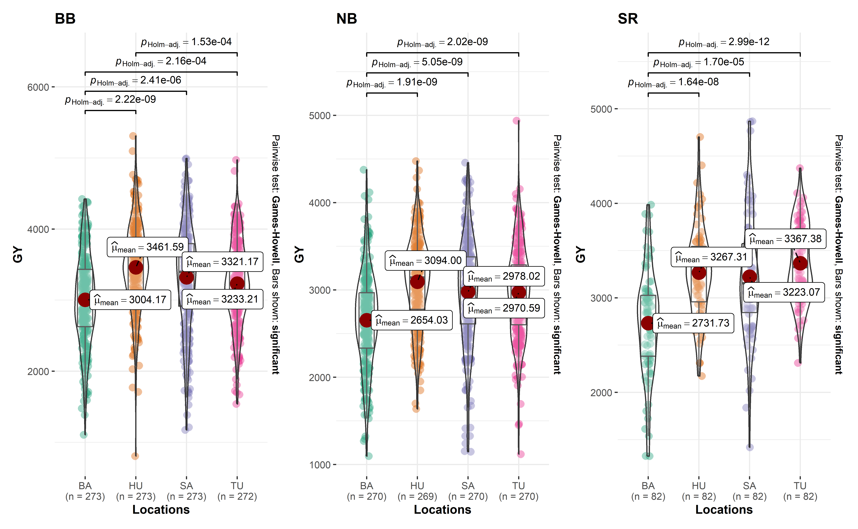

Figure S4: Combination of box and violin plots along with jittered data points for between subjects comparisons by locations of grain yield (GY) for black (BB), Navy (NB) and Red (SR) beans. Pairwise Games-Howell test used. Comparisons showing only significant values. BA: Bay, HU: Huron, SA:Sanilac, TU: Tuscola.

#### 3.6.4.2 Phenotypic variance components

data_beans_var = read.csv("data/VarStack.csv",h=T, stringsAsFactors = T)  
data_beans_var$trait <- factor(data_beans_var$trait, levels=c("GY1", "GY2", "DM", "PH", "LD"))  
  
ggplot(data_beans_var, aes(x = trait, y = Freq, fill = Comp, label = Comp)) +  
 geom_bar(stat = "identity") +  
 #geom_text(size = 3, position = position_stack(vjust = 0.5)) +  
 facet_wrap("mkt") +  
 geom_text(aes(label = round(Freq, 2), x = trait, y = Freq), data = data_beans_var,size = 5, position = position_stack(vjust = 0.5),fontface = "bold") +  
 labs(y = "Proportion of phenotypic variance", fill = "", x = NULL) +  
 theme_classic() +  
 #theme(strip.background = element_blank()) +  
 scale_fill_manual(values=c("#CC6666", "#9999CC", "#66CC99"),  
 labels = c("Res", "G", "GxE")) +  
 theme(legend.position = "bottom",  
 axis.text.x=element_text(face="bold", size = 12),  
 axis.text.y=element_blank(),  
 axis.ticks.y = element_blank(),  
 axis.title.y=element_text(face="bold", size = 14) ,  
 legend.text = element_text(size = 12, face="bold"), ) +  
 scale_y_continuous(expand = expansion(mult = c(0, 0.01)))

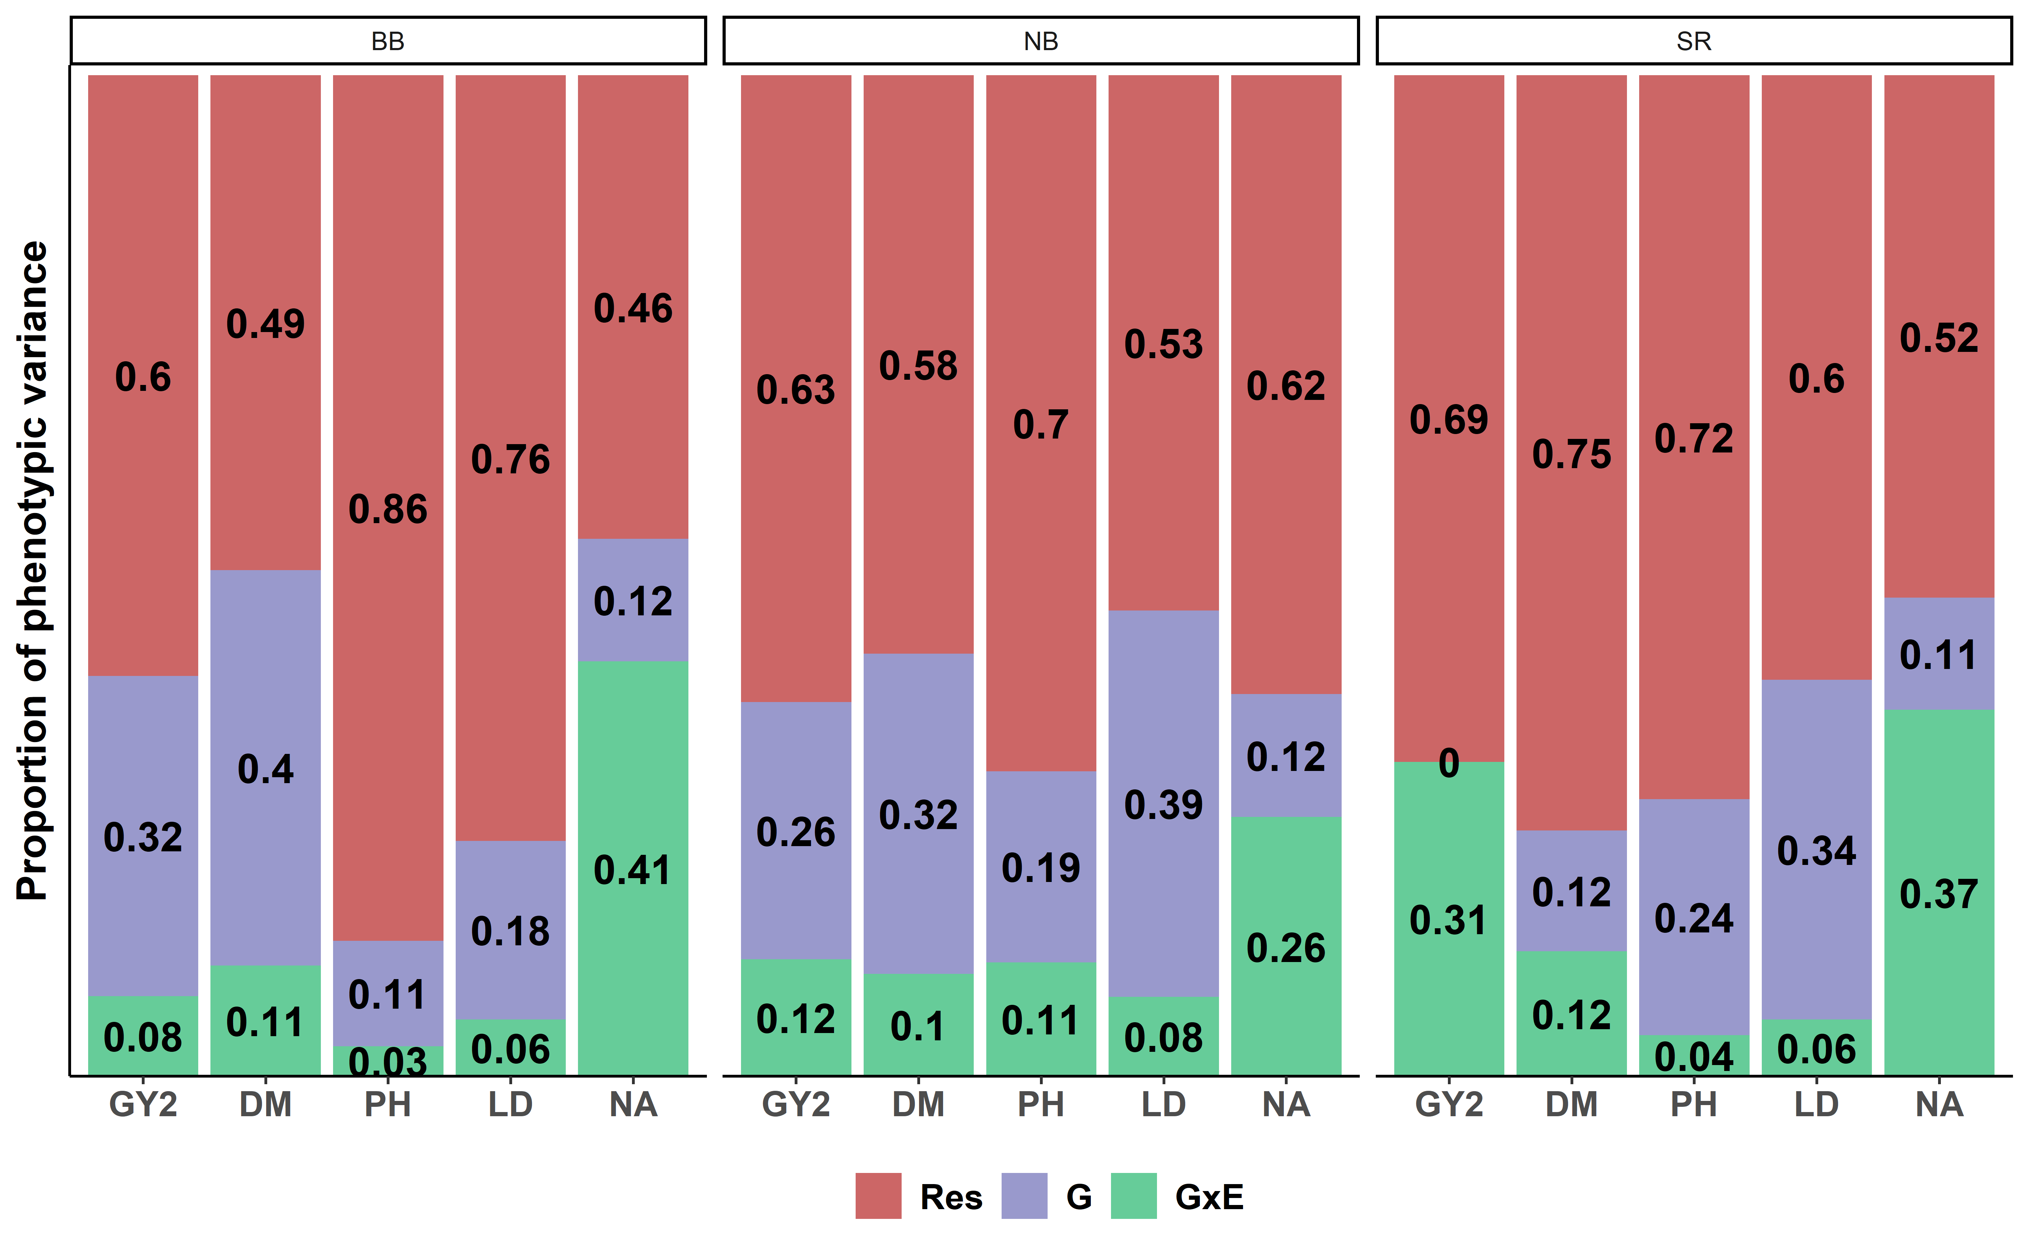

Proportion of the phenotypic variance for three dry beans traits evaluated across three locations. GY1, grain yield from 2017 to 2021; GY2, grain yield only in 2021; DM, days to maturity; PH, plant height; LD, lodging.

#### 3.6.4.3 Genotyping performance

blues_stage.I_BB_ge<- na.omit(blues_stage.I_BB)  
stab_bb <- ge_plot(blues_stage.I_BB_ge, type = 1,  
 env = loc,  
 gen = name,  
 resp = yield) + xlab("") + ylab("Genotypes") +  
theme(axis.text.x = element_text(size = 8, angle = 90, vjust = 0.5, hjust = 1),  
 axis.text.y = element_text(size = 7, angle = 0, vjust = 0.5, hjust = 1),  
 legend.position ="none", plot.title=element_text(hjust=0.5)) +  
 labs(title = "BB")  
#print (stab_bb)  
  
  
blues_stage.I_NB_ge<- na.omit(blues_stage.I_NB)  
stab_nb <- ge_plot(blues_stage.I_NB_ge, type = 1,  
 env = loc,  
 gen = name,  
 resp = yield) + xlab("Locations") + ylab("") +  
theme(axis.text.x = element_text(size = 8, angle = 90, vjust = 0.5, hjust = 1),  
 axis.text.y = element_text(size = 7, angle = 0, vjust = 0.5, hjust = 1),  
 legend.position ="none", plot.title=element_text(hjust=0.5)) +  
 labs(title = "NB")  
#print (stab_nb)  
  
blues_stage.I_SR_ge<- na.omit(blues_stage.I_SR)  
stab_sr <- ge_plot(blues_stage.I_SR_ge, type = 1,  
 env = loc,  
 gen = name,  
 resp = yield) + xlab("") + ylab("") +  
theme(axis.text.x = element_text(size = 8, angle = 90, vjust = 0.5, hjust = 1),  
 axis.text.y = element_text(size = 7, angle = 0, vjust = 0.5, hjust = 1),  
 legend.position ="right",   
 plot.title=element_text(hjust=0.5)) +  
 labs(fill="GY(Kg/ha)", title = "SR")  
#print (stab_sr)  
  
print(arrange_ggplot(stab_bb, stab_nb,stab_sr))

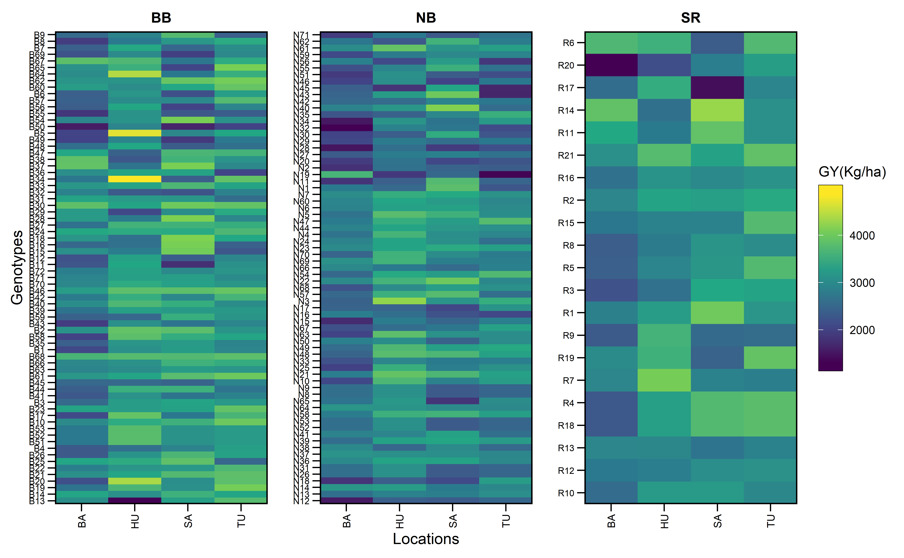

Genotype’s performance across the environments for Black (BB), Navy (NB), and Small Red (SR) beans using the estimated means (BLUEs) from the 1-stage mixed model analysis.

## 3.7 Descriptive MET

* Genetic correlations across environment using the Unstructured (US) variance-covariance structure.

This mixed model will be used only for genotype x environment correlations in order to investigate the GEI correlations.

mod.us.bb <- asreml(fixed = yield ~ loc + loc:rep ,  
 random = ~ name:us(loc) ,  
 data = blues_stage.I_BB,  
 predict = predict.asreml(classify = "name"),  
 trace = F,  
 maxit = 500)  
  
#print(wald(mod.us.bb))  
#print(summary.asreml(mod.us.bb)$varcomp)  
  
f=summary(mod.us.bb)$varcomp[1:10,1]  
z=matrix(0, 4,4)  
z[upper.tri(z)| row(z)==col(z)] <- f  
corf=z/sqrt(diag(z)%*%t(diag(z)))  
#corf  
  
rownames(corf)=c(  
"BA",  
"HU",  
"SA",  
"TU")  
  
colnames(corf)=rownames(corf)  
  
plotBB<- ggcorrplot(corf, colors = c("#6D9EC1", "white", "#E46726"),   
 title = " Black Beans",  
 show.legend = F,  
legend.title = "rgg" ,lab_size=5,tl.srt = 90,type = c("upper"), lab = T,digits = 4,  
outline.color = "white",pch.col = "white", tl.col = "blue",show.diag = FALSE)  
## genetic correlation: manual estimation  
# corr.loc_BA_HU<-summary(mod.us.bb)$varcomp[2,1] /  
# sqrt(summary(mod.us.bb)$varcomp[1,1]*summary(mod.us.bb)$varcomp[3,1])  
  
# print(plotBB)  
  
mod.us.nb <- asreml(fixed = yield ~ loc + loc:rep ,  
 random = ~ name:us(loc) ,  
 data = blues_stage.I_NB,  
 predict = predict.asreml(classify = "name"),  
 trace = F,  
 maxit = 500)  
  
#print(wald(mod.us.nb))  
#print(summary.asreml(mod.us.nb)$varcomp)  
  
f=summary(mod.us.nb)$varcomp[1:10,1]  
z=matrix(0, 4,4)  
z[upper.tri(z)| row(z)==col(z)] <- f  
corf=z/sqrt(diag(z)%*%t(diag(z)))  
#corf  
  
rownames(corf)=c(  
"BA",  
"HU",  
"SA",  
"TU")  
  
colnames(corf)=rownames(corf)  
  
#corf<- as_tibble(corf,rownames=NA)  
  
plotNB<-ggcorrplot(corf, colors = c("#6D9EC1", "white", "#E46726"),   
 title = " Navy Beans",  
 show.legend = F,  
legend.title = "r" ,lab_size=5,tl.srt = 90,type = c("upper"), lab = T,digits = 4,  
outline.color = "white",pch.col = "white", tl.col = "blue",show.diag = FALSE)  
## genetic correlation: manual estimation  
corr.loc<-summary(mod.us.nb)$varcomp[2,1] /  
 sqrt(summary(mod.us.nb)$varcomp[1,1]*summary(mod.us.nb)$varcomp[3,1])  
#print(plotNB)  
  
mod.us.sr <- asreml(fixed = yield ~ loc + loc:rep ,  
 random = ~ name:us(loc) ,  
 data = blues_stage.I_SR,  
 predict = predict.asreml(classify = "name"),  
 trace = F,  
 maxit = 50000)  
  
#print(wald(mod.us.sr))  
#print(summary.asreml(mod.us.sr)$varcomp)  
  
f=summary(mod.us.sr)$varcomp[1:10,1]  
z=matrix(0, 4,4)  
z[upper.tri(z)| row(z)==col(z)] <- f  
corf=z/sqrt(diag(z)%*%t(diag(z)))  
#corf  
  
rownames(corf)=c(  
"BA",  
"HU",  
"SA",  
"TU")  
  
colnames(corf)=rownames(corf)  
  
#corf<- as_tibble(corf,rownames=NA)  
  
plotSR<- ggcorrplot(corf, colors = c("#6D9EC1", "white", "#E46726"),   
 title = " Small Red Beans",   
 #show.legend = F,   
legend.title = "Rge" ,lab_size=5,tl.srt = 90,type = c("upper"), lab = T,digits = 4,  
outline.color = "white",pch.col = "white", tl.col = "blue",show.diag = FALSE)  
## genetic correlation: manual estimation  
corr.loc<-summary(mod.us.sr)$varcomp[2,1] /  
 sqrt(summary(mod.us.sr)$varcomp[1,1]*summary(mod.us.sr)$varcomp[3,1])  
#print(plotSR)

arrange_ggplot(plotBB,plotNB, plotSR,ncol = 3)

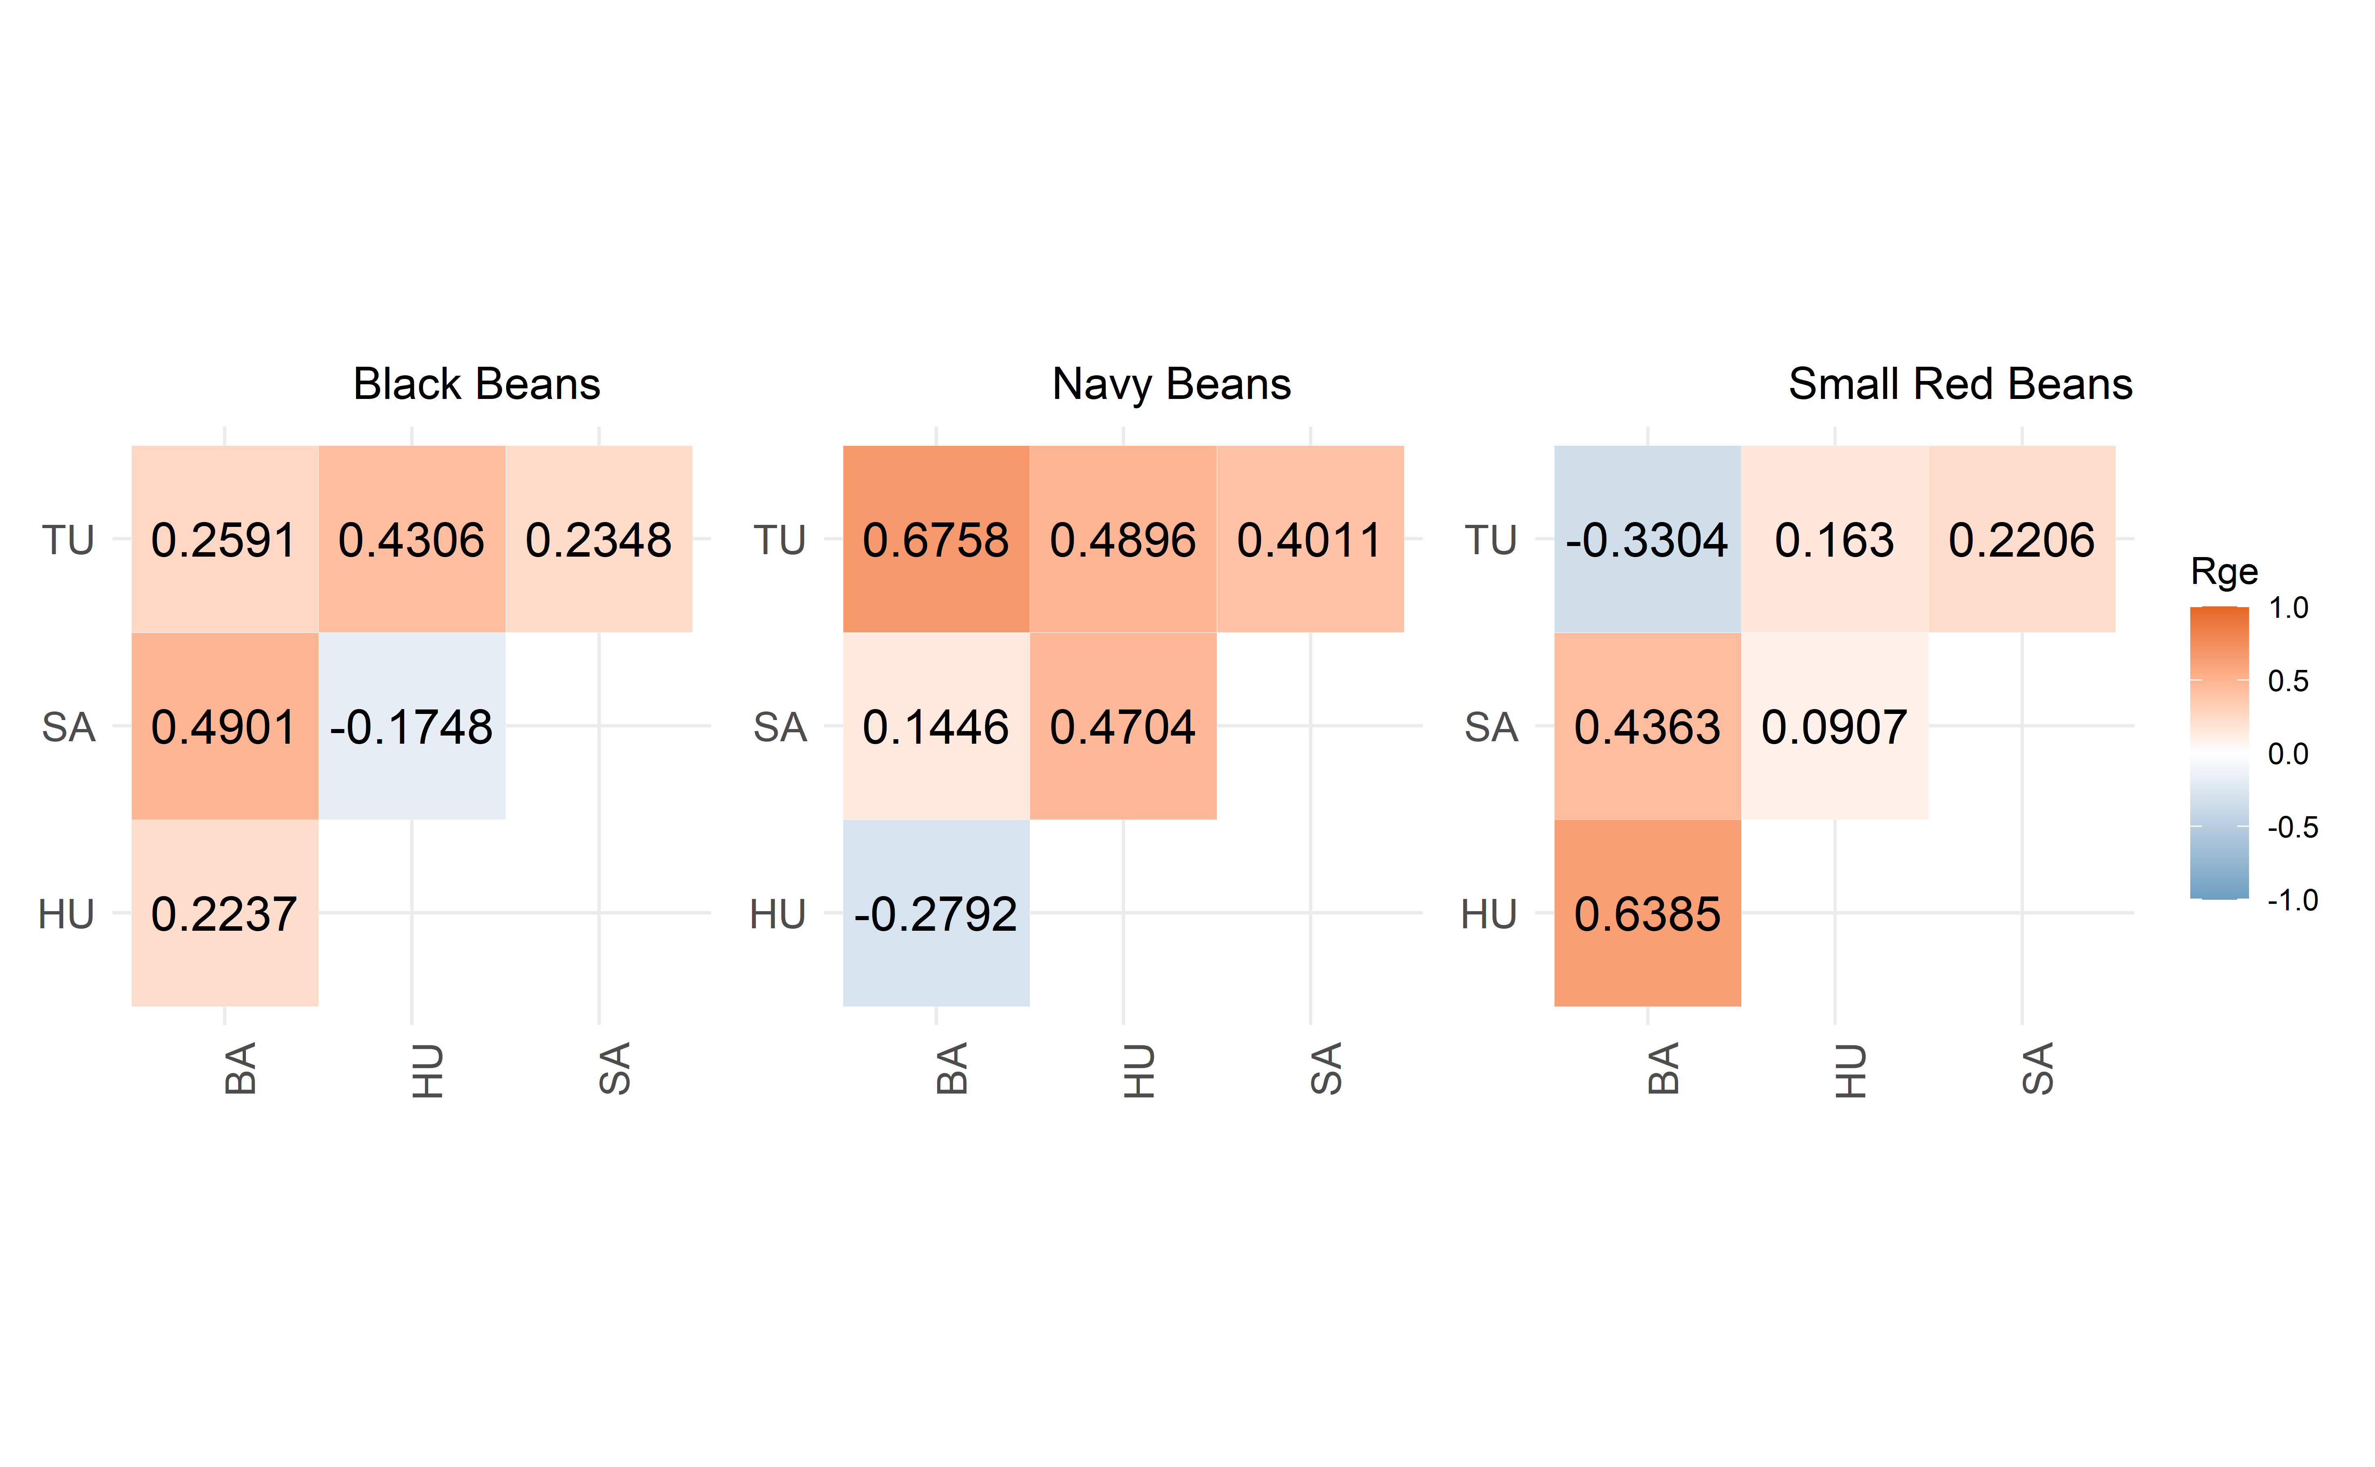

## 3.8 Analyzing MET - GGE

Genotype plus Genotype-vs-Environment interaction (GGE) model has been widely used to genotype evaluation and mega-environment identification in multi-environment trials (MET). This model considers a GGE (i.e., G + GE) biplot, which is constructed by the first two symmetrically scaled principal components (PC1 and PC2) derived from singular value decomposition of environment-centered MET data. The GGE biplot graphically displays G plus GE of a MET in a way that facilitates visual genotype evaluation and mega-environment identification [Yan, Kang, Ma, Woods, & Cornelius (2007a)](GGE%20Biplot%20vs.%20AMMI%20Analysis%20of%20Genotype-by-Environment%20Data).

### 3.8.1 GGE biplot model

The mean yield of genotype *i* in environment *j* is commonly described by a general linear model

$${\hat{y}}_{ij}+μ+α_{i}+β_{j}+ϕ_{ij}$$

where ${\hat{y}}_{ij}$ is the mean yield of genotype *i* in environment *j*, $i=1,...g;j=1,...e$ being *g* and *e* the numbers of genotypes and environments, respectively; $μ$ is the grand mean; $α_{i}$ is the main effect of the genotype *i*; $β_{j}$ is the main effect of the environment *j*, and $ϕ_{ij}$ is the interaction effect between genotype *i* and environment *j*. In the Genotype plus Genotype-vs-Environment interaction (GGE) model the $α_{i}$ term is is deleted from the above model and then the environment-centered data matrix, $ϕ_{ij}$, is subjected to SVD [Yan & Kang (2003)](GGE%20biplot%20analysis:%20a%20graphical%20tool%20for%20breeders,%20geneticists,%20and%20agronomists) and [Yan et al. (2007a)](GGE%20Biplot%20vs.%20AMMI%20Analysis%20of%20Genotype-by-Environment%20Data). Explicitly, we have

$$ϕ_{ij}={\hat{y}}_{ij}−μ−β_{j}=\sum_{k=1}^{p}{ξ_{ik}^{*}}η_{jk}^{*}$$

where $ξ_{ik}^{*}=λ_{k}^{α}ξ_{ik}$; $η_{jk}^{*}=λ_{k}^{1−α}η_{jk}$ being $λ_{k}$ the *k*th eigenvalue from the SVD ($k=1,...p$), with $p≤min\left(e,g\right)$; $α$ is the the singular value partition factor for the Principal Component (PC) *k*; $ξ_{ik}^{*}$ and $η_{jk}^{*}$ are the PC scores for genotype *i* and environment *j*, respectively.

The function gge() from the R package metan [Olivoto et al. (2019)](Olivoto%20et%20al.,%202019a) according to [Yan & Kang (2003)](GGE%20biplot%20analysis:%20a%20graphical%20tool%20for%20breeders,%20geneticists,%20and%20agronomists) was deployed to produce the GGE model in this study.

## 3.9 WAASB index

The function waasb() function computes the Weighted Average of the Absolute Scores considering all possible IPCA from the Singular Value Decomposition of the BLUPs for genotype-vs-environment interaction effects obtained by an Linear Mixed-effect Model [Olivoto et al. (2019)](Olivoto%20et%20al.,%202019a), as follows:

$$WAASB_{i}=\sum_{k=1}^{p}{\left|IPCA_{ik}×EP_{k}\right|}/\sum_{k=1}^{p}{E}P_{k}$$

where $WAASB_{i}$ is the weighted average of absolute scores of the *i*th genotype; $IPCA_{ik}$ is the scores of the *i*th genotype in the *k*th IPCA; and $EP_{k}$ is the explained variance of the *k*th PCA for $k=1,2,..,p$, $p=min\left(g−1;e−1\right)$.

## 3.10 WAASBY index

* Simultaneous selection for mean performance and stability

The **waasby** index is used for genotype ranking considering both the stability (**waasb**) and mean performance (**y**) based on the following model [Olivoto et al. (2019)](Olivoto%20et%20al.,%202019a).

$$waasby_{i}=\frac{\left(rY_{i}×θ_{Y}\right)+\left(rW_{i}×θ_{W}\right)}{θ_{Y}+θ_{W}}$$

where $waasby_{i}$ is the superiority index for the *i*-th genotype; $rY_{i}$ and $rW_{i}$ are the rescaled values (0-100) for the response variable (y) and the stability (WAAS or WAASB), respectively; $θ_{Y}$ and $θ_{W}$ are the weights for mean performance and stability, respectively.

# 4 Appendix D - R codes

## 4.1 MET analysis - **Black beans**

### 4.1.1 MET analysis - ASReml

Running MET using ASReml - only to comparison of variance components with metan outputs

mod.met.asreml.bb1 <- asreml(fixed = yield ~ loc + loc:rep,  
 random = ~ name + name:loc,  
 data = blues_stage.I_BB,  
 predict = predict.asreml(classify = "name"),  
 trace = F,  
 maxit = 500)  
  
summFix.bb.met.asreml<- data.frame(wald(mod.met.asreml.bb1))  
summFix.bb.met.asreml

| **Df** | **Sum.of.Sq** | **Wald.statistic** | **Pr.Chisq.** |
| --- | --- | --- | --- |
| **numeric** | **numeric** | **numeric** | **numeric** |
| 1 | 1,368,373,852 | 7,427.1 | 0 |
| 3 | 7,396,784 | 40.1 | 0 |
| 12 | 21,308,617 | 115.7 | 0 |
|  | 184,240 |  |  |

summ.bb.met.asreml<- data.frame(summary.asreml(mod.met.asreml.bb1)$varcomp)  
summ.bb.met.asreml

| **component** | **std.error** | **z.ratio** | **bound** | **X.ch** |
| --- | --- | --- | --- | --- |
| **numeric** | **numeric** | **numeric** | **character** | **numeric** |
| 48,605.0 | 17,987.9 | 2.7 | P | 0 |
| 164,940.6 | 21,008.6 | 7.9 | P | 0 |
| 184,240.9 | 9,279.9 | 19.9 | P | 0 |

#print(summary.asreml(mod.met.asreml.bb1)$bic)  
mod.met.asreml.bb<- data.table((mod.met.asreml.bb1$predictions$pvals[1:3]))  
names(mod.met.asreml.bb) <- c("name", "yield_BLUPS_MET", "SE")  
  
###

### 4.1.2 MET analysis - lme4

Running MET using metan R package [Olivoto et al. (2019)](Olivoto%20et%20al.,%202019a).

mixed_mod.bb<-   
 gamem_met(blues_stage.I_BB,  
 env = loc,  
 gen = name,  
 rep = rep,  
 resp = yield,  
 random = "gen", #Default  
 verbose = TRUE) #Default

Evaluating trait yield |===============================================================================| 100% 00:00:01

#> Method: REML/BLUP

#> Random effects: GEN, GEN:ENV

#> Fixed effects: ENV, REP(ENV)

#> Denominador DF: Satterthwaite's method

| P-values for Likelihood Ratio Test of the analyzed traits |
| --- |
| model yield COMPLETE NA GEN 5.40e-04 GEN:ENV 5.48e-49 |

All variables with significant (p < 0.05) genotype-vs-environment interaction

### 4.1.3 Printing the model outputs

#### 4.1.3.1 Likelihood Ratio Tests

The output LRT contains the Likelihood Ratio Tests for genotype and genotype-vs-environment random effects.

data_mod_bb_test <- get_model_data(mixed_mod.bb, "lrt")

#> Class of the model: waasb

#> Variable extracted: lrt

data_mod_bb_test

| **VAR** | **model** | **npar** | **logLik** | **AIC** | **LRT** | **Df** | **Pr(>Chisq)** |
| --- | --- | --- | --- | --- | --- | --- | --- |
| **character** | **character** | **integer** | **numeric** | **numeric** | **numeric** | **numeric** | **numeric** |
| yield | GEN | 18 | -8,314.1 | 16,664.3 | 12.0 | 1 | 0.0 |
| yield | GEN:ENV | 18 | -8,416.4 | 16,868.7 | 216.4 | 1 | 0.0 |

#customize the display of numbers and other data in a tibble  
# old <- options(pillar.sigfig = 6)  
#   
# blues_stage.I_BB %>%   
# group_by(loc) %>%   
# dplyr::summarise(Mean = mean(yield, na.rm = TRUE))

#### 4.1.3.2 Detailed parameters

data_mod_bb_det <- get_model_data(mixed_mod.bb, "details")

#> Class of the model: waasb

#> Variable extracted: details

data_mod_bb_det

| **Parameters** | **yield** |
| --- | --- |
| **character** | **character** |
| Mean | 3255.05 |
| SE | 19.84 |
| SD | 655 |
| CV | 20.13 |
| Min | 805.92 (B13 in HU) |
| Max | 5310.16 (B34 in HU) |
| MinENV | BA (3004.17) |
| MaxENV | HU (3461.59) |
| MinGEN | B50 (2031.07) |
| n: 12 | |

#### 4.1.3.3 Random effects

The output LRT contains the Likelihood Ratio Tests for genotype and genotype-vs-environment random effects.

#customize the display of numbers and other data in a tibble  
old <- options(pillar.sigfig = 8)  
  
data_mod_bb_var <- get_model_data(mixed_mod.bb, "vcomp")

#> Class of the model: waasb

#> Variable extracted: vcomp

data_mod_bb_var

| **Group** | **yield** |
| --- | --- |
| **character** | **numeric** |
| GEN | 48,616.4 |
| GEN:ENV | 164,935.3 |
| Residual | 184,240.5 |

#### 4.1.3.4 Variance components and genetic parameters

old <- options(pillar.sigfig = 4)  
data_mod_bb_comp <- get_model_data(mixed_mod.bb)

#> Class of the model: waasb

#> Variable extracted: genpar

data_mod_bb_comp

| **Parameters** | **yield** |
| --- | --- |
| **character** | **numeric** |
| Phenotypic variance | 397,792.2 |
| Heritability | 0.1 |
| GEIr2 | 0.4 |
| h2mg | 0.5 |
| Accuracy | 0.7 |
| rge | 0.5 |
| CVg | 6.8 |
| CVr | 13.2 |
| CV ratio | 0.5 |

### 4.1.4 MET - GGE biplot

Genotype plus Genotype-vs-Environment interaction (GGE). Mega-environment identification in multi-environment trials (MET) according to [(**W?**). Yan et al. 2007](link%20here)

#### 4.1.4.1 GGE ENV biplot

GGE biplot done using:

* **sd**: each value is divided by the standard deviation of its corresponding environment.
* **environment**: environment-centered (G+GE)
* **environment**: singular value is entirely partitioned into the environment eigenvectors, also called column metric preserving

gge_model.bb <- gge(blues_stage.I_BB, loc, name, yield,   
 centering = "environment", #2  
 scaling = "sd", #2  
 svp = "environment")#2  
  
a <- plot(gge_model.bb, type=4,  
 size.text.env = 4.5,  
 plot_theme = theme_metan(grid = "both",color.background = transparent_color()),  
 axis_expand = 1.5,  
 col.alpha.circle = 0.8,  
 shape.gen = NA,  
 col.gen = NA,  
 size.text.lab = NA,  
 size.text.gen = NA,  
 leg.lab=c('Env'),  
 #title = FALSE  
 )  
  
  
gge_model.bb <- gge(blues_stage.I_BB, loc, name, yield,  
 centering = "environment", #1  
 scaling = "sd", #2Y  
 svp = "environment")#2)  
  
b <- plot(gge_model.bb, type = 6,  
 size.text.env = 5,  
 plot_theme = theme_metan(grid = "both",color.background = transparent_color()),  
 axis_expand = 1.5,  
 # col.alpha.circle = 100,  
 col.alpha.circle = 0.8,  
 size.text.lab = 13,  
 #title = FALSE  
 )  
  
 arrange_ggplot(a, b,  
 guides = "collect",  
 tag_levels = "a",  
 tag_prefix = "(",  
 tag_suffix = ")")

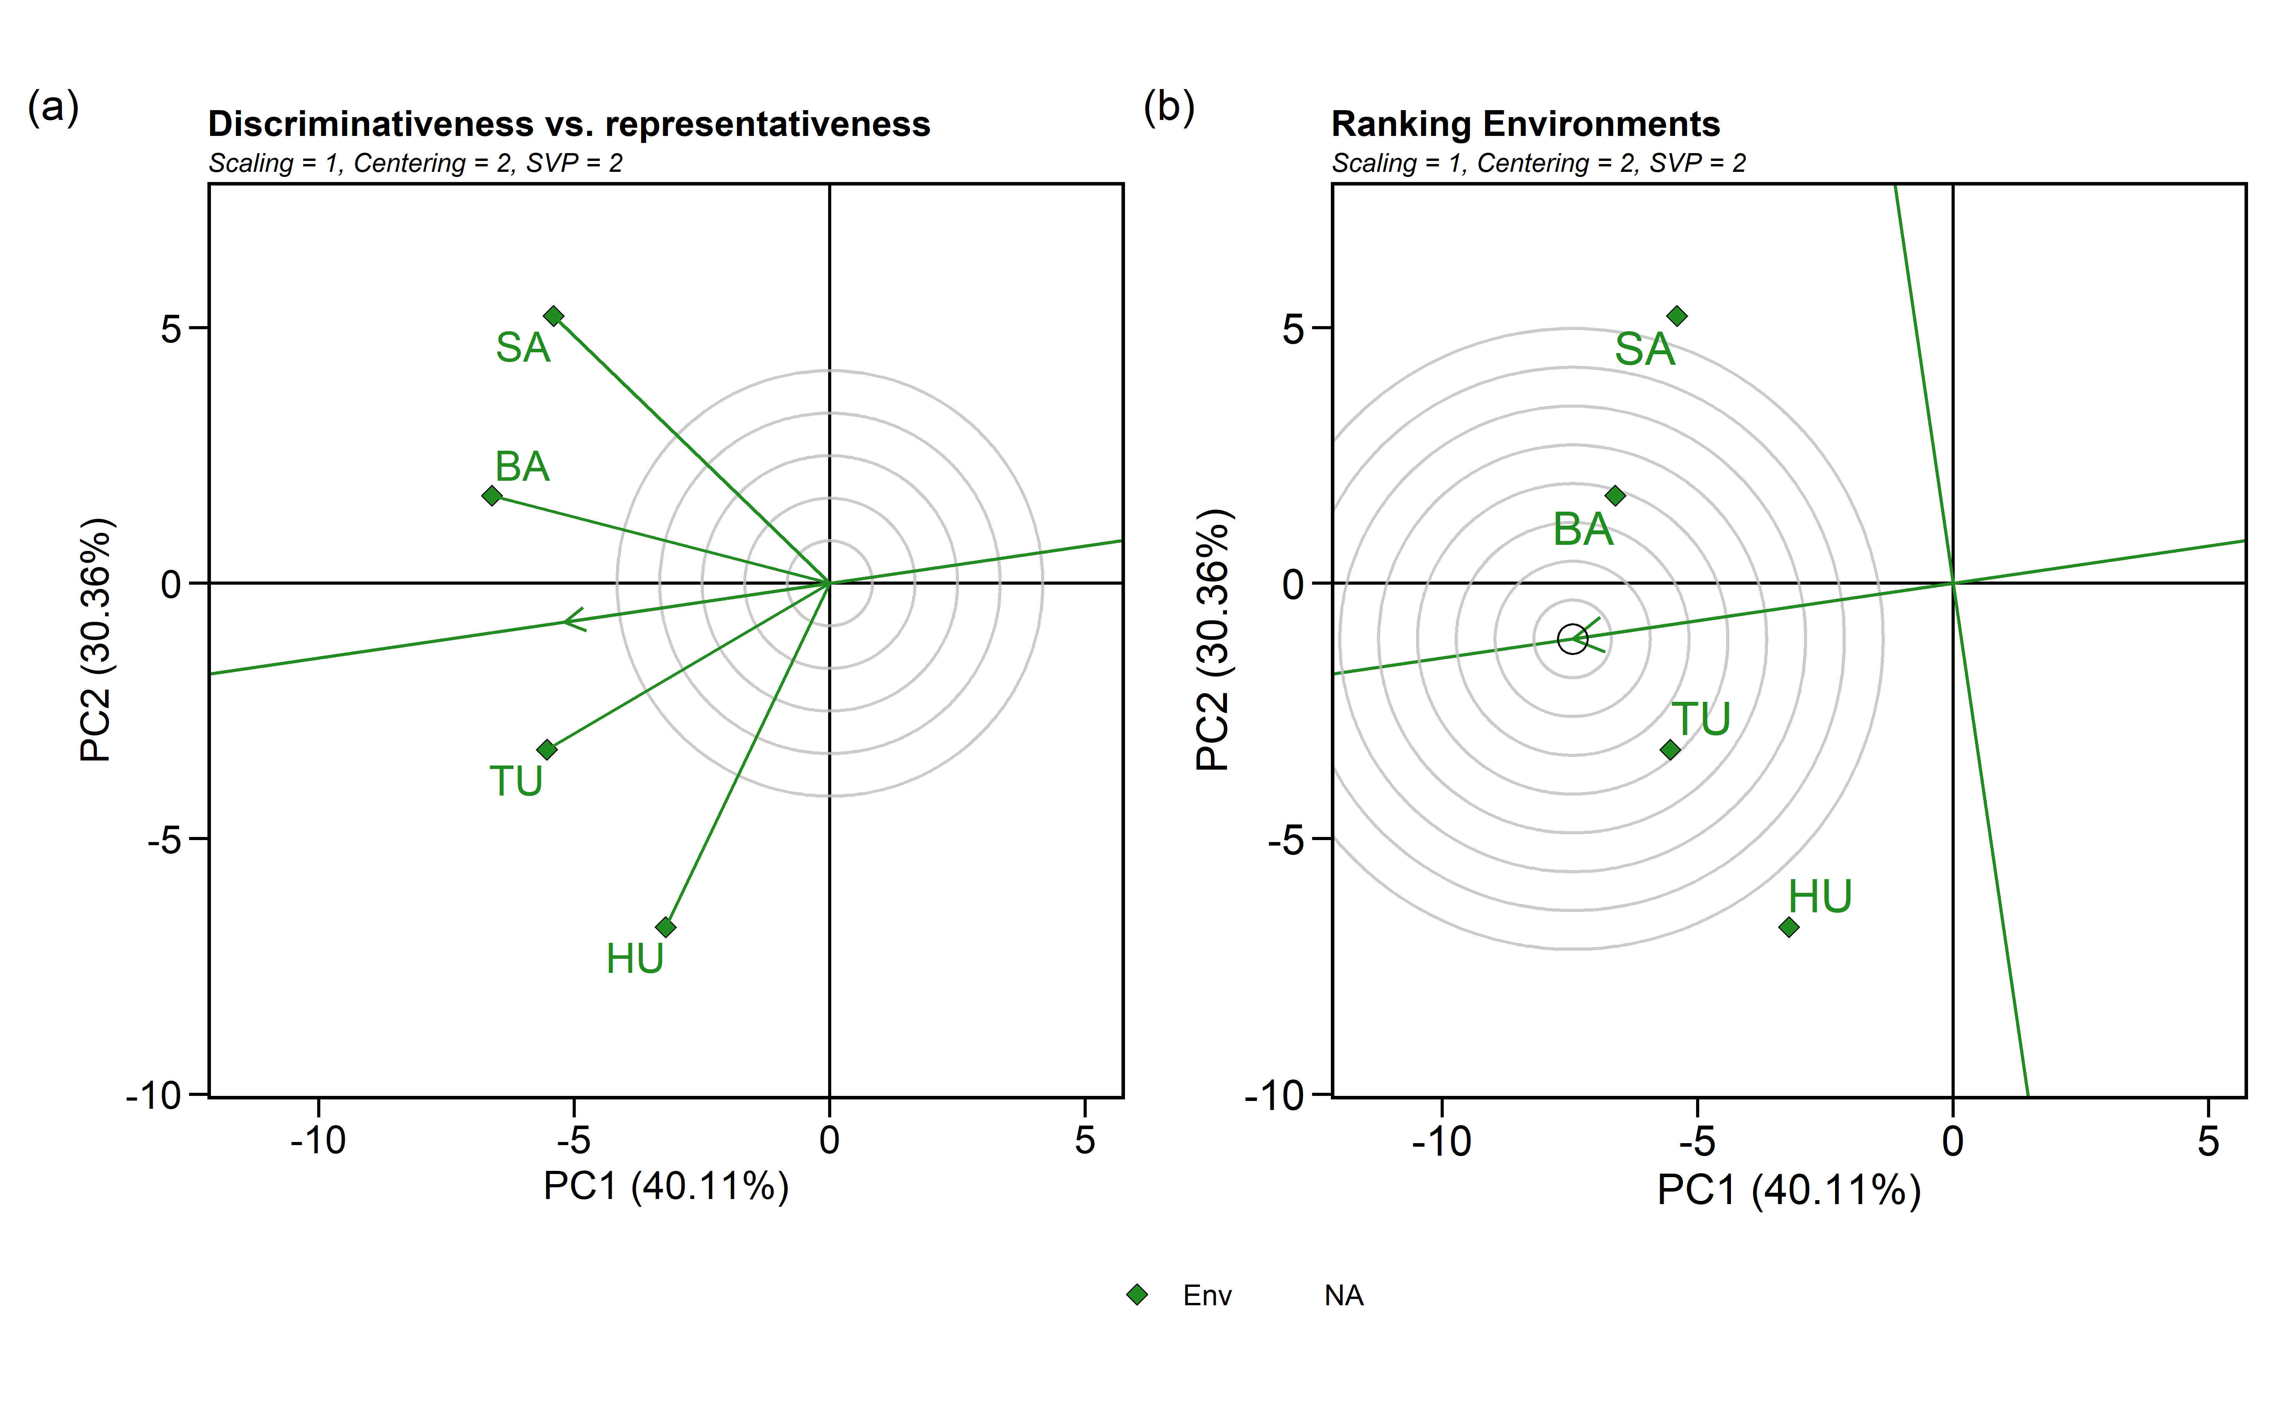

#### 4.1.4.2 Biplot type 3: Which-won-where

GGE biplot done using:

* **sd**: each value is divided by the standard deviation of its corresponding environment.
* **environment**: environment-centered (G+GE)
* **genotype**: singular value is entirely partitioned into the environment eigenvectors, also called column metric preserving

gge_model.bb <- gge(blues_stage.I_BB, loc, name, yield,  
 centering = "environment", #2  
 scaling = "sd", #1  
 svp = "genotype")#2)  
  
e <- plot(gge_model.bb, type = 3,  
 size.text.env = 5,  
 plot_theme = theme_metan(grid = "both",color.background = transparent_color()),  
 axis_expand = 1.2,  
 size.line = 0.7,  
 size.text.gen = 4,  
 size.text.win = 4.5  
 #title = F  
 )  
  
print(e)

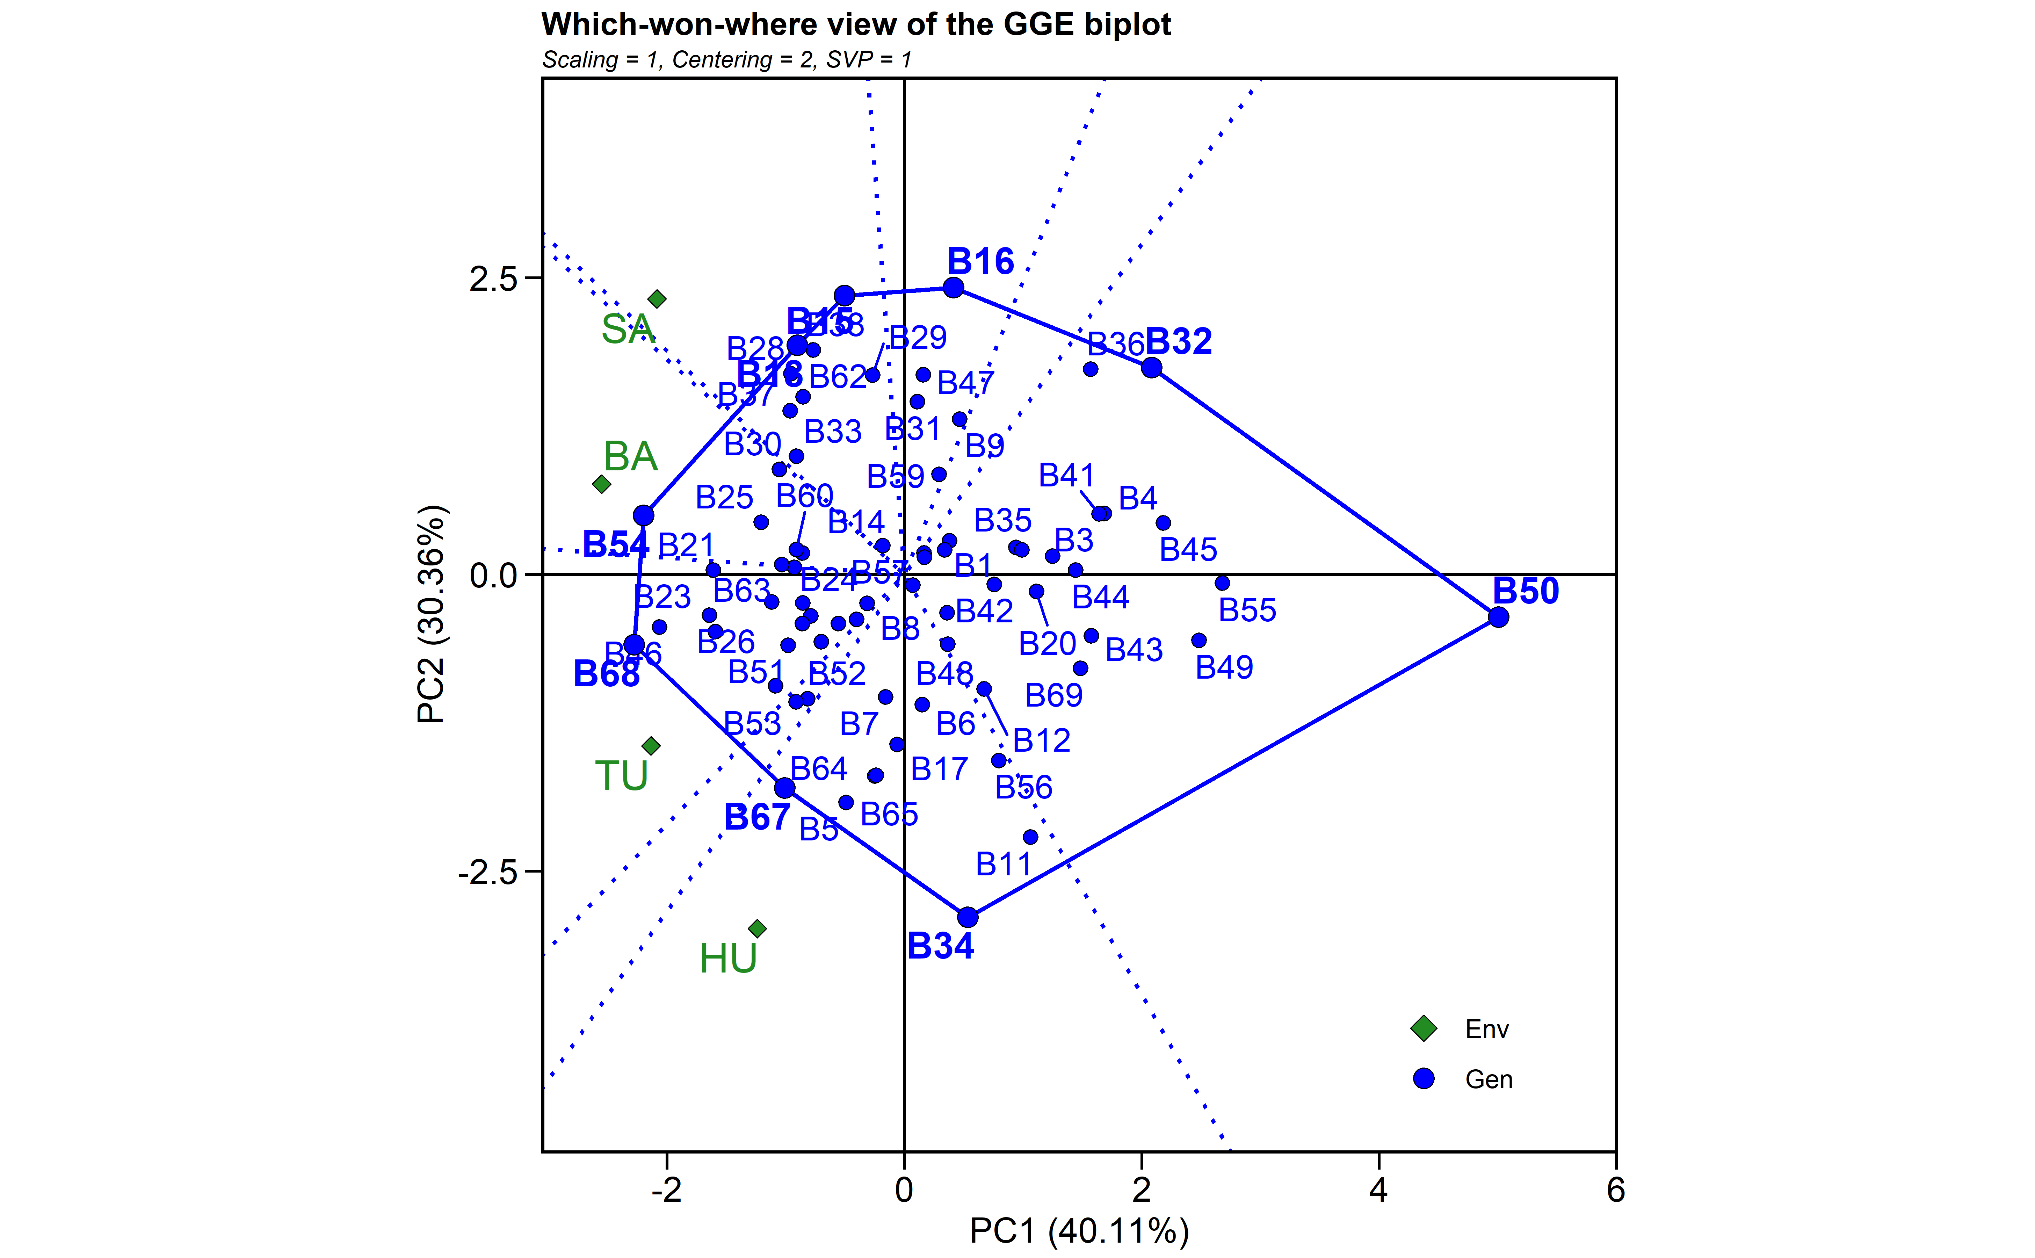

### 4.1.5 Mean performance and stability analysis

WAASP index and BLUPs to estimate stability analysis.

#blues_stage.I_BB<- na.omit(blues_stage.I_BB)  
  
waasb_model_bb <-   
 waasb(blues_stage.I_BB,  
 env = loc,  
 gen = name,  
 rep = rep,  
 resp = yield,  
 random = "gen", #Default  
 verbose = TRUE,  
 wresp = 60) #weight for response variable 60 and 40 for yielding and stability, respectively)

#> Evaluating trait yield |===============================================================================| 100% 00:00:02   
#> ---------------------------------------------------------------------------  
#> P-values for Likelihood Ratio Test of the analyzed traits  
#> ---------------------------------------------------------------------------  
#> model yield  
#> COMPLETE NA  
#> GEN 5.40e-04  
#> GEN:ENV 5.48e-49  
#> ---------------------------------------------------------------------------  
#> All variables with significant (p < 0.05) genotype-vs-environment interaction

waasb_model<- waasb_model_bb$yield$model  
  
#waasb_ind <- gmd(waasb_model_bb, "WAASB")  
#print_tbl(waasb_ind)  
  
#desc <- c("Selected cultivar providing greater performance and stability for GY")  
  
waasp_plot <- plot_scores(waasb_model_bb, type = 3,  
 title = FALSE,  
 size.tex.gen = 4,  
 size.tex.env = 4,  
 size.tex.lab = 13,  
 # highlight = c("B55", "B1" , "B29", "B20" ,"B28"),  
 plot_theme = theme_metan(grid = "both",color.background = transparent_color())  
 ) +  
   
 geom_mark_rect(aes(filter = Code %in% c("B17", "B46", "B10", "B14"),  
 ),  
 label.fontsize = 10,  
 show.legend = F,  
 con.cap = 0,  
 con.colour = "red",  
 color = "red",  
 expand = 0.015,  
 label.buffer = unit(10, "cm"))+  
#theme_gray()+  
theme(legend.position = c(0.1, 0.9),  
 legend.background = element_blank(),  
 legend.title = element_blank(),  
 aspect.ratio = 1) +  
 labs(x = "GY")   
  
print(waasp_plot)

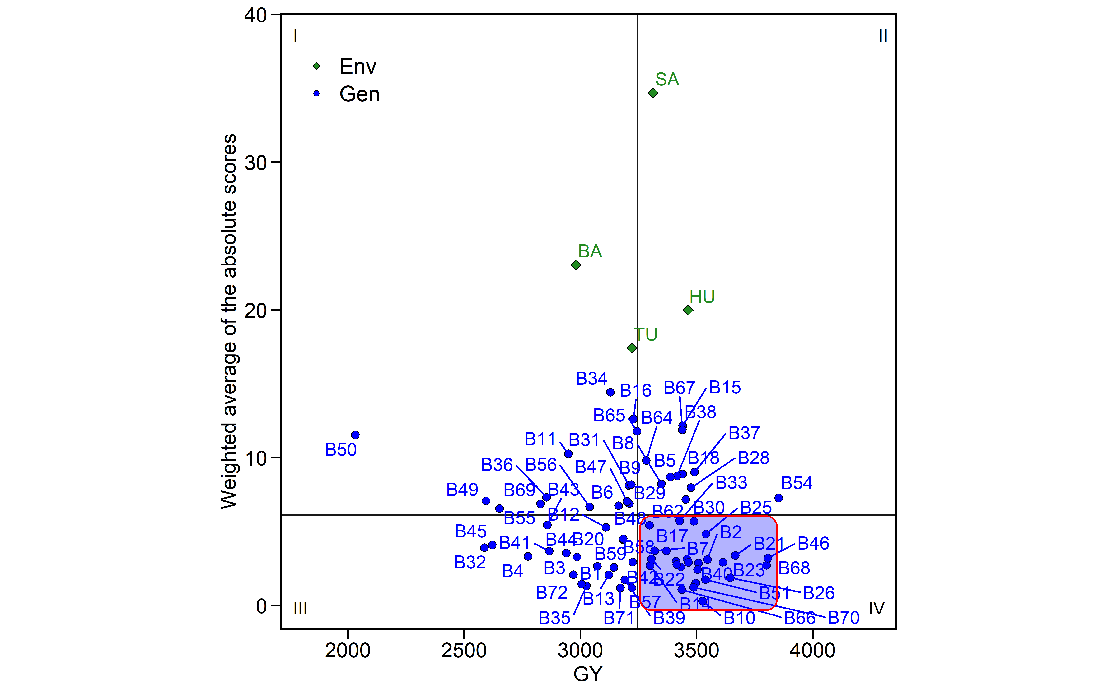

waasb_model_meanWaasb<-mean(waasb_model$WAASB)  
waasb_model_meanY<-mean(waasb_model$Y)  
  
selected <- waasb_model %>%  
 dplyr::filter(Y >= waasb_model_meanY & WAASB <= waasb_model_meanWaasb)   
  
selected_table <- selected  
  
if (knitr::is_html_output()) {  
  
 print_table(selected_table)  
   
}else{  
   
 selected_table[,1:8]   
}

| **type** | **Code** | **Y** | **PC1** | **PC2** | **PC3** | **WAASB** | **PctResp** |
| --- | --- | --- | --- | --- | --- | --- | --- |
| **character** | **character** | **numeric** | **numeric** | **numeric** | **numeric** | **numeric** | **numeric** |
| GEN | B14 | 3,299.5 | 1.7 | 4.6 | 3.1 | 2.7 | 69.6 |
| GEN | B19 | 3,369.1 | -0.5 | -8.0 | -7.6 | 3.7 | 73.4 |
| GEN | B21 | 3,665.5 | 5.0 | 0.9 | -1.8 | 3.4 | 89.7 |
| GEN | B22 | 3,305.2 | -2.3 | -2.2 | -7.5 | 3.2 | 69.9 |
| GEN | B25 | 3,539.1 | 4.7 | 8.2 | -0.2 | 4.8 | 82.8 |
| GEN | B26 | 3,644.3 | 0.9 | 3.2 | -3.1 | 1.9 | 88.5 |
| GEN | B51 | 3,537.4 | -2.4 | 1.3 | -0.3 | 1.7 | 82.7 |
| GEN | B52 | 3,458.7 | -4.3 | 2.3 | -0.5 | 3.1 | 78.4 |
| GEN | B53 | 3,507.4 | -3.4 | 2.1 | 2.3 | 2.9 | 81.0 |
| n: 26 | | | | | | | |

#selected$Code

#### 4.1.5.1 Selection differentials

#Create a data frame with BLUPS - selected and non-selected  
blups_sel <-  
 gmd(waasb_model_bb, "blupge") %>%  
 add_cols(SELECTED = ifelse(GEN %in% selected$Code, "yes", "no")) %>%   
 dplyr::rename(BLUPs_sel = yield) %>%   
 droplevels()  
  
blups_sel_mean<-  
 gmd(waasb_model_bb, "blupge") %>%  
 add_cols(SELECTED = ifelse(GEN %in% selected$Code, "yes", "no")) %>%   
 filter(SELECTED == "yes") %>%   
 dplyr::summarise(mean_GY = mean(yield,na.rm = TRUE), n = n())   
  
# Create a data frame with the waasb index - selected and non-selected  
waasb_sel <-  
 gmd(waasb_model_bb, "WAASB") %>%  
 add_cols(SELECTED = ifelse(GEN %in% selected$Code, "yes", "no")) %>%   
 dplyr::rename(WAASB_sel = yield) %>%   
 droplevels()  
#str(waasb_sel)  
  
waasb_sel_mean<-  
 gmd(waasb_model_bb, "WAASB") %>%  
 add_cols(SELECTED = ifelse(GEN %in% selected$Code, "yes", "no")) %>%   
 filter(SELECTED == "yes") %>%   
 dplyr::summarise(mean_GY = mean(yield,na.rm = TRUE), n = n())   
  
p1<- plot_selected(blups_sel, GEN, BLUPs_sel, mean_sel = blups_sel_mean$mean_GY) +  
 labs(y = "GY")  
  
p3<- plot_selected(waasb_sel, GEN, WAASB_sel, mean_sel = waasb_sel_mean$mean_GY) +  
 labs(y = "WAASB index")  
  
arrange_ggplot(p1, p3,  
 guides = "collect",  
 tag_levels = "a",  
 tag_prefix = "(",  
 tag_suffix = ")")

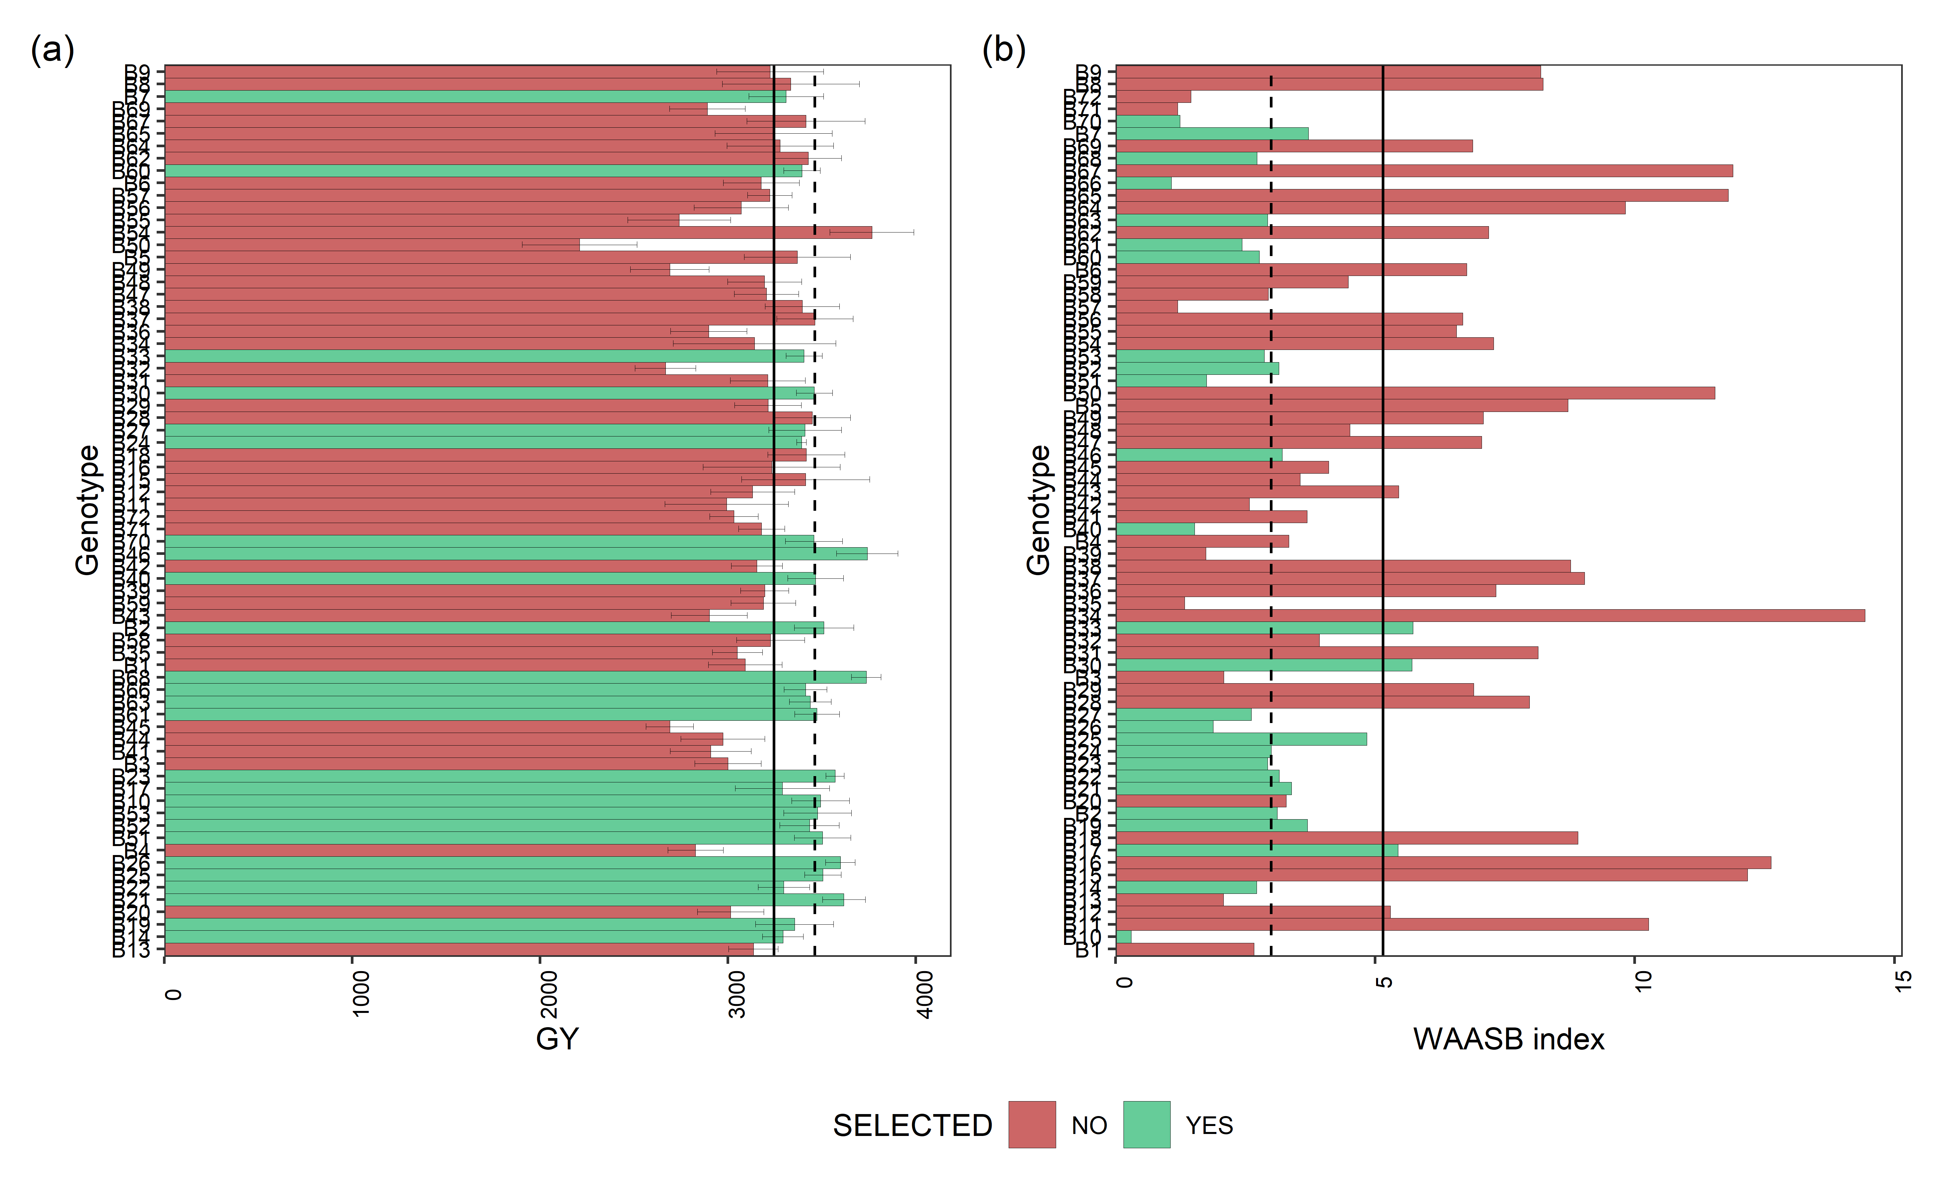

Mean performance (a) and stability (b) for grain yield (GY) of 72 Black beans genotypes. The vertical dashed and solid lines shows, respectivelly, the mean of the selected genotype and the overall mean for both mean performance and WAASB index

Percentage (SD_gain in %) gain from the selected genotypes compared to the general mean.

blups_sel2 <-  
 gmd(waasb_model_bb, "blupg") %>%  
 add_cols(SELECTED = ifelse(GEN %in% selected$Code, "yes", "no")) %>%   
 dplyr::rename(BLUPs_sel = yield) %>%   
 droplevels()

#> Class of the model: waasb

#> Variable extracted: blupg

blups_sel_mean2<-  
 gmd(waasb_model_bb, "blupg") %>%  
 add_cols(SELECTED = ifelse(GEN %in% selected$Code, "yes", "no")) %>%   
 filter(SELECTED == "yes") %>%   
 dplyr::summarise(mean_GY = mean(yield,na.rm = TRUE), n = n())

#> Class of the model: waasb  
#> Variable extracted: blupg

SD_blups<- as_tibble((blups_sel_mean2$mean_GY/mean(blups_sel2$BLUPs_sel, na.rm = T)) -1)*100  
SD_WAASP<- as_tibble((waasb_sel_mean$mean_GY /mean(waasb_sel$WAASB_sel, na.rm = T)) -1)*100  
  
SD_comb<- full_join(SD_blups, SD_WAASP, by = "value") %>%   
 dplyr::rename(SD_gain = value) %>%   
 tibble::add_column(Comp_name = c('BLUPs', 'WAASB')) %>%   
 relocate(Comp_name)  
  
SD_comb$n_selected<- blups_sel_mean2$n  
SD_comb

| **Comp_name** | **SD_gain** | **n_selected** |
| --- | --- | --- |
| **character** | **numeric** | **integer** |
| BLUPs | 3.7 | 26 |
| WAASB | -41.9 | 26 |

blups_sel2$mean_blup <- mean(blups_sel2$BLUPs_sel, na.rm = T)  
waasb_sel$mean_waasb <- mean(waasb_sel$WAASB_sel, na.rm = T)  
  
#str(waasb_sel)  
data_comb<- merge(blups_sel2, waasb_sel, by = c("GEN", "SELECTED"))  
#names(data_comb)  
## SD for each genotype  
data_sel_perc <- data_comb %>%  
 rowwise %>%  
 mutate(Perc_blup_gain = ((BLUPs_sel/mean_blup)*100)-100) %>%   
 mutate(Perc_WAASB_gain = ((WAASB_sel/mean_waasb)*100)-100) %>%   
 as_tibble()  
  
# data_sel_perc_mean <- data_sel_perc %>%   
# dplyr::filter(SELECTED == "yes")  
#   
# mean(data_sel_perc_mean$Perc_blup_gain)  
  
if (knitr::is_html_output()) {  
   
print_table(data_sel_perc)  
   
}else{  
   
data_sel_perc[,1:7]  
}

| **GEN** | **SELECTED** | **BLUPs_sel** | **mean_blup** | **WAASB_sel** | **mean_waasb** | **Perc_blup_gain** |
| --- | --- | --- | --- | --- | --- | --- |
| **character** | **character** | **numeric** | **numeric** | **numeric** | **numeric** | **numeric** |
| B1 | no | 3,173.6 | 3,255.1 | 2.7 | 5.2 | -2.5 |
| B10 | yes | 3,391.1 | 3,255.1 | 0.3 | 5.2 | 4.2 |
| B11 | no | 3,110.5 | 3,255.1 | 10.3 | 5.2 | -4.4 |
| B12 | no | 3,185.4 | 3,255.1 | 5.3 | 5.2 | -2.1 |
| B13 | no | 3,197.5 | 3,255.1 | 2.1 | 5.2 | -1.8 |
| B14 | yes | 3,282.6 | 3,255.1 | 2.7 | 5.2 | 0.8 |
| B15 | no | 3,337.8 | 3,255.1 | 12.2 | 5.2 | 2.5 |
| B16 | no | 3,240.1 | 3,255.1 | 12.6 | 5.2 | -0.5 |
| B17 | yes | 3,281.1 | 3,255.1 | 5.4 | 5.2 | 0.8 |
| n: 72 | | | | | | |

data_sel_perc<- data_sel_perc %>%   
 dplyr::relocate(GEN,SELECTED,BLUPs_sel,mean_blup,Perc_blup_gain,  
 WAASB_sel,mean_waasb ,Perc_WAASB_gain)  
  
#write.xlsx(data_sel_perc, "./data/sel_SD_bb_2.xlsx")  
  
data_sel_perc2 <- data_sel_perc %>%   
 dplyr::select(GEN,SELECTED, BLUPs_sel, WAASB_sel, Perc_blup_gain, Perc_WAASB_gain)  
  
data_sel_perc2

| **GEN** | **SELECTED** | **BLUPs_sel** | **WAASB_sel** | **Perc_blup_gain** | **Perc_WAASB_gain** |
| --- | --- | --- | --- | --- | --- |
| **character** | **character** | **numeric** | **numeric** | **numeric** | **numeric** |
| B1 | no | 3,173.6 | 2.7 | -2.5 | -48.3 |
| B10 | yes | 3,391.1 | 0.3 | 4.2 | -94.2 |
| B11 | no | 3,110.5 | 10.3 | -4.4 | 99.3 |
| B12 | no | 3,185.4 | 5.3 | -2.1 | 2.7 |
| B13 | no | 3,197.5 | 2.1 | -1.8 | -59.6 |
| B14 | yes | 3,282.6 | 2.7 | 0.8 | -47.3 |
| B15 | no | 3,337.8 | 12.2 | 2.5 | 136.2 |
| B16 | no | 3,240.1 | 12.6 | -0.5 | 145.1 |
| B17 | yes | 3,281.1 | 5.4 | 0.8 | 5.6 |
| n: 72 | | | | | |

##BLUPs indexes  
stab_blups_bb<- blup_indexes(waasb_model_bb)   
stab_blups_bb<- as_tibble(stab_blups_bb$yield)  
  
data_waasby <- waasb_model_bb$yield$model %>%   
 dplyr::filter(type != "ENV") %>%   
 dplyr::select("Code", "WAASBY", "OrWAASBY") %>%   
 dplyr::rename(GEN = Code)  
  
stab_blups_bb<- stab_blups_bb %>%   
 full_join(data_waasby, by = "GEN")  
  
if (knitr::is_html_output()) {  
   
print_table(stab_blups_bb)  
   
}else{  
   
stab_blups_bb[,1:8]  
}

| **GEN** | **Y** | **HMGV** | **HMGV_R** | **RPGV** | **RPGV_Y** | **RPGV_R** | **HMRPGV** |
| --- | --- | --- | --- | --- | --- | --- | --- |
| **character** | **numeric** | **numeric** | **numeric** | **numeric** | **numeric** | **numeric** | **numeric** |
| B1 | 3,122.0 | 3,048.9 | 54 | 1.0 | 3,083.2 | 55 | 0.9 |
| B10 | 3,299.5 | 3,473.1 | 10 | 1.1 | 3,489.4 | 10 | 1.1 |
| B11 | 3,369.1 | 2,884.2 | 62 | 0.9 | 2,986.8 | 61 | 0.9 |
| B12 | 2,984.7 | 3,083.1 | 53 | 1.0 | 3,121.1 | 54 | 1.0 |
| B13 | 3,665.5 | 3,118.1 | 52 | 1.0 | 3,136.3 | 52 | 1.0 |
| B14 | 3,305.2 | 3,282.3 | 32 | 1.0 | 3,295.9 | 35 | 1.0 |
| B15 | 3,539.1 | 3,310.4 | 30 | 1.1 | 3,419.2 | 23 | 1.0 |
| B16 | 3,644.3 | 3,128.3 | 51 | 1.0 | 3,228.3 | 40 | 1.0 |
| B17 | 2,774.6 | 3,232.1 | 35 | 1.0 | 3,278.4 | 37 | 1.0 |
| n: 72 | | | | | | | |

# library(openxlsx)  
# write.xlsx(stab_blups_bb, "./data/blups_bb_2.xlsx")

#### 4.1.5.2 Scenarios of waasby estimation

Planning different scenarios of waasby estimation by changing the weights assigned to the stability and the mean performance according to [Olivoto et al. (2019)](Olivoto%20et%20al.,%202019a)

scenarios <- wsmp(waasb_model_bb,progbar = F)  
  
scen1<- plot(scenarios, type = 1) +   
 theme(axis.text.y = element_text(size=8))  
  
scen2<-plot(scenarios, type = 2) +  
 theme(axis.text.y = element_text(size=8))  
  
arrange_ggplot(scen1, scen2,  
 guides = "collect",  
 legend.position = "right",  
 tag_levels = "a",  
 tag_prefix = "(",  
 tag_suffix = ")")

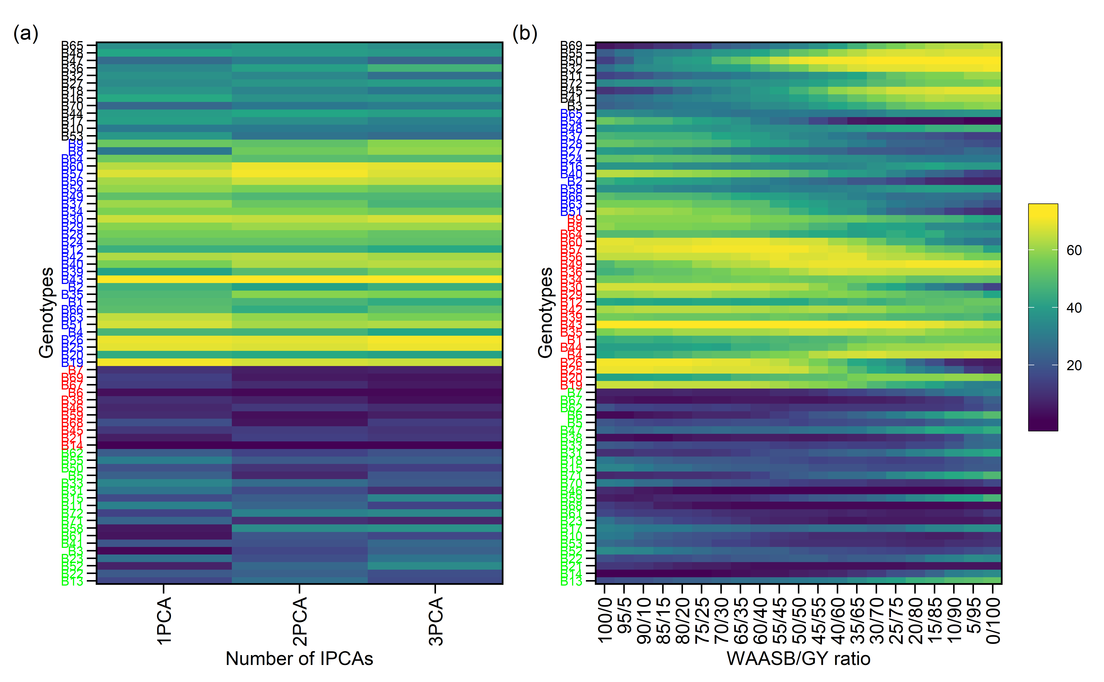

#### 4.1.5.3 Coincidence index of genotype selection

Computes the coincidence index (Hamblin and Zimmermann, 1986) as follows:

where *A* is the number of selected genotypes common to different methods; *C* is the number of expected genotypes selected by chance; and *M* is the number of genotypes selected according to the selection intensity.

coinc_1 <- stab_blups_bb %>% dplyr::select(GEN,HMRPGV_R) %>% arrange(HMRPGV_R)  
coinc_2 <- stab_blups_bb %>% dplyr::select(GEN,RPGV_R) %>% arrange(RPGV_R)  
coinc_3 <- stab_blups_bb %>% dplyr::select(GEN,HMGV_R) %>% arrange(HMGV_R)  
coinc_4 <- stab_blups_bb %>% dplyr::select(GEN,OrWAASBY) %>% arrange(OrWAASBY)  
coinc_5 <- stab_blups_bb %>% dplyr::select(GEN,WAASB_R) %>% arrange(WAASB_R)  
  
selc_perc<- round(nrow(stab_blups_bb)*0.2)  
  
coinc_1.1 <-1  
coinc_1.2 <- coincidence_index(sel1 = coinc_1$GEN[1:selc_perc],   
 sel2 = coinc_2$GEN[1:selc_perc],   
 total = 72)/100  
coinc_1.3 <- coincidence_index(sel1 = coinc_1$GEN[1:selc_perc],   
 sel2 = coinc_3$GEN[1:selc_perc],   
 total = 72)/100  
coinc_1.4 <- coincidence_index(sel1 = coinc_1$GEN[1:selc_perc],   
 sel2 = coinc_4$GEN[1:selc_perc],   
 total = 72)/100  
coinc_1.5 <- coincidence_index(sel1 = coinc_1$GEN[1:selc_perc],   
 sel2 = coinc_5$GEN[1:selc_perc],   
 total = 72)/100  
coinc_2.2 <-1  
coinc_2.3 <- coincidence_index(sel1 = coinc_2$GEN[1:selc_perc],   
 sel2 = coinc_3$GEN[1:selc_perc],   
 total = 72)/100  
coinc_2.4 <- coincidence_index(sel1 = coinc_2$GEN[1:selc_perc],   
 sel2 = coinc_4$GEN[1:selc_perc],   
 total = 72)/100  
coinc_2.5 <- coincidence_index(sel1 = coinc_2$GEN[1:selc_perc],   
 sel2 = coinc_5$GEN[1:selc_perc],   
 total = 72)/100  
coinc_3.3<- 1  
coinc_3.4 <- coincidence_index(sel1 = coinc_3$GEN[1:selc_perc],   
 sel2 = coinc_4$GEN[1:selc_perc],   
 total = 72)/100  
coinc_3.5 <- coincidence_index(sel1 = coinc_3$GEN[1:selc_perc],   
 sel2 = coinc_5$GEN[1:selc_perc],   
 total = 72)/100  
coinc_4.4 <- 1  
coinc_4.5 <- coincidence_index(sel1 = coinc_4$GEN[1:selc_perc],   
 sel2 = coinc_5$GEN[1:selc_perc],   
 total = 72)/100  
coinc_5.5 <- 1  
  
  
coinc<- c(coinc_1.1,coinc_1.2,coinc_2.2,coinc_1.3,coinc_2.3,  
 coinc_3.3,coinc_1.4, coinc_2.4, coinc_3.4,  
 coinc_4.4, coinc_1.5, coinc_2.5,  
 coinc_3.5, coinc_4.5,  
 coinc_5.5)  
   
z=matrix(0,5,5)  
z[upper.tri(z)| row(z)==col(z)] <- coinc  
  
rownames(z)=c(  
"HMRPGV",  
"RPGV",  
'HMGV',  
'WAASBY',  
'WAASB')  
  
colnames(z)=rownames(z)  
  
plotBB<- ggcorrplot(z, colors = c("#6D9EC1", "gray" ,"#E46726"),   
 show.legend = T,  
legend.title = "CI" ,lab_size=5,tl.srt = 90,type = c("upper"), lab = T,digits = 4,  
outline.color = "white",pch.col = "white", tl.col = "blue",show.diag = F) +  
 labs(title = "BLUP-based stability indexes coincidence at BB",  
 subtitle = "Selection intensity of 20% top genotypes")  
  
print(plotBB)

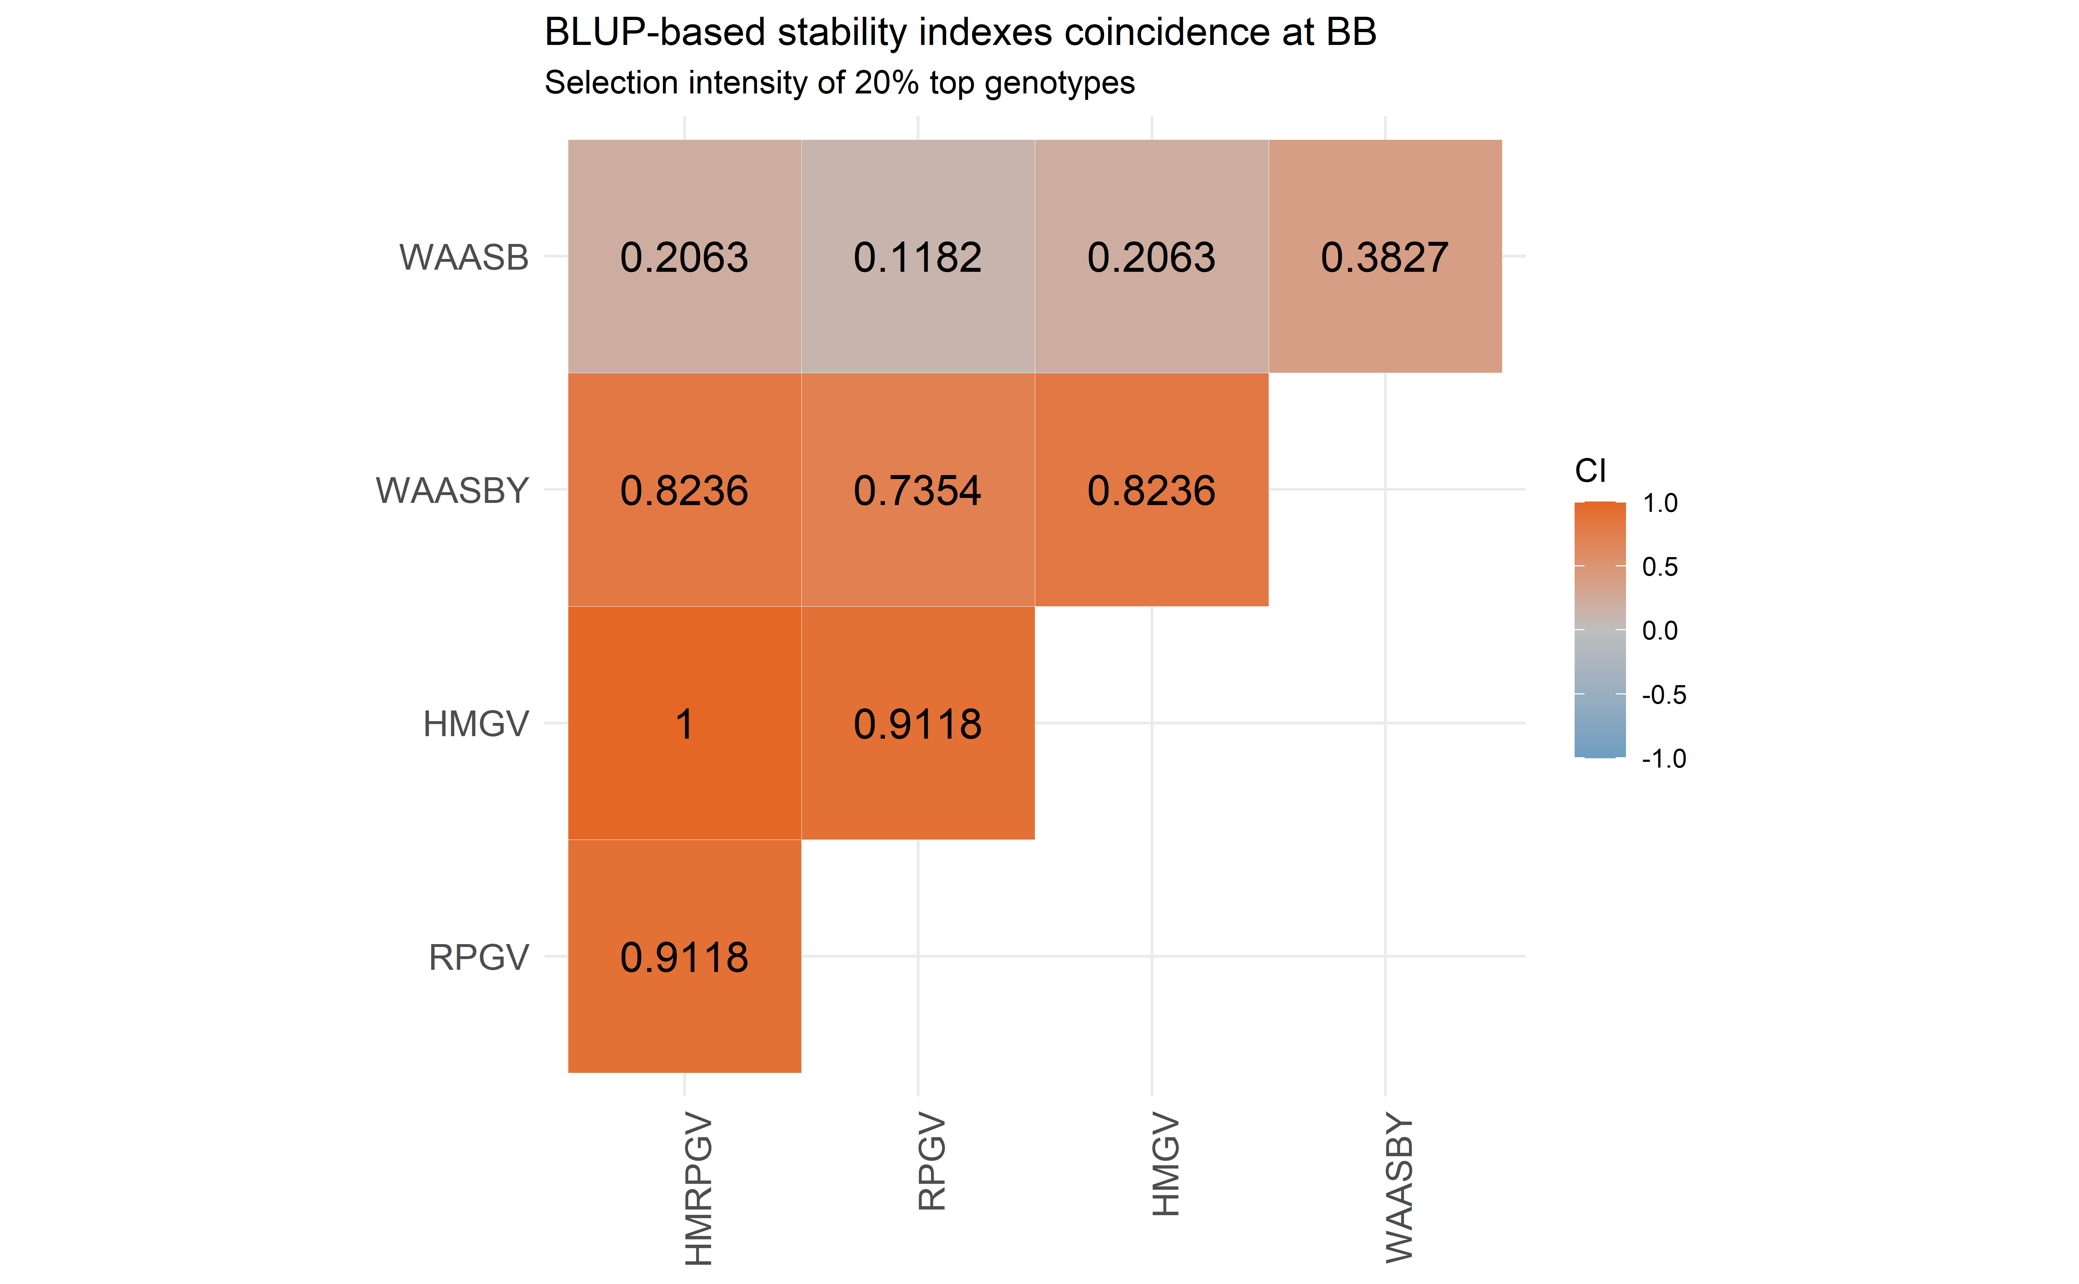

## 4.2 MET analysis - **Navy beans**

### 4.2.1 MET analysis - ASReml

Running MET using ASReml - only to comparison of variance components with metan outputs

mod.met.asreml.nb1 <- asreml(fixed = yield ~ loc + loc:rep,  
 random = ~ name + name:loc,  
 data = blues_stage.I_NB,  
 predict = predict.asreml(classify = "name"),  
 trace = F,  
 maxit = 500)  
  
summFix.nb.met.asreml<- data.frame(wald(mod.met.asreml.nb1))  
summFix.nb.met.asreml

| **Df** | **Sum.of.Sq** | **Wald.statistic** | **Pr.Chisq.** |
| --- | --- | --- | --- |
| **numeric** | **numeric** | **numeric** | **numeric** |
| 1 | 1,636,916,005 | 9,420.3 | 0 |
| 3 | 11,631,057 | 66.9 | 0 |
| 12 | 20,821,488 | 119.8 | 0 |
|  | 173,765 |  |  |

summ.nb.met.asreml<- data.frame(summary.asreml(mod.met.asreml.nb1)$varcomp)  
summ.nb.met.asreml

| **component** | **std.error** | **z.ratio** | **bound** | **X.ch** |
| --- | --- | --- | --- | --- |
| **numeric** | **numeric** | **numeric** | **character** | **numeric** |
| 34,501.8 | 11,258.8 | 3.1 | P | 0 |
| 72,760.9 | 11,918.4 | 6.1 | P | 0 |
| 173,765.2 | 8,797.2 | 19.8 | P | 0 |

#print(summary.asreml(mod.met.asreml.nb1)$bic)  
mod.met.asreml.nb<- data.table((mod.met.asreml.nb1$predictions$pvals[1:3]))  
names(mod.met.asreml.nb) <- c("name", "yield_BLUPS_MET", "SE")  
  
###

### 4.2.2 MET analysis - lme4

Running MET using metan R package [Olivoto et al. (2019)](Olivoto%20et%20al.,%202019a).

#str(blues_stage.I_NB)  
mixed_mod.nb<-   
 gamem_met(blues_stage.I_NB,  
 env = loc,  
 gen = name,  
 rep = rep,  
 resp = yield,  
 random = "gen", #Default  
 verbose = TRUE) #Default

Evaluating trait yield |===============================================================================| 100% 00:00:01

#> Method: REML/BLUP

#> Random effects: GEN, GEN:ENV

#> Fixed effects: ENV, REP(ENV)

#> Denominador DF: Satterthwaite's method

| P-values for Likelihood Ratio Test of the analyzed traits |
| --- |
| model yield COMPLETE NA GEN 3.41e-05 GEN:ENV 6.69e-20 |

All variables with significant (p < 0.05) genotype-vs-environment interaction

### 4.2.3 Printing the model outputs

#### 4.2.3.1 Likelihood Ratio Tests

The output LRT contains the Likelihood Ratio Tests for genotype and genotype-vs-environment random effects.

data_mod_nb_test <- get_model_data(mixed_mod.nb, "lrt")

#> Class of the model: waasb

#> Variable extracted: lrt

data_mod_nb_test

| **VAR** | **model** | **npar** | **logLik** | **AIC** | **LRT** | **Df** | **Pr(>Chisq)** |
| --- | --- | --- | --- | --- | --- | --- | --- |
| **character** | **character** | **integer** | **numeric** | **numeric** | **numeric** | **numeric** | **numeric** |
| yield | GEN | 18 | -8,123.2 | 16,282.4 | 17.2 | 1 | 0.0 |
| yield | GEN:ENV | 18 | -8,156.3 | 16,348.7 | 83.4 | 1 | 0.0 |

#customize the display of numbers and other data in a tibble  
# old <- options(pillar.sigfig = 6)  
#   
# blues_stage.I_NB %>%  
# group_by(loc) %>%  
# dplyr::summarise(Mean = mean(yield, na.rm = TRUE))

#### 4.2.3.2 Detailed parameters

data_mod_nb_det <- get_model_data(mixed_mod.nb, "details")

#> Class of the model: waasb

#> Variable extracted: details

data_mod_nb_det

| **Parameters** | **yield** |
| --- | --- |
| **character** | **character** |
| Mean | 2924 |
| SE | 17.22 |
| SD | 565.35 |
| CV | 19.34 |
| Min | 1096.13 (N32 in BA) |
| Max | 4939.4 (N34 in TU) |
| MinENV | BA (2654.03) |
| MaxENV | HU (3094) |
| MinGEN | N28 (2260.58) |
| n: 12 | |

#### 4.2.3.3 Random effects

The output LRT contains the Likelihood Ratio Tests for genotype and genotype-vs-environment random effects.

old <- options(pillar.sigfig = 8)  
  
data_mod_nb_var <- get_model_data(mixed_mod.nb, "vcomp")

#> Class of the model: waasb

#> Variable extracted: vcomp

data_mod_nb_var

| **Group** | **yield** |
| --- | --- |
| **character** | **numeric** |
| GEN | 34,502.1 |
| GEN:ENV | 72,760.9 |
| Residual | 173,765.0 |

#### 4.2.3.4 Variance components and genetic parameters

old <- options(pillar.sigfig = 4)  
  
data_mod_nb_comp <- get_model_data(mixed_mod.nb)

#> Class of the model: waasb

#> Variable extracted: genpar

data_mod_nb_comp

| **Parameters** | **yield** |
| --- | --- |
| **character** | **numeric** |
| Phenotypic variance | 281,028.0 |
| Heritability | 0.1 |
| GEIr2 | 0.3 |
| h2mg | 0.5 |
| Accuracy | 0.7 |
| rge | 0.3 |
| CVg | 6.4 |
| CVr | 14.3 |
| CV ratio | 0.4 |

### 4.2.4 MET - GGE biplot

Genotype plus Genotype-vs-Environment interaction (GGE). Mega-environment identification in multi-environment trials (MET) according to [(**W?**). Yan et al. 2007](link%20here)

#### 4.2.4.1 GGE ENV biplot

GGE biplot done using:

* **sd**: each value is divided by the standard deviation of its corresponding environment.
* **environment**: environment-centered (G+GE)
* **environment**: singular value is entirely partitioned into the environment eigenvectors, also called column metric preserving

gge_model.nb <- gge(blues_stage.I_NB, loc, name, yield,   
 centering = "environment", #1  
 scaling = "sd", #2  
 svp = "environment")#2  
  
a <- plot(gge_model.nb, type=4,  
 size.text.env = 4.5,  
 plot_theme = theme_metan(grid = "both",color.background = transparent_color()),  
 axis_expand = 1.5,  
 col.alpha.circle = 0.8,  
 shape.gen = NA,  
 col.gen = NA,  
 size.text.lab = NA,  
 size.text.gen = NA,  
 leg.lab=c('Env')  
 #title = FALSE  
 )  
  
  
gge_model.nb <- gge(blues_stage.I_NB, loc, name, yield,  
 centering = "environment", #1  
 scaling = "sd", #2Y  
 svp = "environment")#2)  
  
b <- plot(gge_model.nb, type = 6,  
 size.text.env = 5,  
 plot_theme = theme_metan(grid = "both",color.background = transparent_color()),  
 axis_expand = 1.5,  
 # col.alpha.circle = 100,  
 col.alpha.circle = 0.8,  
 size.text.lab = 13  
 #title = FALSE  
 )  
  
 arrange_ggplot(a, b,  
 guides = "collect",  
 tag_levels = "a",  
 tag_prefix = "(",  
 tag_suffix = ")")

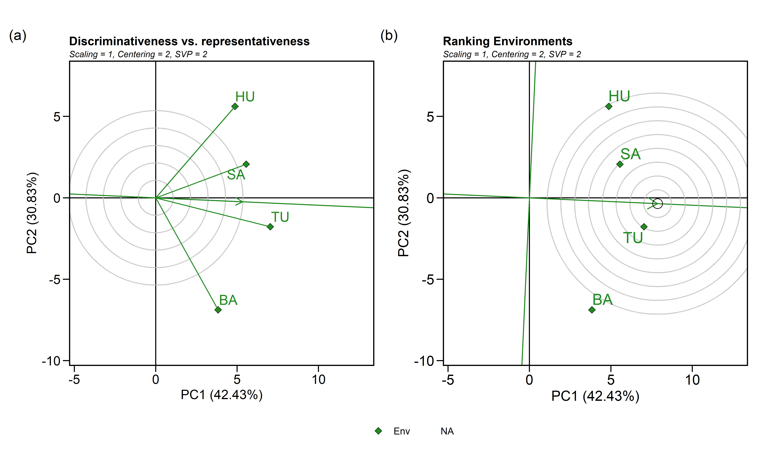

#### 4.2.4.2 Biplot type 3: Which-won-where

GGE biplot done using:

* **sd**: each value is divided by the standard deviation of its corresponding environment.
* **environment**: environment-centered (G+GE)
* **genotype**: singular value is entirely partitioned into the environment eigenvectors, also called column metric preserving

gge_model.nb <- gge(blues_stage.I_NB, loc, name, yield,  
 centering = "environment", #2  
 scaling = "sd", #1  
 svp = "genotype")#2)  
  
e <- plot(gge_model.nb, type = 3,  
 size.text.env = 5,  
 plot_theme = theme_metan(grid = "both",color.background = transparent_color()),  
 axis_expand = 1.2,  
 size.line = 0.7,  
 size.text.gen = 4,  
 size.text.win = 4.5  
 #title = FALSE  
  
 )  
  
print(e)

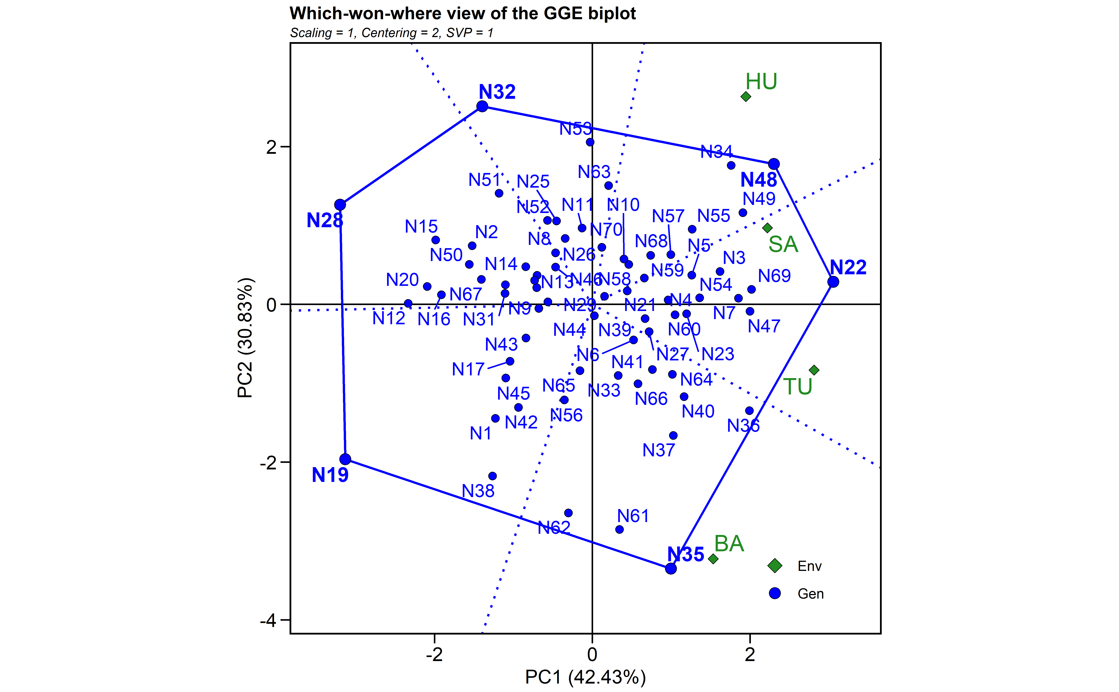

### 4.2.5 Mean performance and stability analysis

WAASP index and BLUPs to estimate stability analysis.

waasb_model_nb <-   
 waasb(blues_stage.I_NB,  
 env = loc,  
 gen = name,  
 rep = rep,  
 resp = yield,  
 random = "gen", #Default  
 verbose = TRUE,  
 wresp = 60) #weight for response variable 60 and 40 for yielding and stability, respectively)

#> Evaluating trait yield |===============================================================================| 100% 00:00:02   
#> ---------------------------------------------------------------------------  
#> P-values for Likelihood Ratio Test of the analyzed traits  
#> ---------------------------------------------------------------------------  
#> model yield  
#> COMPLETE NA  
#> GEN 3.41e-05  
#> GEN:ENV 6.69e-20  
#> ---------------------------------------------------------------------------  
#> All variables with significant (p < 0.05) genotype-vs-environment interaction

waasb_model<- waasb_model_nb$yield$model  
  
waasp_plot <- plot_scores(waasb_model_nb, type = 3,  
 title = FALSE,  
 size.tex.gen = 4,  
 size.tex.env = 4,  
 size.tex.lab = 13,  
 # highlight = c("N38", "N6" , "N61", "N35" ,"N52", "N22"),  
 plot_theme = theme_metan(grid = "both",color.background = transparent_color())  
 ) +  
   
 geom_mark_rect(aes(filter = Code %in% c("N70", "N37", "N69", "N60"),  
 ),  
 label.fontsize = 10,  
 show.legend = F,  
 con.cap = 0,  
 con.colour = "red",  
 color = "red",  
 expand = 0.005,  
 label.buffer = unit(10, "cm"))+  
#theme_gray()+  
theme(legend.position = c(0.1, 0.9),  
 legend.background = element_blank(),  
 legend.title = element_blank(),  
 aspect.ratio = 1) +  
 labs(x = "GY")  
print(waasp_plot)

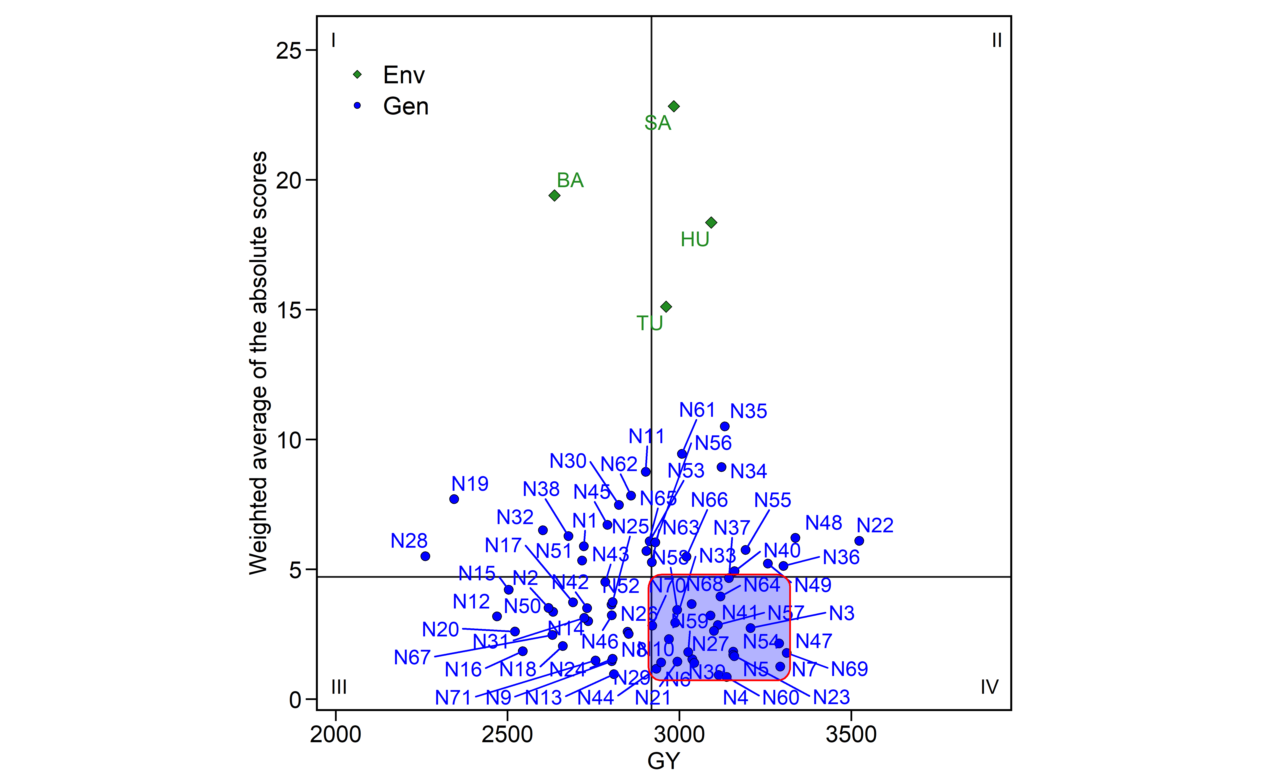

waasb_model_meanWaasb<-mean(waasb_model$WAASB)  
waasb_model_meanY<-mean(waasb_model$Y)  
  
selected <- waasb_model %>%  
 dplyr::filter(Y >= waasb_model_meanY & WAASB <= waasb_model_meanWaasb)   
  
selected_table <- selected   
  
if (knitr::is_html_output()) {  
   
 print_table(selected_table)  
   
}else{  
   
selected_table[,1:8]  
}

| **type** | **Code** | **Y** | **PC1** | **PC2** | **PC3** | **WAASB** | **PctResp** |
| --- | --- | --- | --- | --- | --- | --- | --- |
| **character** | **character** | **numeric** | **numeric** | **numeric** | **numeric** | **numeric** | **numeric** |
| GEN | N37 | 3,143.7 | -8.6 | 0.3 | 1.9 | 4.7 | 70.0 |
| GEN | N39 | 3,037.0 | -1.1 | -1.3 | 3.0 | 1.5 | 61.5 |
| GEN | N41 | 3,090.0 | -3.0 | 4.8 | 1.4 | 3.2 | 65.7 |
| GEN | N58 | 2,993.3 | 3.7 | 3.3 | 3.1 | 3.4 | 58.0 |
| GEN | N64 | 3,118.8 | -5.3 | -2.7 | 2.7 | 4.0 | 68.0 |
| GEN | N10 | 2,969.3 | 3.1 | -0.3 | 3.4 | 2.3 | 56.1 |
| GEN | N21 | 2,993.8 | -0.1 | -3.8 | 1.3 | 1.5 | 58.1 |
| GEN | N33 | 2,987.3 | -4.9 | -0.9 | 1.3 | 2.9 | 57.6 |
| GEN | N3 | 3,206.6 | 2.1 | -1.5 | 6.2 | 2.7 | 74.9 |
| n: 25 | | | | | | | |

#selected$Code

#### 4.2.5.1 Selection differentials

#Create a data frame with BLUPS - selected and non-selected  
blups_sel <-  
 gmd(waasb_model_nb, "blupge") %>%  
 add_cols(SELECTED = ifelse(GEN %in% selected$Code, "yes", "no")) %>%   
 dplyr::rename(BLUPs_sel = yield) %>%   
 droplevels()  
  
blups_sel_mean<-  
 gmd(waasb_model_nb, "blupge") %>%  
 add_cols(SELECTED = ifelse(GEN %in% selected$Code, "yes", "no")) %>%   
 filter(SELECTED == "yes") %>%   
 dplyr::summarise(mean_GY = mean(yield,na.rm = TRUE), n = n())   
  
# Create a data frame with the waasb index - selected and non-selected  
waasb_sel <-  
 gmd(waasb_model_nb, "WAASB") %>%  
 add_cols(SELECTED = ifelse(GEN %in% selected$Code, "yes", "no")) %>%   
 dplyr::rename(WAASB_sel = yield) %>%   
 droplevels()  
#str(waasb_sel)  
  
waasb_sel_mean<-  
 gmd(waasb_model_nb, "WAASB") %>%  
 add_cols(SELECTED = ifelse(GEN %in% selected$Code, "yes", "no")) %>%   
 filter(SELECTED == "yes") %>%   
 dplyr::summarise(mean_GY = mean(yield,na.rm = TRUE), n = n())   
  
p1<- plot_selected(blups_sel, GEN, BLUPs_sel, mean_sel = blups_sel_mean$mean_GY) +  
 labs(y = "GY")  
  
p3<- plot_selected(waasb_sel, GEN, WAASB_sel, mean_sel = waasb_sel_mean$mean_GY) +  
 labs(y = "WAASB index")  
  
arrange_ggplot(p1, p3,  
 guides = "collect",  
 tag_levels = "a",  
 tag_prefix = "(",  
 tag_suffix = ")")

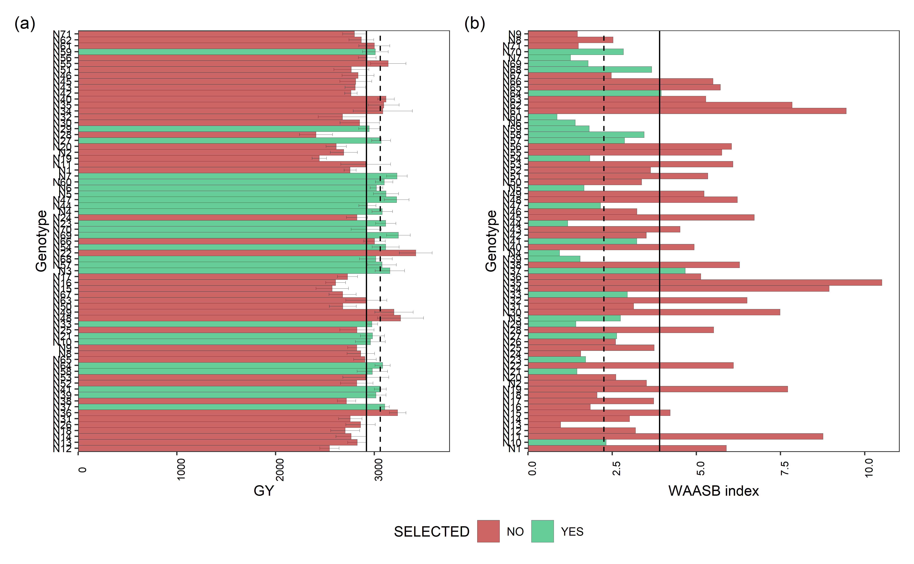

Mean performance (a) and stability (b) for grain yield (GY) of 71 Navy beans genotypes. The vertical dashed and solid lines shows, respectivelly, the mean of the selected genotype and the overall mean for both mean performance and WAASB index

Percentage (SD_gain in %) gain from the selected genotypes compared to the general mean.

blups_sel2 <-  
 gmd(waasb_model_nb, "blupg") %>%  
 add_cols(SELECTED = ifelse(GEN %in% selected$Code, "yes", "no")) %>%   
 dplyr::rename(BLUPs_sel = yield) %>%   
 droplevels()

#> Class of the model: waasb

#> Variable extracted: blupg

blups_sel_mean2<-  
 gmd(waasb_model_nb, "blupg") %>%  
 add_cols(SELECTED = ifelse(GEN %in% selected$Code, "yes", "no")) %>%   
 filter(SELECTED == "yes") %>%   
 dplyr::summarise(mean_GY = mean(yield,na.rm = TRUE), n = n())

#> Class of the model: waasb  
#> Variable extracted: blupg

SD_blups<- as_tibble((blups_sel_mean2$mean_GY/mean(blups_sel2$BLUPs_sel, na.rm = T)) -1)*100  
SD_WAASP<- as_tibble((waasb_sel_mean$mean_GY /mean(waasb_sel$WAASB_sel, na.rm = T)) -1)*100  
  
SD_comb<- full_join(SD_blups, SD_WAASP, by = "value") %>%   
 dplyr::rename(SD_gain = value) %>%   
 tibble::add_column(Comp_name = c('BLUPs', 'WAASB')) %>%   
 relocate(Comp_name)  
  
SD_comb$n_selected<- blups_sel_mean2$n  
SD_comb

| **Comp_name** | **SD_gain** | **n_selected** |
| --- | --- | --- |
| **character** | **numeric** | **integer** |
| BLUPs | 3.2 | 25 |
| WAASB | -42.4 | 25 |

blups_sel2$mean_blup <- mean(blups_sel2$BLUPs_sel, na.rm = T)  
waasb_sel$mean_waasb <- mean(waasb_sel$WAASB_sel, na.rm = T)  
  
#str(waasb_sel)  
data_comb<- merge(blups_sel2, waasb_sel, by = c("GEN", "SELECTED"))  
#names(data_comb)  
## SD for each genotype  
data_sel_perc <- data_comb %>%  
 rowwise %>%  
 mutate(Perc_blup_gain = ((BLUPs_sel/mean_blup)*100)-100) %>%   
 mutate(Perc_WAASB_gain = ((WAASB_sel/mean_waasb)*100)-100) %>%   
 as_tibble()  
  
# data_sel_perc_mean <- data_sel_perc %>%   
# dplyr::filter(SELECTED == "yes")  
#   
# mean(data_sel_perc_mean$Perc_blup_gain)  
  
if (knitr::is_html_output()) {  
   
 print_table(data_sel_perc)  
   
}else{  
   
data_sel_perc[,1:7]  
}

| **GEN** | **SELECTED** | **BLUPs_sel** | **mean_blup** | **WAASB_sel** | **mean_waasb** | **Perc_blup_gain** |
| --- | --- | --- | --- | --- | --- | --- |
| **character** | **character** | **numeric** | **numeric** | **numeric** | **numeric** | **numeric** |
| N1 | no | 2,820.0 | 2,924.0 | 5.9 | 3.9 | -3.6 |
| N10 | yes | 2,954.6 | 2,924.0 | 2.3 | 3.9 | 1.0 |
| N11 | no | 2,899.6 | 2,924.0 | 8.8 | 3.9 | -0.8 |
| N12 | no | 2,682.8 | 2,924.0 | 3.2 | 3.9 | -8.2 |
| N13 | no | 2,867.6 | 2,924.0 | 1.0 | 3.9 | -1.9 |
| N14 | no | 2,826.9 | 2,924.0 | 3.0 | 3.9 | -3.3 |
| N15 | no | 2,701.3 | 2,924.0 | 4.2 | 3.9 | -7.6 |
| N16 | no | 2,723.6 | 2,924.0 | 1.9 | 3.9 | -6.9 |
| N17 | no | 2,802.9 | 2,924.0 | 3.7 | 3.9 | -4.1 |
| n: 71 | | | | | | |

data_sel_perc<- data_sel_perc %>%   
 dplyr::relocate(GEN,SELECTED,BLUPs_sel,mean_blup,Perc_blup_gain,  
 WAASB_sel,mean_waasb ,Perc_WAASB_gain)  
  
#write.xlsx(data_sel_perc, "./data/sel_SD_nb_2.xlsx")  
  
  
data_sel_perc2 <- data_sel_perc %>%   
 dplyr::select(GEN,SELECTED, BLUPs_sel, WAASB_sel, Perc_blup_gain, Perc_WAASB_gain)  
  
data_sel_perc2

| **GEN** | **SELECTED** | **BLUPs_sel** | **WAASB_sel** | **Perc_blup_gain** | **Perc_WAASB_gain** |
| --- | --- | --- | --- | --- | --- |
| **character** | **character** | **numeric** | **numeric** | **numeric** | **numeric** |
| N1 | no | 2,820.0 | 5.9 | -3.6 | 50.6 |
| N10 | yes | 2,954.6 | 2.3 | 1.0 | -40.6 |
| N11 | no | 2,899.6 | 8.8 | -0.8 | 123.9 |
| N12 | no | 2,682.8 | 3.2 | -8.2 | -18.4 |
| N13 | no | 2,867.6 | 1.0 | -1.9 | -75.2 |
| N14 | no | 2,826.9 | 3.0 | -3.3 | -23.0 |
| N15 | no | 2,701.3 | 4.2 | -7.6 | 7.9 |
| N16 | no | 2,723.6 | 1.9 | -6.9 | -52.7 |
| N17 | no | 2,802.9 | 3.7 | -4.1 | -4.6 |
| n: 71 | | | | | |

##BLUPs indexes  
stab_blups_nb<- blup_indexes(waasb_model_nb)   
stab_blups_nb<- as_tibble(stab_blups_nb$yield)  
  
data_waasby <- waasb_model_nb$yield$model %>%   
 dplyr::filter(type != "ENV") %>%   
 dplyr::select("Code", "WAASBY", "OrWAASBY") %>%   
 dplyr::rename(GEN = Code)  
  
stab_blups_nb<- stab_blups_nb %>%   
 full_join(data_waasby, by = "GEN")  
  
if (knitr::is_html_output()) {  
   
 print_table(stab_blups_nb)  
   
}else{  
   
stab_blups_nb[,1:8]  
}

| **GEN** | **Y** | **HMGV** | **HMGV_R** | **RPGV** | **RPGV_Y** | **RPGV_R** | **HMRPGV** |
| --- | --- | --- | --- | --- | --- | --- | --- |
| **character** | **numeric** | **numeric** | **numeric** | **numeric** | **numeric** | **numeric** | **numeric** |
| N1 | 2,468.6 | 2,750.2 | 55 | 0.9 | 2,764.8 | 55 | 0.9 |
| N10 | 2,809.0 | 2,933.7 | 33 | 1.0 | 2,954.2 | 32 | 1.0 |
| N11 | 2,734.1 | 2,849.5 | 41 | 1.0 | 2,905.1 | 39 | 1.0 |
| N12 | 2,660.6 | 2,533.6 | 69 | 0.9 | 2,545.2 | 69 | 0.9 |
| N13 | 2,848.7 | 2,816.4 | 44 | 1.0 | 2,826.8 | 46 | 1.0 |
| N14 | 2,722.7 | 2,739.4 | 57 | 0.9 | 2,761.4 | 57 | 0.9 |
| N15 | 3,302.2 | 2,541.6 | 68 | 0.9 | 2,566.7 | 68 | 0.9 |
| N16 | 3,143.7 | 2,595.2 | 67 | 0.9 | 2,606.1 | 67 | 0.9 |
| N17 | 2,676.8 | 2,716.8 | 59 | 0.9 | 2,730.8 | 59 | 0.9 |
| n: 71 | | | | | | | |

# library(openxlsx)  
# write.xlsx(stab_blups_nb, "./data/blups_nb_2.xlsx")

#### 4.2.5.2 Scenarios of waasby estimation

Planning different scenarios of waasby estimation by changing the weights assigned to the stability and the mean performance according to [Olivoto et al. (2019)](Olivoto%20et%20al.,%202019a).

scenarios <- wsmp(waasb_model_nb,progbar = F)  
  
scen1<- plot(scenarios, type = 1) +   
 theme(axis.text.y = element_text(size=8))  
  
scen2<-plot(scenarios, type = 2) +  
 theme(axis.text.y = element_text(size=8))  
  
arrange_ggplot(scen1, scen2,  
 guides = "collect",  
 legend.position = "right",  
 tag_levels = "a",  
 tag_prefix = "(",  
 tag_suffix = ")")

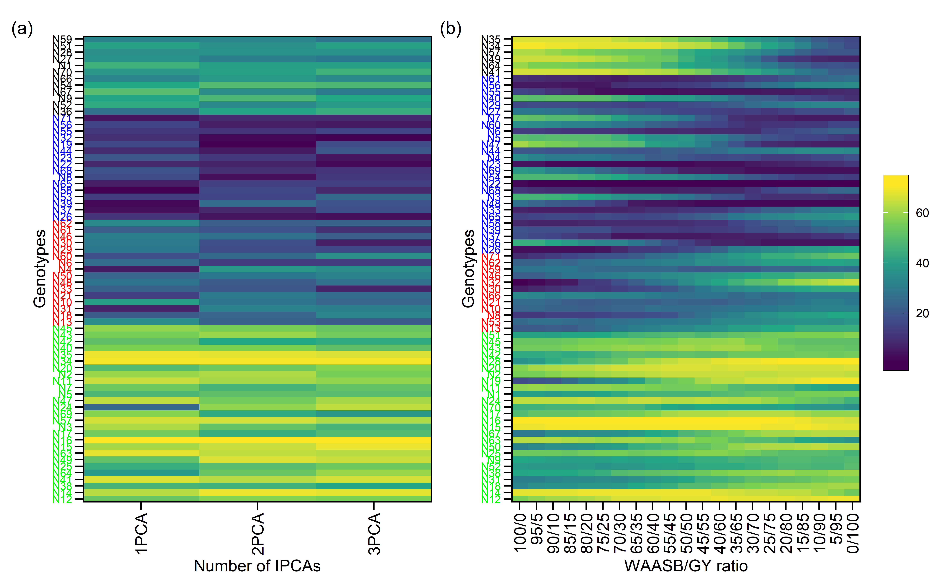

#### 4.2.5.3 Coincidence index of genotype selection

Computes the coincidence index (Hamblin and Zimmermann, 1986) as follows:

where *A* is the number of selected genotypes common to different methods; *C* is the number of expected genotypes selected by chance; and *M* is the number of genotypes selected according to the selection intensity.

coinc_1 <- stab_blups_nb %>% dplyr::select(GEN,HMRPGV_R) %>% arrange(HMRPGV_R)  
coinc_2 <- stab_blups_nb %>% dplyr::select(GEN,RPGV_R) %>% arrange(RPGV_R)  
coinc_3 <- stab_blups_nb %>% dplyr::select(GEN,HMGV_R) %>% arrange(HMGV_R)  
coinc_4 <- stab_blups_nb %>% dplyr::select(GEN,OrWAASBY) %>% arrange(OrWAASBY)  
coinc_5 <- stab_blups_nb %>% dplyr::select(GEN,WAASB_R) %>% arrange(WAASB_R)  
  
selc_perc<- round(nrow(stab_blups_nb)*0.2)  
  
coinc_1.1 <-1  
coinc_1.2 <- coincidence_index(sel1 = coinc_1$GEN[1:selc_perc],   
 sel2 = coinc_2$GEN[1:selc_perc],   
 total = 71)/100  
coinc_1.3 <- coincidence_index(sel1 = coinc_1$GEN[1:selc_perc],   
 sel2 = coinc_3$GEN[1:selc_perc],   
 total = 71)/100  
coinc_1.4 <- coincidence_index(sel1 = coinc_1$GEN[1:selc_perc],   
 sel2 = coinc_4$GEN[1:selc_perc],   
 total = 71)/100  
coinc_1.5 <- coincidence_index(sel1 = coinc_1$GEN[1:selc_perc],   
 sel2 = coinc_5$GEN[1:selc_perc],   
 total = 71)/100  
coinc_2.2 <-1  
coinc_2.3 <- coincidence_index(sel1 = coinc_2$GEN[1:selc_perc],   
 sel2 = coinc_3$GEN[1:selc_perc],   
 total = 71)/100  
coinc_2.4 <- coincidence_index(sel1 = coinc_2$GEN[1:selc_perc],   
 sel2 = coinc_4$GEN[1:selc_perc],   
 total = 71)/100  
coinc_2.5 <- coincidence_index(sel1 = coinc_2$GEN[1:selc_perc],   
 sel2 = coinc_5$GEN[1:selc_perc],   
 total = 71)/100  
coinc_3.3<- 1  
coinc_3.4 <- coincidence_index(sel1 = coinc_3$GEN[1:selc_perc],   
 sel2 = coinc_4$GEN[1:selc_perc],   
 total = 71)/100  
coinc_3.5 <- coincidence_index(sel1 = coinc_3$GEN[1:selc_perc],   
 sel2 = coinc_5$GEN[1:selc_perc],   
 total = 71)/100  
coinc_4.4 <- 1  
coinc_4.5 <- coincidence_index(sel1 = coinc_4$GEN[1:selc_perc],   
 sel2 = coinc_5$GEN[1:selc_perc],   
 total = 71)/100  
coinc_5.5 <- 1  
  
  
coinc<- c(coinc_1.1,coinc_1.2,coinc_2.2,coinc_1.3,coinc_2.3,  
 coinc_3.3,coinc_1.4, coinc_2.4, coinc_3.4,  
 coinc_4.4, coinc_1.5, coinc_2.5,  
 coinc_3.5, coinc_4.5,  
 coinc_5.5)  
   
z=matrix(0,5,5)  
z[upper.tri(z)| row(z)==col(z)] <- coinc  
  
rownames(z)=c(  
"HMRPGV",  
"RPGV",  
'HMGV',  
'WAASBY',  
'WAASB')  
  
colnames(z)=rownames(z)  
  
plotNB<- ggcorrplot(z, colors = c("#6D9EC1", "gray" ,"#E46726"),   
 show.legend = T,  
legend.title = "CI" ,lab_size=5,tl.srt = 90,type = c("upper"), lab = T,digits = 4,  
outline.color = "white",pch.col = "white", tl.col = "blue",show.diag = F) +  
 labs(title = "BLUP-based stability indexes coincidence at NB",  
 subtitle = "Selection intensity of 20% top genotypes")  
  
print(plotNB)

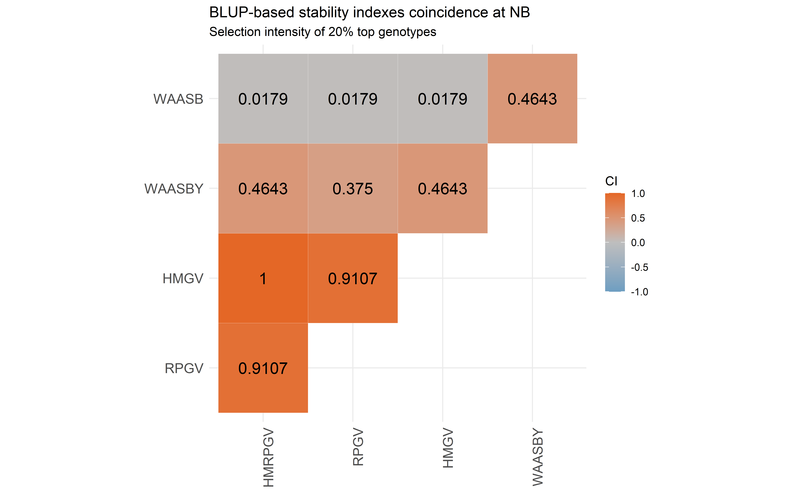

## 4.3 MET analysis - **Red beans**

### 4.3.1 MET analysis - ASReml

Running MET using ASReml - only to comparison of variance components with metan outputs

mod.met.asreml.sr1 <- asreml(fixed = yield ~ loc + loc:rep,  
 random = ~ name + name:loc,  
 data = blues_stage.I_SR,  
 predict = predict.asreml(classify = "name"),  
 trace = F,  
 maxit = 500)  
  
summFix.sr.met.asreml<- data.frame(wald(mod.met.asreml.sr1))  
summFix.sr.met.asreml

| **Df** | **Sum.of.Sq** | **Wald.statistic** | **Pr.Chisq.** |
| --- | --- | --- | --- |
| **numeric** | **numeric** | **numeric** | **numeric** |
| 1 | 457,238,258 | 3,083.4 | 0.0 |
| 3 | 5,392,039 | 36.4 | 0.0 |
| 12 | 4,238,922 | 28.6 | 0.0 |
|  | 148,291 |  |  |

summ.sr.met.asreml<- data.frame(summary.asreml(mod.met.asreml.sr1)$varcomp)  
summ.sr.met.asreml

| **component** | **std.error** | **z.ratio** | **bound** | **X.ch** |
| --- | --- | --- | --- | --- |
| **numeric** | **numeric** | **numeric** | **character** | **numeric** |
| 31,775.8 | 22,260.3 | 1.4 | P | 0 |
| 104,069.5 | 26,514.2 | 3.9 | P | 0 |
| 148,291.7 | 13,802.9 | 10.7 | P | 0 |

#print(summary.asreml(mod.met.asreml.sr1)$bic)  
mod.met.asreml.sr<- data.table((mod.met.asreml.sr1$predictions$pvals[1:3]))  
names(mod.met.asreml.sr) <- c("name", "yield_BLUPS_MET", "SE")  
  
###

### 4.3.2 MET analysis - lme4

Running MET using metan R package [Olivoto et al. (2019)](Olivoto%20et%20al.,%202019a).

mixed_mod.sr<-   
 gamem_met(blues_stage.I_SR,  
 env = loc,  
 gen = name,  
 rep = rep,  
 resp = yield,  
 random = "gen", #Default  
 verbose = TRUE) #Default

Evaluating trait yield |===============================================================================| 100% 00:00:00

#> Method: REML/BLUP

#> Random effects: GEN, GEN:ENV

#> Fixed effects: ENV, REP(ENV)

#> Denominador DF: Satterthwaite's method

| P-values for Likelihood Ratio Test of the analyzed traits |
| --- |
| model yield COMPLETE NA GEN 6.80e-02 GEN:ENV 9.94e-12 |

All variables with significant (p < 0.05) genotype-vs-environment interaction

### 4.3.3 Printing the model outputs

#### 4.3.3.1 Likelihood Ratio Tests

The output LRT contains the Likelihood Ratio Tests for genotype and genotype-vs-environment random effects.

data_mod_sr_test <- get_model_data(mixed_mod.sr, "lrt")

#> Class of the model: waasb

#> Variable extracted: lrt

data_mod_sr_test

| **VAR** | **model** | **npar** | **logLik** | **AIC** | **LRT** | **Df** | **Pr(>Chisq)** |
| --- | --- | --- | --- | --- | --- | --- | --- |
| **character** | **character** | **integer** | **numeric** | **numeric** | **numeric** | **numeric** | **numeric** |
| yield | GEN | 18 | -2,385.1 | 4,806.1 | 3.3 | 1 | 0.1 |
| yield | GEN:ENV | 18 | -2,406.6 | 4,849.1 | 46.3 | 1 | 0.0 |

#customize the display of numbers and other data in a tibble  
# old <- options(pillar.sigfig = 6)  
#   
# blues_stage.I_SR %>%  
# group_by(loc) %>%  
# dplyr::summarise(Mean = mean(yield, na.rm = TRUE))

#### 4.3.3.2 Detailed parameters

data_mod_sr_det <- get_model_data(mixed_mod.sr, "details")

#> Class of the model: waasb

#> Variable extracted: details

data_mod_sr_det

| **Parameters** | **yield** |
| --- | --- |
| **character** | **character** |
| Mean | 3147.37 |
| SE | 32.29 |
| SD | 583.92 |
| CV | 18.58 |
| Min | 1325.5 (R7 in BA) |
| Max | 4868.28 (R6 in SA) |
| MinENV | BA (2731.73) |
| MaxENV | TU (3367.38) |
| MinGEN | R7 (2761.81) |
| n: 12 | |

#### 4.3.3.3 Random effects

The output LRT contains the Likelihood Ratio Tests for genotype and genotype-vs-environment random effects.

old <- options(pillar.sigfig = 8)  
  
data_mod_sr_var <- get_model_data(mixed_mod.sr, "vcomp")

#> Class of the model: waasb

#> Variable extracted: vcomp

data_mod_sr_var

| **Group** | **yield** |
| --- | --- |
| **character** | **numeric** |
| GEN | 31,774.8 |
| GEN:ENV | 104,069.3 |
| Residual | 148,290.9 |

#### 4.3.3.4 Variance components and genetic parameters

old <- options(pillar.sigfig = 4)  
  
data_mod_sr_comp <- get_model_data(mixed_mod.sr)

#> Class of the model: waasb

#> Variable extracted: genpar

data_mod_sr_comp

| **Parameters** | **yield** |
| --- | --- |
| **character** | **numeric** |
| Phenotypic variance | 284,135.1 |
| Heritability | 0.1 |
| GEIr2 | 0.4 |
| h2mg | 0.5 |
| Accuracy | 0.7 |
| rge | 0.4 |
| CVg | 5.7 |
| CVr | 12.2 |
| CV ratio | 0.5 |

### 4.3.4 MET - GGE biplot

Genotype plus Genotype-vs-Environment interaction (GGE). Mega-environment identification in multi-environment trials (MET) according to [(**W?**). Yan et al. 2007](link%20here)

#### 4.3.4.1 GGE ENV biplot

GGE biplot done using:

* **sd**: each value is divided by the standard deviation of its corresponding environment.
* **environment**: environment-centered (G+GE)
* **environment**: singular value is entirely partitioned into the environment eigenvectors, also called column metric preserving

gge_model.sr <- gge(blues_stage.I_SR, loc, name, yield,   
 centering = "environment", #1  
 scaling = "sd", #2  
 svp = "environment")#2  
  
a <- plot(gge_model.sr, type=4,  
 size.text.env = 4.5,  
 plot_theme = theme_metan(grid = "both",color.background = transparent_color()),  
 axis_expand = 1.5,  
 col.alpha.circle = 0.8,  
 shape.gen = NA,  
 col.gen = NA,  
 size.text.lab = NA,  
 size.text.gen = NA,  
 leg.lab=c('Env'),  
 #title = FALSE  
 )  
  
  
gge_model.sr <- gge(blues_stage.I_SR, loc, name, yield,  
 centering = "environment", #1  
 scaling = "sd", #2Y  
 svp = "environment")#2)  
  
b <- plot(gge_model.sr, type = 6,  
 size.text.env = 5,  
 plot_theme = theme_metan(grid = "both",color.background = transparent_color()),  
 axis_expand = 1.5,  
 # col.alpha.circle = 100,  
 col.alpha.circle = 0.8,  
 size.text.lab = 13,  
 #title = FALSE  
 )  
  
 arrange_ggplot(a, b,  
 guides = "collect",  
 tag_levels = "a",  
 tag_prefix = "(",  
 tag_suffix = ")")

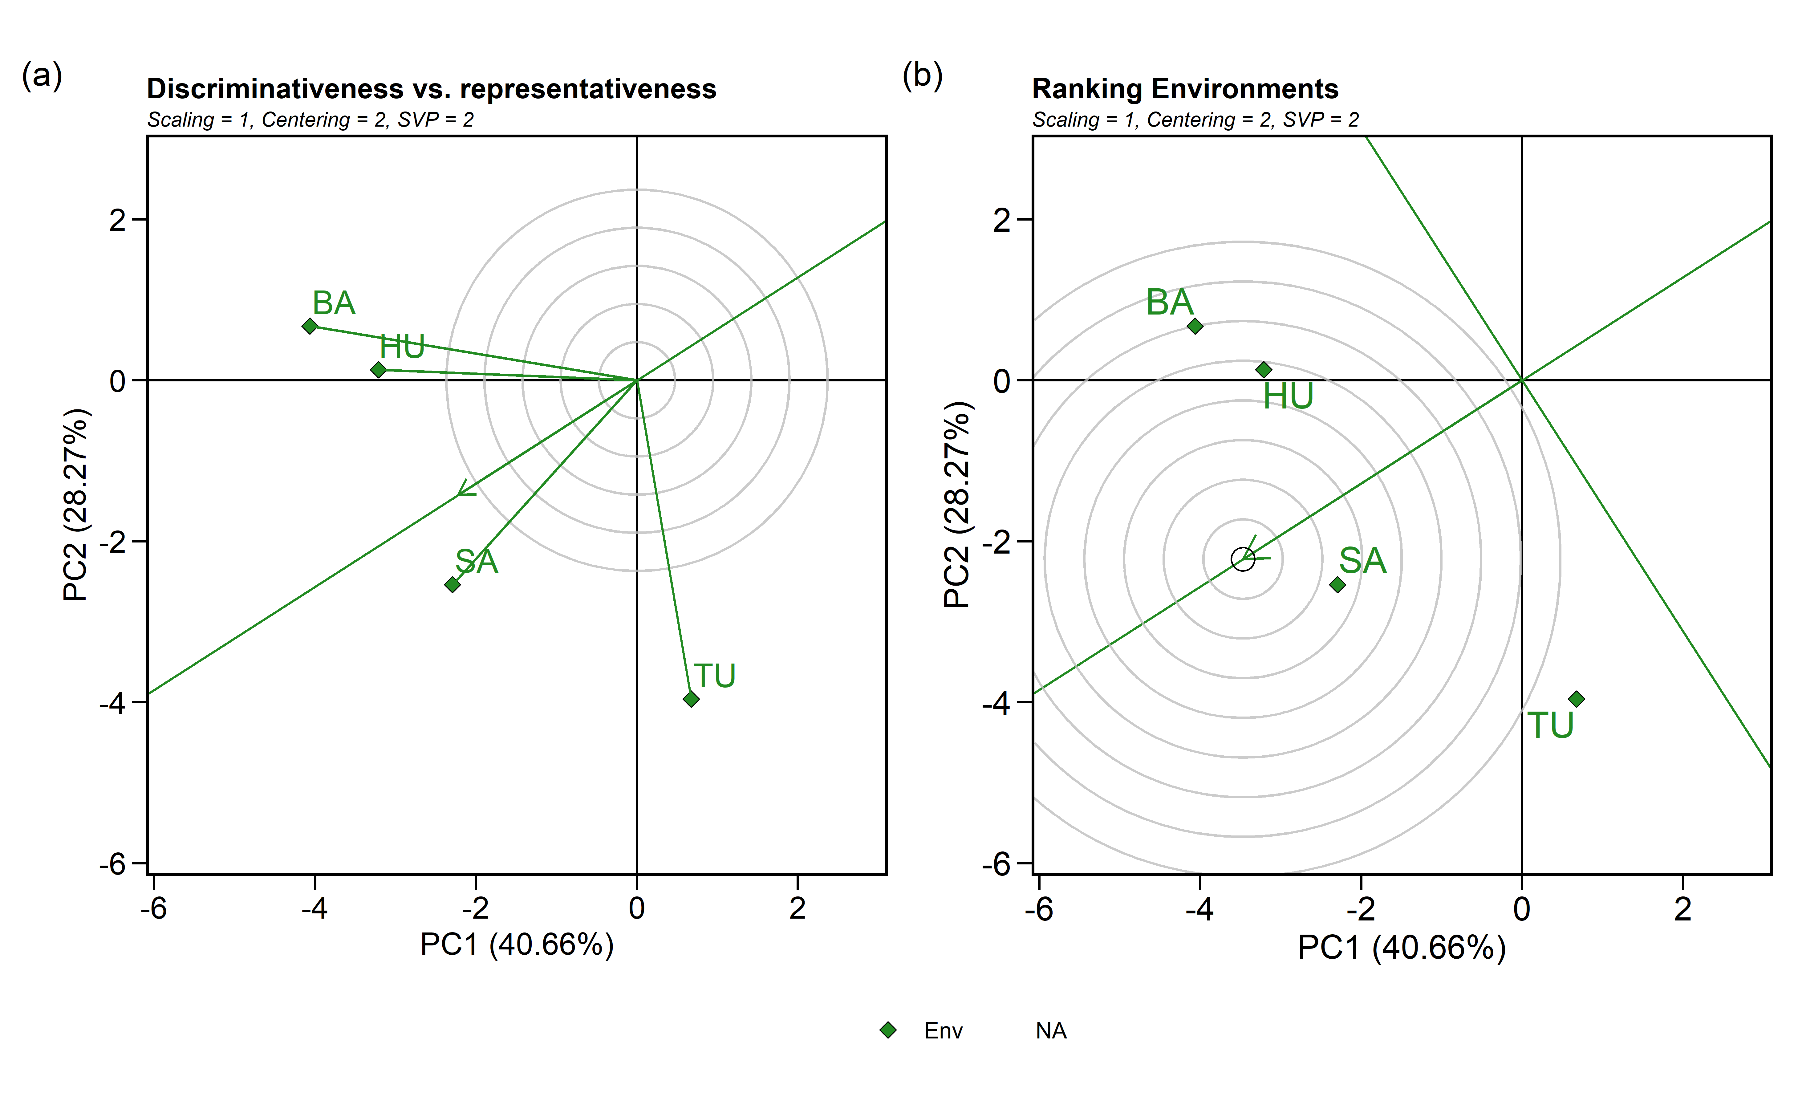

#### 4.3.4.2 Biplot type 3: Which-won-where

GGE biplot done using:

* **sd**: each value is divided by the standard deviation of its corresponding environment.
* **environment**: environment-centered (G+GE)
* **genotype**: singular value is entirely partitioned into the environment eigenvectors, also called column metric preserving

gge_model.sr <- gge(blues_stage.I_SR, loc, name, yield,  
 centering = "environment", #2  
 scaling = "sd", #1  
 svp = "genotype")#2)  
  
e <- plot(gge_model.sr, type = 3,  
 size.text.env = 5,  
 plot_theme = theme_metan(grid = "both",color.background = transparent_color()),  
 axis_expand = 1.2,  
 size.line = 0.7,  
 size.text.gen = 4,  
 size.text.win = 4.5  
 #title = FALSE  
   
 )  
  
print(e)

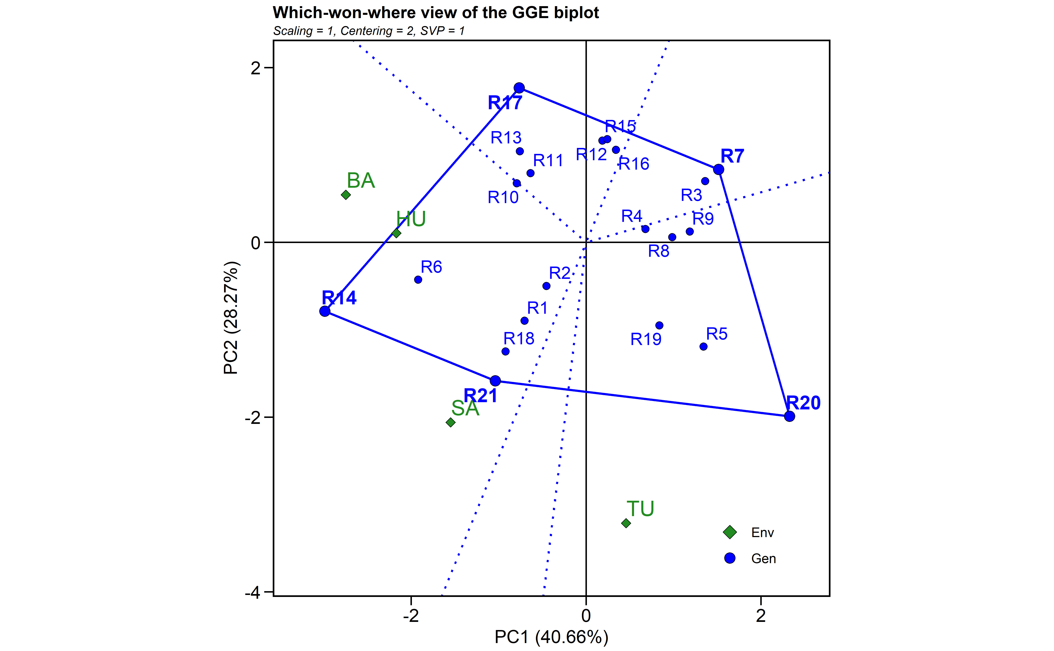

### 4.3.5 Mean performance and stability analysis

WAASP index and BLUPs to estimate stability analysis.

waasb_model_sr <-   
 waasb(blues_stage.I_SR,  
 env = loc,  
 gen = name,  
 rep = rep,  
 resp = yield,  
 random = "gen", #Default  
 verbose = TRUE,  
 wresp = 60) #weight for response variable 60 and 40 for yielding and stability, respectively)

#> Evaluating trait yield |===============================================================================| 100% 00:00:01   
#> ---------------------------------------------------------------------------  
#> P-values for Likelihood Ratio Test of the analyzed traits  
#> ---------------------------------------------------------------------------  
#> model yield  
#> COMPLETE NA  
#> GEN 6.80e-02  
#> GEN:ENV 9.94e-12  
#> ---------------------------------------------------------------------------  
#> All variables with significant (p < 0.05) genotype-vs-environment interaction

waasb_model<- waasb_model_sr$yield$model  
  
waasp_plot <- plot_scores(waasb_model_sr, type = 3,  
 title = FALSE,  
 size.tex.gen = 4,  
 size.tex.env = 4,  
 size.tex.lab = 13,  
 #highlight = c('R13',"R2"),  
 plot_theme = theme_metan(grid = "both",color.background = transparent_color())  
 ) +  
   
 geom_mark_rect(aes(filter = Code %in% c("R13", "R11", "R21", "R1"),  
 ),  
 label.fontsize = 10,  
 show.legend = F,  
 con.cap = 0,  
 con.colour = "red",  
 color = "red",  
 expand = 0.01,  
 label.buffer = unit(10, "cm"))+  
#theme_gray()+  
theme(legend.position = c(0.1, 0.9),  
 legend.background = element_blank(),  
 legend.title = element_blank(),  
 aspect.ratio = 1) +  
 labs(x = "GY")  
print(waasp_plot)

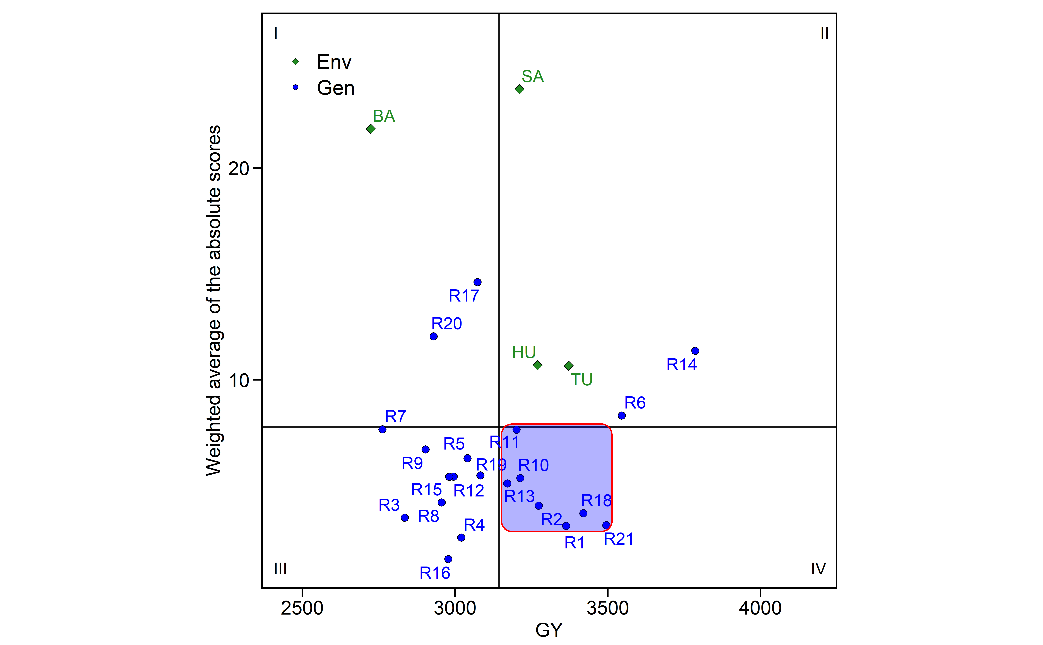

waasb_model_meanWaasb<-mean(waasb_model$WAASB)  
waasb_model_meanY<-mean(waasb_model$Y)  
  
selected <- waasb_model %>%  
 dplyr::filter(Y >= waasb_model_meanY & WAASB <= waasb_model_meanWaasb)   
  
selected_table <- selected  
  
if (knitr::is_html_output()) {  
   
 print_table(selected_table)  
   
}else{  
   
selected_table[,1:8]  
}

| **type** | **Code** | **Y** | **PC1** | **PC2** | **PC3** | **WAASB** | **PctResp** |
| --- | --- | --- | --- | --- | --- | --- | --- |
| **character** | **character** | **numeric** | **numeric** | **numeric** | **numeric** | **numeric** | **numeric** |
| GEN | R10 | 3,213.0 | -7.5 | -2.3 | 7.0 | 5.4 | 44.1 |
| GEN | R13 | 3,170.3 | -0.8 | 11.6 | -0.3 | 5.1 | 39.9 |
| GEN | R18 | 3,419.7 | 1.3 | -3.4 | 14.3 | 3.7 | 64.2 |
| GEN | R1 | 3,363.4 | -3.2 | -2.7 | 4.2 | 3.1 | 58.7 |
| GEN | R2 | 3,273.6 | 3.2 | 6.0 | 0.9 | 4.1 | 50.0 |
| GEN | R21 | 3,494.5 | -3.0 | -2.6 | 5.4 | 3.1 | 71.5 |
| GEN | R11 | 3,200.8 | -13.6 | -0.6 | -7.8 | 7.6 | 42.9 |

#selected$Code

#### 4.3.5.1 Selection differentials

#Create a data frame with BLUPS - selected and non-selected  
blups_sel <-  
 gmd(waasb_model_sr, "blupge") %>%  
 add_cols(SELECTED = ifelse(GEN %in% selected$Code, "yes", "no")) %>%   
 dplyr::rename(BLUPs_sel = yield) %>%   
 droplevels()  
  
blups_sel_mean<-  
 gmd(waasb_model_sr, "blupge") %>%  
 add_cols(SELECTED = ifelse(GEN %in% selected$Code, "yes", "no")) %>%   
 filter(SELECTED == "yes") %>%   
 dplyr::summarise(mean_GY = mean(yield,na.rm = TRUE), n = n())   
  
# Create a data frame with the waasb index - selected and non-selected  
waasb_sel <-  
 gmd(waasb_model_sr, "WAASB") %>%  
 add_cols(SELECTED = ifelse(GEN %in% selected$Code, "yes", "no")) %>%   
 dplyr::rename(WAASB_sel = yield) %>%   
 droplevels()  
#str(waasb_sel)  
  
waasb_sel_mean<-  
 gmd(waasb_model_sr, "WAASB") %>%  
 add_cols(SELECTED = ifelse(GEN %in% selected$Code, "yes", "no")) %>%   
 filter(SELECTED == "yes") %>%   
 dplyr::summarise(mean_GY = mean(yield,na.rm = TRUE), n = n())   
  
p1<- plot_selected(blups_sel, GEN, BLUPs_sel, mean_sel = blups_sel_mean$mean_GY) +  
 labs(y = "GY")  
  
p3<- plot_selected(waasb_sel, GEN, WAASB_sel, mean_sel = waasb_sel_mean$mean_GY) +  
 labs(y = "WAASB index")  
  
arrange_ggplot(p1, p3,  
 guides = "collect",  
 tag_levels = "a",  
 tag_prefix = "(",  
 tag_suffix = ")")

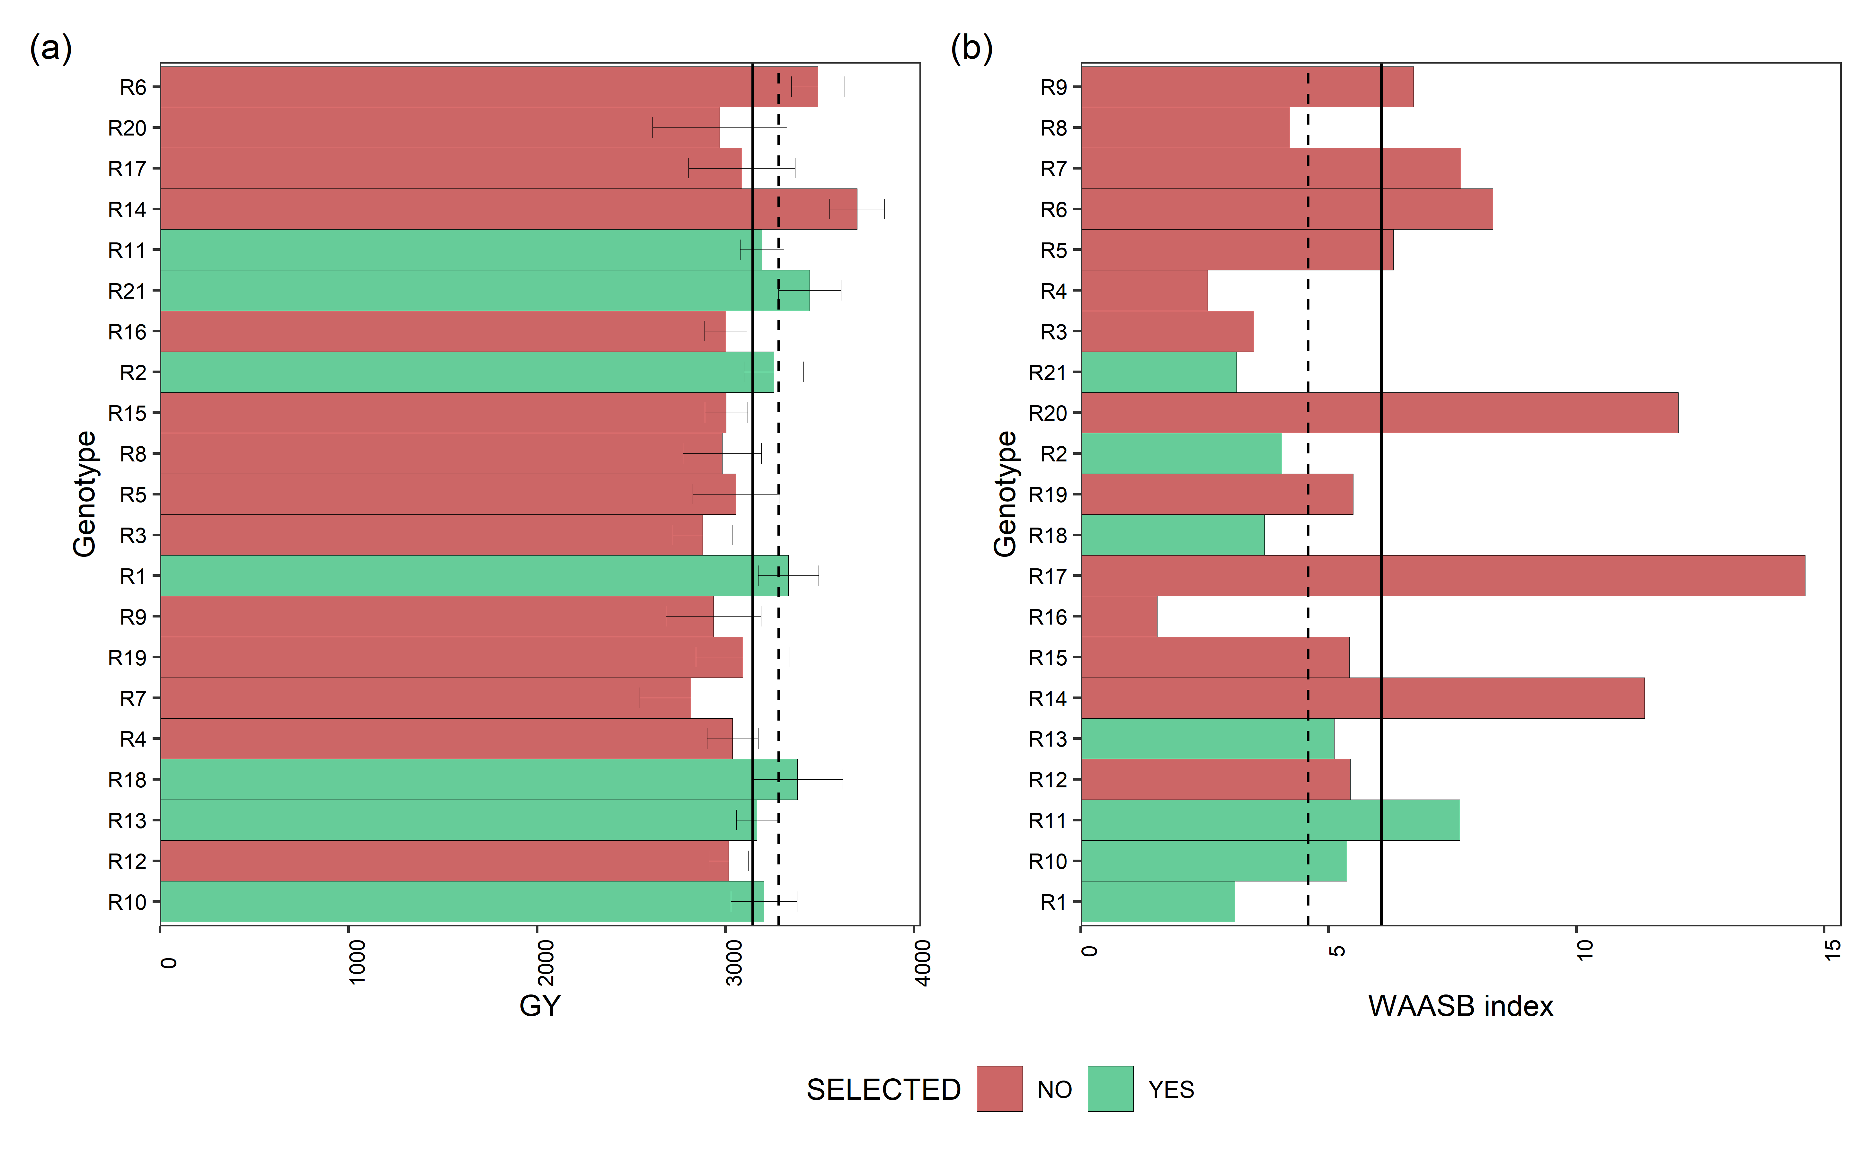

Mean performance (a) and stability (b) for grain yield (GY) of 24 Small Red beans genotypes. The vertical dashed and solid lines shows, respectivelly, the mean of the selected genotype and the overall mean for both mean performance and WAASB index

Percentage (SD_gain in %) gain from the selected genotypes compared to the general mean.

blups_sel2 <-  
 gmd(waasb_model_sr, "blupg") %>%  
 add_cols(SELECTED = ifelse(GEN %in% selected$Code, "yes", "no")) %>%   
 dplyr::rename(BLUPs_sel = yield) %>%   
 droplevels()

#> Class of the model: waasb

#> Variable extracted: blupg

blups_sel_mean2<-  
 gmd(waasb_model_sr, "blupg") %>%  
 add_cols(SELECTED = ifelse(GEN %in% selected$Code, "yes", "no")) %>%   
 filter(SELECTED == "yes") %>%   
 dplyr::summarise(mean_GY = mean(yield,na.rm = TRUE), n = n())

#> Class of the model: waasb  
#> Variable extracted: blupg

SD_blups<- as_tibble((blups_sel_mean2$mean_GY/mean(blups_sel2$BLUPs_sel, na.rm = T)) -1)*100  
SD_WAASP<- as_tibble((waasb_sel_mean$mean_GY /mean(waasb_sel$WAASB_sel, na.rm = T)) -1)*100  
  
SD_comb<- full_join(SD_blups, SD_WAASP, by = "value") %>%   
 dplyr::rename(SD_gain = value) %>%   
 tibble::add_column(Comp_name = c('BLUPs', 'WAASB')) %>%   
 relocate(Comp_name)  
  
SD_comb$n_selected<- blups_sel_mean2$n  
SD_comb

| **Comp_name** | **SD_gain** | **n_selected** |
| --- | --- | --- |
| **character** | **numeric** | **integer** |
| BLUPs | 2.4 | 7 |
| WAASB | -24.3 | 7 |

blups_sel2$mean_blup <- mean(blups_sel2$BLUPs_sel, na.rm = T)  
waasb_sel$mean_waasb <- mean(waasb_sel$WAASB_sel, na.rm = T)  
  
#str(waasb_sel)  
data_comb<- merge(blups_sel2, waasb_sel, by = c("GEN", "SELECTED"))  
#names(data_comb)  
## SD for each genotype  
data_sel_perc <- data_comb %>%  
 rowwise %>%  
 mutate(Perc_blup_gain = ((BLUPs_sel/mean_blup)*100)-100) %>%   
 mutate(Perc_WAASB_gain = ((WAASB_sel/mean_waasb)*100)-100) %>%   
 as_tibble()  
  
# data_sel_perc_mean <- data_sel_perc %>%  
# dplyr::filter(SELECTED == "yes")  
#   
# mean(data_sel_perc_mean$Perc_blup_gain)  
  
if (knitr::is_html_output()) {  
   
 print_table(data_sel_perc)  
   
}else{  
   
data_sel_perc[,1:7]  
}

| **GEN** | **SELECTED** | **BLUPs_sel** | **mean_blup** | **WAASB_sel** | **mean_waasb** | **Perc_blup_gain** |
| --- | --- | --- | --- | --- | --- | --- |
| **character** | **character** | **numeric** | **numeric** | **numeric** | **numeric** | **numeric** |
| R1 | yes | 3,251.2 | 3,147.4 | 3.1 | 6.1 | 3.3 |
| R10 | yes | 3,180.0 | 3,147.4 | 5.4 | 6.1 | 1.0 |
| R11 | yes | 3,174.2 | 3,147.4 | 7.6 | 6.1 | 0.9 |
| R12 | no | 3,076.7 | 3,147.4 | 5.4 | 6.1 | -2.2 |
| R13 | yes | 3,159.7 | 3,147.4 | 5.1 | 6.1 | 0.4 |
| R14 | no | 3,451.4 | 3,147.4 | 11.4 | 6.1 | 9.7 |
| R15 | no | 3,069.8 | 3,147.4 | 5.4 | 6.1 | -2.5 |
| R16 | no | 3,068.5 | 3,147.4 | 1.5 | 6.1 | -2.5 |
| R17 | no | 3,113.8 | 3,147.4 | 14.6 | 6.1 | -1.1 |
| n: 21 | | | | | | |

data_sel_perc<- data_sel_perc %>%   
 dplyr::relocate(GEN,SELECTED,BLUPs_sel,mean_blup,Perc_blup_gain,  
 WAASB_sel,mean_waasb ,Perc_WAASB_gain)  
  
#write.xlsx(data_sel_perc, "./data/sel_SD_sr_2.xlsx")  
  
  
data_sel_perc2 <- data_sel_perc %>%   
 dplyr::select(GEN,SELECTED, BLUPs_sel, WAASB_sel, Perc_blup_gain, Perc_WAASB_gain)  
  
data_sel_perc2

| **GEN** | **SELECTED** | **BLUPs_sel** | **WAASB_sel** | **Perc_blup_gain** | **Perc_WAASB_gain** |
| --- | --- | --- | --- | --- | --- |
| **character** | **character** | **numeric** | **numeric** | **numeric** | **numeric** |
| R1 | yes | 3,251.2 | 3.1 | 3.3 | -48.7 |
| R10 | yes | 3,180.0 | 5.4 | 1.0 | -11.5 |
| R11 | yes | 3,174.2 | 7.6 | 0.9 | 26.1 |
| R12 | no | 3,076.7 | 5.4 | -2.2 | -10.4 |
| R13 | yes | 3,159.7 | 5.1 | 0.4 | -15.7 |
| R14 | no | 3,451.4 | 11.4 | 9.7 | 87.5 |
| R15 | no | 3,069.8 | 5.4 | -2.5 | -10.6 |
| R16 | no | 3,068.5 | 1.5 | -2.5 | -74.6 |
| R17 | no | 3,113.8 | 14.6 | -1.1 | 141.0 |
| n: 21 | | | | | |

##BLUPs indexes  
stab_blups_sr<- blup_indexes(waasb_model_sr)   
stab_blups_sr<- as_tibble(stab_blups_sr$yield)  
  
data_waasby <- waasb_model_sr$yield$model %>%   
 dplyr::filter(type != "ENV") %>%   
 dplyr::select("Code", "WAASBY", "OrWAASBY") %>%   
 dplyr::rename(GEN = Code)  
  
stab_blups_sr<- stab_blups_sr %>%   
 full_join(data_waasby, by = "GEN")  
  
  
if (knitr::is_html_output()) {  
   
 print_table(stab_blups_sr)  
   
}else{  
   
stab_blups_sr[,1:8]  
}

| **GEN** | **Y** | **HMGV** | **HMGV_R** | **RPGV** | **RPGV_Y** | **RPGV_R** | **HMRPGV** |
| --- | --- | --- | --- | --- | --- | --- | --- |
| **character** | **numeric** | **numeric** | **numeric** | **numeric** | **numeric** | **numeric** | **numeric** |
| R1 | 3,213.0 | 3,307.4 | 5 | 1.1 | 3,332.3 | 5 | 1.1 |
| R10 | 2,995.1 | 3,173.5 | 8 | 1.0 | 3,205.9 | 8 | 1.0 |
| R11 | 3,170.3 | 3,181.2 | 7 | 1.0 | 3,211.9 | 7 | 1.0 |
| R12 | 3,419.7 | 3,005.0 | 13 | 1.0 | 3,027.2 | 14 | 1.0 |
| R13 | 3,019.6 | 3,155.4 | 9 | 1.0 | 3,179.9 | 9 | 1.0 |
| R14 | 2,761.8 | 3,681.0 | 1 | 1.2 | 3,723.7 | 1 | 1.2 |
| R15 | 3,082.8 | 2,990.4 | 15 | 1.0 | 3,012.4 | 15 | 1.0 |
| R16 | 2,903.1 | 2,987.0 | 16 | 1.0 | 3,005.0 | 16 | 1.0 |
| R17 | 3,363.4 | 3,005.7 | 12 | 1.0 | 3,095.9 | 10 | 1.0 |
| n: 21 | | | | | | | |

# library(openxlsx)  
# write.xlsx(stab_blups_sr, "./data/blups_sr_2.xlsx")

#### 4.3.5.2 Scenarios of waasby estimation

Planning different scenarios of waasby estimation by changing the weights assigned to the stability and the mean performance according to [Olivoto et al. (2019)](Olivoto%20et%20al.,%202019a).

scenarios <- wsmp(waasb_model_sr,progbar = F)  
  
scen1<- plot(scenarios, type = 1) +   
 theme(axis.text.y = element_text(size=8))  
  
scen2<-plot(scenarios, type = 2) +  
 theme(axis.text.y = element_text(size=8))  
  
arrange_ggplot(scen1, scen2,  
 guides = "collect",  
 legend.position = "right",  
 tag_levels = "a",  
 tag_prefix = "(",  
 tag_suffix = ")")

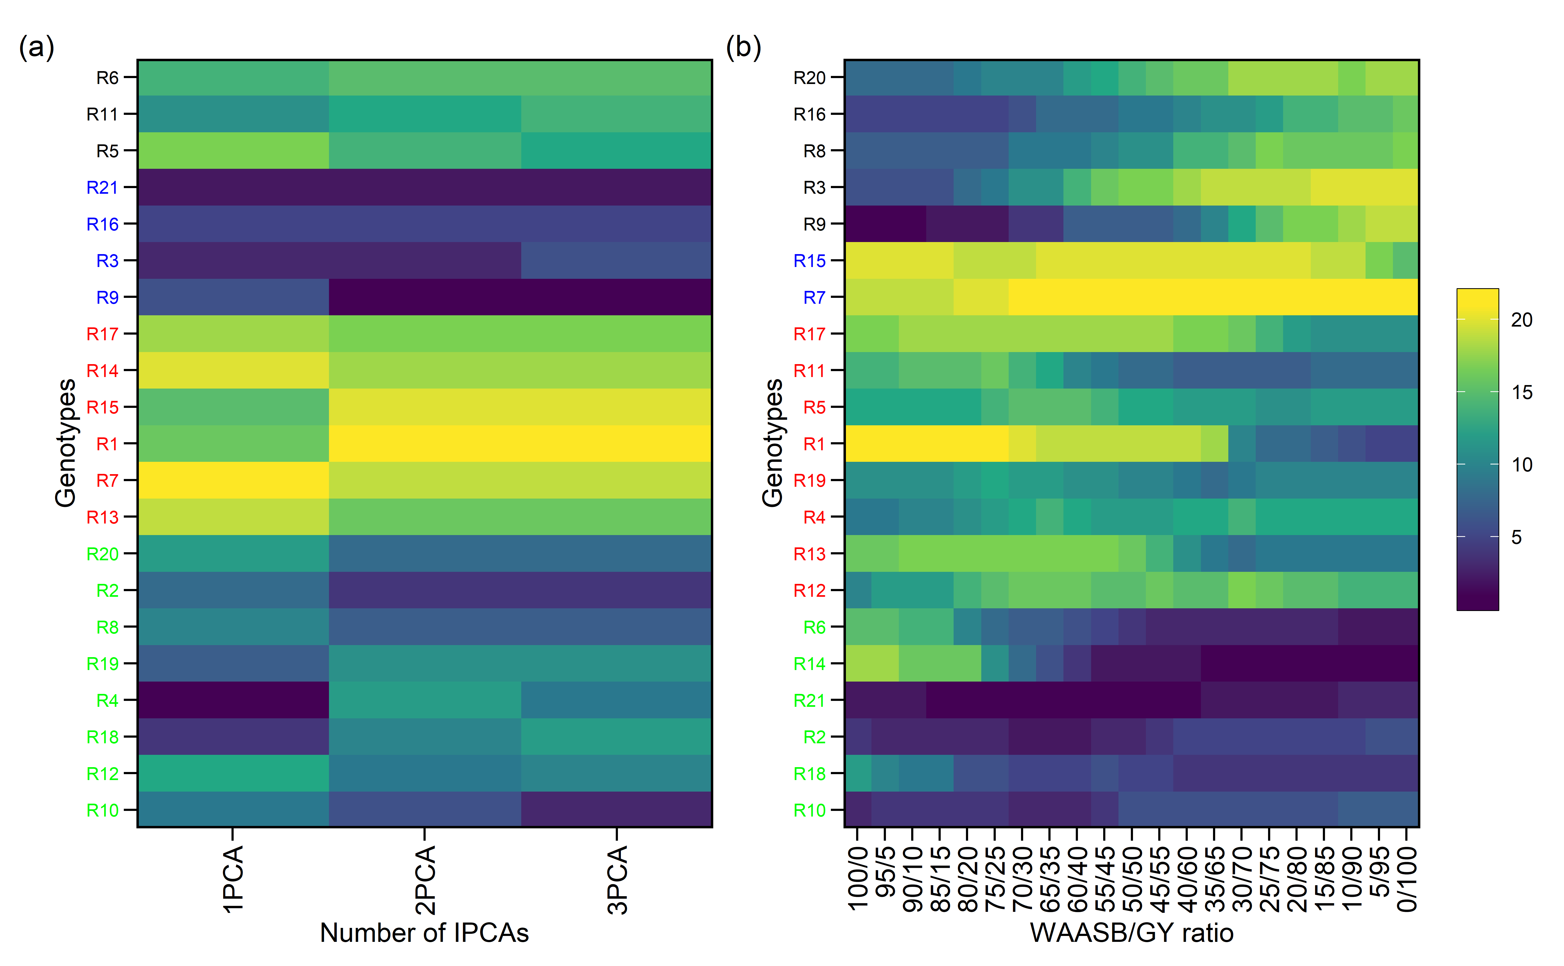

#plot_eigen(waasb_model_sr, size.lab = 14, size.tex.lab = 14)

#### 4.3.5.3 Coincidence index of genotype selection

Computes the coincidence index (Hamblin and Zimmermann, 1986) as follows:

where *A* is the number of selected genotypes common to different methods; *C* is the number of expected genotypes selected by chance; and *M* is the number of genotypes selected according to the selection intensity.

coinc_1 <- stab_blups_sr %>% dplyr::select(GEN,HMRPGV_R) %>% arrange(HMRPGV_R)  
coinc_2 <- stab_blups_sr %>% dplyr::select(GEN,RPGV_R) %>% arrange(RPGV_R)  
coinc_3 <- stab_blups_sr %>% dplyr::select(GEN,HMGV_R) %>% arrange(HMGV_R)  
coinc_4 <- stab_blups_sr %>% dplyr::select(GEN,OrWAASBY) %>% arrange(OrWAASBY)  
coinc_5 <- stab_blups_sr %>% dplyr::select(GEN,WAASB_R) %>% arrange(WAASB_R)  
  
selc_perc<- round(nrow(stab_blups_sr)*0.2)  
  
coinc_1.1 <-1  
coinc_1.2 <- coincidence_index(sel1 = coinc_1$GEN[1:selc_perc],   
 sel2 = coinc_2$GEN[1:selc_perc],   
 total = 21)/100  
coinc_1.3 <- coincidence_index(sel1 = coinc_1$GEN[1:selc_perc],   
 sel2 = coinc_3$GEN[1:selc_perc],   
 total = 21)/100  
coinc_1.4 <- coincidence_index(sel1 = coinc_1$GEN[1:selc_perc],   
 sel2 = coinc_4$GEN[1:selc_perc],   
 total = 21)/100  
coinc_1.5 <- coincidence_index(sel1 = coinc_1$GEN[1:selc_perc],   
 sel2 = coinc_5$GEN[1:selc_perc],   
 total = 21)/100  
coinc_2.2 <-1  
coinc_2.3 <- coincidence_index(sel1 = coinc_2$GEN[1:selc_perc],   
 sel2 = coinc_3$GEN[1:selc_perc],   
 total = 21)/100  
coinc_2.4 <- coincidence_index(sel1 = coinc_2$GEN[1:selc_perc],   
 sel2 = coinc_4$GEN[1:selc_perc],   
 total = 21)/100  
coinc_2.5 <- coincidence_index(sel1 = coinc_2$GEN[1:selc_perc],   
 sel2 = coinc_5$GEN[1:selc_perc],   
 total = 21)/100  
coinc_3.3<- 1  
coinc_3.4 <- coincidence_index(sel1 = coinc_3$GEN[1:selc_perc],   
 sel2 = coinc_4$GEN[1:selc_perc],   
 total = 21)/100  
coinc_3.5 <- coincidence_index(sel1 = coinc_3$GEN[1:selc_perc],   
 sel2 = coinc_5$GEN[1:selc_perc],   
 total = 21)/100  
coinc_4.4 <- 1  
coinc_4.5 <- coincidence_index(sel1 = coinc_4$GEN[1:selc_perc],   
 sel2 = coinc_5$GEN[1:selc_perc],   
 total = 21)/100  
coinc_5.5 <- 1  
  
  
coinc<- c(coinc_1.1,coinc_1.2,coinc_2.2,coinc_1.3,coinc_2.3,  
 coinc_3.3,coinc_1.4, coinc_2.4, coinc_3.4,  
 coinc_4.4, coinc_1.5, coinc_2.5,  
 coinc_3.5, coinc_4.5,  
 coinc_5.5)  
   
z=matrix(0,5,5)  
z[upper.tri(z)| row(z)==col(z)] <- coinc  
  
rownames(z)=c(  
"HMRPGV",  
"RPGV",  
'HMGV',  
'WAASBY',  
'WAASB')  
  
colnames(z)=rownames(z)  
  
plotSR<- ggcorrplot(z, colors = c("#6D9EC1", "gray" ,"#E46726"),   
 show.legend = T,  
legend.title = "CI" ,lab_size=5,tl.srt = 90,type = c("upper"), lab = T,digits = 4,  
outline.color = "white",pch.col = "white", tl.col = "blue",show.diag = F) +  
 labs(title = "BLUP-based stability indexes coincidence at SR",  
 subtitle = "CSelection intensity of 20% top genotypes")  
  
print(plotSR)

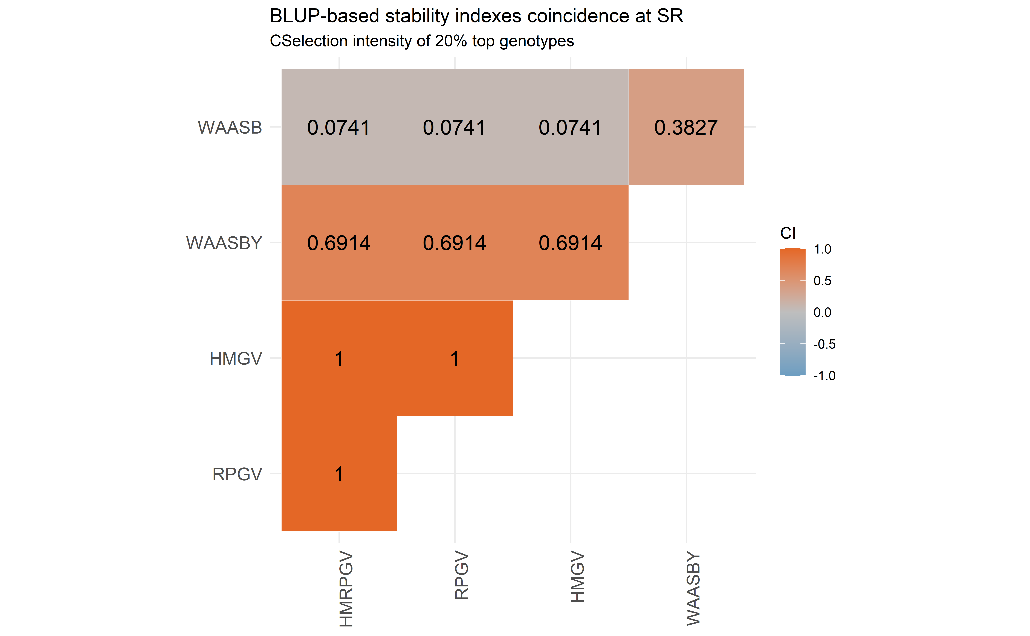

# 5 Appendix E - R codes

## 5.1 Multi-trait Multi-env analysis

## 5.2 Descriptive Stats - Multi-trait data

* GY data set: were obtained from the adjusted data in the 2nd-stage mixed models analysis.
* PH, PM, and LD were obtained from the coincident locations (TU, BA and SA) in 2021 only.

### 5.2.1 Data set

data_beans_compl = read.csv("data/data_beans_Multi-trait.csv",h=T, stringsAsFactors = T)  
data_beans_compl<- data_beans_compl[,-c(1:2)]  
colnames(data_beans_compl)<- c('name', 'loc', 'mkt', 'rep', 'GY', 'DM', 'PH', "LD")  
#str(data_beans_compl)  
  
# Data adjustment  
# All the effect columns must be as a factor to run in ASReml-r.  
cols <- c("rep", "name", "loc", "mkt")  
data_beans_compl[cols] <- lapply(data_beans_compl[cols], factor)  
data_beans_compl <- data.table(data_beans_compl)  
  
data_beans_compl

| **name** | **loc** | **mkt** | **rep** | **GY** | **DM** | **PH** | **LD** |
| --- | --- | --- | --- | --- | --- | --- | --- |
| **factor** | **factor** | **factor** | **factor** | **numeric** | **numeric** | **numeric** | **numeric** |
| B1 | BA | BB | 1 | 2,481.7 | 89 | 16 | 1 |
| B1 | BA | BB | 2 | 3,279.0 | 90 | 18 | 1 |
| B1 | BA | BB | 3 | 2,479.2 | 90 | 14 | 1 |
| B1 | BA | BB | 4 | 1,911.4 | 89 | 15 | 1 |
| B2 | BA | BB | 1 | 3,159.8 | 90 | 20 | 2 |
| B2 | BA | BB | 2 | 3,424.3 | 89 | 19 | 1 |
| B2 | BA | BB | 3 | 2,655.0 | 91 | 15 | 2 |
| B2 | BA | BB | 4 | 2,923.2 | 92 | 18 | 2 |
| B4 | BA | BB | 1 | 2,565.5 |  |  |  |
| n: 1056 | | | | | | | |

Number of genotype per market class:

data_beans_compl_count<- data_beans_compl%>%   
 means_by(name, mkt, na.rm = TRUE)%>%   
 group_by(mkt) %>%   
 dplyr::summarise(n = n())   
  
data_beans_compl_count

| **mkt** | **n** |
| --- | --- |
| **factor** | **integer** |
| BB | 37 |
| NB | 37 |
| SR | 14 |

### 5.2.2 Box plot distribuation

## Data visualization  
  
  
#print(c)  
a<- ggplot(data=data_beans_compl, aes(x=reorder(loc, -DM), y=DM, fill=loc)) +  
 geom_boxplot()+  
 facet_grid("mkt")+  
 theme_bw()+  
 theme(axis.text.x=element_text(angle = 90),  
 strip.text=element_text(face="bold"), legend.position = "none")+  
 labs(title="Days to Plant DM in days (DPM)",   
 caption=NULL, x=NULL, y=NULL)  
  
#print(a)  
  
b<- ggplot(data=data_beans_compl, aes(x=reorder(loc, -PH), y=PH, fill=loc)) +  
 geom_boxplot()+  
 facet_grid("mkt")+  
 theme_bw()+  
 theme(axis.text.x=element_text(angle = 90),  
 strip.text=element_text(face="bold"), legend.position = "none")+  
 labs(title="Plant PH in cm (PH)",   
 caption=NULL, x=NULL, y=NULL)  
  
d<- ggplot(data=data_beans_compl, aes(x=reorder(loc, -LD), y=LD , fill=loc)) +  
 geom_boxplot()+  
 facet_grid("mkt")+  
 theme_bw()+  
 theme(axis.text.x=element_text(angle = 90),  
 strip.text=element_text(face="bold"), legend.position = "none")+  
 labs(title="Lodging ratings (LD)",   
 caption=NULL, x=NULL, y=NULL)  
  
c<- ggplot(data=data_beans_compl, aes(x=reorder(loc, -GY), y=GY , fill=loc)) +  
 geom_boxplot()+  
 facet_grid("mkt")+  
 theme_bw()+  
 theme(axis.text.x=element_text(angle = 90),  
 strip.text=element_text(face="bold"), legend.position = "none")+  
 labs(title="Grain yield (GY)",   
 caption=NULL, x=NULL, y=NULL)  
  
#print(a)  
  
arrange_ggplot(c,a,b,d)

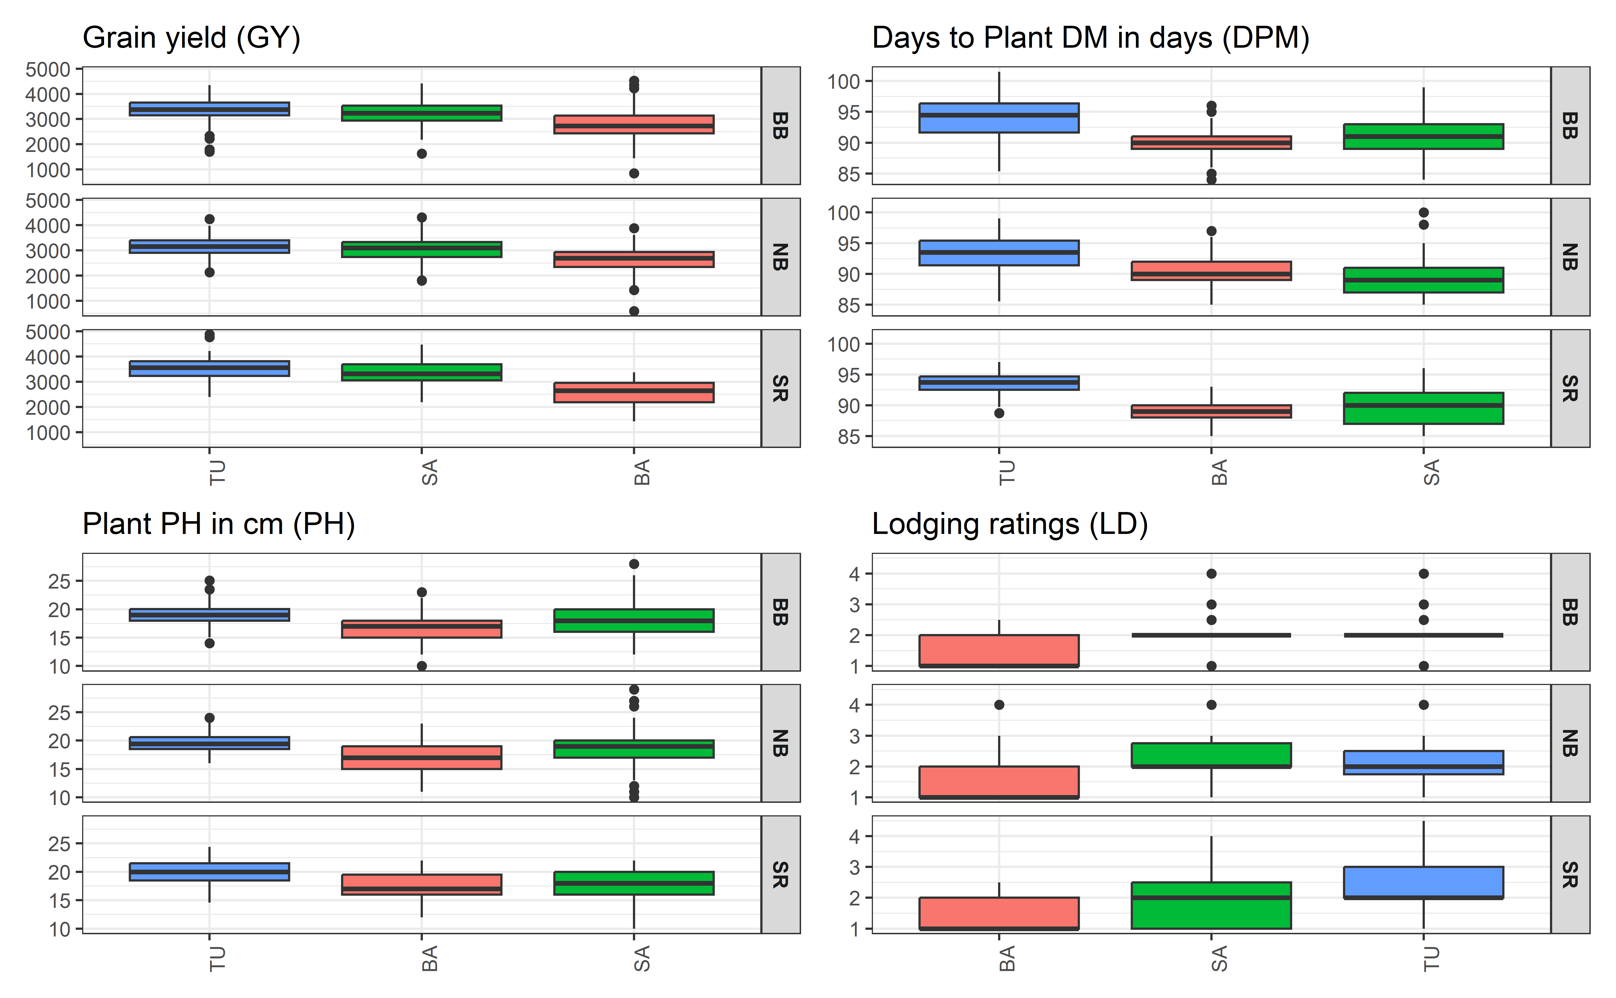

Box Plot for grain yield (GY), date of maturity (DM), Plant height (PH), and Lodging (LD) across environment

### 5.2.3 Scatter plot distribuation GY

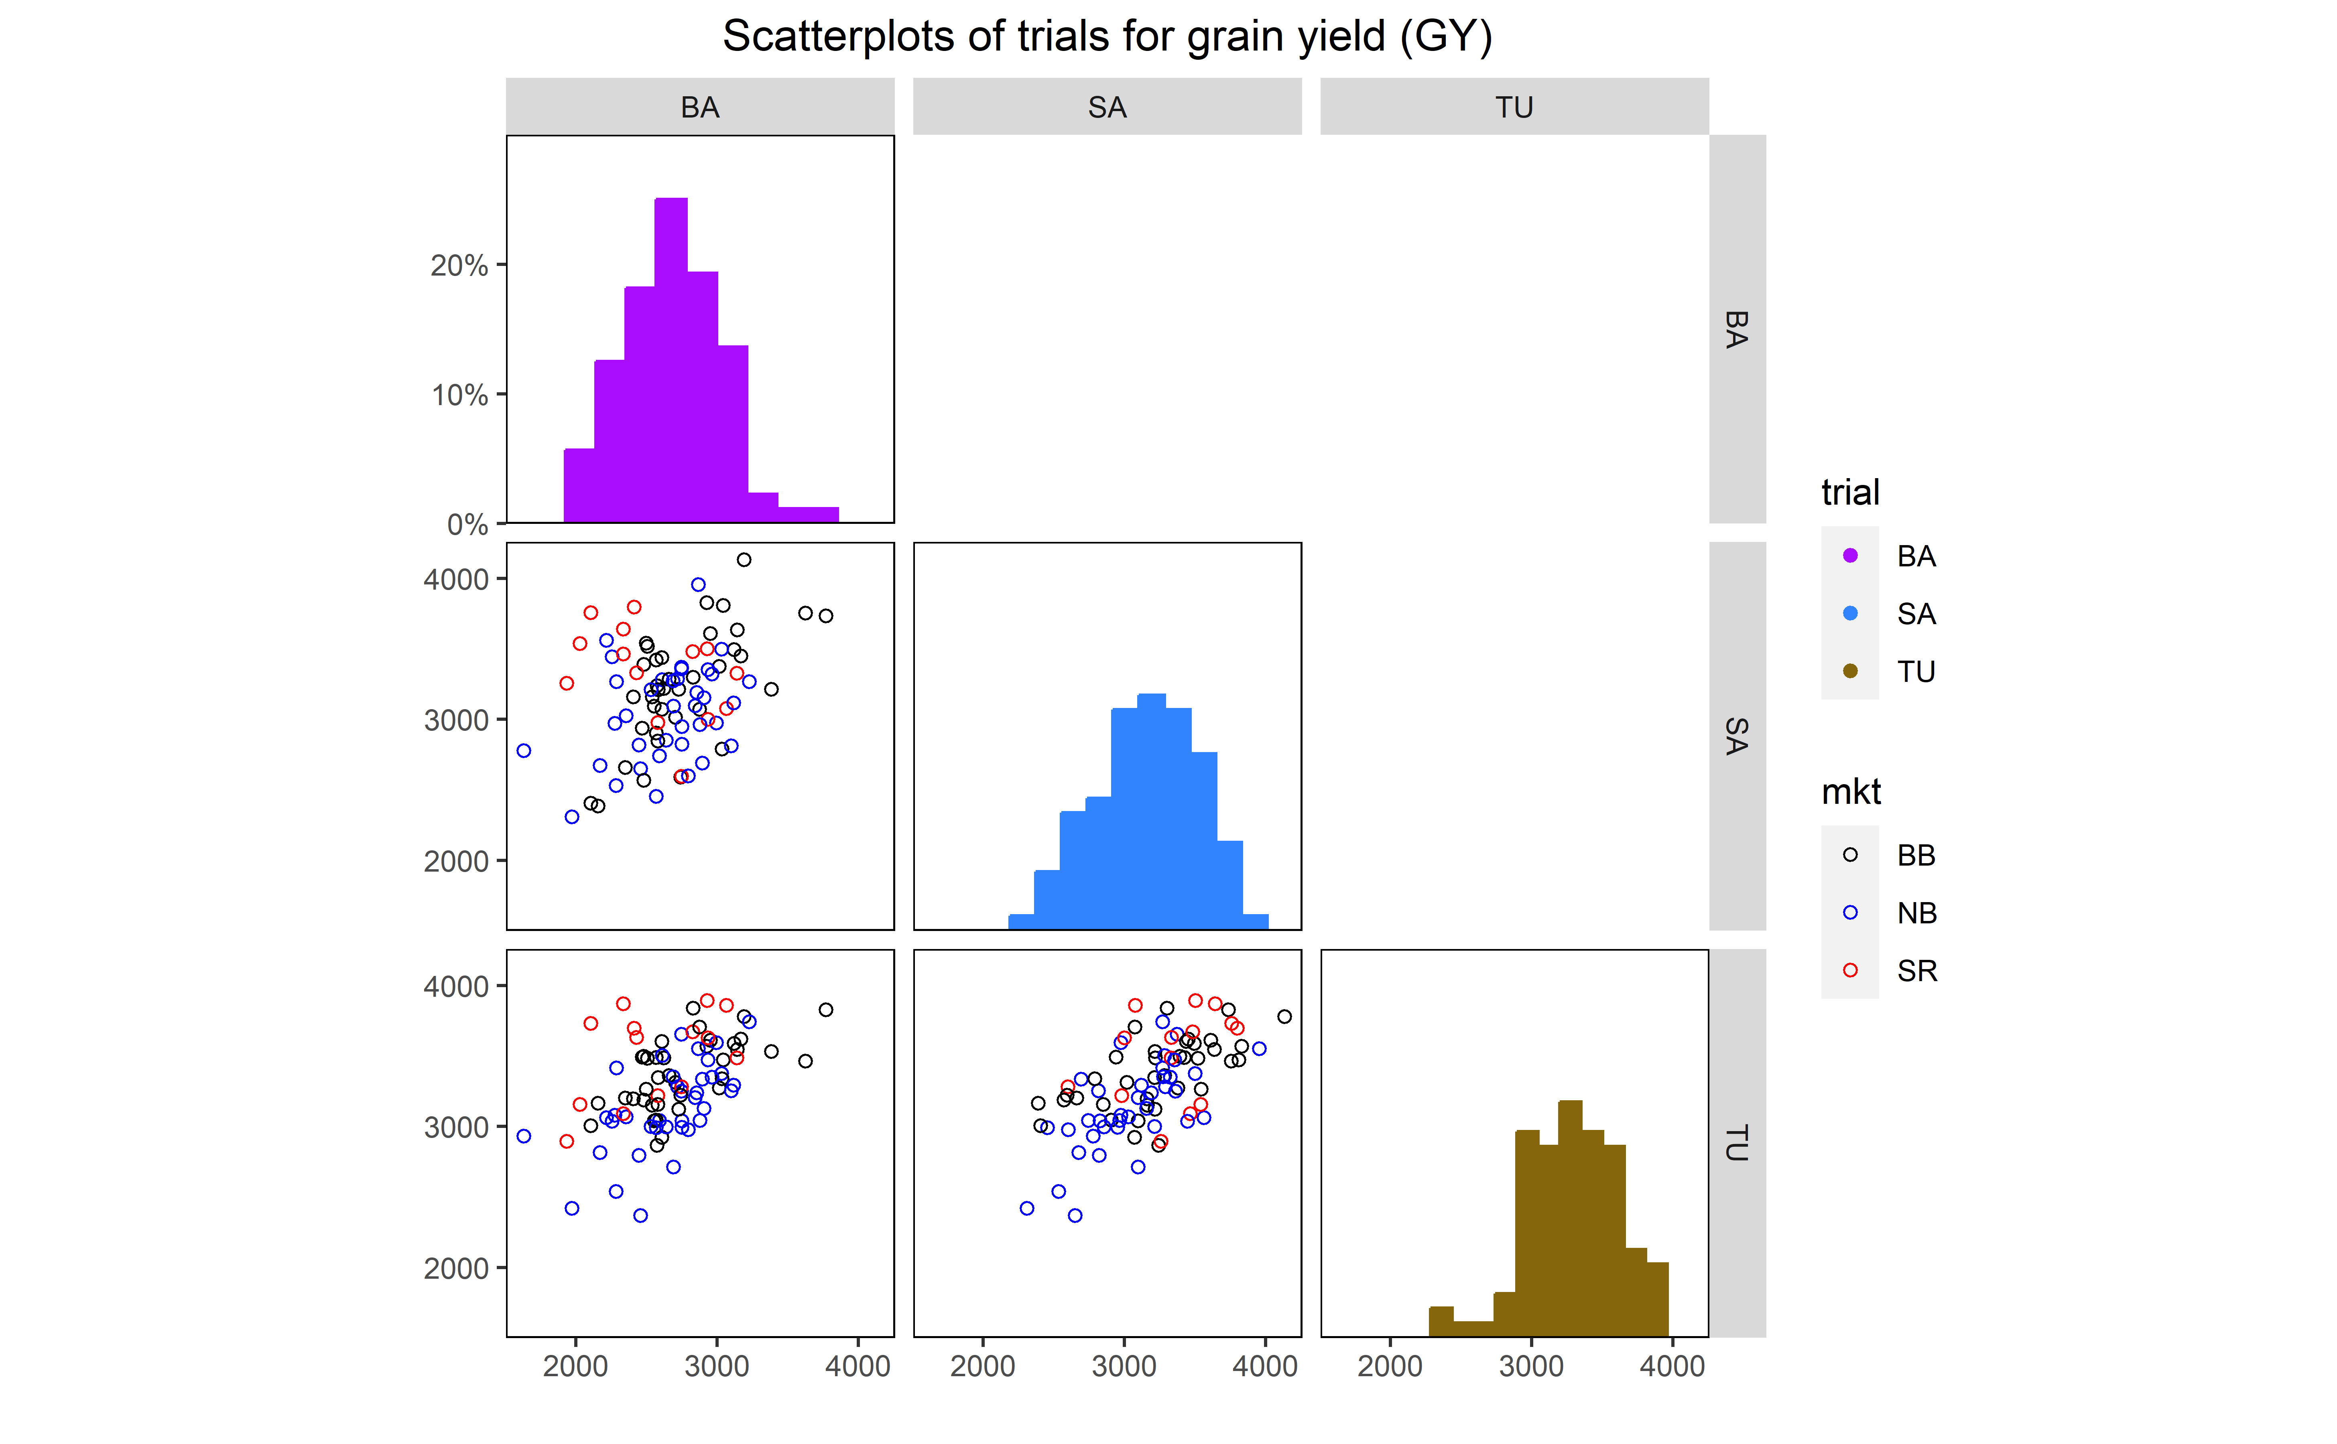

Scatterplot matrix of trials for grain yield (GY). The diagonal shows the distribution and the bottom left shows the scatter points for DM in each location.

### 5.2.4 Scatter plot distribuation DM

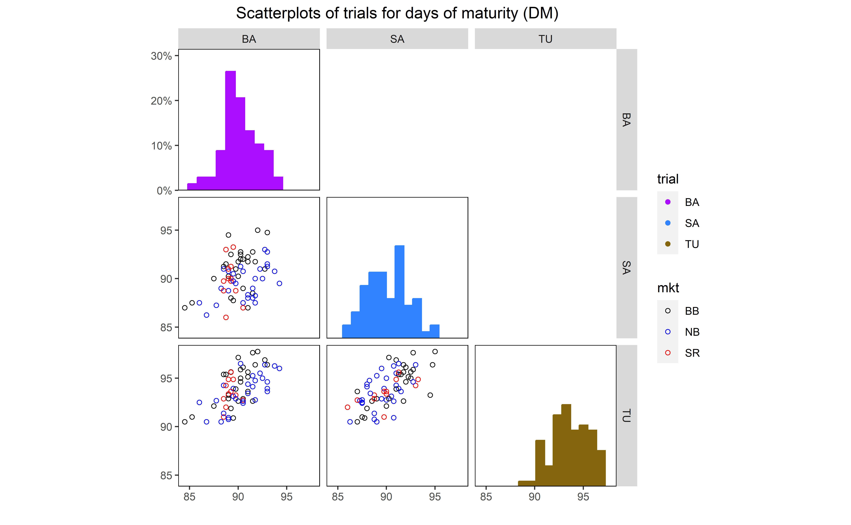

Scatterplot matrix of trials for days of maturity (DM). The diagonal shows the distribution and the bottom left shows the scatter points for DM in each location.

### 5.2.5 Scatter plot distribuation PH

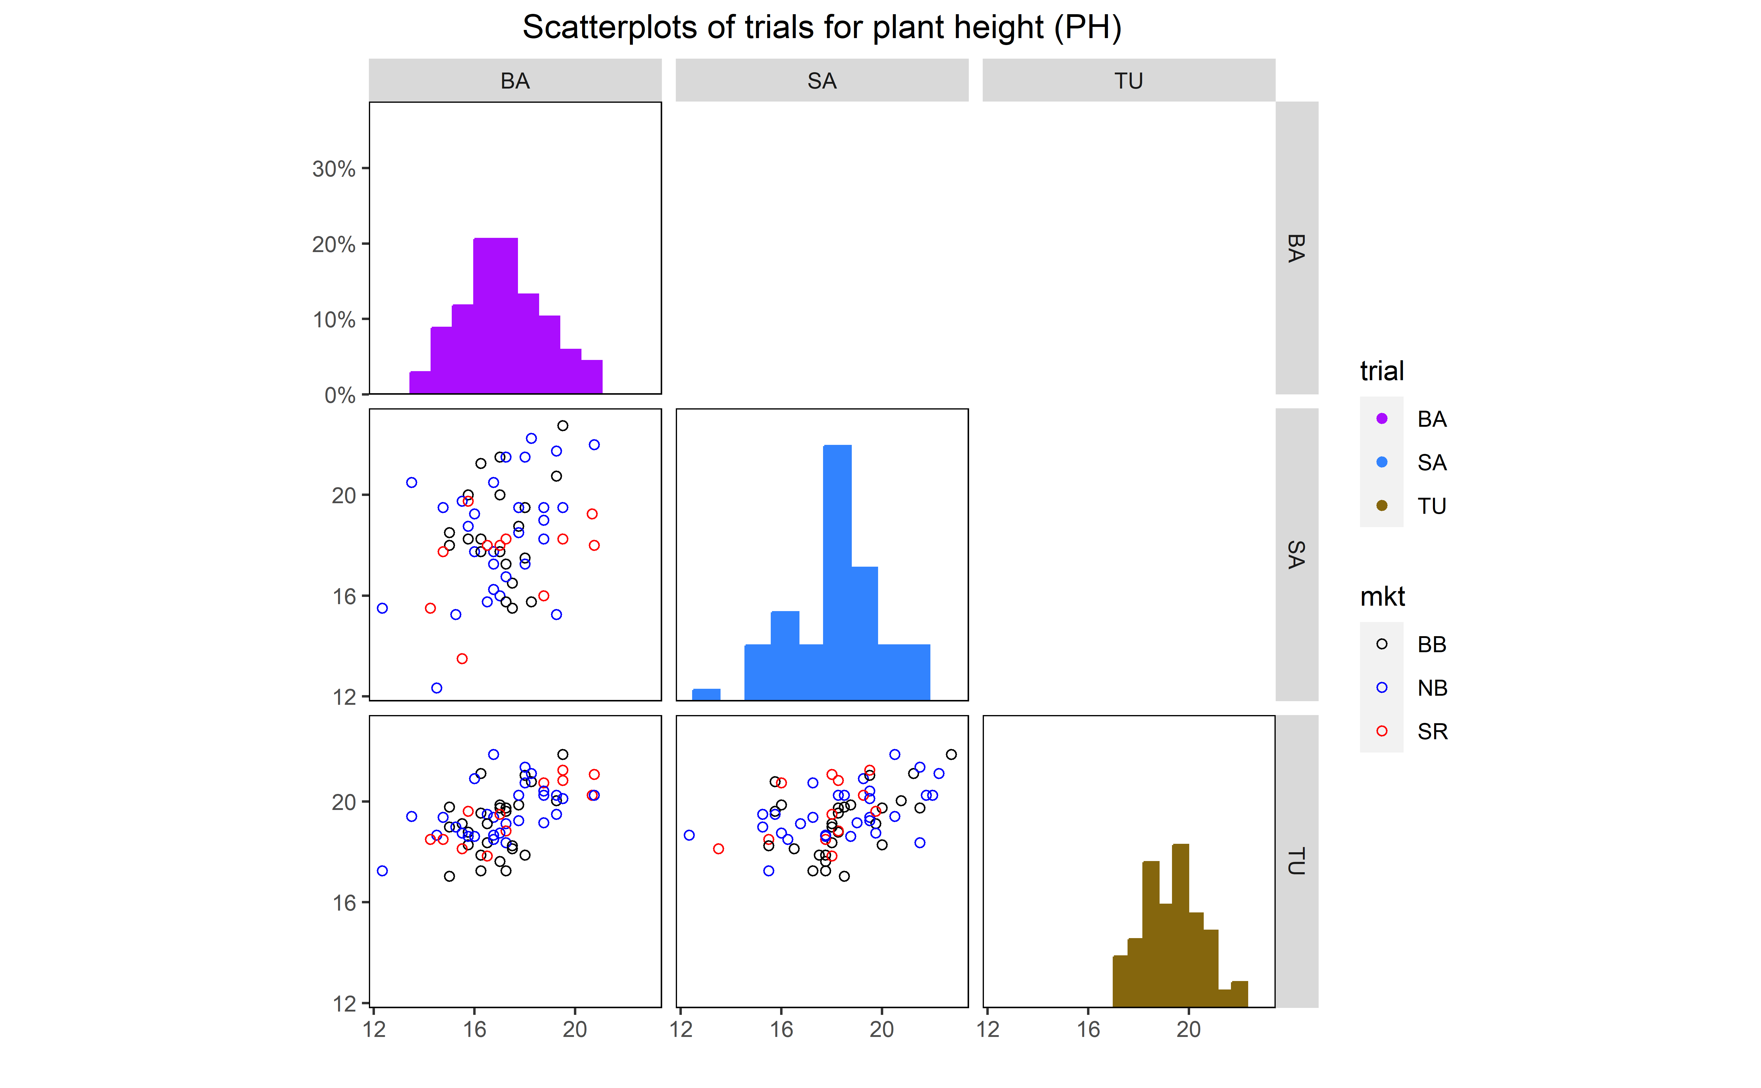

Scatterplot matrix of trials for plant height (PH). The diagonal shows the distribution and the bottom left shows the scatter points for PH in each location.

### 5.2.6 Scatter plot distribuation LD

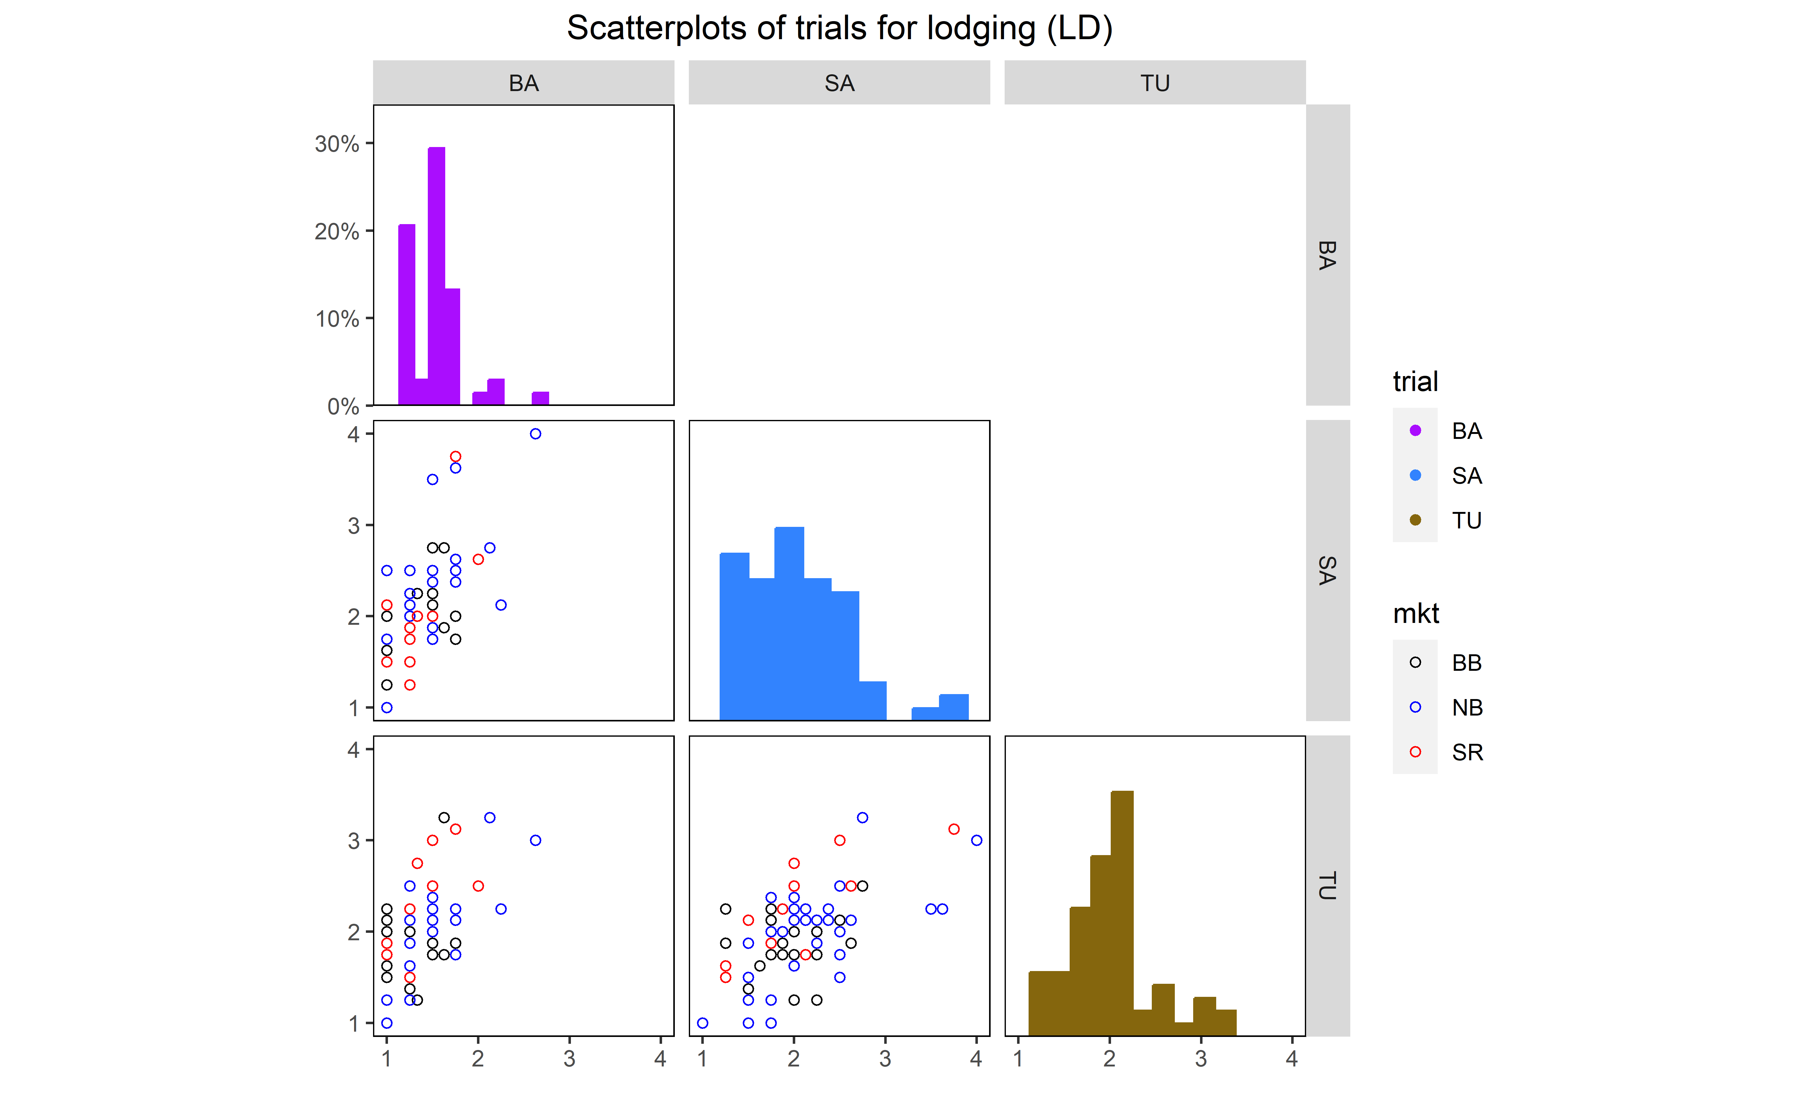

Scatterplot matrix of trials for lodging (LD). The diagonal shows the distribution and the bottom left shows the scatter points for LD in each location.

### 5.2.7 Missing values

#str(data_beans_compl)  
gg_miss_fct(data_beans_compl,fct = mkt)+ggtitle("Missing values (NA)") +  
 theme(axis.text.x=element_text(face="bold", size = 12),   
 axis.text.y = element_text(face = "bold",size = 12) ,  
 title = element_text(face = "bold",size = 14))

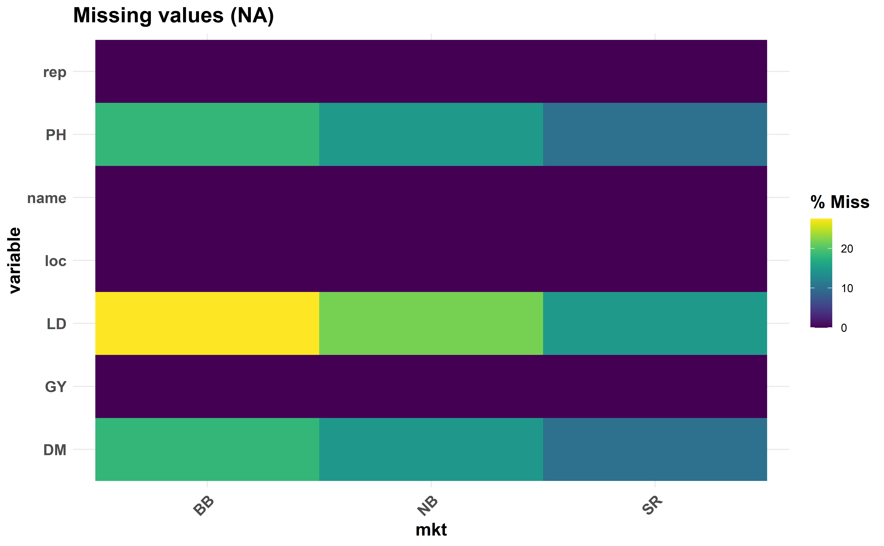

Missing genotypes by market classes

### 5.2.8 Linear phenotypic correlation

corr_plot(data_beans_compl,  
 col.by = loc, # Different color for each level of ENV  
 alpha.point = 0.5, # Color transparency of the points  
 size.point = 0.3, # Size of the point  
 size.line = 0.1) # The size of the line

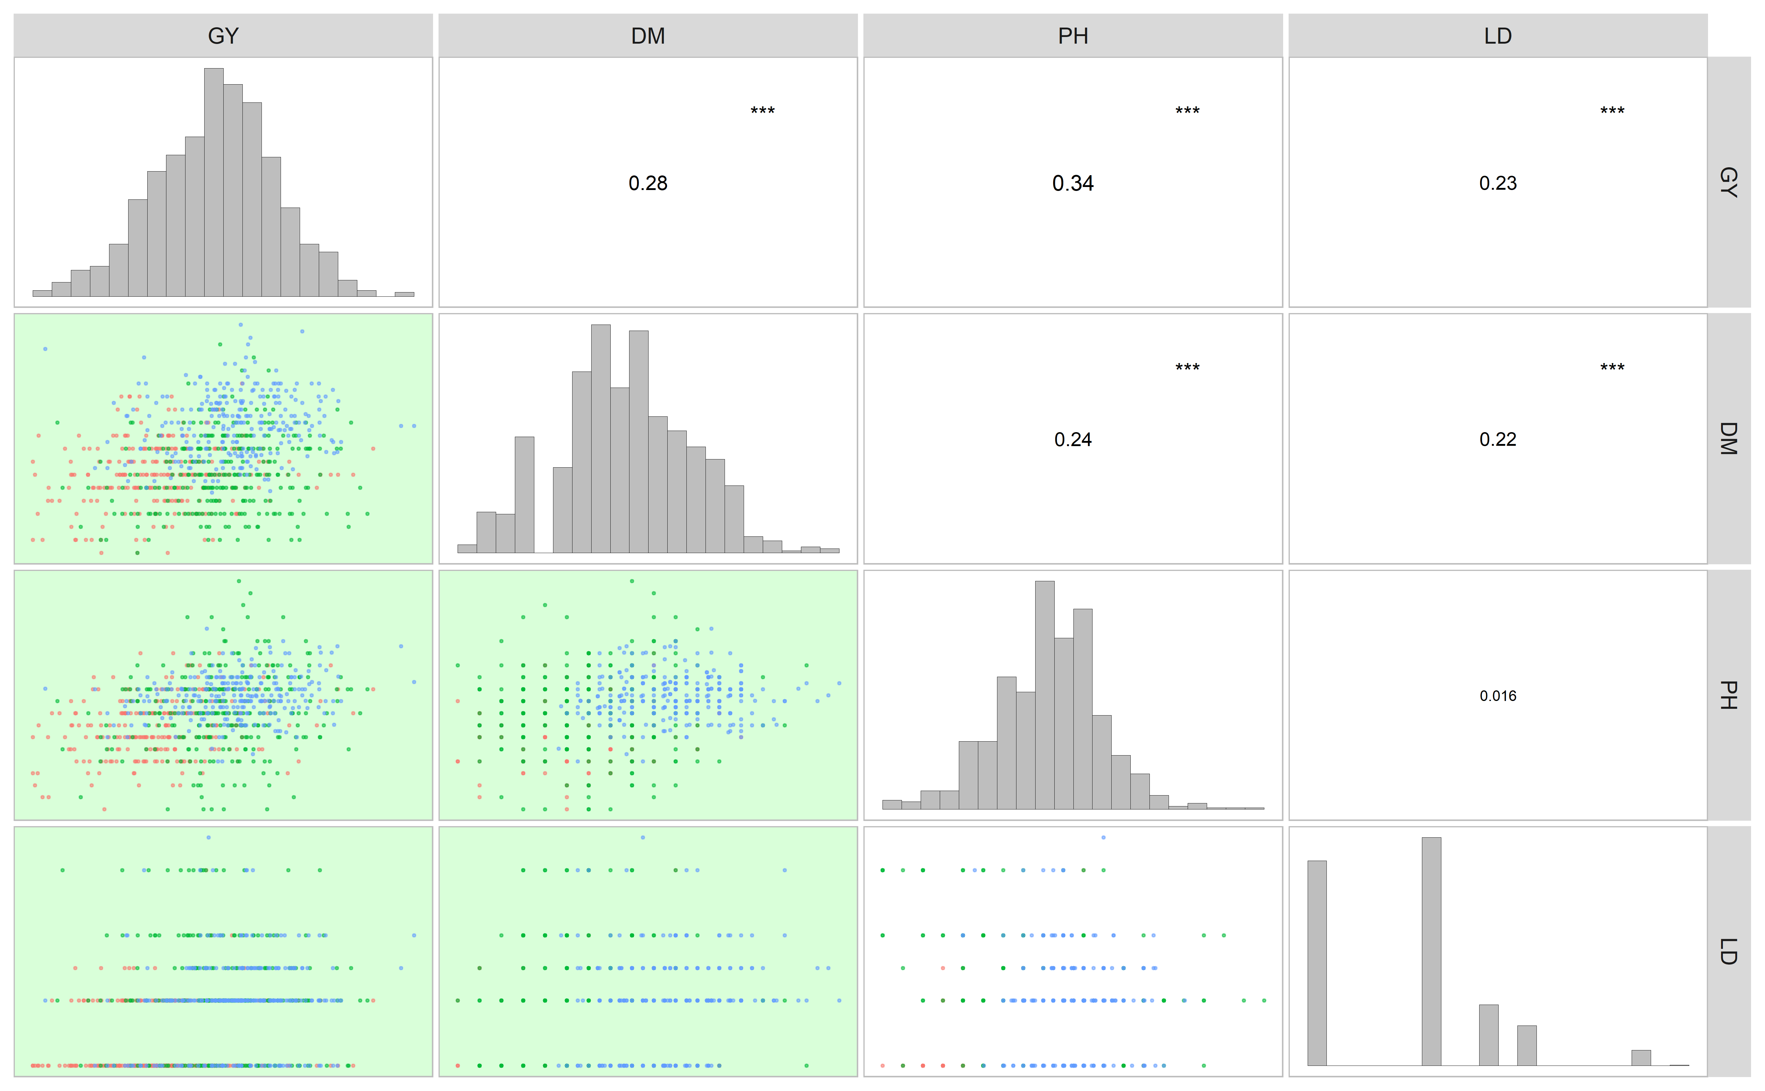

Pearson’s linear correlation between the studied traits. The lower diagonal shows the scatter plot where the environments are mapped with diferent point colors (BA = green, SA = salmon, TU = cyan)

## 5.3 Multi-trait stability index and selection gains

* For this study, the goal to response variables GY, DM, PH and LD are:
  + GY: higher (increase)
  + DM: smaller (decrease)
  + PH: higher (increase)
  + LD: smaller (decrease)
* The weights for the response variable are:
  + GY: 60 (60 yielding and 40 stability)
  + DM: 40 (40 maturity and 60 stability)
  + PH: 40 (40 height and 60 stability)
  + LD: 40 (40 lodging and 60 stability)
* Selection intensity (SI) of 20%

## 5.4 Black beans

data_beans_BB <- droplevels(subset(data_beans_compl, mkt == "BB"))  
  
data_beans_BB <- droplevels(na.omit(data_beans_BB))  
#str(data_beans_BB)

### 5.4.1 Multi-trait index selection

waasb_model_bb.1 <- waasb(data_beans_BB,  
 env = loc,  
 gen = name,  
 rep = rep,  
 resp = everything(),  
 random = "gen", #Default  
 verbose = F,  
 wresp = c(60, 40, 40, 40),  
 mresp = c("h,l,h,l") ) #'GY', 'DM', 'PH', LD  
 #weight for response variable 60 and 40 for yielding and stability, respectively)  
  
options(digits = 3)  
mtsi1 = mtsi(waasb_model_bb.1, index = "waasby", SI = 20, mineval = 1, verbose = F)  
  
Sel_waasb <- sel_gen(mtsi1)  
  
mtsi1_resul<- mtsi1$sel_dif_trait  
  
 if (knitr::is_html_output()) {  
   
 print_table(mtsi1_resul[,1:6])  
   
}else{  
   
mtsi1_resul[,1:6]  
}

| **VAR** | **Factor** | **Xo** | **Xs** | **SD** | **SDperc** |
| --- | --- | --- | --- | --- | --- |
| **character** | **character** | **numeric** | **numeric** | **numeric** | **numeric** |
| GY | FA 1 | 3,200.6 | 3,258.5 | 57.9 | 1.8 |
| LD | FA 1 | 1.7 | 1.6 | -0.1 | -5.6 |
| DM | FA 2 | 91.8 | 91.9 | 0.1 | 0.1 |
| PH | FA 2 | 18.1 | 18.3 | 0.2 | 1.1 |

### 5.4.2 Model outputs

#### 5.4.2.1 Variance plot

plot(waasb_model_bb.1,  
type = "vcomp", # Chose the type of plot.  
width.bar = 1, # No spaces between the bars  
size.line = 0.3) + # Controls the size of the line  
geom_hline(yintercept = 0.5, linetype = 2) # Add the dashed line

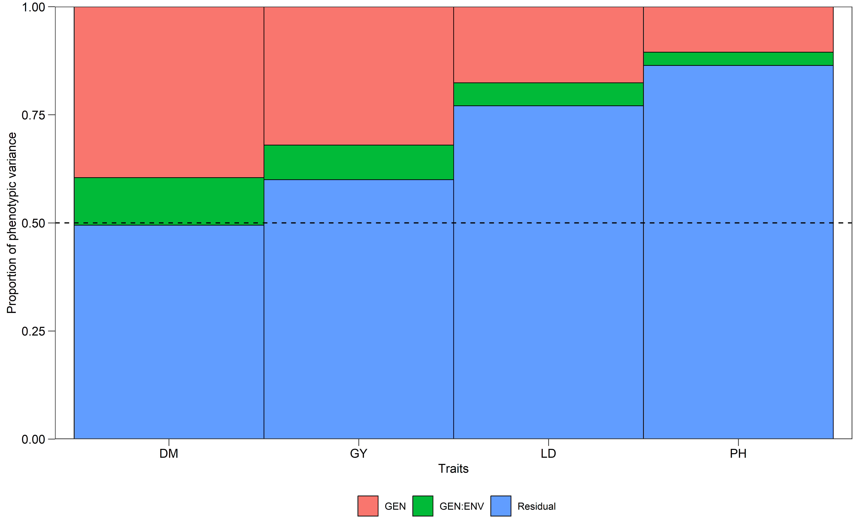

#### 5.4.2.2 Likelihood-ratio test

get_model_data(waasb_model_bb.1, "lrt")

#> Class of the model: waasb

#> Variable extracted: lrt

| **VAR** | **model** | **npar** | **logLik** | **AIC** | **LRT** | **Df** | **Pr(>Chisq)** |
| --- | --- | --- | --- | --- | --- | --- | --- |
| **character** | **character** | **integer** | **numeric** | **numeric** | **numeric** | **numeric** | **numeric** |
| GY | GEN | 14 | -2,333.5 | 4,695.1 | 25.1 | 1 | 0.0 |
| GY | GEN:ENV | 14 | -2,322.9 | 4,673.9 | 4.0 | 1 | 0.0 |
| DM | GEN | 14 | -720.5 | 1,469.0 | 30.2 | 1 | 0.0 |
| DM | GEN:ENV | 14 | -710.2 | 1,448.5 | 9.7 | 1 | 0.0 |
| PH | GEN | 14 | -733.1 | 1,494.3 | 6.1 | 1 | 0.0 |
| PH | GEN:ENV | 14 | -730.3 | 1,488.5 | 0.4 | 1 | 0.5 |
| LD | GEN | 14 | -289.8 | 607.5 | 12.3 | 1 | 0.0 |
| LD | GEN:ENV | 14 | -284.3 | 596.6 | 1.3 | 1 | 0.2 |

#### 5.4.2.3 Variance components

get_model_data(waasb_model_bb.1, "vcomp")

#> Class of the model: waasb

#> Variable extracted: vcomp

| **Group** | **GY** | **DM** | **PH** | **LD** |
| --- | --- | --- | --- | --- |
| **character** | **numeric** | **numeric** | **numeric** | **numeric** |
| GEN | 68,571.6 | 2.9 | 0.6 | 0.1 |
| GEN:ENV | 17,115.1 | 0.8 | 0.2 | 0.0 |
| Residual | 128,582.1 | 3.6 | 5.2 | 0.3 |

#### 5.4.2.4 Genetic parameters

get_model_data(waasb_model_bb.1, "genpar")

#> Class of the model: waasb

#> Variable extracted: genpar

| **Parameters** | **GY** | **DM** | **PH** | **LD** |
| --- | --- | --- | --- | --- |
| **character** | **numeric** | **numeric** | **numeric** | **numeric** |
| Phenotypic variance | 214,268.9 | 7.2 | 6.0 | 0.4 |
| Heritability | 0.3 | 0.4 | 0.1 | 0.2 |
| GEIr2 | 0.1 | 0.1 | 0.0 | 0.1 |
| h2mg | 0.8 | 0.8 | 0.6 | 0.7 |
| Accuracy | 0.9 | 0.9 | 0.7 | 0.8 |
| rge | 0.1 | 0.2 | 0.0 | 0.1 |
| CVg | 8.2 | 1.8 | 4.4 | 14.5 |
| CVr | 11.2 | 2.1 | 12.5 | 30.3 |
| CV ratio | 0.7 | 0.9 | 0.3 | 0.5 |

#### 5.4.2.5 Models details

get_model_data(waasb_model_bb.1, "details")

#> Class of the model: waasb

#> Variable extracted: details

| **Parameters** | **GY** | **DM** | **PH** | **LD** |
| --- | --- | --- | --- | --- |
| **character** | **character** | **character** | **character** | **character** |
| Mean | 3199.25 | 91.77 | 18.14 | 1.73 |
| SE | 30.37 | 0.19 | 0.15 | 0.04 |
| SD | 544.12 | 3.32 | 2.67 | 0.67 |
| CV | 17.03 | 3.63 | 14.75 | 38.72 |
| Min | 1601.88 (B43 in BA) | 84 (B22 in BA) | 10 (B27 in BA) | 1 (B1 in BA) |
| Max | 4524.05 (B26 in BA) | 101.5 (B61 in TU) | 28 (B40 in SA) | 4 (B25 in SA) |
| MinENV | BA (2828.83) | BA (89.91) | BA (16.86) | BA (1.32) |
| MaxENV | TU (3405.26) | TU (94.44) | TU (19.13) | SA (1.96) |
| MinGEN | B45 (2570.2) | B45 (87.33) | B60 (16.85) | B14 (1.25) |
| n: 14 | | | | |

#### 5.4.2.6 Fixed effects

get_model_data(waasb_model_bb.1, "fixed")

#> Class of the model: waasb

#> Variable extracted: fixed

| **VAR** | **SOURCE** | **Sum Sq** | **Mean Sq** | **NumDF** | **DenDF** | **F value** | **Pr(>F)** |
| --- | --- | --- | --- | --- | --- | --- | --- |
| **character** | **character** | **numeric** | **numeric** | **integer** | **numeric** | **numeric** | **numeric** |
| GY | ENV | 3,275,190.1 | 1,637,595.1 | 2 | 243.1 | 12.7 | 0.0 |
| GY | ENV:REP | 6,661,855.0 | 740,206.1 | 9 | 229.8 | 5.8 | 0.0 |
| DM | ENV | 303.7 | 151.9 | 2 | 221.8 | 42.4 | 0.0 |
| DM | ENV:REP | 110.2 | 12.2 | 9 | 232.4 | 3.4 | 0.0 |
| PH | ENV | 47.2 | 23.6 | 2 | 267.7 | 4.6 | 0.0 |
| PH | ENV:REP | 152.1 | 16.9 | 9 | 233.3 | 3.3 | 0.0 |
| LD | ENV | 7.1 | 3.6 | 2 | 260.5 | 13.0 | 0.0 |
| LD | ENV:REP | 6.1 | 0.7 | 9 | 233.1 | 2.5 | 0.0 |

#### 5.4.2.7 Enviroment means

get_model_data(waasb_model_bb.1, "blupge") %>%  
 means_by(ENV)

#> Class of the model: waasb

#> Variable extracted: blupge

| **ENV** | **GY** | **DM** | **PH** | **LD** |
| --- | --- | --- | --- | --- |
| **factor** | **numeric** | **numeric** | **numeric** | **numeric** |
| BA | 2,835.2 | 89.9 | 16.9 | 1.3 |
| SA | 3,362.1 | 91.0 | 18.4 | 2.0 |
| TU | 3,401.9 | 94.4 | 19.1 | 1.9 |

### 5.4.3 Selection Description

#### 5.4.3.1 Genotype ranking

* Varieties ranking based on the multi-trait stability index. Selected varieties are highlighted in red.

# Get the random effects  
#get_model_data(waasb_model_bb.1, what = "ranef")   
  
mtsi1_value<- mtsi1$MTSI  
  
#plot(mtsi1,arrange.label = TRUE)  
  
p2 = plot(mtsi1, SI = 20, radar = FALSE) +  
 coord_flip() +  
 theme_bw() +  
 labs(x = "Genotypes", y = "multi-trait stability index") +  
 theme(legend.position = c(0.2, 0.9),  
 legend.background = element_blank(),  
 legend.key = element_blank(),  
 legend.title = element_blank())  
print(p2)

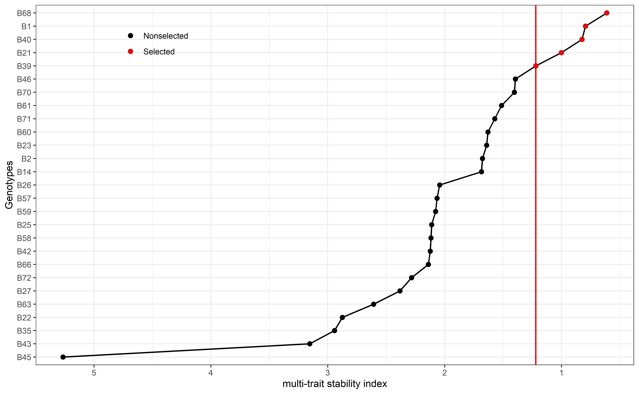

Cultivars ranking based on the multi-trait stability index. Selected cultivars are highlighted in red.

Sel_waasb

#> [1] "B68" "B1" "B40" "B21" "B39"

#### 5.4.3.2 Mean performance and stability for GY

p1<- plot_selected(blups_sel, GEN, GY, blups_sel_mean_GY$mean_GY)  
p2<- plot_selected(waasb_sel, GEN, GY, waasb_sel_mean_GY$mean_GY) + labs(y = "WAASB index")  
  
arrange_ggplot(p1, p2,  
 guides = "collect",  
 tag_levels = "a",  
 tag_prefix = "(",  
 tag_suffix = ")")

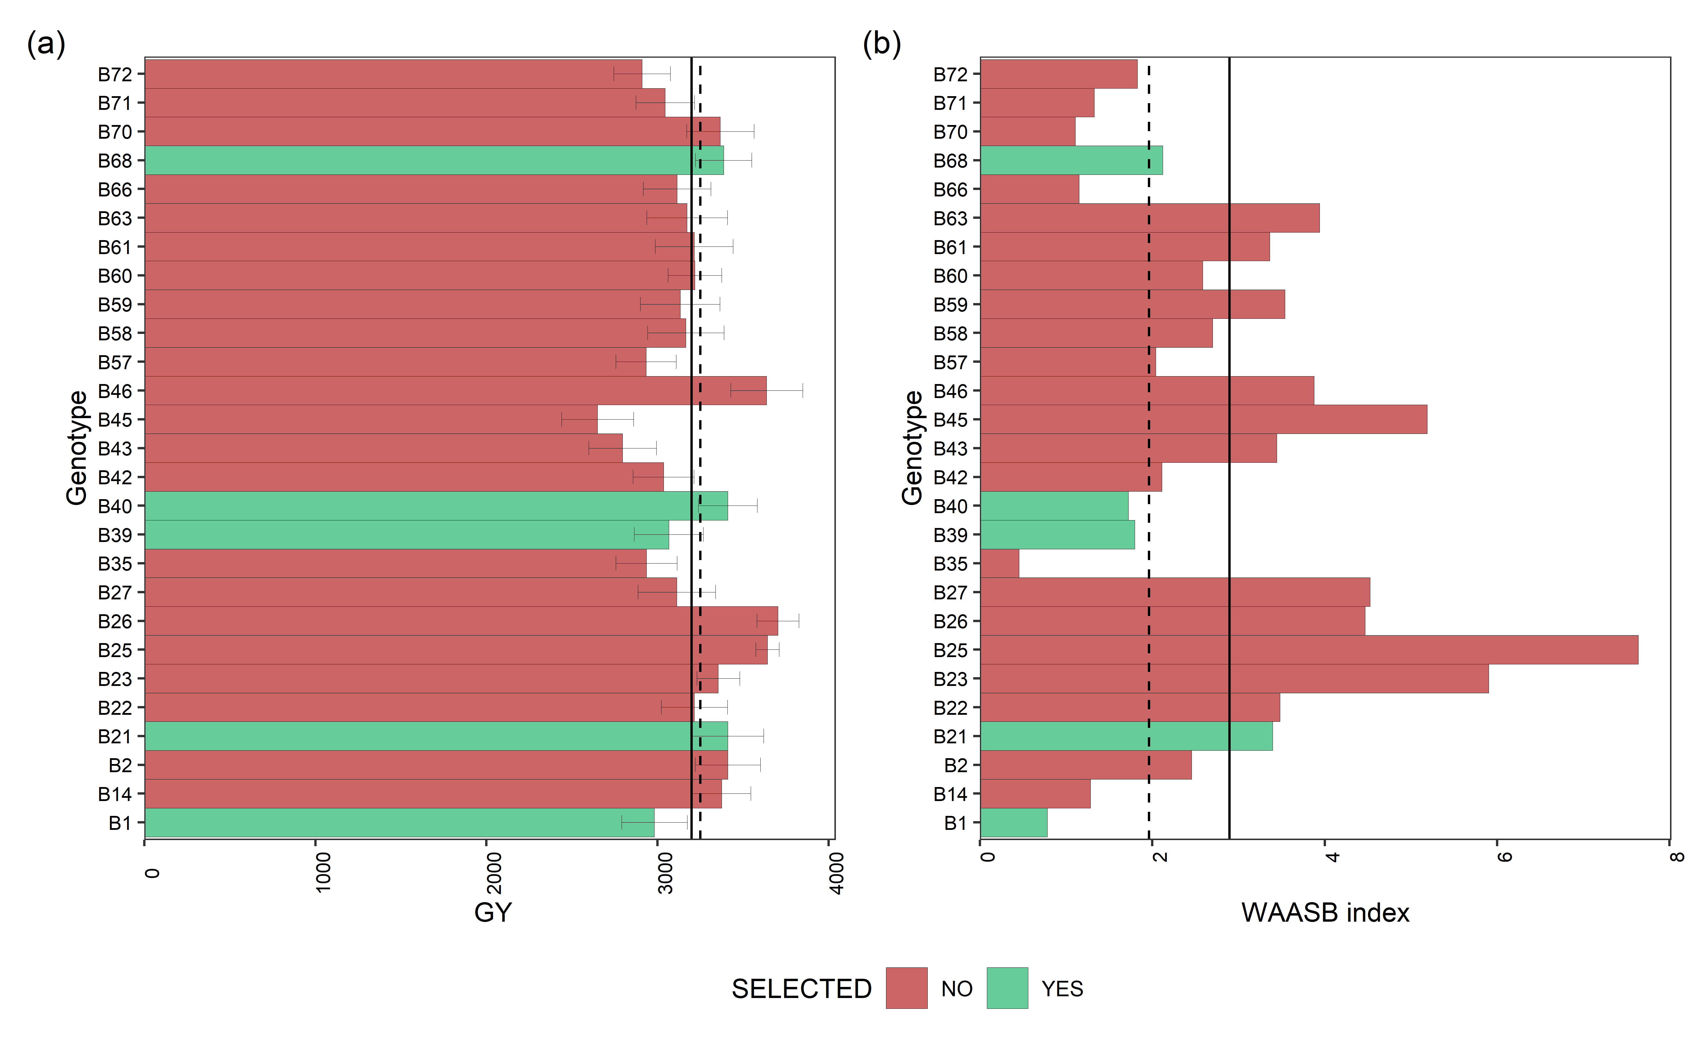

Mean performance (a) and stability (b) for grain yield (GY) of 27 black beans genotypes. The vertical dashed and solid lines shows, respectivelly, the mean of the selected genotype and the overall mean for both mean performance and WAASB index

#### 5.4.3.3 Mean performance and stability for DM

p1<- plot_selected(blups_sel, GEN, DM, blups_sel_mean_DM$mean_DM)  
p2<- plot_selected(waasb_sel, GEN, DM, waasb_sel_mean_DM$mean_DM) + labs(y = "WAASB index")  
  
arrange_ggplot(p1, p2,  
 guides = "collect",  
 tag_levels = "a",  
 tag_prefix = "(",  
 tag_suffix = ")")

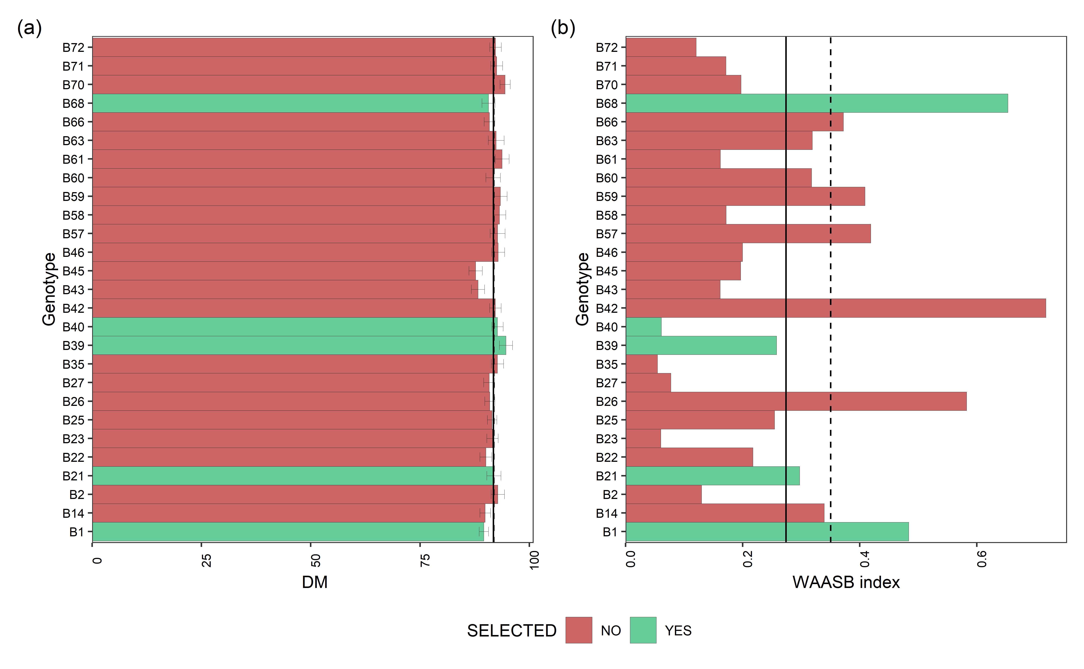

Mean performance (a) and stability (b) for days of maturity (DM) of 27 black beans genotypes. The vertical dashed and solid lines shows, respectivelly, the mean of the selected genotype and the overall mean for both mean performance and WAASB index

#### 5.4.3.4 Mean performance and stability for PH

p1<- plot_selected(blups_sel, GEN, PH, blups_sel_mean_PH$mean_PH)  
p2<- plot_selected(waasb_sel, GEN, PH, waasb_sel_mean_PH$mean_PH) + labs(y = "WAASB index")  
  
arrange_ggplot(p1, p2,  
 guides = "collect",  
 tag_levels = "a",  
 tag_prefix = "(",  
 tag_suffix = ")")

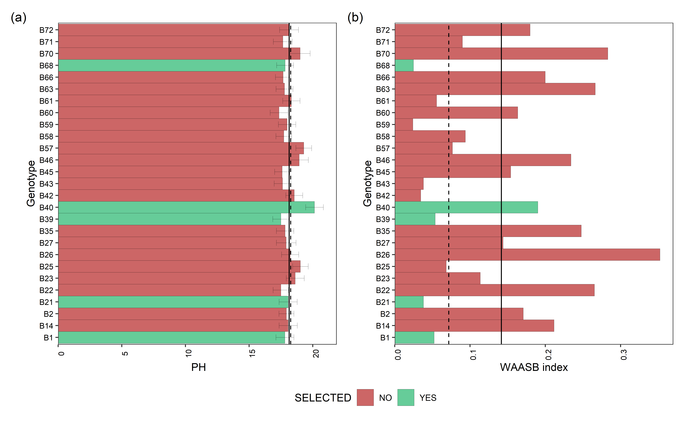

Mean performance (a) and stability (b) for plant height (PH) of 27 black beans genotypes. The vertical dashed and solid lines shows, respectivelly, the mean of the selected genotype and the overall mean for both mean performance and WAASB index

#### 5.4.3.5 Mean performance and stability for LD

p1<- plot_selected(blups_sel, GEN, LD, blups_sel_mean_LD$mean_LD)  
p2<- plot_selected(waasb_sel, GEN, LD, waasb_sel_mean_LD$mean_LD) + labs(y = "WAASB index")  
  
arrange_ggplot(p1, p2,  
 guides = "collect",  
 tag_levels = "a",  
 tag_prefix = "(",  
 tag_suffix = ")")

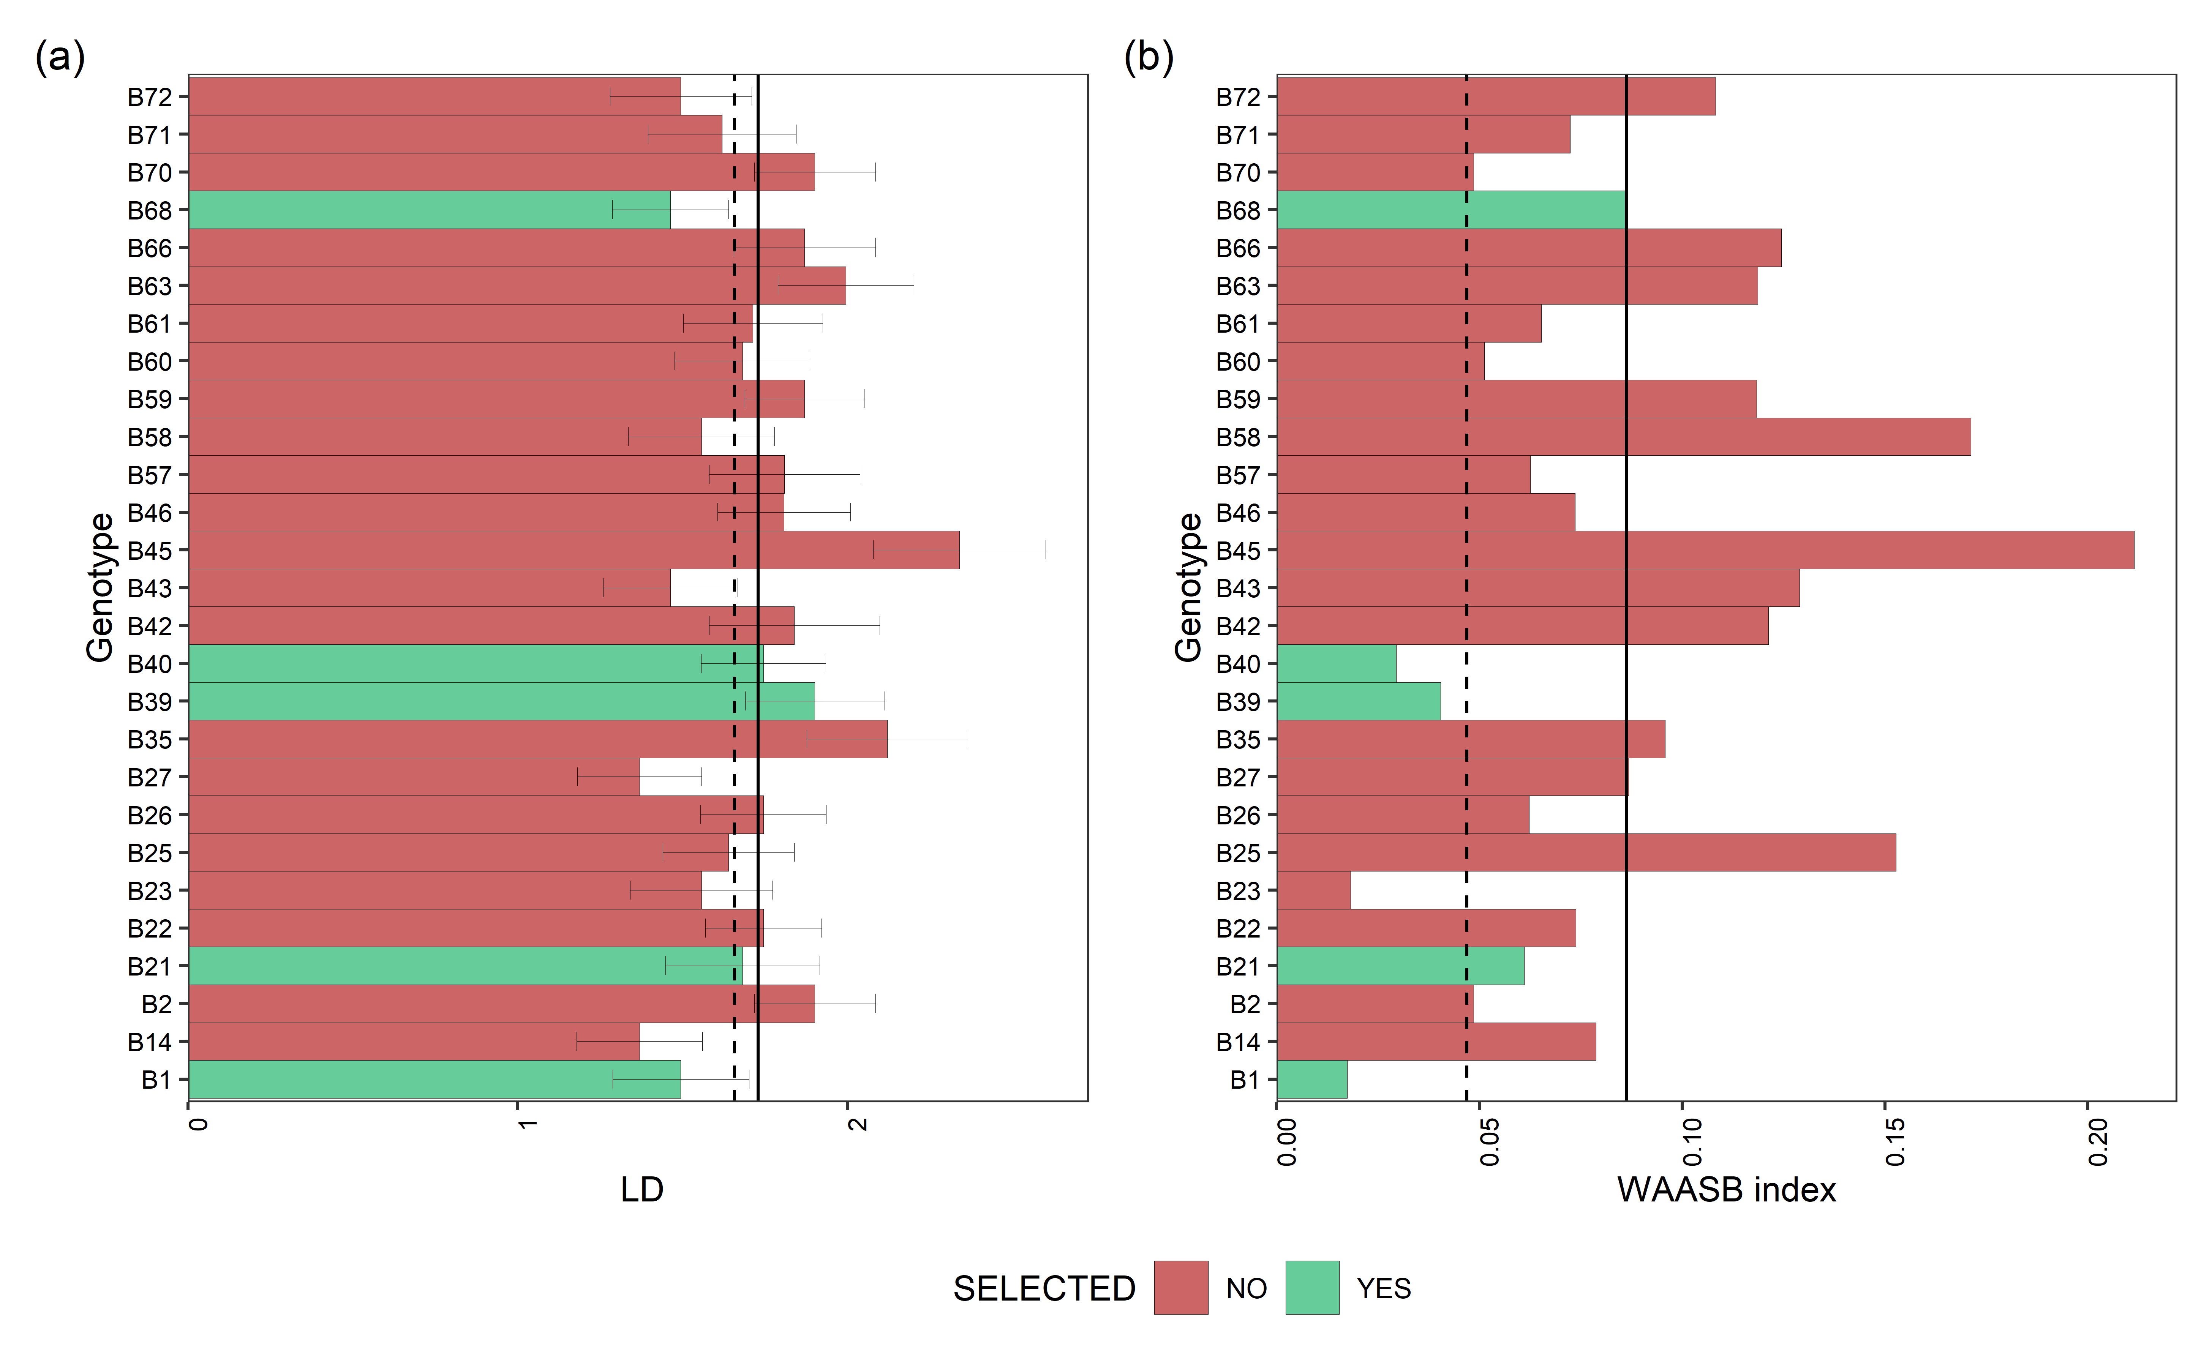

Mean performance (a) and stability (b) for lodging (LD) of 27 black beans genotypes. The vertical dashed and solid lines shows, respectivelly, the mean of the selected genotype and the overall mean for both mean performance and WAASB index

## 5.5 Navy beans

data_beans_NB <- droplevels(subset(data_beans_compl, mkt == "NB"))  
  
data_beans_NB <- droplevels(na.omit(data_beans_NB))  
  
#str(data_beans_NB)

### 5.5.1 Multi-trait index selection

waasb_model_nb.1 <- waasb(data_beans_NB,  
 env = loc,  
 gen = name,  
 rep = rep,  
 resp = everything(),  
 random = "gen", #Default  
 verbose = F,  
 wresp = c(60, 40, 40, 40),  
 mresp = c("h, l,h, l") ) #'GY', 'DM', 'PH', LD  
 #weight for response variable 60 and 40 for yielding and stability, respectively)  
  
options(digits = 3)  
mtsi1 = mtsi(waasb_model_nb.1, index = "waasby", SI = 20, mineval = 1, verbose = F)  
  
mtsi1_resul<- mtsi1$sel_dif_trait  
  
Sel_waasb <- sel_gen(mtsi1)  
  
 if (knitr::is_html_output()) {  
   
 print_table(mtsi1_resul[,1:6])  
   
}else{  
   
mtsi1_resul[,1:6]  
}

| **VAR** | **Factor** | **Xo** | **Xs** | **SD** | **SDperc** |
| --- | --- | --- | --- | --- | --- |
| **character** | **character** | **numeric** | **numeric** | **numeric** | **numeric** |
| GY | FA 1 | 3,006.1 | 3,145.0 | 138.9 | 4.6 |
| DM | FA 1 | 91.3 | 91.5 | 0.3 | 0.3 |
| PH | FA 1 | 18.3 | 19.7 | 1.4 | 7.4 |
| LD | FA 1 | 1.9 | 1.7 | -0.2 | -11.9 |

### 5.5.2 Model outputs

#### 5.5.2.1 Variance plot

plot(waasb_model_nb.1,  
type = "vcomp", # Chose the type of plot.  
width.bar = 1, # No spaces between the bars  
size.line = 0.3) + # Controls the size of the line  
geom_hline(yintercept = 0.5, linetype = 2) # Add the dashed line

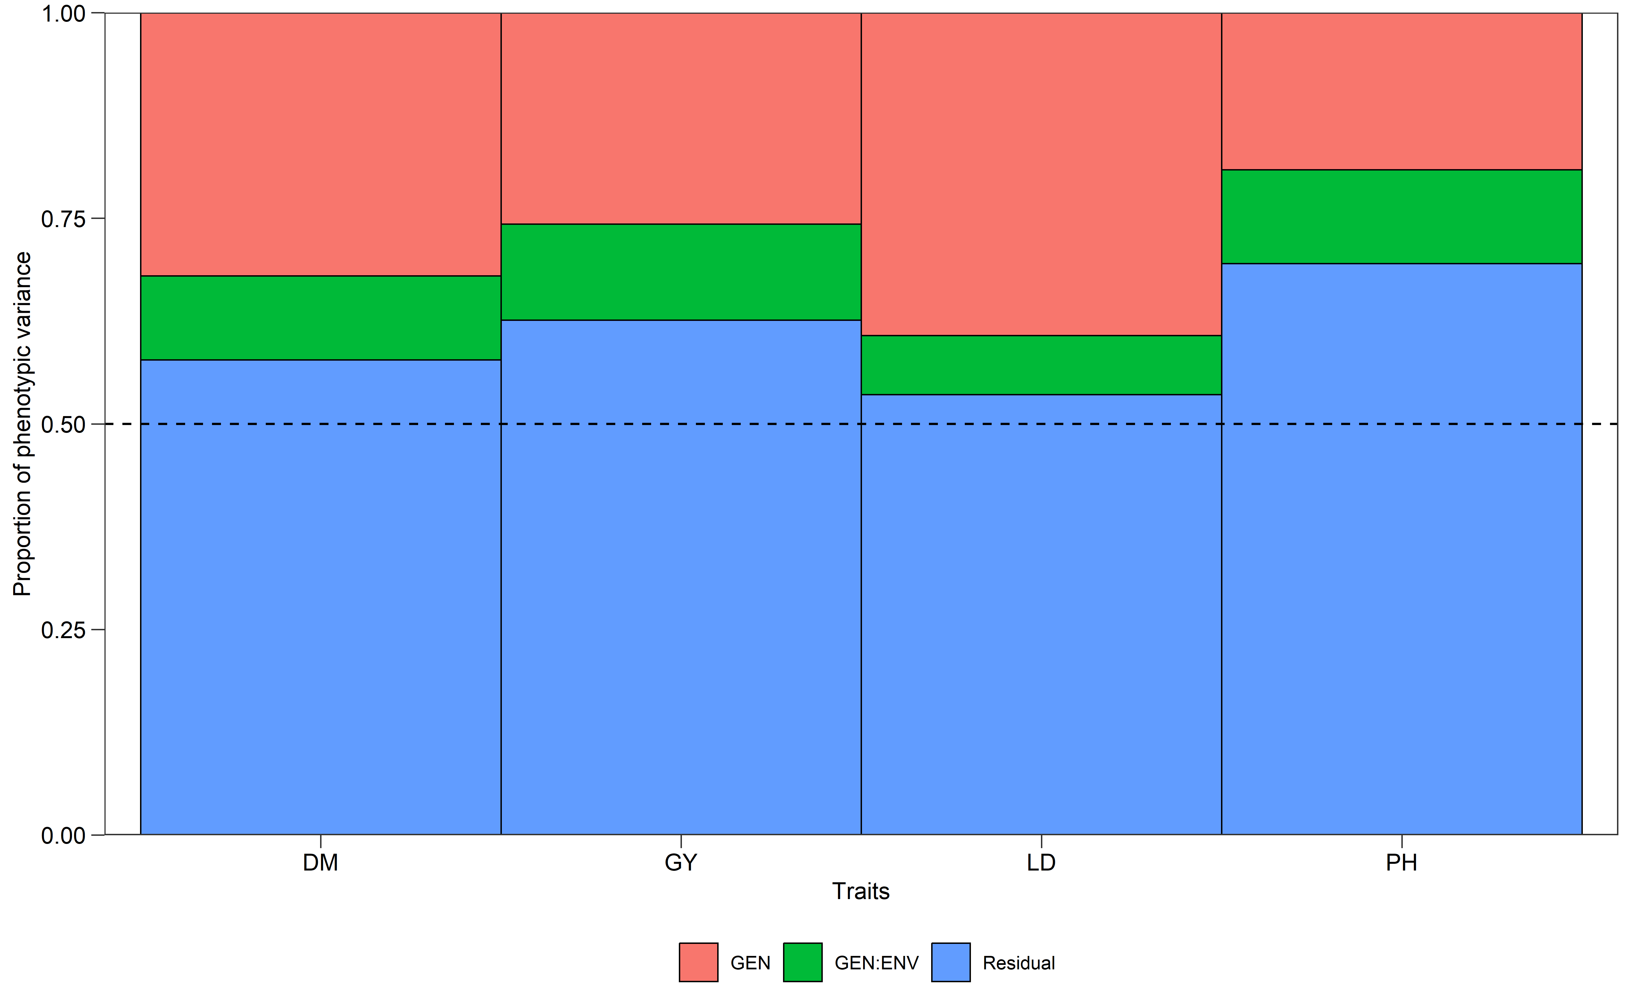

#### 5.5.2.2 Likelihood-ratio test

get_model_data(waasb_model_nb.1, "lrt")

#> Class of the model: waasb

#> Variable extracted: lrt

| **VAR** | **model** | **npar** | **logLik** | **AIC** | **LRT** | **Df** | **Pr(>Chisq)** |
| --- | --- | --- | --- | --- | --- | --- | --- |
| **character** | **character** | **integer** | **numeric** | **numeric** | **numeric** | **numeric** | **numeric** |
| GY | GEN | 14 | -2,501.2 | 5,030.4 | 17.9 | 1 | 0.0 |
| GY | GEN:ENV | 14 | -2,496.2 | 5,020.3 | 7.8 | 1 | 0.0 |
| DM | GEN | 14 | -763.5 | 1,555.0 | 25.4 | 1 | 0.0 |
| DM | GEN:ENV | 14 | -754.4 | 1,536.8 | 7.2 | 1 | 0.0 |
| PH | GEN | 14 | -803.6 | 1,635.2 | 12.1 | 1 | 0.0 |
| PH | GEN:ENV | 14 | -800.6 | 1,629.3 | 6.1 | 1 | 0.0 |
| LD | GEN | 14 | -335.4 | 698.9 | 36.0 | 1 | 0.0 |
| LD | GEN:ENV | 14 | -319.7 | 667.4 | 4.5 | 1 | 0.0 |

#### 5.5.2.3 Variance components

get_model_data(waasb_model_nb.1, "vcomp")

#> Class of the model: waasb

#> Variable extracted: vcomp

| **Group** | **GY** | **DM** | **PH** | **LD** |
| --- | --- | --- | --- | --- |
| **character** | **numeric** | **numeric** | **numeric** | **numeric** |
| GEN | 50,195.5 | 2.0 | 1.4 | 0.2 |
| GEN:ENV | 22,779.4 | 0.6 | 0.8 | 0.0 |
| Residual | 122,206.2 | 3.6 | 4.9 | 0.3 |

#### 5.5.2.4 Genetic parameters

get_model_data(waasb_model_nb.1, "genpar")

#> Class of the model: waasb

#> Variable extracted: genpar

| **Parameters** | **GY** | **DM** | **PH** | **LD** |
| --- | --- | --- | --- | --- |
| **character** | **numeric** | **numeric** | **numeric** | **numeric** |
| Phenotypic variance | 195,181.1 | 6.2 | 7.1 | 0.5 |
| Heritability | 0.3 | 0.3 | 0.2 | 0.4 |
| GEIr2 | 0.1 | 0.1 | 0.1 | 0.1 |
| h2mg | 0.7 | 0.8 | 0.7 | 0.9 |
| Accuracy | 0.9 | 0.9 | 0.8 | 0.9 |
| rge | 0.2 | 0.2 | 0.1 | 0.1 |
| CVg | 7.4 | 1.5 | 6.3 | 23.6 |
| CVr | 11.6 | 2.1 | 12.1 | 27.6 |
| CV ratio | 0.6 | 0.7 | 0.5 | 0.9 |

#### 5.5.2.5 Models details

get_model_data(waasb_model_nb.1, "details")

#> Class of the model: waasb

#> Variable extracted: details

| **Parameters** | **GY** | **DM** | **PH** | **LD** |
| --- | --- | --- | --- | --- |
| **character** | **character** | **character** | **character** | **character** |
| Mean | 3009.36 | 91.28 | 18.37 | 1.87 |
| SE | 26.04 | 0.16 | 0.15 | 0.04 |
| SD | 483.58 | 3.02 | 2.84 | 0.77 |
| CV | 16.09 | 3.31 | 15.46 | 41.04 |
| Min | 1618.91 (N35 in BA) | 85 (N15 in BA) | 10 (N38 in SA) | 1 (N3 in BA) |
| Max | 4313.9 (N36 in SA) | 100 (N57 in SA) | 29 (N23 in SA) | 4 (N47 in BA) |
| MinENV | BA (2737.08) | SA (89.57) | BA (17.05) | BA (1.46) |
| MaxENV | TU (3195.31) | TU (93.57) | TU (19.57) | SA (2.19) |
| MinGEN | N15 (2272.31) | N15 (87.82) | N15 (15.27) | N15 (1) |
| n: 14 | | | | |

#### 5.5.2.6 Fixed effects

get_model_data(waasb_model_nb.1, "fixed")

#> Class of the model: waasb

#> Variable extracted: fixed

| **VAR** | **SOURCE** | **Sum Sq** | **Mean Sq** | **NumDF** | **DenDF** | **F value** | **Pr(>F)** |
| --- | --- | --- | --- | --- | --- | --- | --- |
| **character** | **character** | **numeric** | **numeric** | **integer** | **numeric** | **numeric** | **numeric** |
| GY | ENV | 2,987,371.0 | 1,493,685.5 | 2 | 247.7 | 12.2 | 0.0 |
| GY | ENV:REP | 2,887,992.3 | 320,888.0 | 9 | 250.1 | 2.6 | 0.0 |
| DM | ENV | 240.1 | 120.0 | 2 | 251.3 | 33.7 | 0.0 |
| DM | ENV:REP | 114.4 | 12.7 | 9 | 250.3 | 3.6 | 0.0 |
| PH | ENV | 82.4 | 41.2 | 2 | 254.2 | 8.3 | 0.0 |
| PH | ENV:REP | 66.4 | 7.4 | 9 | 247.6 | 1.5 | 0.2 |
| LD | ENV | 4.7 | 2.4 | 2 | 262.2 | 8.9 | 0.0 |
| LD | ENV:REP | 8.3 | 0.9 | 9 | 249.5 | 3.5 | 0.0 |

#### 5.5.2.7 Enviroment means

get_model_data(waasb_model_nb.1, "blupge") %>%  
 means_by(ENV)

#> Class of the model: waasb

#> Variable extracted: blupge

| **ENV** | **GY** | **DM** | **PH** | **LD** |
| --- | --- | --- | --- | --- |
| **factor** | **numeric** | **numeric** | **numeric** | **numeric** |
| BA | 2,732.0 | 90.6 | 17.0 | 1.5 |
| SA | 3,094.1 | 89.6 | 18.5 | 2.2 |
| TU | 3,195.3 | 93.6 | 19.6 | 2.0 |

### 5.5.3 Selection Description

#### 5.5.3.1 Genotype ranking

* Varieties ranking based on the multi-trait stability index. Selected varieties are highlighted in red.

# Get the random effects  
#get_model_data(waasb_model_nb.1, what = "ranef")   
  
mtsi1_value<- mtsi1$MTSI  
  
#plot(mtsi1,arrange.label = TRUE)  
  
p2 = plot(mtsi1, SI = 20, radar = FALSE) +  
 coord_flip() +  
 theme_bw() +  
 labs(x = "Genotypes", y = "multi-trait stability index") +  
 theme(legend.position = c(0.2, 0.9),  
 legend.background = element_blank(),  
 legend.key = element_blank(),  
 legend.title = element_blank())  
print(p2)

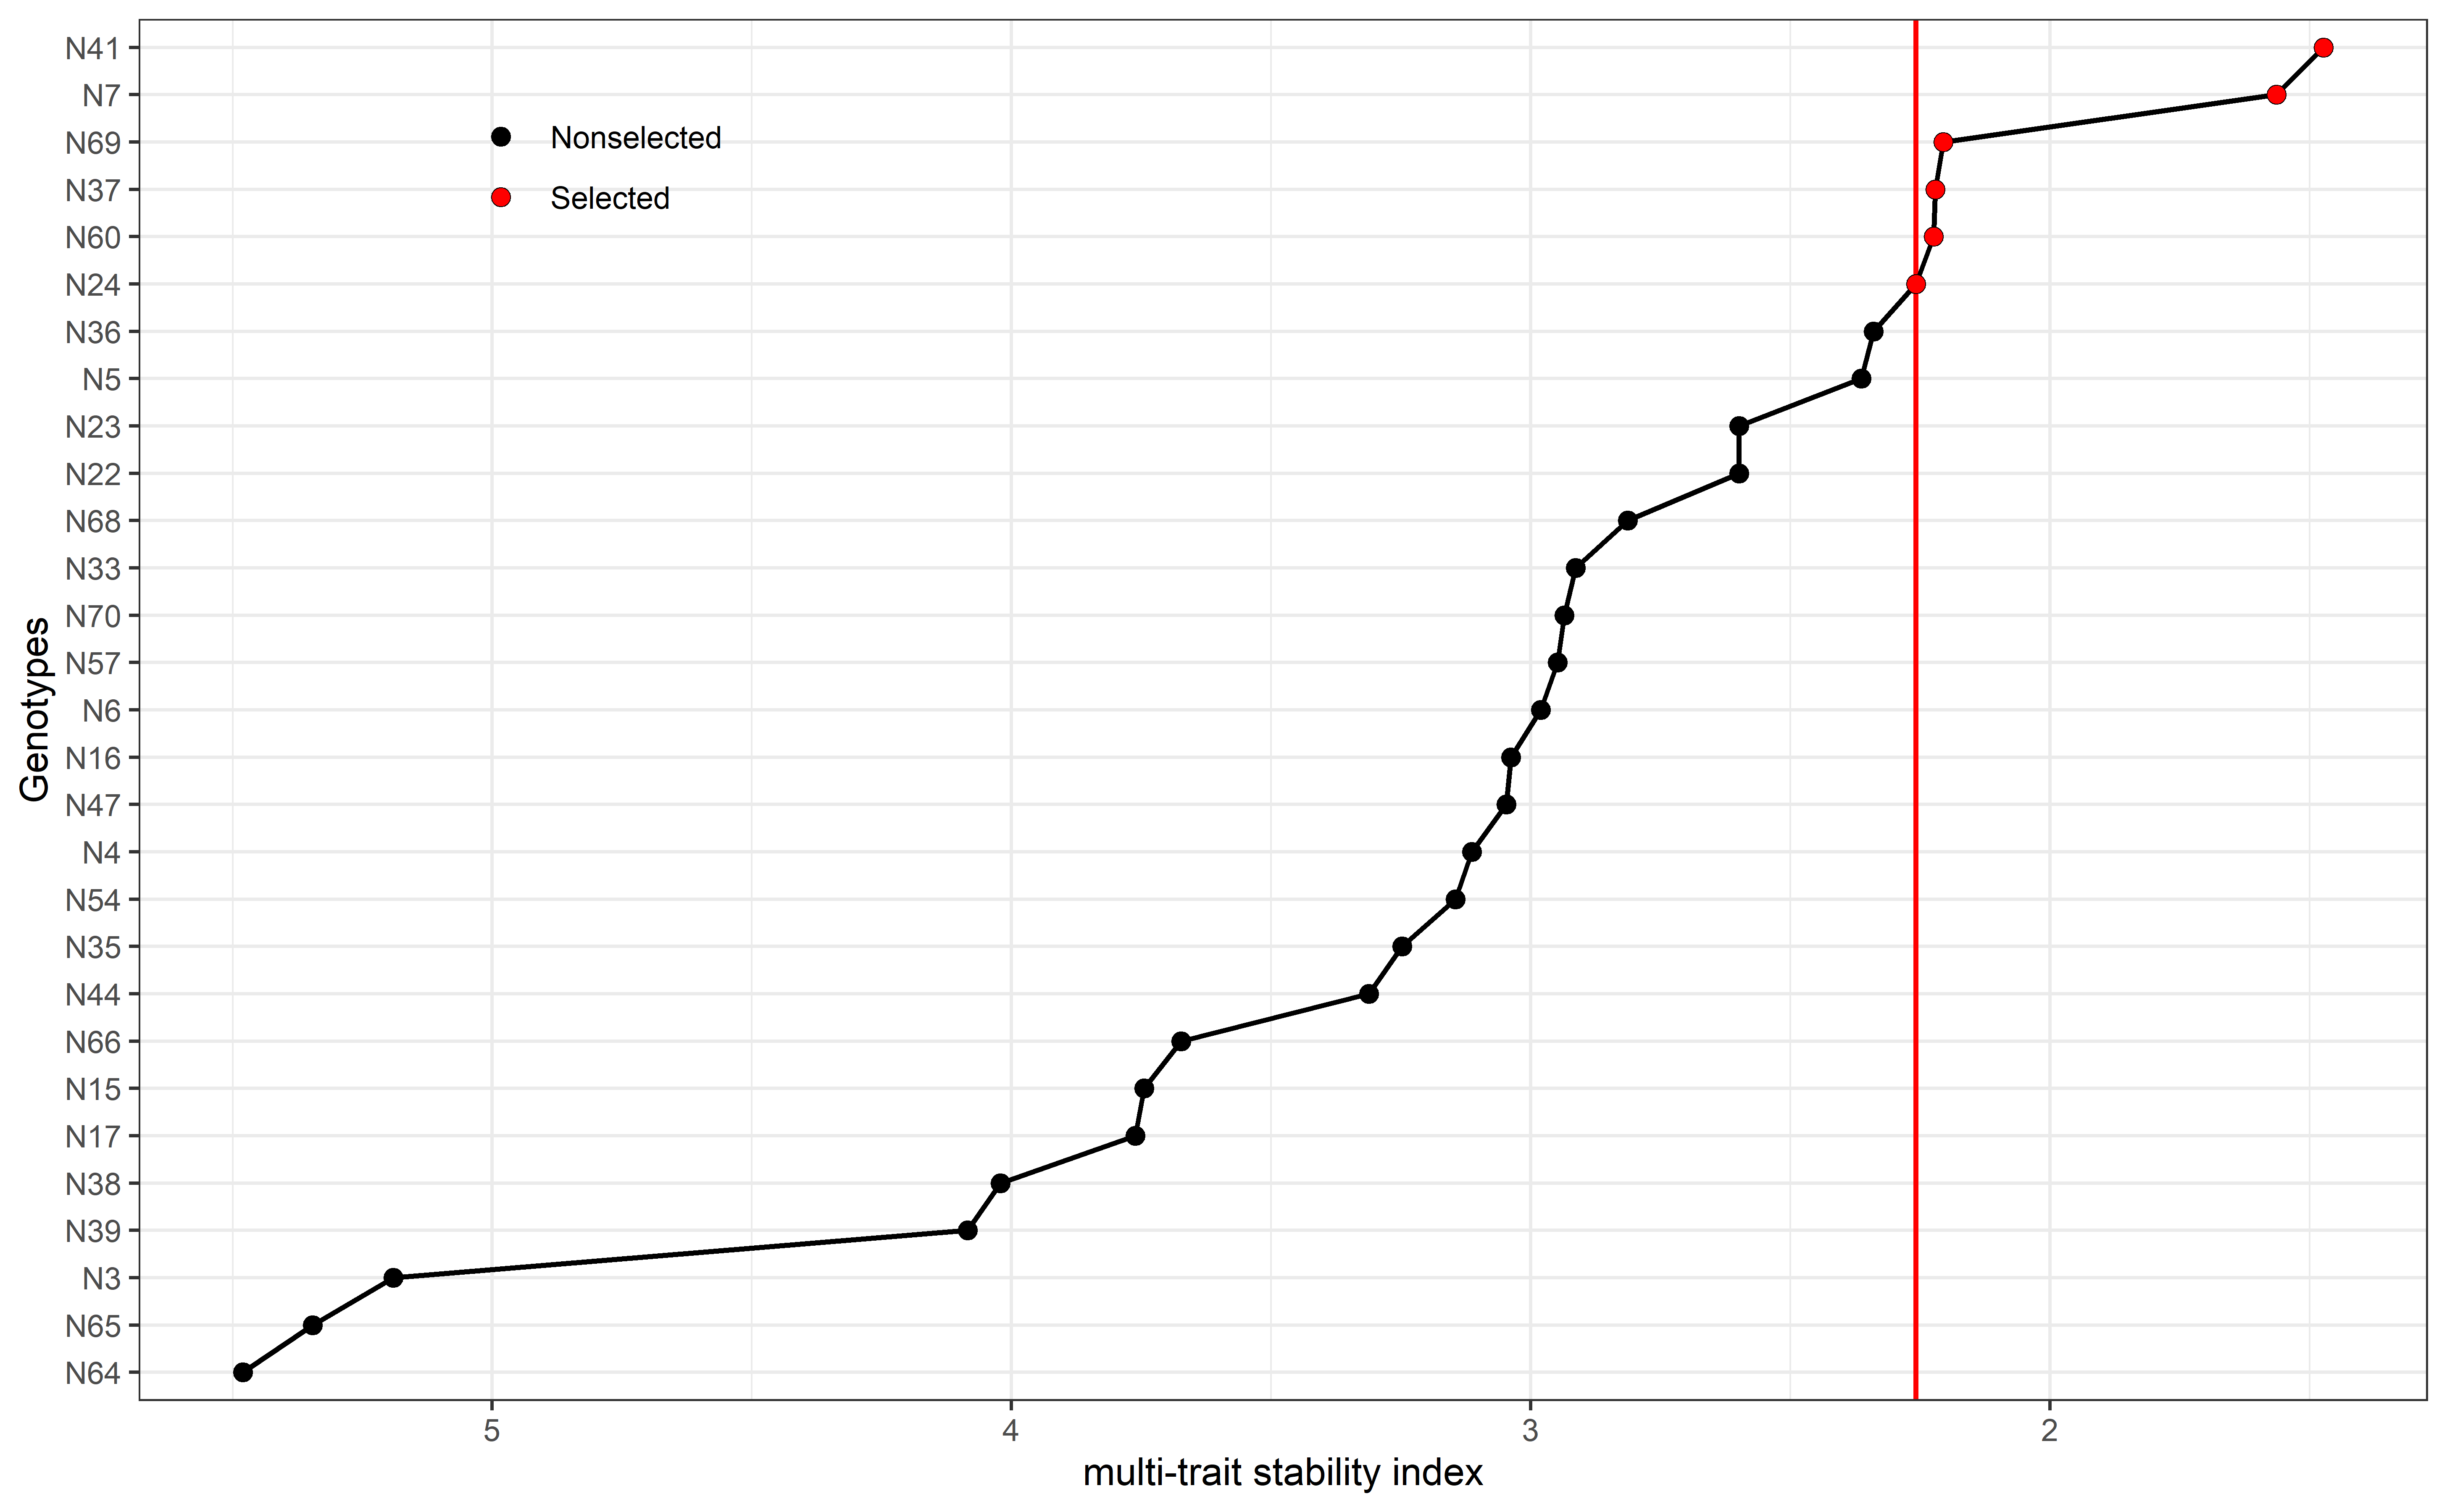

Cultivars ranking based on the multi-trait stability index. Selected cultivars are highlighted in red.

Sel_waasb

#> [1] "N41" "N7" "N69" "N37" "N60" "N24"

#### 5.5.3.2 Mean performance and stability for GY

p1<- plot_selected(blups_sel, GEN, GY, blups_sel_mean_GY$mean_GY)  
p2<- plot_selected(waasb_sel, GEN, GY, waasb_sel_mean_GY$mean_GY) + labs(y = "WAASB index")  
  
arrange_ggplot(p1, p2,  
 guides = "collect",  
 tag_levels = "a",  
 tag_prefix = "(",  
 tag_suffix = ")")

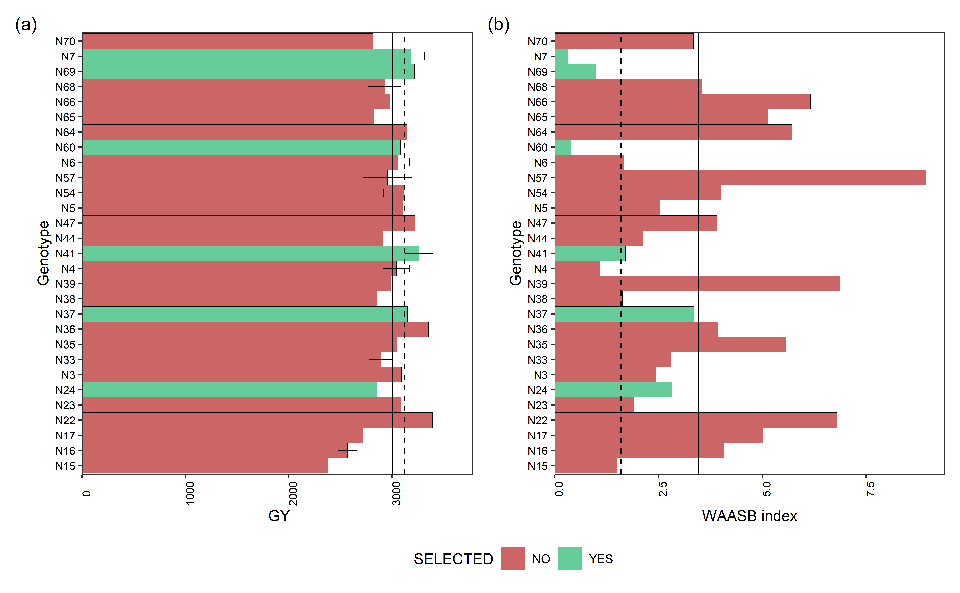

Mean performance (a) and stability (b) for grain yield (GY) of 29 navy beans genotypes. The vertical dashed and solid lines shows, respectivelly, the mean of the selected genotype and the overall mean for both mean performance and WAASB index

#### 5.5.3.3 Mean performance and stability for DM

p1<- plot_selected(blups_sel, GEN, DM, blups_sel_mean_DM$mean_DM)  
p2<- plot_selected(waasb_sel, GEN, DM, waasb_sel_mean_DM$mean_DM) + labs(y = "WAASB index")  
  
arrange_ggplot(p1, p2,  
 guides = "collect",  
 tag_levels = "a",  
 tag_prefix = "(",  
 tag_suffix = ")")

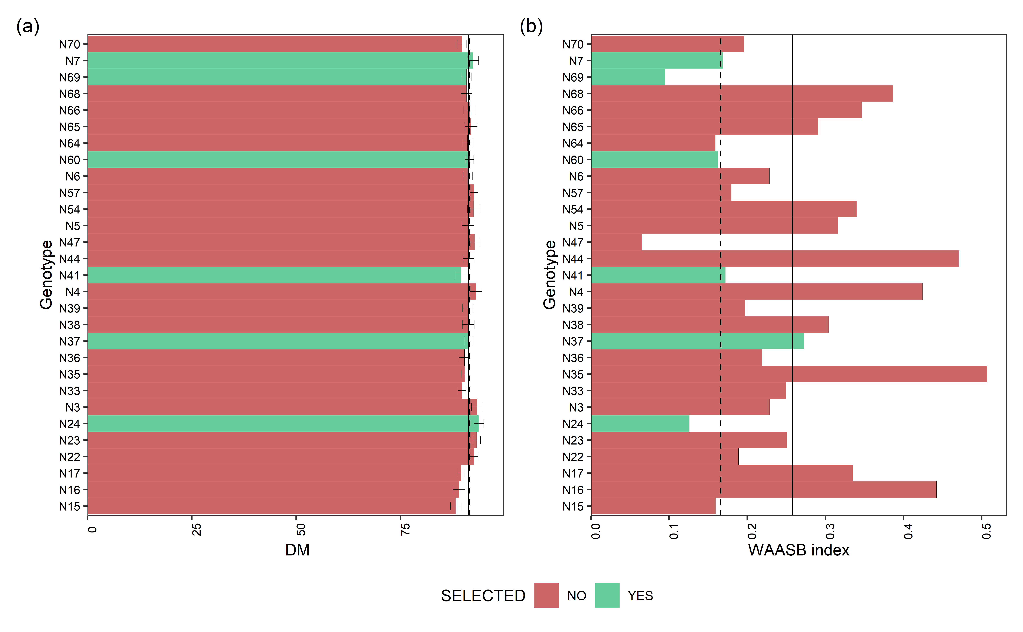

Mean performance (a) and stability (b) for days of maturity (DM) of 29 navy beans genotypes. The vertical dashed and solid lines shows, respectivelly, the mean of the selected genotype and the overall mean for both mean performance and WAASB index

#### 5.5.3.4 Mean performance and stability for PH

p1<- plot_selected(blups_sel, GEN, PH, blups_sel_mean_PH$mean_PH)  
p2<- plot_selected(waasb_sel, GEN, PH, waasb_sel_mean_PH$mean_PH) + labs(y = "WAASB index")  
  
arrange_ggplot(p1, p2,  
 guides = "collect",  
 tag_levels = "a",  
 tag_prefix = "(",  
 tag_suffix = ")")

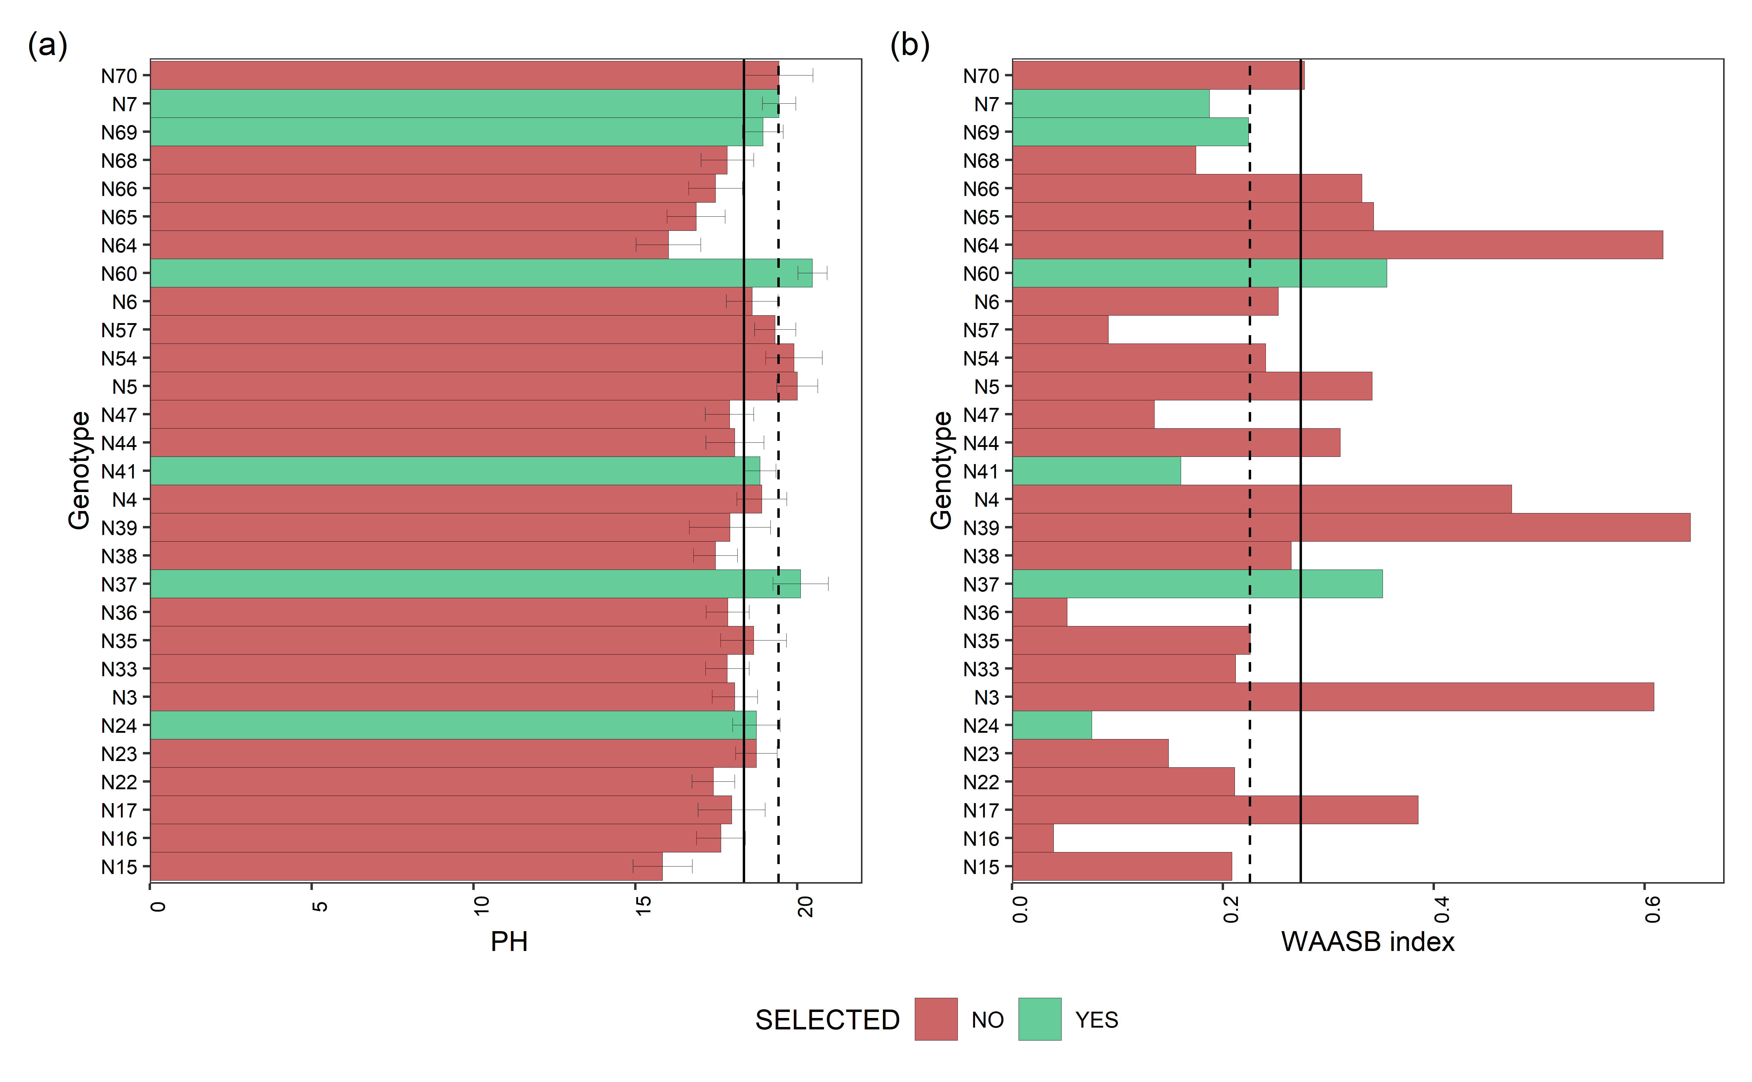

Mean performance (a) and stability (b) for plant height (PH) of 29 navy beans genotypes. The vertical dashed and solid lines shows, respectivelly, the mean of the selected genotype and the overall mean for both mean performance and WAASB index

#### 5.5.3.5 Mean performance and stability for LD

p1<- plot_selected(blups_sel, GEN, LD, blups_sel_mean_LD$mean_LD)  
p2<- plot_selected(waasb_sel, GEN, LD, waasb_sel_mean_LD$mean_LD) + labs(y = "WAASB index")  
  
arrange_ggplot(p1, p2,  
 guides = "collect",  
 tag_levels = "a",  
 tag_prefix = "(",  
 tag_suffix = ")")

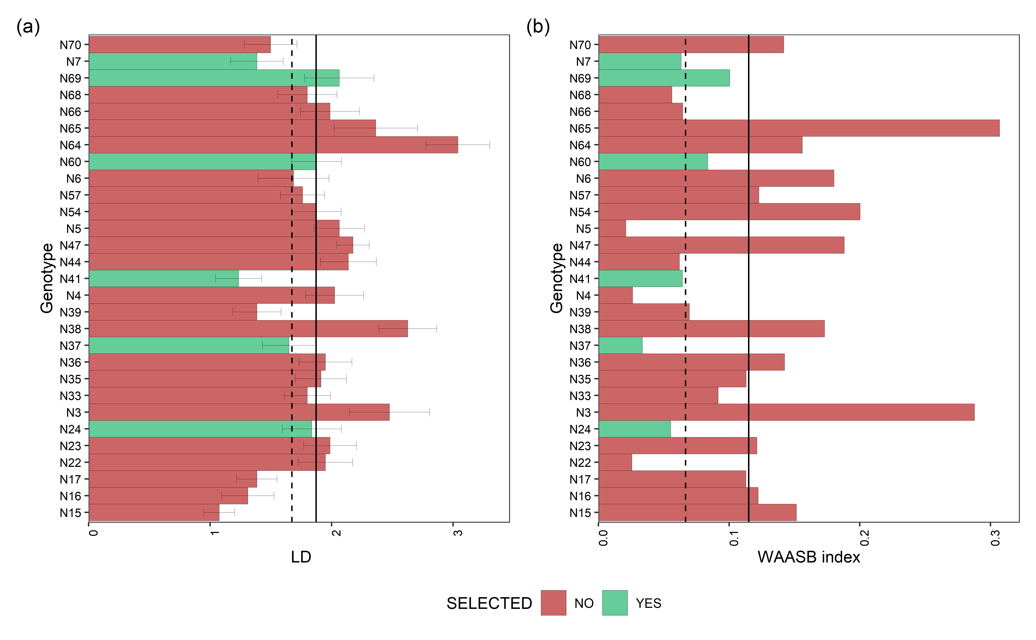

Mean performance (a) and stability (b) for lodging (LD) of 29 navy beans genotypes. The vertical dashed and solid lines shows, respectivelly, the mean of the selected genotype and the overall mean for both mean performance and WAASB index

## 5.6 Red beans

data_beans_SR <- droplevels(subset(data_beans_compl, mkt == "SR"))  
  
data_beans_SR<- droplevels(na.omit(data_beans_SR))  
#str(data_beans_SR)

### 5.6.1 Multi-trait index selection

waasb_model_sr.1 <- waasb(data_beans_SR,  
 env = loc,  
 gen = name,  
 rep = rep,  
 resp = everything(),  
 random = "gen", #Default  
 verbose = F,  
 wresp = c(60, 40, 40, 40),  
 mresp = c("h, l,h, l") ) #'GY', 'DM', 'PH', LD  
 #weight for response variable 60 and 40 for yielding and stability, respectively)  
  
options(digits = 3)  
mtsi1 = mtsi(waasb_model_sr.1, index = "waasby", SI = 20, mineval = 1, verbose = F)  
  
mtsi1_resul<- mtsi1$sel_dif_trait  
  
Sel_waasb <- sel_gen(mtsi1)  
  
  
if (knitr::is_html_output()) {  
   
 print_table(mtsi1_resul[,1:6])  
   
}else{  
   
mtsi1_resul[,1:6]  
}

| **VAR** | **Factor** | **Xo** | **Xs** | **SD** | **SDperc** |
| --- | --- | --- | --- | --- | --- |
| **character** | **character** | **numeric** | **numeric** | **numeric** | **numeric** |
| PH | FA 1 | 18.3 | 20.1 | 1.8 | 10.0 |
| LD | FA 1 | 1.9 | 1.9 | 0.0 | 2.1 |
| GY | FA 2 | 3,155.9 | 3,161.8 | 5.9 | 0.2 |
| DM | FA 2 | 90.8 | 90.9 | 0.0 | 0.0 |

#print_table(mtsi1_resul[,1:6])

### 5.6.2 Model outputs

#### 5.6.2.1 Variance plot

plot(waasb_model_sr.1,  
type = "vcomp", # Chose the type of plot.  
width.bar = 1, # No spaces between the bars  
size.line = 0.3) + # Controls the size of the line  
geom_hline(yintercept = 0.5, linetype = 2) # Add the dashed line

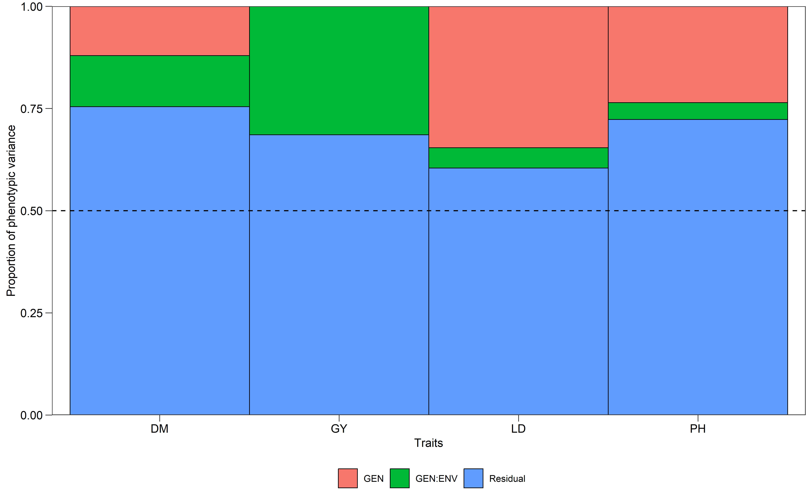

#### 5.6.2.2 Likelihood-ratio test

get_model_data(waasb_model_sr.1, "lrt")

#> Class of the model: waasb

#> Variable extracted: lrt

| **VAR** | **model** | **npar** | **logLik** | **AIC** | **LRT** | **Df** | **Pr(>Chisq)** |
| --- | --- | --- | --- | --- | --- | --- | --- |
| **character** | **character** | **integer** | **numeric** | **numeric** | **numeric** | **numeric** | **numeric** |
| GY | GEN | 14 | -1,005.1 | 2,038.1 | -0.0 | 1 | 1.0 |
| GY | GEN:ENV | 14 | -1,011.2 | 2,050.3 | 12.2 | 1 | 0.0 |
| DM | GEN | 14 | -302.1 | 632.2 | 2.3 | 1 | 0.1 |
| DM | GEN:ENV | 14 | -302.3 | 632.5 | 2.6 | 1 | 0.1 |
| PH | GEN | 14 | -323.0 | 674.0 | 8.1 | 1 | 0.0 |
| PH | GEN:ENV | 14 | -319.1 | 666.2 | 0.4 | 1 | 0.5 |
| LD | GEN | 14 | -147.4 | 322.7 | 13.0 | 1 | 0.0 |
| LD | GEN:ENV | 14 | -141.3 | 310.5 | 0.8 | 1 | 0.4 |

#### 5.6.2.3 Variance components

get_model_data(waasb_model_sr.1, "vcomp")

#> Class of the model: waasb

#> Variable extracted: vcomp

| **Group** | **GY** | **DM** | **PH** | **LD** |
| --- | --- | --- | --- | --- |
| **character** | **numeric** | **numeric** | **numeric** | **numeric** |
| GEN | 0.0 | 0.6 | 1.7 | 0.2 |
| GEN:ENV | 75,950.2 | 0.6 | 0.3 | 0.0 |
| Residual | 165,821.6 | 3.8 | 5.1 | 0.3 |

#### 5.6.2.4 Genetic parameters

get_model_data(waasb_model_sr.1, "genpar")

#> Class of the model: waasb

#> Variable extracted: genpar

| **Parameters** | **GY** | **DM** | **PH** | **LD** |
| --- | --- | --- | --- | --- |
| **character** | **numeric** | **numeric** | **numeric** | **numeric** |
| Phenotypic variance | 241,771.8 | 5.1 | 7.1 | 0.5 |
| Heritability | 0.0 | 0.1 | 0.2 | 0.3 |
| GEIr2 | 0.3 | 0.1 | 0.0 | 0.0 |
| h2mg | 0.0 | 0.5 | 0.8 | 0.8 |
| Accuracy | 0.0 | 0.7 | 0.9 | 0.9 |
| rge | 0.3 | 0.1 | 0.1 | 0.1 |
| CVg | 0.0 | 0.9 | 7.1 | 22.9 |
| CVr | 12.9 | 2.1 | 12.4 | 30.2 |
| CV ratio | 0.0 | 0.4 | 0.6 | 0.8 |

#### 5.6.2.5 Models details

get_model_data(waasb_model_sr.1, "details")

#> Class of the model: waasb

#> Variable extracted: details

| **Parameters** | **GY** | **DM** | **PH** | **LD** |
| --- | --- | --- | --- | --- |
| **character** | **character** | **character** | **character** | **character** |
| Mean | 3157.34 | 90.86 | 18.23 | 1.87 |
| SE | 53.6 | 0.25 | 0.24 | 0.07 |
| SD | 638.78 | 2.95 | 2.8 | 0.85 |
| CV | 20.3 | 3.26 | 15.42 | 45.39 |
| Min | 1643.85 (R10 in BA) | 85 (R5 in BA) | 10 (R5 in SA) | 1 (R2 in BA) |
| Max | 4876.34 (R10 in TU) | 97 (R9 in TU) | 23.59 (R12 in TU) | 4.5 (R16 in TU) |
| MinENV | BA (2579) | BA (89.17) | BA (17.45) | BA (1.36) |
| MaxENV | TU (3546.13) | TU (93.51) | TU (19.59) | TU (2.24) |
| MinGEN | R15 (2875.55) | R13 (88.92) | R16 (15.71) | R12 (1.33) |
| n: 14 | | | | |

#### 5.6.2.6 Fixed effects

get_model_data(waasb_model_sr.1, "fixed")

#> Class of the model: waasb

#> Variable extracted: fixed

| **VAR** | **SOURCE** | **Sum Sq** | **Mean Sq** | **NumDF** | **DenDF** | **F value** | **Pr(>F)** |
| --- | --- | --- | --- | --- | --- | --- | --- |
| **character** | **character** | **numeric** | **numeric** | **integer** | **numeric** | **numeric** | **numeric** |
| GY | ENV | 3,444,789.9 | 1,722,394.9 | 2 | 101.3 | 10.4 | 0.0 |
| GY | ENV:REP | 2,181,509.9 | 242,390.0 | 9 | 98.2 | 1.5 | 0.2 |
| DM | ENV | 174.4 | 87.2 | 2 | 99.8 | 22.9 | 0.0 |
| DM | ENV:REP | 68.4 | 7.6 | 9 | 98.5 | 2.0 | 0.0 |
| PH | ENV | 26.0 | 13.0 | 2 | 111.3 | 2.5 | 0.1 |
| PH | ENV:REP | 61.0 | 6.8 | 9 | 97.9 | 1.3 | 0.2 |
| LD | ENV | 2.5 | 1.2 | 2 | 108.6 | 3.9 | 0.0 |
| LD | ENV:REP | 13.4 | 1.5 | 9 | 98.4 | 4.6 | 0.0 |

#### 5.6.2.7 Enviroment means

get_model_data(waasb_model_sr.1, "blupge") %>%  
 means_by(ENV)

#> Class of the model: waasb

#> Variable extracted: blupge

| **ENV** | **GY** | **DM** | **PH** | **LD** |
| --- | --- | --- | --- | --- |
| **factor** | **numeric** | **numeric** | **numeric** | **numeric** |
| BA | 2,583.6 | 89.2 | 17.5 | 1.4 |
| SA | 3,334.8 | 89.9 | 17.6 | 2.0 |
| TU | 3,546.1 | 93.5 | 19.6 | 2.2 |

### 5.6.3 Selection Description

#### 5.6.3.1 Genotype ranking

* Varieties ranking based on the multi-trait stability index. Selected varieties are highlighted in red.

# Get the random effects  
#get_model_data(waasb_model_sr.1, what = "ranef")   
  
mtsi1_value<- mtsi1$MTSI  
  
#plot(mtsi1,arrange.label = TRUE)  
  
p2 = plot(mtsi1, SI = 20, radar = FALSE) +  
 coord_flip() +  
 theme_bw() +  
 labs(x = "Genotypes", y = "multi-trait stability index") +  
 theme(legend.position = c(0.2, 0.9),  
 legend.background = element_blank(),  
 legend.key = element_blank(),  
 legend.title = element_blank())  
print(p2)

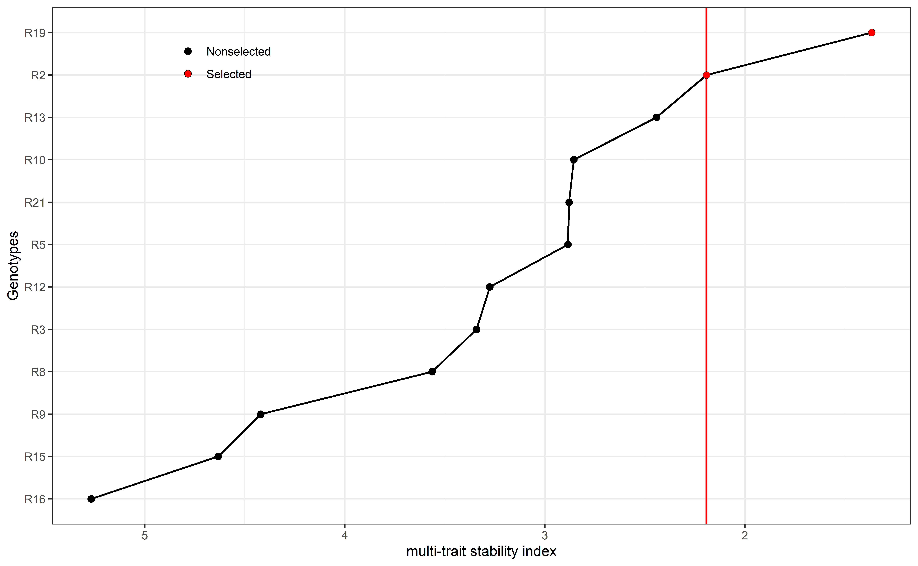

Cultivars ranking based on the multi-trait stability index. Selected cultivars are highlighted in red.

Sel_waasb

#> [1] "R19" "R2"

#### 5.6.3.2 Mean performance and stability for GY

p1<- plot_selected(blups_sel, GEN, GY, blups_sel_mean_GY$mean_GY)  
p2<- plot_selected(waasb_sel, GEN, GY, waasb_sel_mean_GY$mean_GY) + labs(y = "WAASB index")  
  
arrange_ggplot(p1, p2,  
 guides = "collect",  
 tag_levels = "a",  
 tag_prefix = "(",  
 tag_suffix = ")")

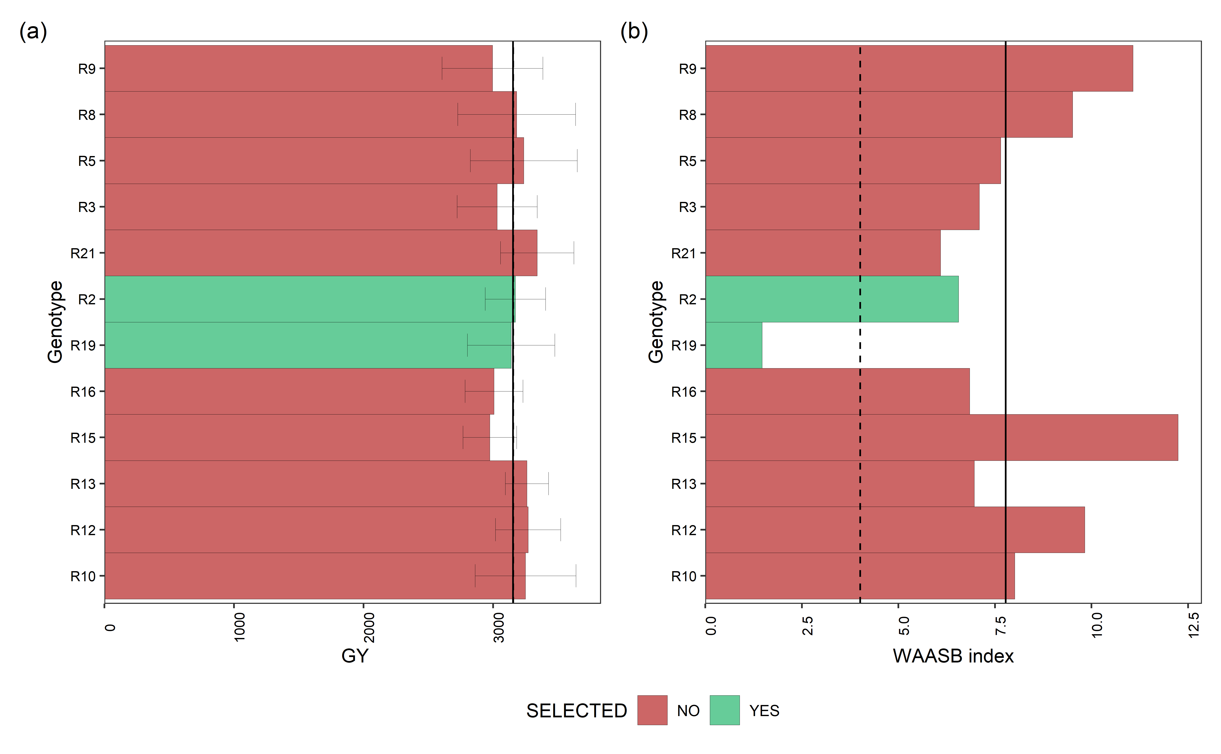

Mean performance (a) and stability (b) for grain yield (GY) of 12 red bens genotypes. The vertical dashed and solid lines shows, respectivelly, the mean of the selected genotype and the overall mean for both mean performance and WAASB index

#### 5.6.3.3 Mean performance and stability for DM

p1<- plot_selected(blups_sel, GEN, DM, blups_sel_mean_DM$mean_DM)  
p2<- plot_selected(waasb_sel, GEN, DM, waasb_sel_mean_DM$mean_DM) + labs(y = "WAASB index")  
  
arrange_ggplot(p1, p2,  
 guides = "collect",  
 tag_levels = "a",  
 tag_prefix = "(",  
 tag_suffix = ")")

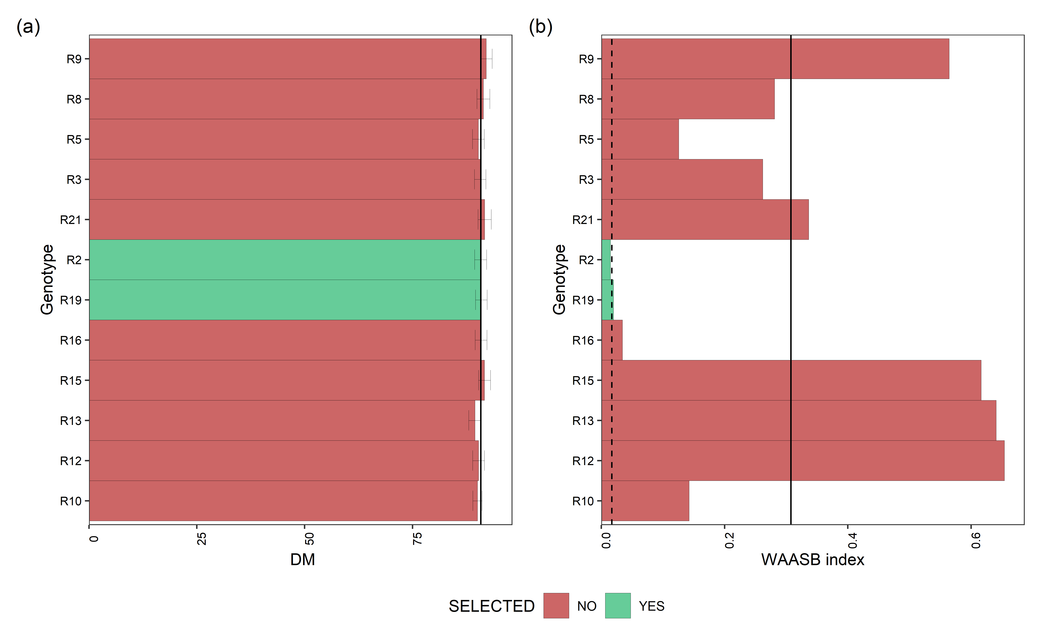

Mean performance (a) and stability (b) for days of maturity (DM) of 12 red beans genotypes. The vertical dashed and solid lines shows, respectivelly, the mean of the selected genotype and the overall mean for both mean performance and WAASB index

#### 5.6.3.4 Mean performance and stability for PH

p1<- plot_selected(blups_sel, GEN, PH, blups_sel_mean_PH$mean_PH)  
p2<- plot_selected(waasb_sel, GEN, PH, waasb_sel_mean_PH$mean_PH) + labs(y = "WAASB index")  
  
arrange_ggplot(p1, p2,  
 guides = "collect",  
 tag_levels = "a",  
 tag_prefix = "(",  
 tag_suffix = ")")

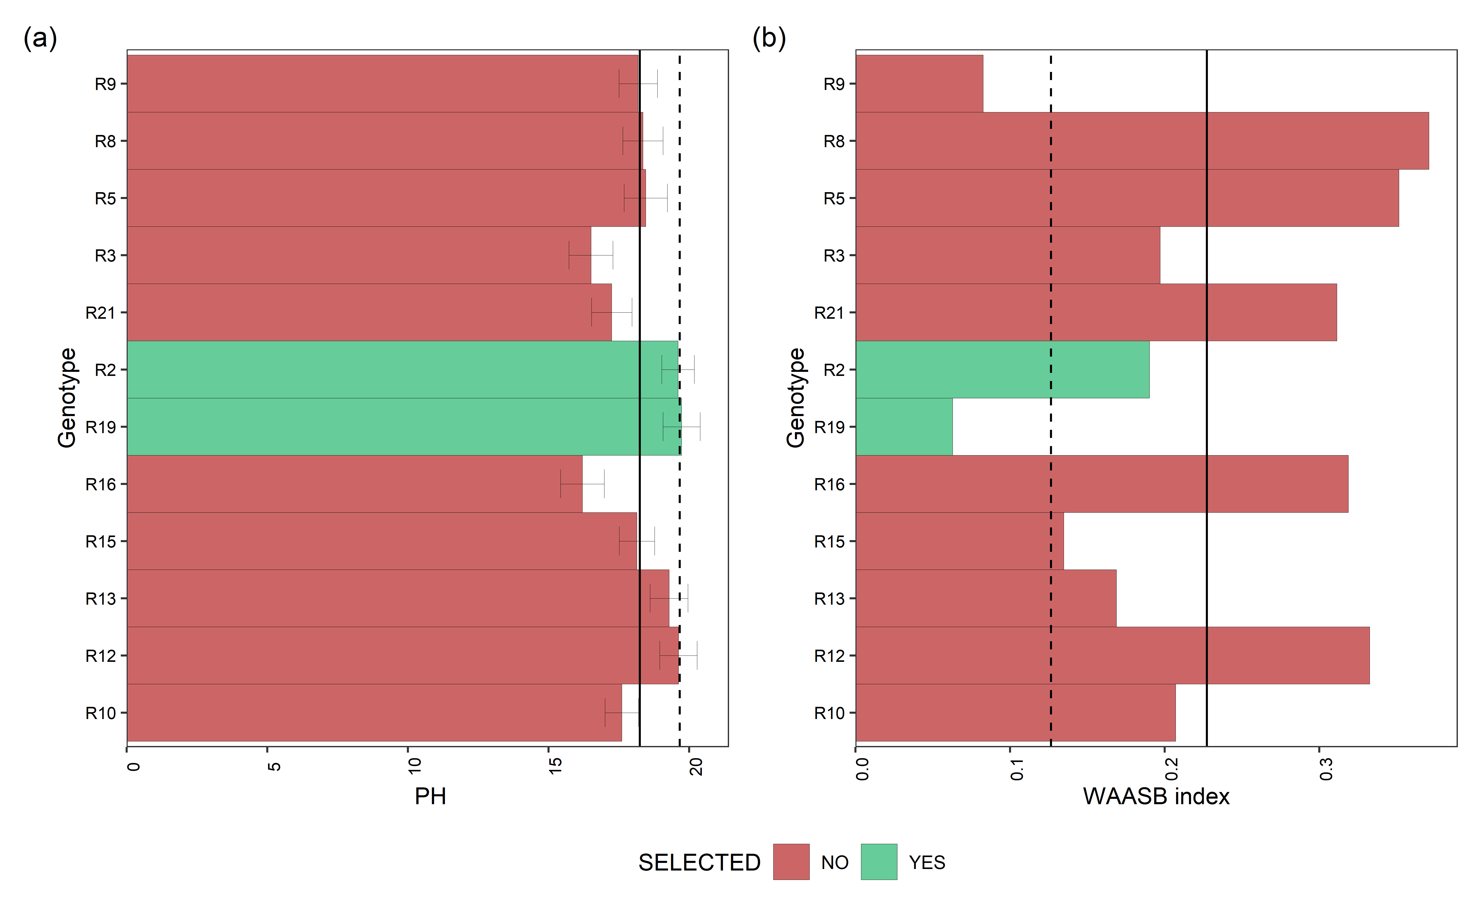

Mean performance (a) and stability (b) for plant height (PH) of 12 red beans genotypes. The vertical dashed and solid lines shows, respectivelly, the mean of the selected genotype and the overall mean for both mean performance and WAASB index

#### 5.6.3.5 Mean performance and stability for LD

p1<- plot_selected(blups_sel, GEN, LD, blups_sel_mean_LD$mean_LD)  
p2<- plot_selected(waasb_sel, GEN, LD, waasb_sel_mean_LD$mean_LD) + labs(y = "WAASB index")  
  
arrange_ggplot(p1, p2,  
 guides = "collect",  
 tag_levels = "a",  
 tag_prefix = "(",  
 tag_suffix = ")")

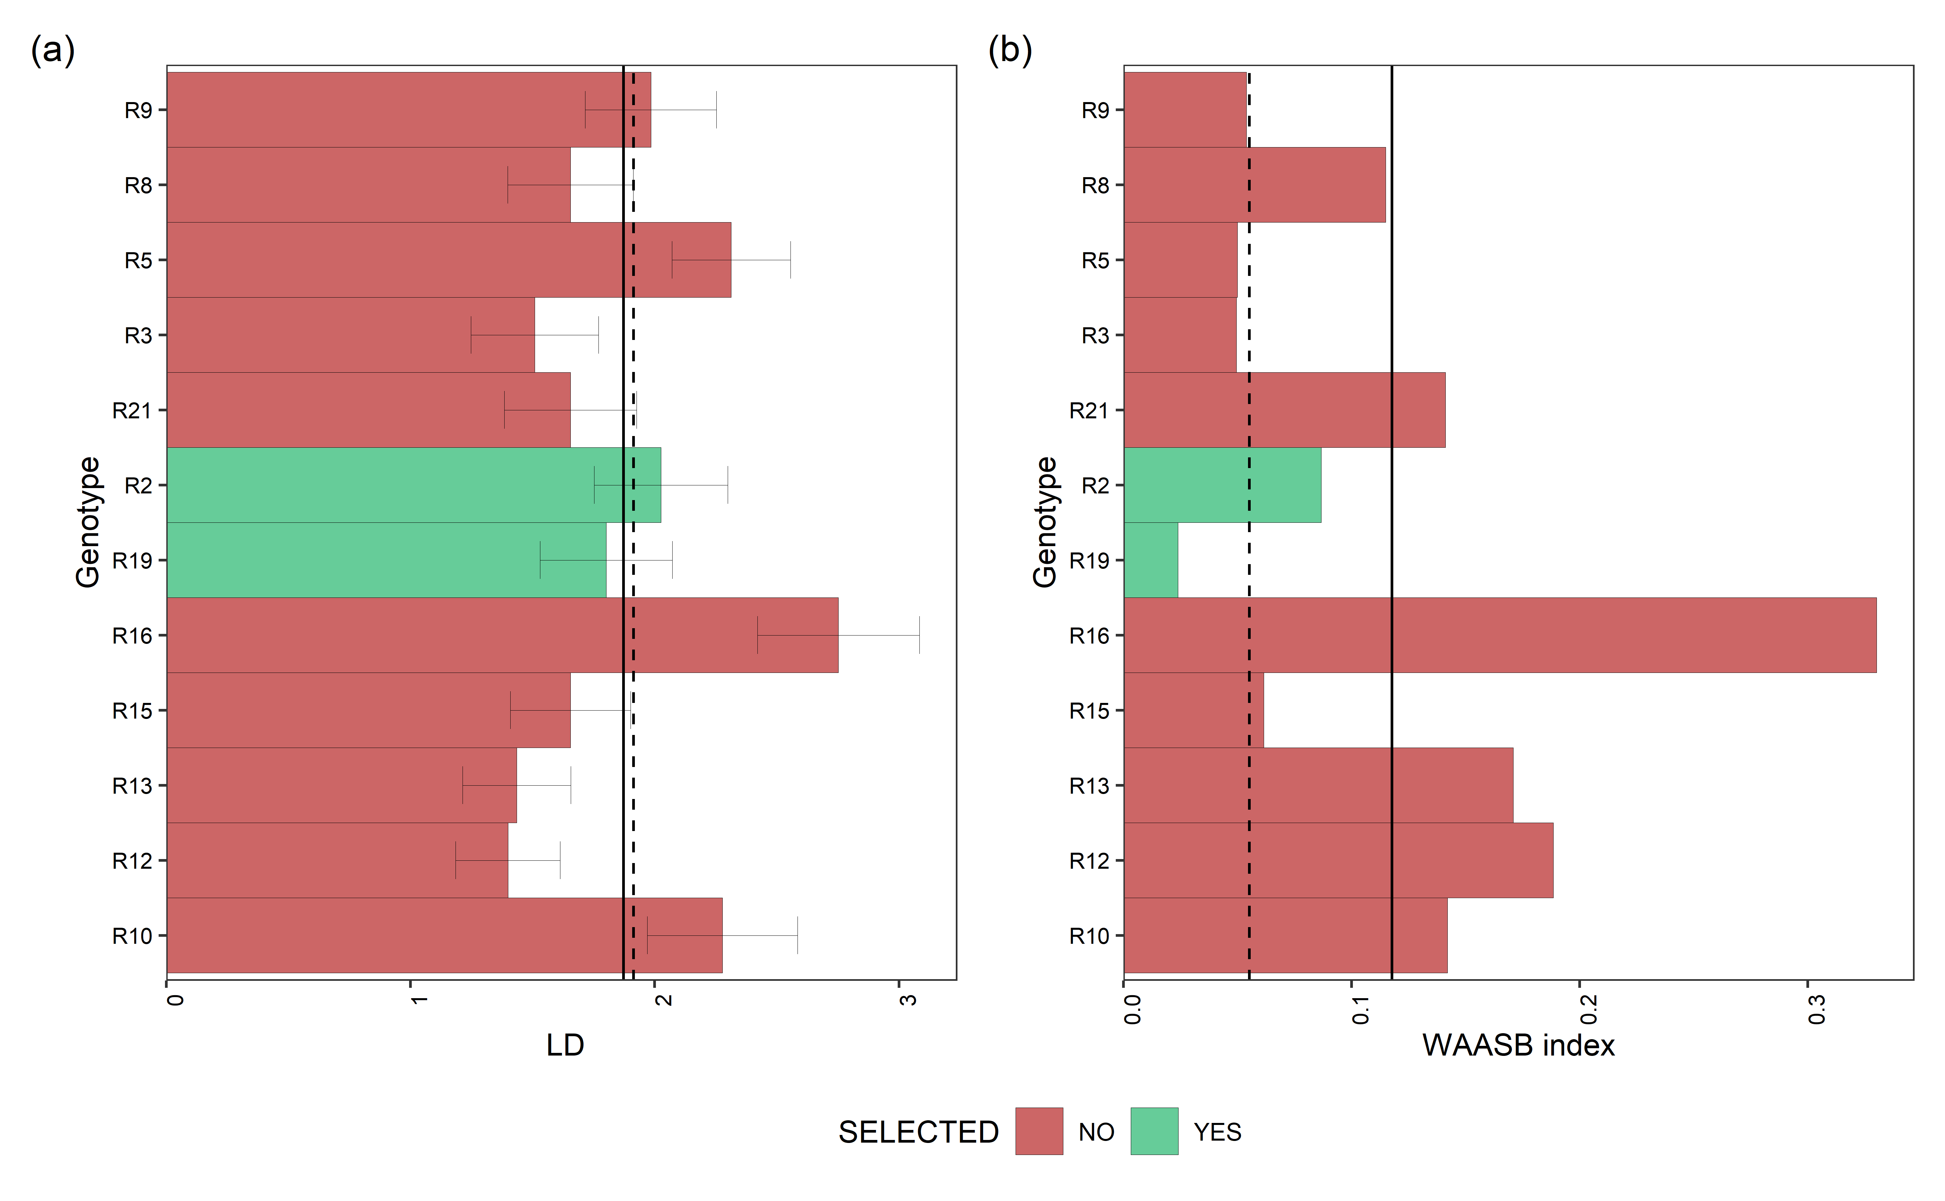

Mean performance (a) and stability (b) for lodging (LD) of 12 red beans genotypes. The vertical dashed and solid lines shows, respectivelly, the mean of the selected genotype and the overall mean for both mean performance and WAASB index

## 5.7 MTME mixed model

### 5.7.1 Black beans

data_beans_BB <- droplevels(data_beans_compl[which(data_beans_compl$mkt=="BB")])  
#TU  
data_beans_BB.sc.TU <- droplevels(subset(data_beans_BB, loc=="TU"))  
data_beans_BB.sc.TU <-scale(data_beans_BB.sc.TU[,5:8])  
#dim(data_beans_BB.sc.TU)   
#BA  
data_beans_BB.sc.BA <- droplevels(subset(data_beans_BB, loc=="BA"))  
data_beans_BB.sc.BA <-scale(data_beans_BB.sc.BA[,5:8])  
  
#SA  
data_beans_BB.sc.SA <- droplevels(subset(data_beans_BB, loc=="SA"))  
data_beans_BB.sc.SA <-scale(data_beans_BB.sc.SA[,5:8])  
  
#data_beans_BB.sc<- scale(data_beans_BB[,5:6])  
data_beans_BB<- data_beans_BB %>%  
 dplyr::select(name, loc, mkt,rep)  
  
data_beans_BB.sc<- rbind(data_beans_BB.sc.BA,data_beans_BB.sc.SA, data_beans_BB.sc.TU)  
  
#dim(data_beans_BB)  
#dim(data_beans_BB.sc)  
  
data_beans_BB<- cbind(data_beans_BB, data_beans_BB.sc)  
#str(data_beans_BB)  
  
#dim(data_beans_BB)  
  
mod_MTME.bb <- asreml(fixed = cbind(GY, DM, PH, LD) ~ trait:rep + trait, # trait:rep -1,  
 random = ~ us(trait):name + us(trait):name:loc, #name:us(loc)  
 #residuals = ~dsum(~us(name)|loc),  
 residuals = ~ units:us(trait),  
 data = data_beans_BB,  
 trace = F,  
 maxit = 10000,  
 predict = predict.asreml(classify = "name:loc:trait") )  
  
#update.asreml(mod_MTME.bb)  
d1<- data.frame(wald(mod_MTME.bb))  
  
  
d2<- data.frame(summary.asreml(mod_MTME.bb)$varcomp)   
  
  
# results as data.table  
blup.mtme.bb<- data.table((mod_MTME.bb$predictions$pvals[1:6])) # set the BLUP   
  
  
# d1  
# Df Sum.of.Sq Wald.statistic Pr.Chisq.  
# trait 4 0.323 0.323 9.88e-01  
# trait:rep 12 55.248 55.248 1.63e-07  
# residual (MS) NA 1.000 NA NA  
  
# d2  
# component std.error z.ratio bound X.ch  
# trait:name!trait_GY:GY 0.25787 0.0798 3.2327 P 0.0  
# trait:name!trait_DM:GY 0.11359 0.0692 1.6409 P 0.0  
# trait:name!trait_DM:DM 0.36827 0.1091 3.3752 P 0.0  
# trait:name!trait_PH:GY 0.08661 0.0496 1.7466 P 0.0  
# trait:name!trait_PH:DM 0.09752 0.0570 1.7104 P 0.0  
# trait:name!trait_PH:PH 0.11734 0.0545 2.1547 P 0.0  
# trait:name!trait_LD:GY -0.07238 0.0585 -1.2380 P 0.0  
# trait:name!trait_LD:DM 0.05215 0.0652 0.7996 P 0.0  
# trait:name!trait_LD:PH 0.01736 0.0451 0.3845 P 0.0  
# trait:name!trait_LD:LD 0.15495 0.0707 2.1911 P 0.0  
# trait:name:loc!trait_GY:GY 0.07426 NA NA B 0.0  
# trait:name:loc!trait_DM:GY -0.00742 NA NA B 0.0  
# trait:name:loc!trait_DM:DM 0.07241 NA NA B 0.0  
# trait:name:loc!trait_PH:GY -0.01275 NA NA B 0.0  
# trait:name:loc!trait_PH:DM 0.00149 NA NA B 0.0  
# trait:name:loc!trait_PH:PH 0.06344 NA NA B 0.0  
# trait:name:loc!trait_LD:GY 0.04234 NA NA B 0.0  
# trait:name:loc!trait_LD:DM -0.00585 NA NA B 0.0  
# trait:name:loc!trait_LD:PH -0.01030 NA NA B 0.0  
# trait:name:loc!trait_LD:LD 0.09790 NA NA B 0.0  
# units:trait!R 1.00000 NA NA F 0.0  
# units:trait!trait_GY:GY 0.66440 0.0488 13.6191 P 0.0  
# units:trait!trait_DM:GY 0.09813 0.0354 2.7707 P 0.0  
# units:trait!trait_DM:DM 0.53533 0.0443 12.0755 P 0.0  
# units:trait!trait_PH:GY 0.14825 0.0430 3.4472 P 0.0  
# units:trait!trait_PH:DM 0.02495 0.0380 0.6564 P 0.0  
# units:trait!trait_PH:PH 0.80001 0.0651 12.2932 P 0.0  
# units:trait!trait_LD:GY 0.04123 0.0465 0.8857 P 0.0  
# units:trait!trait_LD:DM 0.11857 0.0416 2.8483 P 0.0  
# units:trait!trait_LD:PH 0.00104 0.0485 0.0214 P 0.2  
# units:trait!trait_LD:LD 0.78932 0.0686 11.5024 P 0.0

### 5.7.2 Navy beans

data_beans_NB <- droplevels(data_beans_compl[which(data_beans_compl$mkt=="NB")])  
#data_beans_NB <- na.omit(data_beans_NB)  
#str(data_beans_NB)  
#TU  
data_beans_NB.sc.TU <- droplevels(subset(data_beans_NB, loc=="TU"))  
data_beans_NB.sc.TU <-scale(data_beans_NB.sc.TU[,5:8])  
#dim(data_beans_NB.sc.TU)   
#BA  
data_beans_NB.sc.BA <- droplevels(subset(data_beans_NB, loc=="BA"))  
data_beans_NB.sc.BA <-scale(data_beans_NB.sc.BA[,5:8])  
  
#SA  
data_beans_NB.sc.SA <- droplevels(subset(data_beans_NB, loc=="SA"))  
data_beans_NB.sc.SA <-scale(data_beans_NB.sc.SA[,5:8])  
  
#data_beans_NB.sc<- scale(data_beans_NB[,5:6])  
data_beans_NB<- data_beans_NB %>%  
 dplyr::select(name, loc, mkt,rep)  
  
data_beans_NB.sc<- rbind(data_beans_NB.sc.BA,data_beans_NB.sc.SA, data_beans_NB.sc.TU)  
  
#dim(data_beans_NB)  
#dim(data_beans_NB.sc)  
  
data_beans_NB<- cbind(data_beans_NB, data_beans_NB.sc)  
#str(data_beans_NB)  
  
#data_beans_NB <- na.omit(data_beans_NB)  
  
mod_MTME.nb <- asreml(fixed = cbind(GY, DM, PH, LD) ~ trait:rep + trait, # trait:rep -1,  
 random = ~ us(trait):name + us(trait):name:loc, #name:us(loc)  
 #residuals = ~dsum(~us(name)|loc),  
 residuals = ~ units:us(trait),  
 data = data_beans_NB,  
 trace = F,  
 maxit = 10000,  
 predict = predict.asreml(classify = "name:loc:trait") )  
#update.asreml(mod_MTME.nb)  
#update.asreml(mod_MTME)  
d1<- data.frame(wald(mod_MTME.nb))  
  
d2<-data.frame(summary.asreml(mod_MTME.nb)$varcomp)   
  
# results as data.table  
blup.mtme.nb<- data.table((mod_MTME.nb$predictions$pvals[1:6])) # set the BLUP  
  
  
# d1  
# Df Sum.of.Sq Wald.statistic Pr.Chisq.  
# trait 4 0.663 0.663 9.56e-01  
# trait:rep 12 63.914 63.914 4.33e-09  
# residual (MS) NA 1.000 NA NA  
#   
# d2  
# component std.error z.ratio bound X.ch  
# trait:name!trait_GY:GY 0.28345 0.0865 3.278 P 0  
# trait:name!trait_DM:GY 0.18415 0.0733 2.514 P 0  
# trait:name!trait_DM:DM 0.33087 0.1036 3.195 P 0  
# trait:name!trait_PH:GY 0.12097 0.0620 1.951 P 0  
# trait:name!trait_PH:DM 0.06994 0.0646 1.083 P 0  
# trait:name!trait_PH:PH 0.22001 0.0765 2.875 P 0  
# trait:name!trait_LD:GY 0.15304 0.0820 1.867 P 0  
# trait:name!trait_LD:DM 0.23406 0.0922 2.539 P 0  
# trait:name!trait_LD:PH -0.06152 0.0715 -0.860 P 0  
# trait:name!trait_LD:LD 0.42545 0.1305 3.261 P 0  
# trait:name:loc!trait_GY:GY 0.08495 0.0408 2.081 P 0  
# trait:name:loc!trait_DM:GY -0.00607 0.0315 -0.192 P 0  
# trait:name:loc!trait_DM:DM 0.09322 0.0442 2.107 P 0  
# trait:name:loc!trait_PH:GY -0.01022 0.0325 -0.315 P 0  
# trait:name:loc!trait_PH:DM 0.04445 0.0323 1.376 P 0  
# trait:name:loc!trait_PH:PH 0.05325 0.0464 1.148 P 0  
# trait:name:loc!trait_LD:GY -0.01023 0.0285 -0.359 P 0  
# trait:name:loc!trait_LD:DM -0.03865 0.0282 -1.372 P 0  
# trait:name:loc!trait_LD:PH -0.00769 0.0288 -0.267 P 0  
# trait:name:loc!trait_LD:LD 0.03354 0.0351 0.956 P 0  
# units:trait!R 1.00000 NA NA F 0  
# units:trait!trait_GY:GY 0.61060 0.0475 12.845 P 0  
# units:trait!trait_DM:GY -0.03874 0.0355 -1.093 P 0  
# units:trait!trait_DM:DM 0.54619 0.0461 11.851 P 0  
# units:trait!trait_PH:GY 0.12173 0.0416 2.928 P 0  
# units:trait!trait_PH:DM -0.02890 0.0380 -0.760 P 0  
# units:trait!trait_PH:PH 0.73727 0.0625 11.803 P 0  
# units:trait!trait_LD:GY 0.01485 0.0377 0.393 P 0  
# units:trait!trait_LD:DM 0.04894 0.0351 1.396 P 0  
# units:trait!trait_LD:PH -0.04851 0.0408 -1.190 P 0  
# units:trait!trait_LD:LD 0.57031 0.0503 11.330 P 0

### 5.7.3 Red beans

## MTME mixed model Small Red - Pink Beans  
# This model is not working! Too many missing genotypes and few genotypes available for thos market class.  
  
data_beans_SR <- droplevels(data_beans_compl[which(data_beans_compl$mkt=="SR")])  
  
#data_beans_SR <- na.omit(data_beans_SR)  
  
#dim(data_beans_SR)  
#TU  
data_beans_SR.sc.TU <- droplevels(subset(data_beans_SR, loc=="TU"))  
data_beans_SR.sc.TU <-scale(data_beans_SR.sc.TU[,5:8])  
#dim(data_beans_SR.sc.TU)  
#BA  
data_beans_SR.sc.BA <- droplevels(subset(data_beans_SR, loc=="BA"))  
data_beans_SR.sc.BA <-scale(data_beans_SR.sc.BA[,5:8])  
  
#SA  
data_beans_SR.sc.SA <- droplevels(subset(data_beans_SR, loc=="SA"))  
data_beans_SR.sc.SA <-scale(data_beans_SR.sc.SA[,5:8])  
  
#data_beans_SR.sc<- scale(data_beans_SR[,5:6])  
data_beans_SR<- data_beans_SR %>%  
 dplyr::select(name, loc, mkt,rep)  
#dim(data_beans_SR)  
data_beans_SR.sc<- rbind(data_beans_SR.sc.BA,data_beans_SR.sc.SA, data_beans_SR.sc.TU)  
  
#dim(data_beans_SR)  
#dim(data_beans_SR.sc)  
  
data_beans_SR<- cbind(data_beans_SR, data_beans_SR.sc)  
#str(data_beans_SR)  
  
mod_MTME.sr <- asreml(fixed = cbind(GY, DM, PH, LD) ~ trait:rep + trait, # trait:rep -1,  
 random = ~ us(trait):name + us(trait):name:loc, #name:us(loc)  
 #residuals = ~dsum(~us(name)|loc),  
 residuals = ~ units:us(trait),  
 data = data_beans_SR,  
 trace = F,  
 maxit = 10000,  
 predict = predict.asreml(classify = "name:loc:trait") )  
  
#update.asreml(mod_MTME.sr)  
d1<- data.frame(wald(mod_MTME.sr))  
  
#   
d2<- data.frame(summary.asreml(mod_MTME.sr)$varcomp)  
  
# d1  
# Df Sum.of.Sq Wald.statistic Pr.Chisq.  
# trait 4 0.0747 0.0747 9.99e-01  
# trait:rep 12 58.7787 58.7787 3.77e-08  
# residual (MS) NA 1.0000 NA NA  
  
  
# d2  
# component std.error z.ratio bound X.ch  
# trait:name!trait_GY:GY 0.014673 NA NA B 0.0  
# trait:name!trait_DM:GY 0.002083 NA NA B 0.0  
# trait:name!trait_DM:DM 0.000615 NA NA B 0.0  
# trait:name!trait_PH:GY 0.007643 NA NA B 0.0  
# trait:name!trait_PH:DM 0.007450 NA NA B 0.0  
# trait:name!trait_PH:PH 0.003715 NA NA B 0.0  
# trait:name!trait_LD:GY -0.020386 NA NA B 0.0  
# trait:name!trait_LD:DM 0.015287 NA NA B 0.0  
# trait:name!trait_LD:PH -0.009582 NA NA B 0.0  
# trait:name!trait_LD:LD 0.032827 NA NA B 0.0  
# trait:name:loc!trait_GY:GY 0.257368 NA NA B 0.0  
# trait:name:loc!trait_DM:GY -0.140886 NA NA B 0.0  
# trait:name:loc!trait_DM:DM 0.427960 NA NA B 0.0  
# trait:name:loc!trait_PH:GY -0.094343 NA NA B 0.0  
# trait:name:loc!trait_PH:DM -0.293548 NA NA B 0.0  
# trait:name:loc!trait_PH:PH 0.490821 NA NA B 0.0  
# trait:name:loc!trait_LD:GY 0.257104 NA NA B 0.0  
# trait:name:loc!trait_LD:DM -0.198700 NA NA B 0.0  
# trait:name:loc!trait_LD:PH -0.051090 NA NA B 0.0  
# trait:name:loc!trait_LD:LD 0.320474 NA NA B 0.0  
# units:trait!R 1.000000 NA NA F 0.0  
# units:trait!trait_GY:GY 0.754348 0.0923 8.173 P 0.0  
# units:trait!trait_DM:GY 0.162496 0.0719 2.259 P 0.0  
# units:trait!trait_DM:DM 0.792539 0.1027 7.714 P 0.0  
# units:trait!trait_PH:GY 0.311365 0.0741 4.204 P 0.0  
# units:trait!trait_PH:DM 0.046331 0.0705 0.657 P 0.0  
# units:trait!trait_PH:PH 0.757329 0.1005 7.538 P 0.0  
# units:trait!trait_LD:GY -0.025897 0.0648 -0.400 P 0.1  
# units:trait!trait_LD:DM 0.108011 0.0672 1.608 P 0.0  
# units:trait!trait_LD:PH -0.017539 0.0661 -0.265 P 0.0  
# units:trait!trait_LD:LD 0.634711 0.0852 7.451 P 0.0

## 5.8 MTME Var Comp and corr

* Variance Component and correlations analysis

# Black  
#traits  
a=summary(mod_MTME.bb)$varcomp[1:10,1]  
  
z=matrix(0, 4,4)  
z[upper.tri(z)| row(z)==col(z)] <- a  
cora=z/sqrt(diag(z)%*%t(diag(z)))  
#cora  
  
#int traits - locations  
b=summary(mod_MTME.bb)$varcomp[11:20,1]  
  
z=matrix(0, 4,4)  
z[upper.tri(z)| row(z)==col(z)] <- b  
corb=z/sqrt(diag(z)%*%t(diag(z)))  
#corb  
  
# Navys  
#traits  
c=summary(mod_MTME.nb)$varcomp[1:10,1]  
  
z=matrix(0, 4,4)  
z[upper.tri(z)| row(z)==col(z)] <- c  
corc=z/sqrt(diag(z)%*%t(diag(z)))  
#corc  
  
#int traits - locations  
d=summary(mod_MTME.nb)$varcomp[11:20,1]  
  
z=matrix(0, 4,4)  
z[upper.tri(z)| row(z)==col(z)] <- d  
cord=z/sqrt(diag(z)%*%t(diag(z)))  
#cord  
  
corr=as.matrix(bdiag(cora,corb, corc, cord))  
  
rownames(corr)=c(  
 "BB_GY",  
 "BB_DM",  
 "BB_PH",  
 "BB_LD",  
 "BB_Loc-GY",  
 "BB_Loc-DM",  
 "BB_Loc-PH",  
 "BB_Loc-LD",  
 "NB_GY",  
 "NB_DM",  
 "NB_PH",  
 "NB_LD",  
 "NB_Loc-GY",  
 "NB_Loc-DM",  
 "NB_Loc-PH",  
 "NB_Loc-LD")  
  
colnames(corr)=rownames(corr)  
  
corr1<- as_tibble(corr)  
  
corr1<- corr1 %>%  
 tidyr::pivot_longer(  
 cols = everything(),  
 names_to = "var",  
 values_to = "corr")  
  
corr1<-corr1 %>%  
 dplyr::filter(corr != 0) %>%   
 dplyr::filter(corr != 1)  
  
names=c(  
 "G GY-DM_BB",   
 "G GY-PH_BB",  
 "G GY-LD_BB",  
 "G PH-DM_BB",  
 "G DM-LD_BB",  
 "G PH-LD_BB",  
 "GxE GY-DM_BB",  
 "GxE GY-PH_BB",  
 "GxE GY-LD_BB",  
 "GxE PH-DM_BB",  
 "GxE DM-LD_BB",  
 "GxE PH-LD_BB",  
   
 "G GY-DM_NB",   
 "G GY-PH_NB",  
 "G GY-LD_NB",  
 "G PH-DM_NB",  
 "G DM-LD_NB",  
 "G PH-LD_NB",  
 "GxE GY-DM_NB",  
 "GxE GY-PH_NB",  
 "GxE GY-LD_NB",  
 "GxE PH-DM_NB",  
 "GxE DM-LD_NB",  
 "GxE PH-LD_NB"  
   
 )  
  
names2=c(  
 "GY-DM",   
 "GY-PH",  
 "GY-LD",  
 "PH-DM",  
 "DM-LD",  
 "PH-LD",  
   
 "GY-DM",   
 "GY-PH",  
 "GY-LD",  
 "PH-DM",  
 "DM-LD",  
 "PH-LD",  
   
 "GY-DM",   
 "GY-PH",  
 "GY-LD",  
 "PH-DM",  
 "DM-LD",  
 "PH-LD",  
   
 "GY-DM",   
 "GY-PH",  
 "GY-LD",  
 "PH-DM",  
 "DM-LD",  
 "PH-LD"  
 )  
  
corr1$names<-names  
corr1$names2<-names2  
  
# Create new_id using dplyr only  
corr1 <- corr1 %>%   
 mutate(mkt = str_split(names, "_", simplify = TRUE)[ , 2])  
  
#str(corr1)  
branded_colors <- c("#00798c", "#d1495b", "#edae49",  
 "#66a182","#2e4057","#8d96a3")  
  
ggplot(data=corr1, aes(x=names, y=corr, fill = names2)) +  
 geom_bar(stat="identity", position=position_dodge())+  
 geom_text(aes(label=mkt), vjust=-0.2, color="black",  
 position = position_dodge(width = 1), size=4, fontface="bold")+  
 scale_fill_brewer(palette="Paired")+  
 theme_minimal() +  
 theme(axis.text.x=element_blank(),  
 strip.text=element_text(face="bold")) +  
 scale_fill_manual(values=branded_colors) +  
labs(caption=NULL, x=NULL, y="Rge", fill = 'Traits') +  
 scale_y_continuous(limits=c(-0.8, 0.8), n.breaks = 10) +   
 geom_vline(xintercept = 12.47) +  
 annotate(geom="text", x=6.6, y=0.8, label="G",size=5, fontface="bold",  
 color="black") +  
 annotate(geom="text", x=18.5, y=0.8, label="GxE",size=5, fontface="bold",  
 color="black")

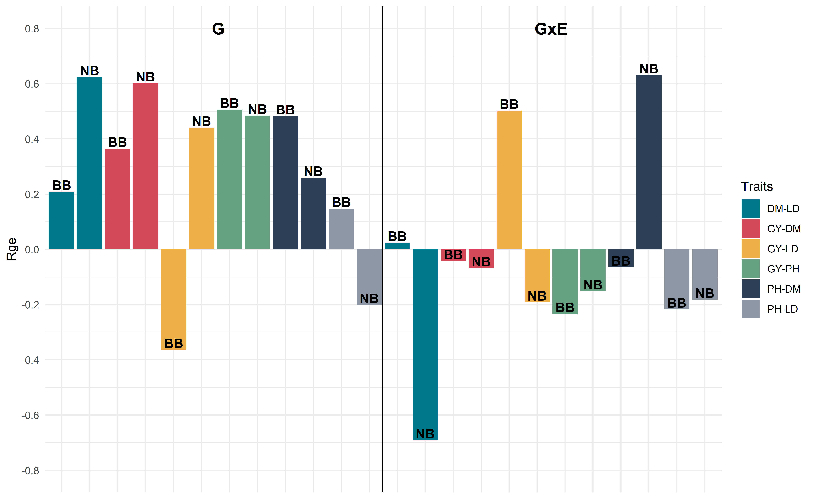

cat("\n\n\\pagebreak\n")

# 6 Package References

* Allaire J, Xie Y, McPherson J, Luraschi J, Ushey K, Atkins A, Wickham H, Cheng J, Chang W, Iannone R(2022). *rmarkdown: Dynamic Documents for R*. R package version 2.19,<https://github.com/rstudio/rmarkdown>.Xie Y, Allaire J, Grolemund G (2018). *R Markdown: The Definitive Guide*. Chapman and Hall/CRC, BocaRaton, Florida. ISBN 9781138359338, <https://bookdown.org/yihui/rmarkdown>.Xie Y, Dervieux C, Riederer E (2020). *R Markdown Cookbook*. Chapman and Hall/CRC, Boca Raton, Florida.ISBN 9780367563837, <https://bookdown.org/yihui/rmarkdown-cookbook>.
* Aphalo P (2022). *ggpmisc: Miscellaneous Extensions to ‘ggplot2’*. R package version 0.5.1,<https://CRAN.R-project.org/package=ggpmisc>.
* Aphalo P (2022). *ggpp: Grammar Extensions to ‘ggplot2’*. R package version 0.5.0,<https://CRAN.R-project.org/package=ggpp>.
* Auguie B (2017). *gridExtra: Miscellaneous Functions for “Grid” Graphics*. R package version 2.3,<https://CRAN.R-project.org/package=gridExtra>.
* Bache S, Wickham H (2022). *magrittr: A Forward-Pipe Operator for R*. R package version 2.0.3,<https://CRAN.R-project.org/package=magrittr>.
* Bates D, Maechler M, Jagan M (2022). *Matrix: Sparse and Dense Matrix Classes and Methods*. R packageversion 1.5-1, <https://CRAN.R-project.org/package=Matrix>.
* Becker OScbRA, Brownrigg. ARWRvbR (2022). *mapdata: Extra Map Databases*. R package version 2.3.1,<https://CRAN.R-project.org/package=mapdata>.
* Becker OScbRA, Minka ARWRvbRBEbTP, Deckmyn. A (2022). *maps: Draw Geographical Maps*. R package version3.4.1, <https://CRAN.R-project.org/package=maps>.
* Bivand R, Nowosad J, Lovelace R (2022). *spData: Datasets for Spatial Analysis*. R package version 2.2.1,<https://CRAN.R-project.org/package=spData>.
* Brien C (2022). *asremlPlus: Augments ‘ASReml-R’ in Fitting Mixed Models and Packages Generally inExploring Prediction Differences*. R package version 4.3.40,<https://CRAN.R-project.org/package=asremlPlus>.
* Butler D (2021). *asreml: Fits the Linear Mixed Model*. R package version 4.1.0.160, <www.vsni.co.uk>.
* Dancho M, Vaughan D (2022). *tidyquant: Tidy Quantitative Financial Analysis*. R package version 1.0.6,<https://CRAN.R-project.org/package=tidyquant>.
* Dowle M, Srinivasan A (2022). *data.table: Extension of data.frame*. R package version 1.14.4,<https://CRAN.R-project.org/package=data.table>.
* Gohel D, Skintzos P (2022). *flextable: Functions for Tabular Reporting*. R package version 0.8.3,<https://CRAN.R-project.org/package=flextable>.
* Grolemund G, Wickham H (2011). “Dates and Times Made Easy with lubridate.” *Journal of StatisticalSoftware*, *40*(3), 1-25. <https://www.jstatsoft.org/v40/i03/>.
* Henry L, Wickham H (2022). *purrr: Functional Programming Tools*. R package version 0.3.5,<https://CRAN.R-project.org/package=purrr>.
* Hijmans R (2022). *raster: Geographic Data Analysis and Modeling*. R package version 3.6-3,<https://CRAN.R-project.org/package=raster>.
* Kassambara A (2022). *ggcorrplot: Visualization of a Correlation Matrix using ‘ggplot2’*. R packageversion 0.1.4, <https://CRAN.R-project.org/package=ggcorrplot>.
* Kay M (2023). *ggdist: Visualizations of Distributions and Uncertainty*. <doi:10.5281/zenodo.3879620><https://doi.org/10.5281/zenodo.3879620>, R package version 3.2.1, <https://mjskay.github.io/ggdist/>.
* Müller K, Wickham H (2022). *tibble: Simple Data Frames*. R package version 3.1.8,<https://CRAN.R-project.org/package=tibble>.
* Nowosad J (2018). *‘CARTOColors’ Palettes*. R package version 1.0,<https://nowosad.github.io/rcartocolor>.
* Olivoto T, L’ucio AD (2020). “metan: an R package for multi-environment trial analysis.” *Methods inEcology and Evolution*, *11*(6), 783-789. <doi:10.1111/2041-210X.13384><https://doi.org/10.1111/2041-210X.13384>.
* Patil I (2021). “Visualizations with statistical details: The ‘ggstatsplot’ approach.” *Journal of OpenSource Software*, *6*(61), 3167. <doi:10.21105/joss.03167> <https://doi.org/10.21105/joss.03167>,<https://doi.org/10.21105/joss.03167>.
* Pebesma E (2018). “Simple Features for R: Standardized Support for Spatial Vector Data.” *The R Journal*,*10*(1), 439-446. <doi:10.32614/RJ-2018-009> <https://doi.org/10.32614/RJ-2018-009>,<https://doi.org/10.32614/RJ-2018-009>.
* Pebesma EJ, Bivand RS (2005). “Classes and methods for spatial data in R.” *R News*, *5*(2), 9-13.<https://CRAN.R-project.org/doc/Rnews/>.Bivand RS, Pebesma E, Gomez-Rubio V (2013). *Applied spatial data analysis with R, Second edition*.Springer, NY. <https://asdar-book.org/>.
* Pedersen T (2022). *ggforce: Accelerating ‘ggplot2’*. R package version 0.4.1,<https://CRAN.R-project.org/package=ggforce>.
* Peterson BG, Carl P (2020). *PerformanceAnalytics: Econometric Tools for Performance and Risk Analysis*.R package version 2.0.4, <https://CRAN.R-project.org/package=PerformanceAnalytics>.
* R Core Team (2022). *R: A Language and Environment for Statistical Computing*. R Foundation forStatistical Computing, Vienna, Austria. <https://www.R-project.org/>.
* Robinson D, Hayes A, Couch S (2022). *broom: Convert Statistical Objects into Tidy Tibbles*. R packageversion 1.0.2, <https://CRAN.R-project.org/package=broom>.
* Ryan JA, Ulrich JM (2022). *quantmod: Quantitative Financial Modelling Framework*. R package version0.4.20, <https://CRAN.R-project.org/package=quantmod>.
* Ryan JA, Ulrich JM (2022). *xts: eXtensible Time Series*. R package version 0.12.2,<https://CRAN.R-project.org/package=xts>.
* Schauberger P, Walker A (2022). *openxlsx: Read, Write and Edit xlsx Files*. R package version 4.2.5.1,<https://CRAN.R-project.org/package=openxlsx>.
* Spinu V (2022). *timechange: Efficient Manipulation of Date-Times*. R package version 0.1.1,<https://CRAN.R-project.org/package=timechange>.
* Tierney N, Cook D, McBain M, Fay C (2021). *naniar: Data Structures, Summaries, and Visualisations forMissing Data*. R package version 0.6.1, <https://CRAN.R-project.org/package=naniar>.
* Ulrich J (2021). *TTR: Technical Trading Rules*. R package version 0.24.3,<https://CRAN.R-project.org/package=TTR>.
* van Rossum B (2022). *statgenGxE: Genotype by Environment (GxE) Analysis*. R package version 1.0.5,<https://CRAN.R-project.org/package=statgenGxE>.
* Walker K (2022). *tigris: Load Census TIGER/Line Shapefiles*. R package version 2.0,<https://CRAN.R-project.org/package=tigris>.
* Wickham H (2011). “The Split-Apply-Combine Strategy for Data Analysis.” *Journal of StatisticalSoftware*, *40*(1), 1-29. <https://www.jstatsoft.org/v40/i01/>.
* Wickham H (2016). *ggplot2: Elegant Graphics for Data Analysis*. Springer-Verlag New York. ISBN978-3-319-24277-4, <https://ggplot2.tidyverse.org>.
* Wickham H (2022). *forcats: Tools for Working with Categorical Variables (Factors)*. R package version0.5.2, <https://CRAN.R-project.org/package=forcats>.
* Wickham H (2022). *stringr: Simple, Consistent Wrappers for Common String Operations*. R package version1.5.0, <https://CRAN.R-project.org/package=stringr>.
* Wickham H, Averick M, Bryan J, Chang W, McGowan LD, François R, Grolemund G, Hayes A, Henry L, Hester J,Kuhn M, Pedersen TL, Miller E, Bache SM, Müller K, Ooms J, Robinson D, Seidel DP, Spinu V, Takahashi K,Vaughan D, Wilke C, Woo K, Yutani H (2019). “Welcome to the tidyverse.” *Journal of Open SourceSoftware*, *4*(43), 1686. <doi:10.21105/joss.01686> <https://doi.org/10.21105/joss.01686>.
* Wickham H, François R, Henry L, Müller K (2022). *dplyr: A Grammar of Data Manipulation*. R packageversion 1.0.10, <https://CRAN.R-project.org/package=dplyr>.
* Wickham H, Girlich M (2022). *tidyr: Tidy Messy Data*. R package version 1.2.1,<https://CRAN.R-project.org/package=tidyr>.
* Wickham H, Hester J, Bryan J (2022). *readr: Read Rectangular Text Data*. R package version 2.1.3,<https://CRAN.R-project.org/package=readr>.
* Wilke C (2020). *cowplot: Streamlined Plot Theme and Plot Annotations for ‘ggplot2’*. R package version1.1.1, <https://CRAN.R-project.org/package=cowplot>.
* Wolak ME (2012). “nadiv: an R package to create relatedness matrices for estimating non-additive geneticvariances in animal models.” *Methods in Ecology and Evolution*, *3*(5), 792-796.
* Xie Y, Cheng J, Tan X (2022). *DT: A Wrapper of the JavaScript Library ‘DataTables’*. R package version0.26, <https://CRAN.R-project.org/package=DT>.
* Zeileis A, Grothendieck G (2005). “zoo: S3 Infrastructure for Regular and Irregular Time Series.”*Journal of Statistical Software*, *14*(6), 1-27. <doi:10.18637/jss.v014.i06><https://doi.org/10.18637/jss.v014.i06>.
* Zhu H (2021). *kableExtra: Construct Complex Table with ‘kable’ and Pipe Syntax*. R package version1.3.4, <https://CRAN.R-project.org/package=kableExtra>.

# References

Aguate, F., Crossa, J., & Balzarini, M. (2019). Effect of Missing Values on Variance Component Estimates in Multienvironment Trials. *Crop Science*, *59*(2), 508–517. <https://doi.org/10.2135/cropsci2018.03.0209>

Ahakpaz, F., Abdi, H., Neyestani, E., Hesami, A., Mohammadi, B., Mahmoudi, K. N., … Alipour, H. (2021). Genotype-by-environment interaction analysis for grain yield of barley genotypes under dryland conditions and the role of monthly rainfall. *Agricultural Water Management*, *245*, 106665. <https://doi.org/10.1016/j.agwat.2020.106665>

Bänziger, M., & Cooper, M. (2001). Breeding for low input conditions and consequences for participatory plant breeding examples from tropical maize and wheat. *Euphytica*, *122:503519*, 18. <https://doi.org/10.1023/A:1017510928038>

Bates, D., Mächler, M., Bolker, B., & Walker, S. (2015). Fitting Linear Mixed-Effects Models Using **Lme4**. *Journal of Statistical Software*, *67*(1). <https://doi.org/10.18637/jss.v067.i01>

Bernardeli, A., Rocha, J. R. A. S. de C., Borém, A., Lorenzoni, R., Aguiar, R., Silva, J. N. B., … Lamas Costa, M. D. (2021). Modeling spatial trends and enhancing genetic selection: An approach to soybean seed composition breeding. *Crop Science*, *61*(2), 976–988. <https://doi.org/10.1002/csc2.20364>

Bernardo, R. (2014). *Essentials of plant breeding*. Woodbury, Minnesota: Stemma Press.

Boer, M. P., Wright, D., Feng, L., Podlich, D. W., Luo, L., Cooper, M., & van Eeuwijk, F. A. (2007). A Mixed-Model Quantitative Trait Loci (QTL) Analysis for Multiple-Environment Trial Data Using Environmental Covariables for QTL-by-Environment Interactions, With an Example in Maize. *Genetics*, *177*(3), 1801–1813. <https://doi.org/10.1534/genetics.107.071068>

Buntaran, H., Forkman, J., & Piepho, H.-P. (2021). Projecting results of zoned multi-environment trials to new locations using environmental covariates with random coefficient models: Accuracy and precision. *Theoretical and Applied Genetics*, *134*(5), 1513–1530. <https://doi.org/10.1007/s00122-021-03786-2>

Buntaran, H., Piepho, H., Schmidt, P., Rydén, J., Halling, M., & Forkman, J. (2020). Cross‐validation of stagewise mixed‐model analysis of Swedish variety trials with winter wheat and spring barley. *Crop Science*, *60*(5), 2221–2240. <https://doi.org/10.1002/csc2.20177>

Butler, D. G., Cullis, B. R., Gilmour, A. R., Gogel, B. J., & Thompson, R. (n.d.). *ASReml estimates variance components under a general linear*. 188.

Cichy, K. A., Wiesinger, J. A., Berry, M., Nchimbi‐Msolla, S., Fourie, D., Porch, T. G., … Miklas, P. N. (2019). The role of genotype and production environment in determining the cooking time of dry beans ( *Phaseolus* *Vulgaris* L.). *Legume Science*, *1*(1). <https://doi.org/10.1002/leg3.13>

Colombari Filho, J. M., de Resende, M. D. V., de Morais, O. P., de Castro, A. P., Guimarães, É. P., Pereira, J. A., … Breseghello, F. (2013). Upland rice breeding in Brazil: A simultaneous genotypic evaluation of stability, adaptability and grain yield. *Euphytica*, *192*(1), 117–129. <https://doi.org/10.1007/s10681-013-0922-2>

Costa-Neto, G. M. F., Morais Júnior, O. P., Heinemann, A. B., de Castro, A. P., & Duarte, J. B. (2020). A novel GIS-based tool to reveal spatial trends in reaction norm: Upland rice case study. *Euphytica*, *216*(3), 37. <https://doi.org/10.1007/s10681-020-2573-4>

Costa-Neto, G., Fritsche-Neto, R., & Crossa, J. (2021). Nonlinear kernels, dominance, and envirotyping data increase the accuracy of genome-based prediction in multi-environment trials. *Heredity*, *126*(1), 92–106. <https://doi.org/10.1038/s41437-020-00353-1>

Costa-Neto, G., Galli, G., Carvalho, H. F., Crossa, J., & Fritsche-Neto, R. (n.d.). *EnvRtype: A software to interplay enviromics and quantitative genomics in agriculture*. 64.

Crespo-Herrera, L., Howard, R., Piepho, H.-P., Pérez-Rodríguez, P., Montesinos-Lopez, O., Burgueño, J., … Crossa, J. (2021). Genome-enabled prediction for sparse testing in multi-environmental wheat trials. *The Plant Genome*, *14*(3), e20151. <https://doi.org/10.1002/tpg2.20151>

Crossa, J., Fritsche-Neto, R., Montesinos-Lopez, O. A., Costa-Neto, G., Dreisigacker, S., Montesinos-Lopez, A., & Bentley, A. R. (2021). The Modern Plant Breeding Triangle: Optimizing the Use of Genomics, Phenomics, and Enviromics Data. *Frontiers in Plant Science*, *12*, 651480. <https://doi.org/10.3389/fpls.2021.651480>

da Silva, K. J., Teodoro, P. E., da Silva, M. J., Teodoro, L. P. R., Cardoso, M. J., Godinho, V. de P. C., … Menezes, C. B. (2021a). Identification of mega‐environments for grain sorghum in Brazil using GGE biplot methodology. *Agronomy Journal*, *113*(4), 3019–3030. <https://doi.org/10.1002/agj2.20707>

da Silva, K. J., Teodoro, P. E., da Silva, M. J., Teodoro, L. P. R., Cardoso, M. J., Godinho, V. de P. C., … Menezes, C. B. (2021b). Identification of mega‐environments for grain sorghum in Brazil using GGE biplot methodology. *Agronomy Journal*, *113*(4), 3019–3030. <https://doi.org/10.1002/agj2.20707>

DeLacy, I. H., Basford, K. E., Cooper, M., Bull, J. K., & McLaren, C. G. (1996). Analysis of multi-environment trials - an historical perspective. *Plant Adaptation and Crop Improvement.*, 39–124. Retrieved from <https://www.cabdirect.org/cabdirect/abstract/19961610824>

Dramadri, I. O., Nkalubo, S. T., Kramer, D. M., & Kelly, J. D. (2021a). Genome‐wide association analysis of drought adaptive traits in common bean. *Crop Science*, *61*(5), 3232–3253. <https://doi.org/10.1002/csc2.20484>

Dramadri, I. O., Nkalubo, S. T., Kramer, D. M., & Kelly, J. D. (2021b). Genome‐wide association analysis of drought adaptive traits in common bean. *Crop Science*, *61*(5), 3232–3253. <https://doi.org/10.1002/csc2.20484>

Fehr, W. R. (n.d.). *Stages of Soybean Development*. 12.

Ferreira, F. M., de Carvalho Rocha, J. R. do A. S., Alves, R. S., Malikouski, R. G., Peixoto, M. A., Suellen Sales de Oliveira, … Bhering, L. L. (2021). GGE biplot-based genetic selection to guide interspecific crossing in Corymbia spp. *Bragantia*. <https://doi.org/10.1590/1678-4499.20210195>

Finlay, K., & Wilkinson, G. (1963). The analysis of adaptation in a plant-breeding programme. *Australian Journal of Agricultural Research*, *14*(6), 742. <https://doi.org/10.1071/AR9630742>

Gabriel, K. R. (2002). Goodness of fit of biplots and correspondence analysis. *Biometrika*, *89*(2), 423–436. <https://doi.org/10.1093/biomet/89.2.423>

Galli, G., Horne, D. W., Collins, S. D., Jung, J., Chang, A., Fritsche‐Neto, R., & Rooney, W. L. (2020). Optimization of UAS‐based high‐throughput phenotyping to estimate plant health and grain yield in sorghum. *The Plant Phenome Journal*, *3*(1). <https://doi.org/10.1002/ppj2.20010>

Gauch, H. G. (1988). Model Selection and Validation for Yield Trials with Interaction. *Biometrics*, *44*(3), 705. <https://doi.org/10.2307/2531585>

Gauch, H. G. (Ed.). (1992). *Statistical Analysis of Regional Yield Trials: AMMI Analysis of Factorial Designs* (1st edition). Amsterdam ; New York: Elsevier Science.

Gauch, Hugh. G., & Zobel, R. W. (1997). Identifying Mega‐Environments and Targeting Genotypes. *Crop Science*, *37*(2), 311–326. <https://doi.org/10.2135/cropsci1997.0011183X003700020002x>

GGE Biplot Analysis: A Graphical Tool for Breeders, Geneticists, and A. (n.d.). Retrieved June 7, 2022, from <https://www.routledge.com/GGE-Biplot-Analysis-A-Graphical-Tool-for-Breeders-Geneticists-and-Agronomists/Yan-Kang/p/book/9780367454791>

Gilmour, A. R., Gogel, B. J., Cullis, B. R., Welham, S. J., & Thompson, R. (2015). *ASReml User Guide Release 4.1 Functional Specification* (HP1 1ES). Retrieved from <http://www.vsni.co.uk/>

González‐Barrios, P., Díaz‐García, L., & Gutiérrez, L. (2019). Mega‐Environmental Design: Using Genotype × Environment Interaction to Optimize Resources for Cultivar Testing. *Crop Science*, *59*(5), 1899–1915. <https://doi.org/10.2135/cropsci2018.11.0692>

Gurumurthy, S., Singh, J., Basu, P. S., Meena, S. K., Rane, J., Singh, N. P., & Hazra, K. K. (2022). Increased significance of chickpea (Cicer arietinum L.) Senescence trait under water-deficit environment. *Environmental Challenges*, *8*, 100565. <https://doi.org/10.1016/j.envc.2022.100565>

Hamblin, J., & Zimmermann, M. J. de O. (1986). Breeding Common Bean for Yield in Mixtures. In J. Janick (Ed.), *Plant Breeding Reviews* (pp. 245–272). <https://doi.org/10.1002/9781118061015.ch8>

Happ, M. M., Graef, G. L., Wang, H., Howard, R., Posadas, L., & Hyten, D. L. (2021). Comparing a Mixed Model Approach to Traditional Stability Estimators for Mapping Genotype by Environment Interactions and Yield Stability in Soybean [Glycine max (L.) Merr.]. *Frontiers in Plant Science*, *12*, 630175. <https://doi.org/10.3389/fpls.2021.630175>

Hartung, J., & Piepho, H. (2021). Effect of missing values in multi‐environmental trials on variance component estimates. *Crop Science*, *61*(6), 4087–4097. <https://doi.org/10.1002/csc2.20621>

Heilig, J. A., Wright, E. M., & Kelly, J. D. (2017). Symbiotic Nitrogen Fixation of Black and Navy Bean under Organic Production Systems. *Agronomy Journal*, *109*(5), 2223–2230. <https://doi.org/10.2134/agronj2017.01.0051>

Henderson, C. R. (1975). Best Linear Unbiased Estimation and Prediction under a Selection Model. *Biometrics*, *31*(2), 423. <https://doi.org/10.2307/2529430>

Hoyos-Villegas, V., O’Connor, J. R., Heslop, A. D., Hilditch, A., Jahufer, M. Z. Z., & Barrett, B. A. (2019). Rate of Genetic Gain for Persistence to Grazing and Dry Matter Yield in White Clover across 90 Years of Cultivar Development. *Crop Science*, *59*(2), 537–552. <https://doi.org/10.2135/cropsci2018.07.0471>

Hoyos-Villegas, V., Wright, E. M., & Kelly, J. D. (2016). GGE Biplot Analysis of Yield Associations with Root Traits in a Mesoamerican Bean Diversity Panel. *Crop Science*, *56*(3), 1081–1094. <https://doi.org/10.2135/cropsci2015.10.0609>

Huang, X., Jang, S., Kim, B., Piao, Z., Redona, E., & Koh, H.-J. (2021a). Evaluating Genotype × Environment Interactions of Yield Traits and Adaptability in Rice Cultivars Grown under Temperate, Subtropical and Tropical Environments. *Agriculture*, *11*(6), 558. <https://doi.org/10.3390/agriculture11060558>

Huang, X., Jang, S., Kim, B., Piao, Z., Redona, E., & Koh, H.-J. (2021b). Evaluating Genotype × Environment Interactions of Yield Traits and Adaptability in Rice Cultivars Grown under Temperate, Subtropical and Tropical Environments. *Agriculture*, *11*(6), 558. <https://doi.org/10.3390/agriculture11060558>

Isik, F., Holland, J., & Maltecca, C. (2017). *Genetic Data Analysis for Plant and Animal Breeding*. <https://doi.org/10.1007/978-3-319-55177-7>

Kamfwa, K., Cichy, K. A., & Kelly, J. D. (2015). Genome‐Wide Association Study of Agronomic Traits in Common Bean. *The Plant Genome*, *8*(2). <https://doi.org/10.3835/plantgenome2014.09.0059>

Kang, M. S. (2020). Genotype-environment interaction and stability analyses: An update. In M. S. Kang (Ed.), *Quantitative genetics, genomics and plant breeding* (2nd ed., pp. 140–161). <https://doi.org/10.1079/9781789240214.0140>

Katuuramu, D. N., Luyima, G. B., Nkalubo, S. T., Wiesinger, J. A., Kelly, J. D., & Cichy, K. A. (2020a). On-farm multi-location evaluation of genotype by environment interactions for seed yield and cooking time in common bean. *Scientific Reports*, *10*(1), 3628. <https://doi.org/10.1038/s41598-020-60087-2>

Katuuramu, D. N., Luyima, G. B., Nkalubo, S. T., Wiesinger, J. A., Kelly, J. D., & Cichy, K. A. (2020b). On-farm multi-location evaluation of genotype by environment interactions for seed yield and cooking time in common bean. *Scientific Reports*, *10*(1), 3628. <https://doi.org/10.1038/s41598-020-60087-2>

Katuuramu, D. N., Wiesinger, J. A., Luyima, G. B., Nkalubo, S. T., Glahn, R. P., & Cichy, K. A. (2021). Investigation of Genotype by Environment Interactions for Seed Zinc and Iron Concentration and Iron Bioavailability in Common Bean. *Frontiers in Plant Science*, *12*, 670965. <https://doi.org/10.3389/fpls.2021.670965>

Kelly, James D., Awale, H. E., Wiersma, A. T., & Wright, E. M. (2021). Registration of “Adams” black bean. *Journal of Plant Registrations*, *15*(2), 253–259. <https://doi.org/10.1002/plr2.20063>

Kelly, James D., & Cichy, K. A. (2012). Dry Bean Breeding and Production Technologies. In M. Siddiq & M. A. Uebersax (Eds.), *Dry Beans and Pulses Production, Processing and Nutrition* (1st ed., pp. 23–54). <https://doi.org/10.1002/9781118448298.ch2>

Kelly, James D., Kolkman, J. M., & Schneider, K. (1998). Breeding for yield in dry bean (Phaseolus vulgaris L.). *Euphytica*, *102*(343–356), 14. <https://doi.org/10.1023/A:1018392901978>

Kelly, James D., Varner, G. V., Cichy, K. A., & Wright, E. M. (2015). Registration of “Alpena” Navy Bean. *Journal of Plant Registrations*, *9*(1), 10–14. <https://doi.org/10.3198/jpr2014.04.0025crc>

Koundinya A.V.V., Ajeesh B.R., Vivek H., Sheela M.N., Mohan C., & Asha K.I. (2021). Genetic parameters, stability and selection of cassava genotypes between rainy and water stress conditions using AMMI, WAAS, BLUP and MTSI. *Scientia Horticulturae*, *281*, 109949. <https://doi.org/10.1016/j.scienta.2021.109949>

Krause, M. D., Dias, K. O. G., Singh, A. K., & Beavis, W. D. (2022). *Using large soybean historical data to study genotype by environment variation and identify mega-environments with the integration of genetic and non-genetic factors* [Preprint]. <https://doi.org/10.1101/2022.04.11.487885>

Ligarreto–Moreno, G., & Pimentel–Ladino, C. (2022). Grain yield and genotype x environment interaction in bean cultivars with different growth habits. *Plant Production Science*, *25*(2), 232–241. <https://doi.org/10.1080/1343943X.2021.1981141>

Lin, C. S., & Binns, M. R. (1988). A SUPERIORITY MEASURE OF CULTIVAR PERFORMANCE FOR CULTIVAR × LOCATION DATA. *Canadian Journal of Plant Science*, *68*(1), 193–198. <https://doi.org/10.4141/cjps88-018>

MacQueen, A. H., White, J. W., Lee, R., Osorno, J. M., Schmutz, J., Miklas, P. N., … Juenger, T. E. (2020). Genetic Associations in Four Decades of Multienvironment Trials Reveal Agronomic Trait Evolution in Common Bean. *Genetics*, *215*(1), 267–284. <https://doi.org/10.1534/genetics.120.303038>

Malosetti, M., Bustos-Korts, D., Boer, M. P., & van Eeuwijk, F. A. (2016). Predicting Responses in Multiple Environments: Issues in Relation to Genotype × Environment Interactions. *Crop Science*, *56*(5), 2210–2222. <https://doi.org/10.2135/cropsci2015.05.0311>

Malosetti, M., Ribaut, J.-M., & van Eeuwijk, F. A. (2013a). The statistical analysis of multi-environment data: Modeling genotype-by-environment interaction and its genetic basis. *Frontiers in Physiology*, *4*. <https://doi.org/10.3389/fphys.2013.00044>

Malosetti, M., Ribaut, J.-M., & van Eeuwijk, F. A. (2013b). The statistical analysis of multi-environment data: Modeling genotype-by-environment interaction and its genetic basis. *Frontiers in Physiology*, *4*. <https://doi.org/10.3389/fphys.2013.00044>

Miklas, P. N., Kelly, J. D., Beebe, S. E., & Blair, M. W. (2006). Common bean breeding for resistance against biotic and abiotic stresses: From classical to MAS breeding. *Euphytica*, *147*(1), 105–131. <https://doi.org/10.1007/s10681-006-4600-5>

Miklas, P. N., Kelly, J. D., & Cichy, K. A. (2022a). Dry Bean Breeding and Production Technologies. In *Dry Beans and Pulses* (pp. 29–56). <https://doi.org/10.1002/9781119776802.ch2>

Miklas, P. N., Kelly, J. D., & Cichy, K. A. (2022b). Dry Bean Breeding and Production Technologies. In M. Siddiq & M. A. Uebersax (Eds.), *Dry Beans and Pulses* (1st ed., pp. 29–56). <https://doi.org/10.1002/9781119776802.ch2>

Millet, E., Welcker, C., Kruijer, W., Negro, S., Nicolas, S., Praud, S., … Bauland, C. (2016). Genome-wide analysis of yield in Europe: Allelic effects as functions of drought and heat scenarios. *Plant Physiology*, pp.00621.2016. <https://doi.org/10.1104/pp.16.00621>

Mrode, R. A. (2014). *Linear models for the prediction of animal breeding values* (3rd ed). Boston, MA: CABI.

Nataraj, V., Bhartiya, A., Singh, C. P., Devi, H. N., Deshmukh, M. P., Verghese, P., … Gupta, S. (2021). WAASB‐based stability analysis and simultaneous selection for grain yield and early maturity in soybean. *Agronomy Journal*, *113*(4), 3089–3099. <https://doi.org/10.1002/agj2.20750>

Olivoto, T., Lúcio, A. D. C., Silva, J. A. G., Marchioro, V. S., Souza, V. Q., & Jost, E. (2019). Mean Performance and Stability in Multi‐Environment Trials I: Combining Features of AMMI and BLUP Techniques. *Agronomy Journal*, *111*(6), 2949–2960. <https://doi.org/10.2134/agronj2019.03.0220>

Olivoto, T., Lúcio, A. D. C., Silva, J. A. G., Sari, B. G., & Diel, M. I. (2019). Mean Performance and Stability in Multi‐Environment Trials II: Selection Based on Multiple Traits. *Agronomy Journal*, *111*(6), 2961–2969. <https://doi.org/10.2134/agronj2019.03.0221>

Olivoto, T., Nardino, M., Meira, D., Meier, C., Follmann, D. N., Souza, V. Q., … Baretta, D. (2021). Multi‐trait selection for mean performance and stability in maize. *Agronomy Journal*, *113*(5), 3968–3974. <https://doi.org/10.1002/agj2.20741>

Philipo, M., Ndakidemi, P. A., & Mbega, E. R. (2021). Environmentally stable common bean genotypes for production in different agro-ecological zones of Tanzania. *Heliyon*, *7*(1), e05973. <https://doi.org/10.1016/j.heliyon.2021.e05973>

Piepho, H.-P. (2018). Allowing for the structure of a designed experiment when estimating and testing trait correlations. *The Journal of Agricultural Science*, *156*(1), 59–70. <https://doi.org/10.1017/S0021859618000059>

Piepho, H.-P., Edmondson, R., & Yaseen, M. (n.d.). *Tutorial Analysis of Some Agricultural Experiments*. 46.

Pour-Aboughadareh, A., Khalili, M., Poczai, P., & Olivoto, T. (2022). Stability Indices to Deciphering the Genotype-by-Environment Interaction (GEI) Effect: An Applicable Review for Use in Plant Breeding Programs. *Plants*, *11*(3), 414. <https://doi.org/10.3390/plants11030414>

Qureshi, A. M. I., & Sadohara, R. (2019). Breeding Dry Beans (Phaseolus vulqaris L.) With Improved Cooking and Canning Quality Traits. In A. M. I. Qureshi, Z. A. Dar, & S. H. Wani (Eds.), *Quality Breeding in Field Crops* (pp. 173–191). <https://doi.org/10.1007/978-3-030-04609-5_8>

Rakshit, S., K N, G., Gomashe, S., Swapna, M., More, A., Gadakh, S., … Bhat, P. (2014). GGE biplot analysis of genotype × environment interaction in rabi grain sorghum [ Sorghum bicolor (L.) Moench]. *Indian Journal of Genetics and Plant Breeding*, *74*, 558–563. <https://doi.org/10.5958/0975-6906.2014.00889.X>

Resende, M. D. V. de. (2016a). Software Selegen-REML/BLUP: A useful tool for plant breeding. *Crop Breeding and Applied Biotechnology*, *16*(4), 330–339. <https://doi.org/10.1590/1984-70332016v16n4a49>

Resende, M. D. V. de. (2016b). Software Selegen-REML/BLUP: A useful tool for plant breeding. *Crop Breeding and Applied Biotechnology*, *16*(4), 330–339. <https://doi.org/10.1590/1984-70332016v16n4a49>

Resende, R. T., Piepho, H.-P., Rosa, G. J. M., Silva-Junior, O. B., e Silva, F. F., de Resende, M. D. V., & Grattapaglia, D. (2021). Enviromics in breeding: Applications and perspectives on envirotypic-assisted selection. *Theoretical and Applied Genetics*, *134*(1), 95–112. <https://doi.org/10.1007/s00122-020-03684-z>

Rodrigues, F. C., Silva, F. C. S., Carneiro, P. C. S., Peternelli, L. A., Bhering, L. L., & da Silva, F. L. (2022). Environmental stratification in trials of unbalanced multiyear soybean (Glycine max (l.) Merril) via the integration of GGE Biplot graphs and networks of environmental similarity. *Euphytica*, *218*(6), 71. <https://doi.org/10.1007/s10681-022-02994-1>

Rosales, M. A., Ocampo, E., Rodríguez-Valentín, R., Olvera-Carrillo, Y., Acosta-Gallegos, J., & Covarrubias, A. A. (2012). Physiological analysis of common bean (Phaseolus vulgaris L.) Cultivars uncovers characteristics related to terminal drought resistance. *Plant Physiology and Biochemistry*, *56*, 24–34. <https://doi.org/10.1016/j.plaphy.2012.04.007>

Shukla, G. K. (1972). Some statistical aspects of partitioning genotype-environmental components of variability. *Heredity*, *29*(2), 237–245. <https://doi.org/10.1038/hdy.1972.87>

Siddiq, M., & Uebersax, M. A. (Eds.). (2022). *Dry Beans and PulsesProduction, Processing, and Nutrition* (Second Edition). <https://doi.org/10.1002/9781119776802.fmatter>

Singamsetti, A., Shahi, J. P., Zaidi, P. H., Seetharam, K., Vinayan, M. T., Kumar, M., … Madankar, K. (2021). Genotype × environment interaction and selection of maize (Zea mays L.) Hybrids across moisture regimes. *Field Crops Research*, *270*, 108224. <https://doi.org/10.1016/j.fcr.2021.108224>

Singh, B., Das, A., Parihar, A. K., Bhagawati, B., Singh, D., Pathak, K. N., … Gupta, S. (2020a). Delineation of Genotype-by-Environment interactions for identification and validation of resistant genotypes in mungbean to root-knot nematode (Meloidogyne incognita) using GGE biplot. *Scientific Reports*, *10*(1), 4108. <https://doi.org/10.1038/s41598-020-60820-x>

Singh, B., Das, A., Parihar, A. K., Bhagawati, B., Singh, D., Pathak, K. N., … Gupta, S. (2020b). Delineation of Genotype-by-Environment interactions for identification and validation of resistant genotypes in mungbean to root-knot nematode (Meloidogyne incognita) using GGE biplot. *Scientific Reports*, *10*(1), 4108. <https://doi.org/10.1038/s41598-020-60820-x>

Smith, A., Norman, A., Kuchel, H., & Cullis, B. (2021a). Plant Variety Selection Using Interaction Classes Derived From Factor Analytic Linear Mixed Models: Models With Independent Variety Effects. *Frontiers in Plant Science*, *12*, 737462. <https://doi.org/10.3389/fpls.2021.737462>

Smith, A., Norman, A., Kuchel, H., & Cullis, B. (2021b). Plant Variety Selection Using Interaction Classes Derived From Factor Analytic Linear Mixed Models: Models With Independent Variety Effects. *Frontiers in Plant Science*, *12*, 737462. <https://doi.org/10.3389/fpls.2021.737462>

Smith, M. R., Dinglasan, E., Veneklaas, E., Polania, J., Rao, I. M., Beebe, S. E., & Merchant, A. (2022). Effect of Drought and Low P on Yield and Nutritional Content in Common Bean. *Frontiers in Plant Science*, *13*, 814325. <https://doi.org/10.3389/fpls.2022.814325>

Tize, I., Fotso, A. K., Nukenine, E. N., Masso, C., Ngome, F. A., Suh, C., … Hanna, R. (2021). New cassava germplasm for food and nutritional security in Central Africa. *Scientific Reports*, *11*(1), 7394. <https://doi.org/10.1038/s41598-021-86958-w>

Tokatlidis, I. S., Papadopoulos, I. I., Baxevanos, D., & Koutita, O. (2010). Genotype × Environment Effects on Single-Plant Selection at Low Density for Yield and Stability in Climbing Dry Bean Populations. *Crop Science*, *50*(3), 775–783. <https://doi.org/10.2135/cropsci2009.08.0459>

Uebersax, M. A., Cichy, K. A., Gomez, F. E., Porch, T. G., Heitholt, J., Osorno, J. M., … Bales, S. (2022a). Dry beans ( *Phaseolus* *Vulgaris* L.) As a vital component of sustainable agriculture and food security—A review. *Legume Science*. <https://doi.org/10.1002/leg3.155>

Uebersax, M. A., Cichy, K. A., Gomez, F. E., Porch, T. G., Heitholt, J., Osorno, J. M., … Bales, S. (2022b). Dry beans (Phaseolus vulgaris L.) As a vital component of sustainable agriculture and food security—A review. *Legume Science*. <https://doi.org/10.1002/leg3.155>

USDA-NASS. (2022). *Crop Values Summary 2021*. 48.

van Eeuwijk, F. A., Bustos-Korts, D. V., & Malosetti, M. (2016a). What Should Students in Plant Breeding Know About the Statistical Aspects of Genotype × Environment Interactions? *Crop Science*, *56*(5), 2119–2140. <https://doi.org/10.2135/cropsci2015.06.0375>

van Eeuwijk, F. A., Bustos-Korts, D. V., & Malosetti, M. (2016b). What Should Students in Plant Breeding Know About the Statistical Aspects of Genotype × Environment Interactions? *Crop Science*, *56*(5), 2119–2140. <https://doi.org/10.2135/cropsci2015.06.0375>

Vandemark, G. J., Brick, M. A., Osorno, J. M., Kelly, J. D., & Urrea, C. A. (2015). Edible Grain Legumes. In S. Smith, B. Diers, J. Specht, & B. Carver (Eds.), *CSSA Special Publications* (pp. 87–123). <https://doi.org/10.2135/cssaspecpub33.c5>

Verma, A., & Singh, G. P. (2021). Stability, Adaptability Analysis of Wheat Genotypes by AMMI with BLUP for Restricted Irrigated Multi Location Trials in Peninsular Zone of India. *Agricultural Sciences*, *12*(03), 198–212. <https://doi.org/10.4236/as.2021.123013>

Volpato, L., Alves, R. S., Teodoro, P. E., Vilela de Resende, M. D., Nascimento, M., Nascimento, A. C. C., … Borém, A. (2019). Multi-trait multi-environment models in the genetic selection of segregating soybean progeny. *PLOS ONE*, *14*(4), e0215315. <https://doi.org/10.1371/journal.pone.0215315>

Wang, W., Wright, E. M., Uebersax, M. A., & Cichy, K. (2021). A pilot-scale dry bean canning and evaluation protocol. *Journal of Food Processing and Preservation*, *00*(e16171), e16171. <https://doi.org/10.1111/jfpp.16171>

Yan, W. (2002). Singular-Value Partitioning in Biplot Analysis of Multienvironment Trial Data. *Agronomy Journal*, *94*(5), 990. <https://doi.org/10.2134/agronj2002.0990>

Yan, W. (2015). Mega-environment Analysis and Test Location Evaluation Based on Unbalanced Multiyear Data. *Crop Science*, *55*(1), 113–122. <https://doi.org/10.2135/cropsci2014.03.0203>

Yan, W. (2016). Analysis and Handling of G × E in a Practical Breeding Program. *Crop Science*, *56*(5), 2106–2118. <https://doi.org/10.2135/cropsci2015.06.0336>

Yan, W., Hunt, L. A., Sheng, Q., & Szlavnics, Z. (2000). Cultivar Evaluation and Mega-Environment Investigation Based on the GGE Biplot. *Crop Science*, *40*(3), 597–605. <https://doi.org/10.2135/cropsci2000.403597x>

Yan, W., & Kang, M. S. (2002a). *GGE Biplot Analysis: A Graphical Tool for Breeders, Geneticists, and Agronomists*. <https://doi.org/10.1201/9781420040371>

Yan, W., & Kang, M. S. (2002b). *GGE biplot analysis: A graphical tool for breeders, geneticists, and agronomists*. Boca Raton, Fla: CRC Press.

Yan, W., & Kang, M. S. (2003). *GGE biplot analysis: A graphical tool for breeders, geneticists, and agronomists*. Boca Raton, Fla: CRC Press.

Yan, W., Kang, M. S., Ma, B., Woods, S., & Cornelius, P. L. (2007a). GGE Biplot vs. AMMI Analysis of Genotype-by-Environment Data. *Crop Science*, *47*(2), 643–653. <https://doi.org/10.2135/cropsci2006.06.0374>

Yan, W., Kang, M. S., Ma, B., Woods, S., & Cornelius, P. L. (2007b). GGE Biplot vs. AMMI Analysis of Genotype-by-Environment Data. *Crop Science*, *47*(2), 643–653. <https://doi.org/10.2135/cropsci2006.06.0374>

Yan, W., & Tinker, N. A. (2006a). Biplot analysis of multi-environment trial data: Principles and applications. *Canadian Journal of Plant Science*, *86*(3), 623–645. <https://doi.org/10.4141/P05-169>

Yan, W., & Tinker, N. A. (2006b). Biplot analysis of multi-environment trial data: Principles and applications. *Canadian Journal of Plant Science*, *86*(3), 623–645. <https://doi.org/10.4141/P05-169>

Yohannes, S., Loha, G., & Gessese, M. K. (2020). Performance Evaluation of Common Bean ( *Phaseolus* *Vulgaris* L.) Genotypes for Yield and Related Traits at Areka, Southern Ethiopia. *Advances in Agriculture*, *2020*, 1–8. <https://doi.org/10.1155/2020/1497530>

Zuffo, A. M., Steiner, F., Aguilera, J. G., Teodoro, P. E., Teodoro, L. P. R., & Busch, A. (2020). Multi‐trait stability index: A tool for simultaneous selection of soya bean genotypes in drought and saline stress. *Journal of Agronomy and Crop Science*, *206*(6), 815–822. <https://doi.org/10.1111/jac.12409>

Zuiderveen, G. H., Padder, B. A., Kamfwa, K., Song, Q., & Kelly, J. D. (2016). Genome-Wide Association Study of Anthracnose Resistance in Andean Beans (Phaseolus vulgaris). *PLOS ONE*, *11*(6), e0156391. <https://doi.org/10.1371/journal.pone.0156391>